**ENGG1500 Assessment A4 Title Page**

Student number: c…………………..

Discipline: ……………………….. engineering

Workshop class: Workshop number / Day / Time

W01/…….../……………………../…………………….

*Your workshop number can be found by googling ENGG1500, getting the 2020 online timetable and finding your class*

Team number: ………….

How many hours did this assignment take:………………..

What mark would you honestly give yourself: …………../10

*Putting a low mark here will not negatively affect your mark*

**Compliance**

*Your report will not be accepted until the following list is complete*

|  |  |
| --- | --- |
| *Staple in the top left hand corner (or bound)* |  |
| *UoN coversheet attached to hard copy after this page. Try googling UoN cover page* |  |
| *Font is 12 point Times New Roman* |  |
| *Online submission made by 3pm Monday week 9 to* ***BB*** *as a docx with the correct naming convention* |  |
| *Online submission is identical to this report* |  |
| *Submitted as a hard copy to the workshop leader* ***before*** *5 min past the beginning of your week 9 workshop* |  |

Contents

Executive summary 3

Introduction/Description/Scope 4

Constraints and Assumptions 5

Performance Criteria: 6

Evidence of design thinking process and discussion of unexpected problems, solutions, and constraints. 7

Description of own initial design 9

## Executive summary

## Introduction/Description/Scope

A robot will be built to navigate through a course which will be composed of a range of different possible ‘sections’, including tracks, corners, walls and other elements. The robot will carry a payload developed by engineering firm Corridor.ai. The kit supplied includes an Arduino Uno, geared DC motor, motor driver, battery, voltage regulator board, a hobby servo, optical and ultrasonic sensors. As much as possible, the robot hardware should be the minimum viable, as extensive modifications will be time-consuming while adding complexity and points of potential failure. For the payload to have maximum effectiveness, the robot must move smoothly.

## Constraints and Assumptions (max 1 page)

## Performance Criteria: (max 1 page, week 3 lecture, week 5 task)

## Evidence of design thinking process and discussion of unexpected problems, solutions, and constraints. (max 2 pages)

The first few weeks the basic design provided was used, however, some modifications were made; The initial design used only one Infra-Red (IR) sensor (Figure 1), which in our view is not enough to make it autonomous. This caused us some trouble in the competency task in week 4 but this was eventually resolved by changing the angle of the ultrasonic sensor

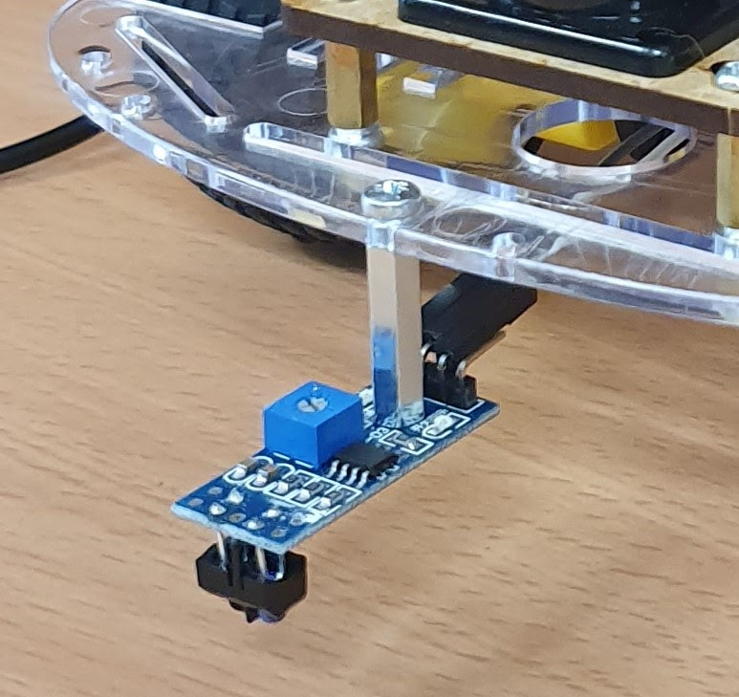

*Figure 1: One IR sensor design during the competency task.*

Programming has been another issue, at some level, it was assumed everyone had prior experience with the C++ language, however Joel is completely new to it and it has been a steep curve learning to code. ENGG1003 so far has only introduced C (which is a different language) and much of the content is very much unrelated to this project. Isaac and Josh, however, have previous experience with C++ which has enabled us to get a lot of code written and also enabled us to be one of the only groups to complete the competency. Joel has been working hard to learn C++ and this is enabling him to contribute to discussions to do with the programming of the robot and to write pseudocode for the project, which was a milestone.

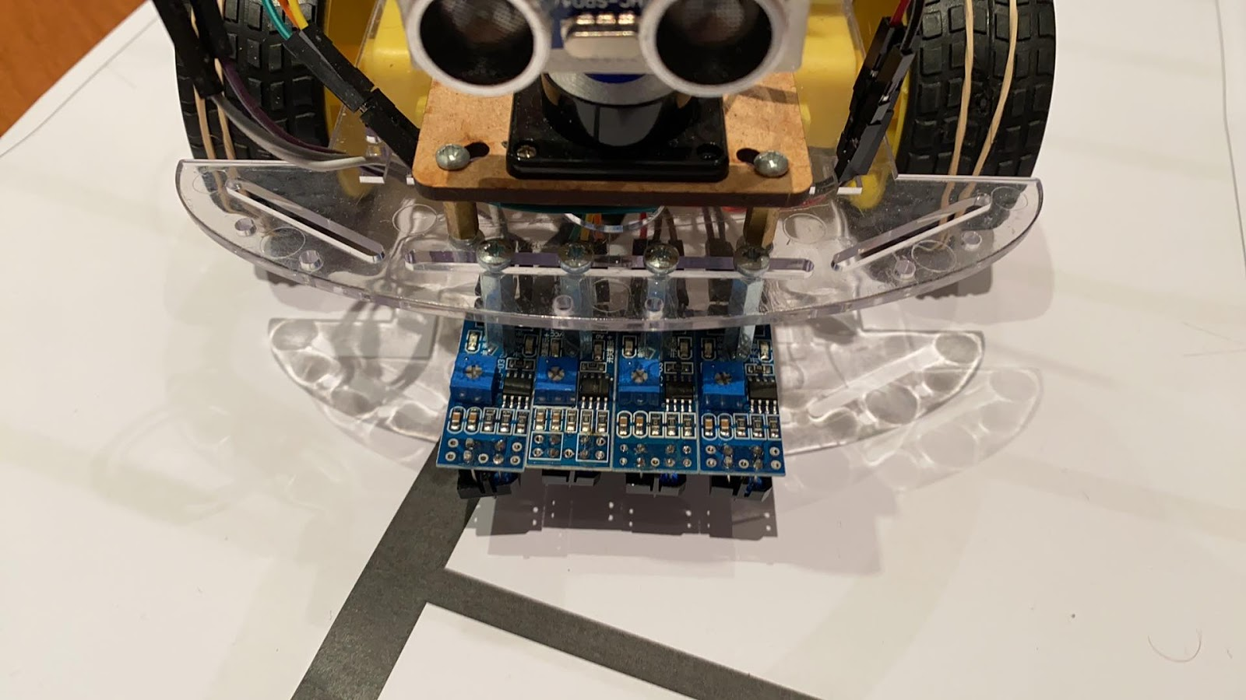It was realised that adding three more IR sensors would allow the robot to follow the track more effectively on test day. These 3 extra sensors will add to its ability to complete the course by allowing the outer two sensors to detect intersections or a curve on the track, once triggered the robot will then decide whether to stop, turn or continue moving forward. Programming this, however, has proven to be difficult though we are sure we can manage to get it working by test day.

*Figure 2: Four IR sensor design after competency task.*

Through discussions and collective problem solving we have persevered and are excited for testing day, as we are always completing our milestones on time and the biggest hurdles are behind us. We also have effective communication allowing us to work together to think of ideas and solutions for any obstacles we come across. These are one of the many reasons you should continue investing in us so we can complete this task and prove ourselves as some of the best in the industry.

## Description of own initial design (max 1 page)

## Description of teams leading design (max 2 pages)

## Weeks 5 – 9 milestone sheets (max 1 page for each milestone)

## Weeks 9 – 12 milestone sheets (max 2 A4 pages)

## Bonus Task: Gantt chart (maximum 2 A4 pages)

## Expected performance on test day and expected mark (0.25 pages)