4. Principal Component Analysis (PCA)
Principal Component Analysis (PCA) was performed to explore the multivariate structure of the continuous cardiovascular risk variables in the Cleveland Heart Disease dataset. PCA is a dimensionality reduction method that transforms a set of correlated variables into a smaller number of uncorrelated components while preserving as much original variance as possible. This is particularly valuable in medical datasets where physiological measurements are often interdependent. By summarizing correlated predictors into orthogonal components, PCA simplifies interpretation, reduces redundancy, and enables effective visualization and downstream statistical analysis.
Only continuous numeric variables were selected for PCA: age, trestbps, chol, thalach, oldpeak, ca, slope, and thal. These variables reflect key cardiovascular risk factors such as age, cholesterol metabolism, resting blood pressure, heart rate response, and ischemic changes during exercise. Categorical features such as sex, chest-pain type, and fasting blood sugar were excluded because PCA relies on covariance structures and assumes continuous data. All selected variables were standardized using z-scores to eliminate unit-related differences, ensuring that each contributes equally to the PCA solution.
After preprocessing, PCA was performed on 297 observations. The explained variance ratio showed that the first component (PC1) accounted for 32.3% of the total variance, PC2 for 16.0%, and PC3 for 12.1%. Together, PC1 and PC2 explained 48.3% of variance, while the first four components captured 71.0%. The scree plot Figure 1 displayed a clear curvature after the second component, indicating an 'elbow' and suggesting that two dominant components summarize most shared structure in the data.
PC1 had strong positive loadings for oldpeak (0.46), slope (0.41), thal (0.35), and a strong negative loading for thalach (-0.42). These variables are physiologically related: high ST-segment depression (oldpeak), abnormal slope and thallium perfusion defects are common among individuals with impaired coronary blood flow, while low maximum heart rate suggests reduced exercise tolerance. Therefore, PC1 represents a latent 'ischemic response under exertion' dimension.
PC2 showed substantial contributions from age (0.46), cholesterol (0.57), and resting blood pressure (0.36). These variables represent traditional cardiovascular risk factors that accumulate over time. Hence, PC2 appears to reflect a 'baseline metabolic and vascular burden' dimension — a chronic rather than acute risk pattern.
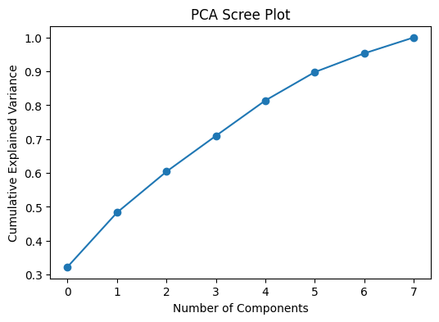
Figure 1: PCA Scree Plot

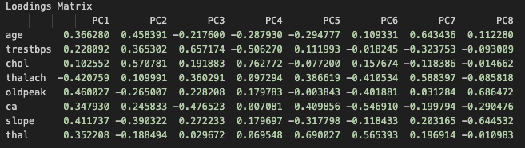
Figure 2: Loading Matrix

5. Factor Analysis (FA)
Exploratory Factor Analysis (EFA) was conducted to identify latent constructs responsible for correlations among the same continuous variables. Unlike PCA, which summarizes total variance, Factor Analysis focuses only on shared variance attributable to hidden factors. Maximum likelihood extraction with varimax rotation was applied. Rotation improves interpretability by simplifying factor structure so that each variable loads strongly on only one factor whenever possible.
Sampling adequacy was assessed before extracting factors. The Kaiser-Meyer-Olkin (KMO) statistic was 0.68, indicating acceptable sampling adequacy, and Bartlett’s test of sphericity was highly significant (p < .001), confirming that the correlation matrix was suitable for factor extraction. Two interpretable factors were retained.
Factor 1 showed high loadings for oldpeak (0.79), slope (0.70), and thal (0.44), and a negative loading for thalach (-0.44). These variables align with ischemic exercise response and myocardial perfusion deficits. Thus, Factor 1 represents an 'exercise-induced ischemia' dimension.
Factor 2 showed a dominant loading for age (0.99) along with additional contributions from trestbps and cholesterol. This suggests a 'chronic cardiovascular burden' dimension reflecting long‑term metabolic risk and age‑related vascular changes.
Communalities indicated that age (0.995) and oldpeak (0.64) were strongly explained by the latent factors, whereas cholesterol (0.04) and resting blood pressure (0.10) had weak communalities. This means that ischemic response and age-related physiology account for most shared variance among variables.
Factor scores Figure 5 quantify each patient’s position on the latent dimensions. Positive scores on Factor 1 indicate stronger ischemic response during exercise, while negative Factor 1 scores indicate good perfusion and heart-rate recovery. Factor 2 scores reflect chronic vascular burden: older patients with higher cholesterol and blood pressure tend to score higher.
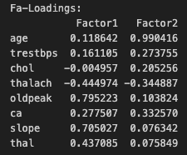
Figure 3:Fa-Loadings
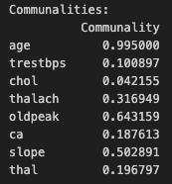
Figure 4: Communalities

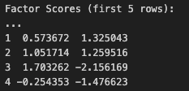
Figure 5: FA Score

References
- Jolliffe, I. T., & Cadima, J. (2016). Principal component analysis: A review and recent developments. Philosophical Transactions of the Royal Society A, 374(2065), 20150202.
- Abdi, H., & Williams, L. J. (2010). Principal component analysis. Wiley Interdisciplinary Reviews: Computational Statistics, 2(4), 433–459.
- Kaiser, H. F. (1974). An index of factorial simplicity. Psychometrika, 39(1), 31–36.
- Fabrigar, L. R., Wegener, D. T., MacCallum, R. C., & Strahan, E. J. (1999). Evaluating the use of exploratory factor analysis in psychological research. Psychological Methods, 4(3), 272–299.
- Detrano, R., et al. (1989). International application of a new probability algorithm for the diagnosis of coronary artery disease. The American Journal of Cardiology, 64(5), 304–310.

