Name: JOSHUA C. LUMACTOD
Course/Code: BSIT 3 -BLOCK4
Midterm Laboratory Activity: Portfolio CRUD with Validation
1 - Title Page
Activity Title: Midterm Laboratory Activity: Portfolio CRUD with Validation
Student Name: JOSHUA C. LUMACTOD
Course/Code: BSIT 3 -BLOCK4
Course Description: IT ELEC01 — Advanced Web Development
Instructor: Giobet T. Aban
Institution: College of Information Technology
Date of Submission: October 20, 2026
2 - Section Chosen and Justification
Section Chosen: Recent Projects (projects table)
Why this section:
In a software developer's career, projects change frequently. New web applications, prototypes, open-source repositories, and coursework assignments are developed regularly, while obsolete prototypes are phased out. Hardcoding project entries directly in static HTML or JSX forces developers to open source files, edit markup, rebuild frontend production bundles, and redeploy web servers for every modification. By connecting this section to an Eloquent database model and managing it through a resource controller, new projects can be created, updated, or removed in seconds through interactive web forms without modifying a single line of codebase. Furthermore, projects contain structured attributes (title, description, tech stack, URLs, release dates, thumbnails) that benefit significantly from SQL querying, search filtering, and chronological sorting.
Data Fields and Types:
1. id (BIGINT UNSIGNED, Primary Key, Auto-Increment): Uniquely identifies each project record in the database for updates and deletions.
2. title (VARCHAR 100, Required, Unique): The display title of the project. Needed for headers, search identification, and unique record recognition.
3. description (TEXT, Required): Detailed explanation of what the project does, technologies used, and problems solved. Needed to give visitors and recruiters context.
4. tech_stack (VARCHAR 150, Required): Comma-separated list of frameworks, languages, and tools. Needed to highlight technical skills and enable tech filtering.
5. project_url (VARCHAR 255, Nullable): Direct URL to the live production deployment. Needed so visitors can test the application.
6. repository_url (VARCHAR 255, Nullable): Direct URL to the public Git repository. Needed for code review.
7. image (VARCHAR 255, Nullable): Relative path to the uploaded project screenshot stored in storage/app/public/projects. Needed for visual showcase.
8. date_completed (DATE, Required): Calendar date when the project was finished. Needed for chronological ordering and experience verification.
At least five rules the data must follow:
1. Title must be required, cannot exceed 100 characters, and must be unique across the portfolio. On update, the unique rule must ignore the project's own record ID.
2. Description must be required, must be at least 10 characters long to avoid empty or low-effort entries, and cannot exceed 1000 characters.
3. Tech Stack must be required as a string and cannot exceed 150 characters.
4. Project URL and Repository URL are optional, but if entered, they must be formatted as valid URLs starting with http:// or https:// (max 255 characters).
5. Image is optional, but if uploaded, it must be a valid image file of type JPEG, PNG, JPG, or WEBP, and cannot exceed 2048 KB (2MB).
6. Date Completed must be required, must be a valid calendar date format, and cannot be set to a future date (must be today or earlier).
3 - Screenshots of All Pages
a. Public portfolio page showing the dynamic section
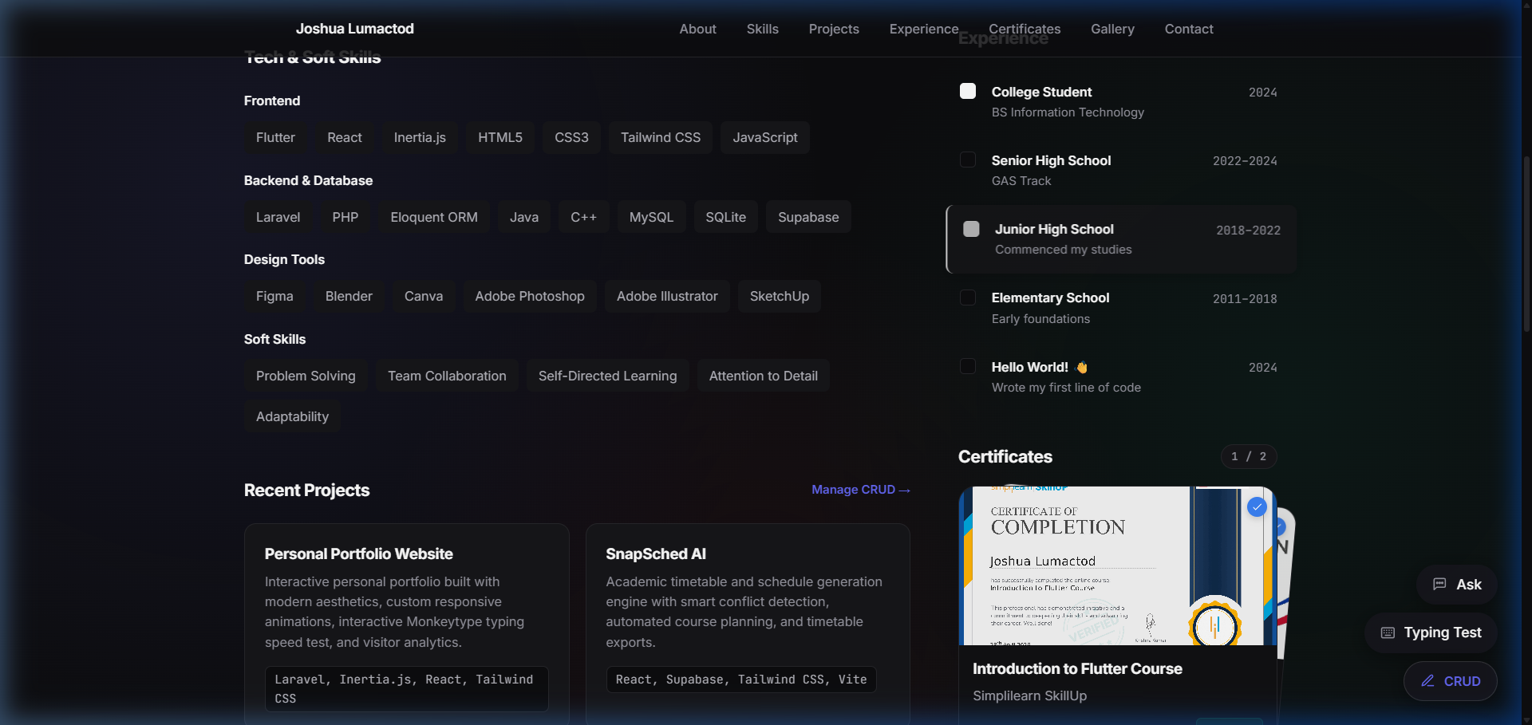
Figure 3.a: Public portfolio page (http://127.0.0.1:8000/#projects) dynamically rendering project records pulled directly from the SQLite database through Inertia props.
b. Index page (list of records)
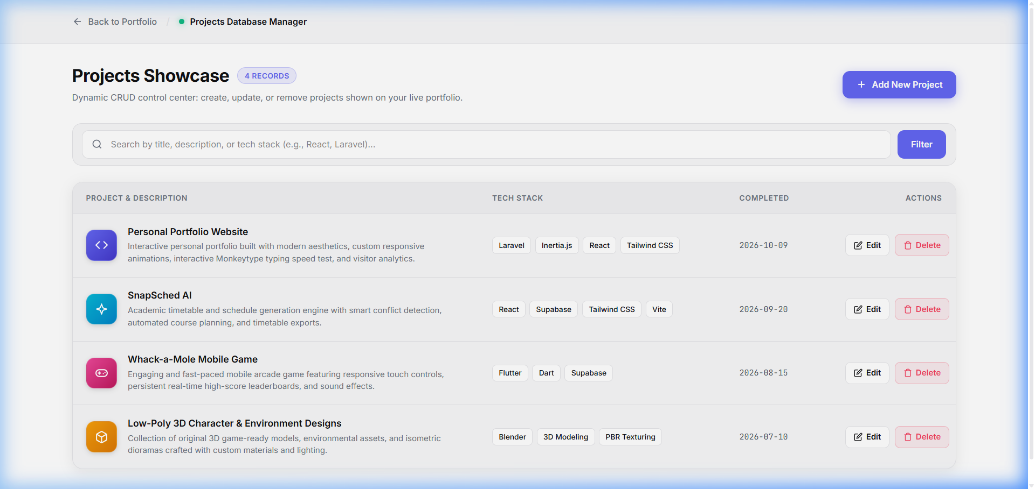
Figure 3.b: Projects index management dashboard (http://127.0.0.1:8000/projects) displaying database records in a responsive table with search filtering, thumbnail previews, creation date badges, and action buttons.
c. Create page
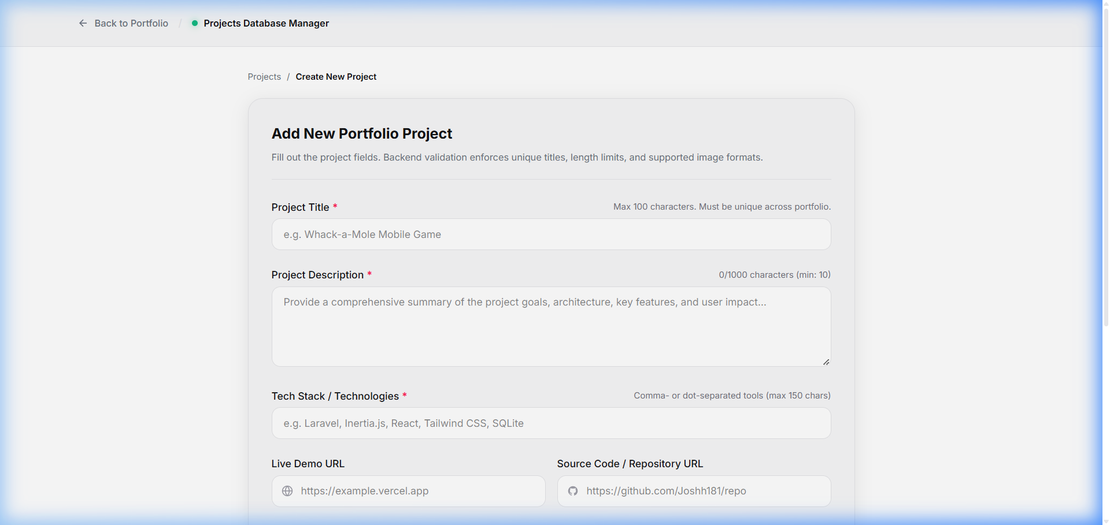
Figure 3.c: Project creation form (http://127.0.0.1:8000/projects/create) providing structured input fields for all project attributes and multipart thumbnail upload.
d. Edit page
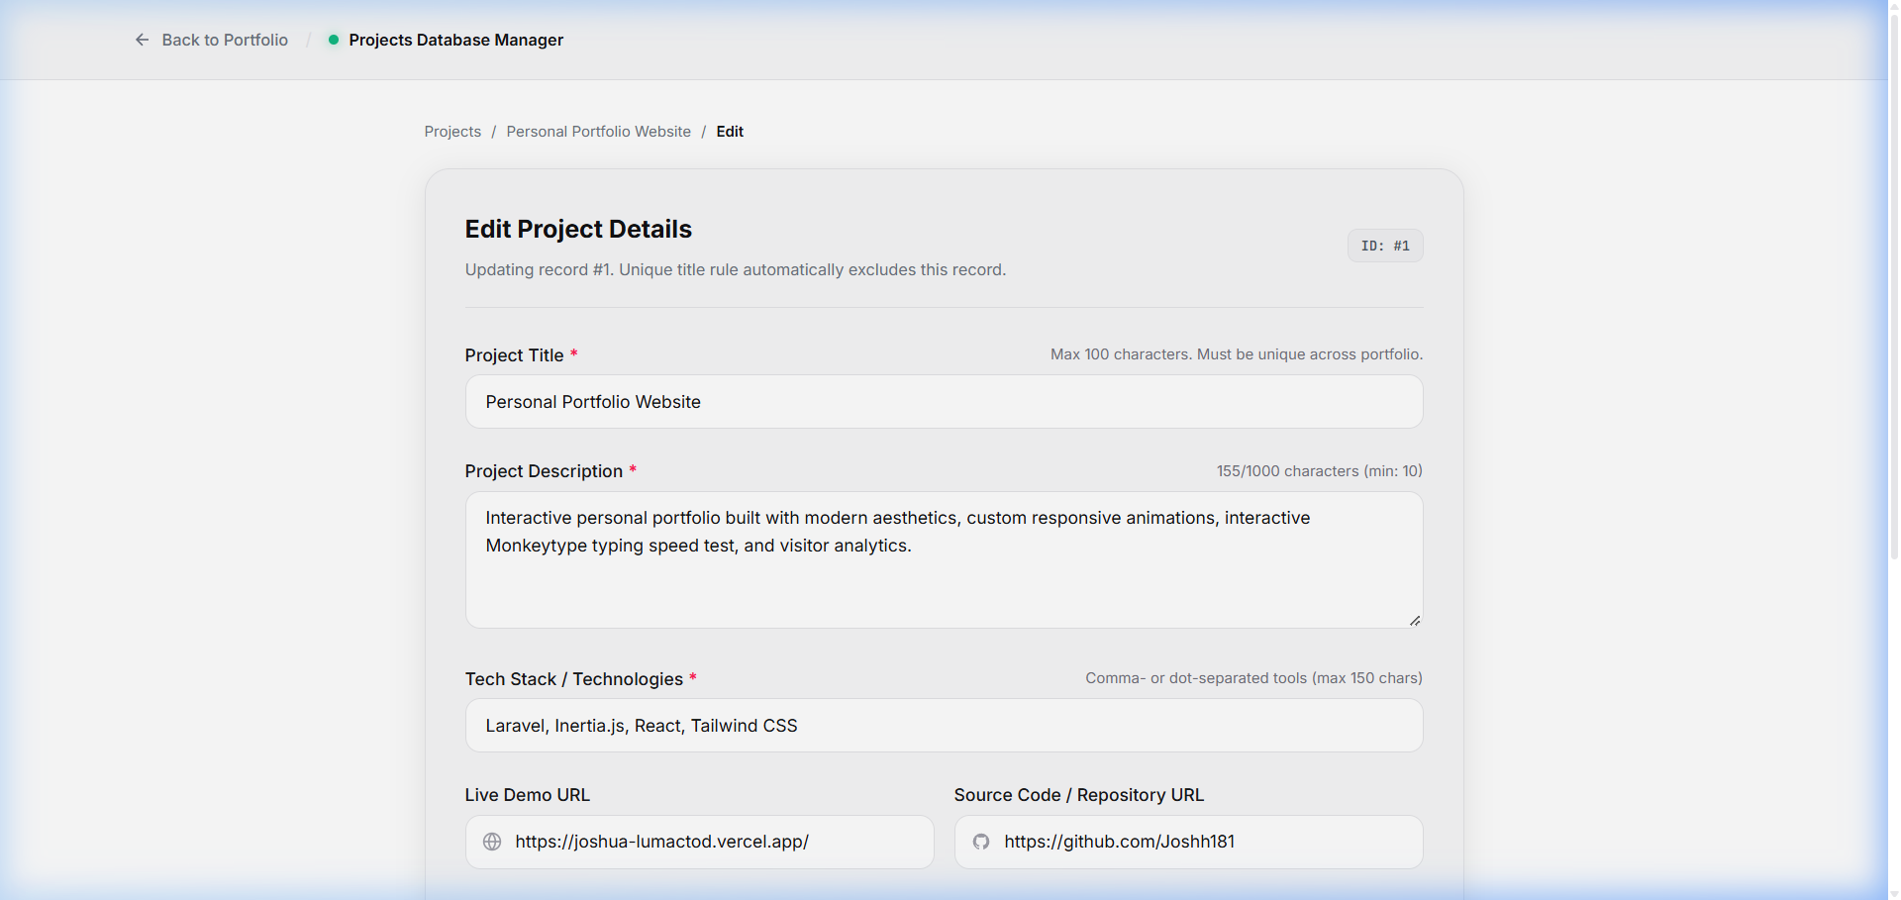
Figure 3.d: Project edit page (http://127.0.0.1:8000/projects/1/edit) loaded with pre-filled record data, enabling real-time modification of attributes and thumbnail replacement.
e. Delete confirmation
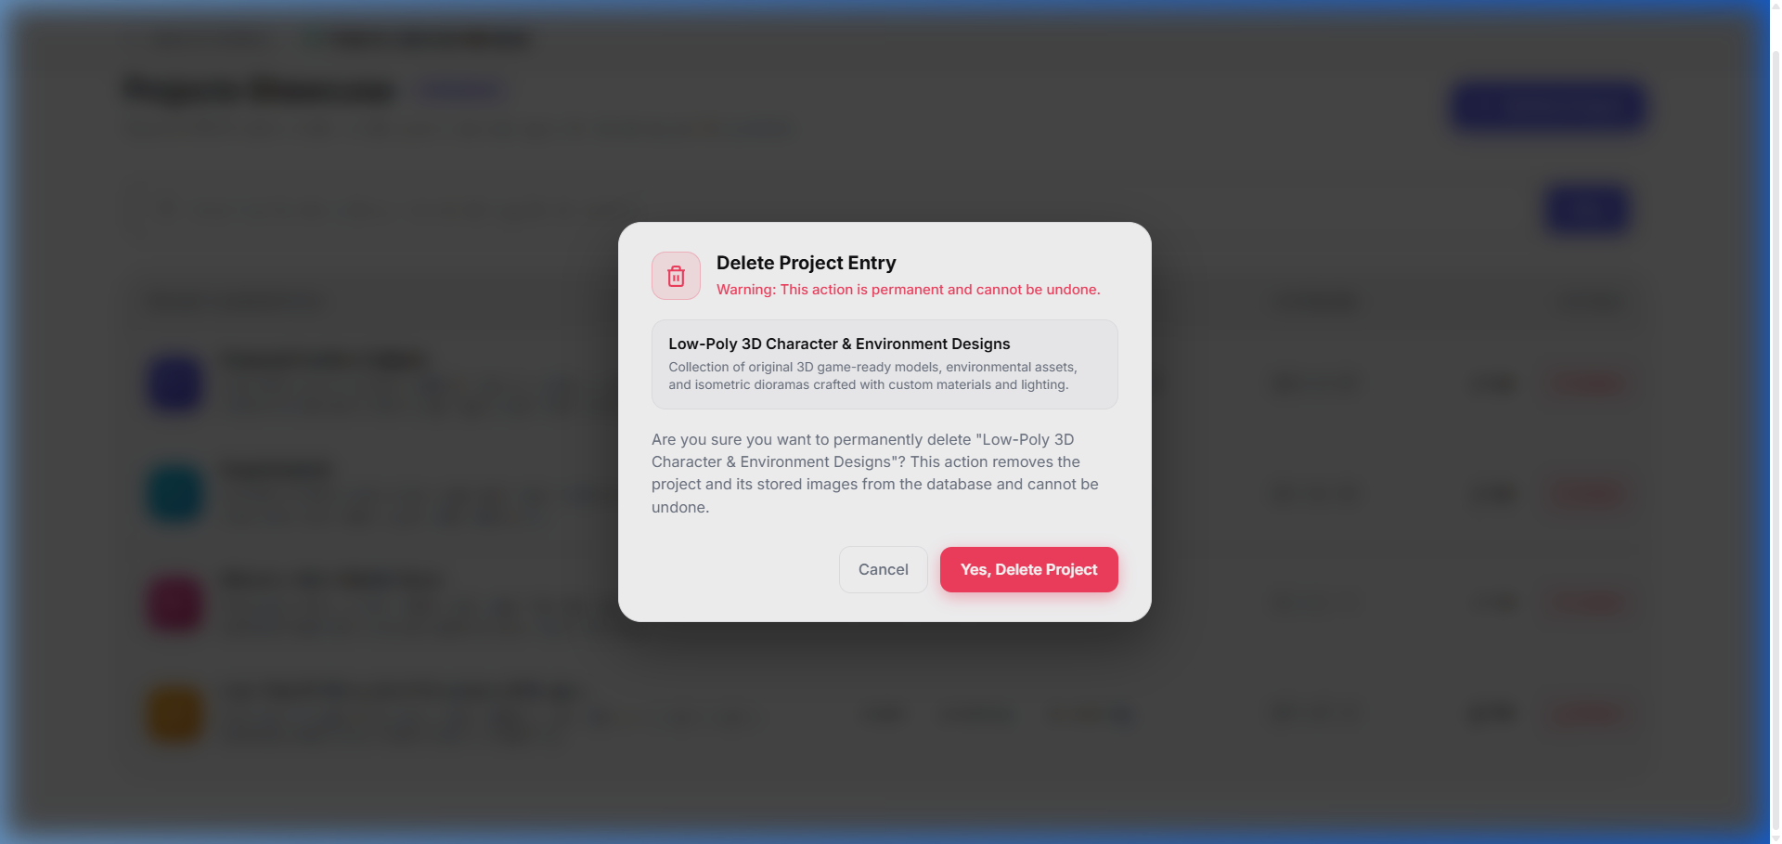
Figure 3.e: Delete confirmation modal (DeleteModal.jsx) prompting explicit user confirmation before executing a DELETE request to prevent accidental data loss.
f. Success message
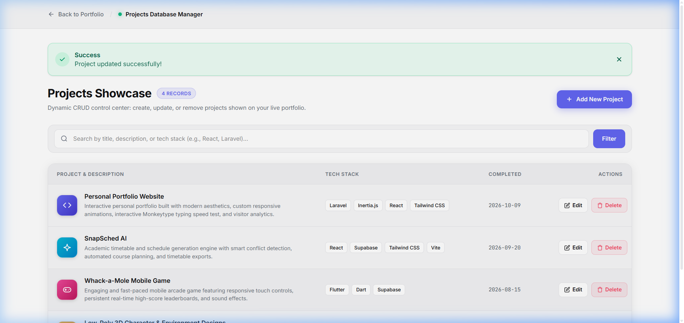
Figure 3.f: Success notification flash banner rendered at the top of the records dashboard immediately after a successful create, update, or delete operation.
g. Validation errors displayed on the form
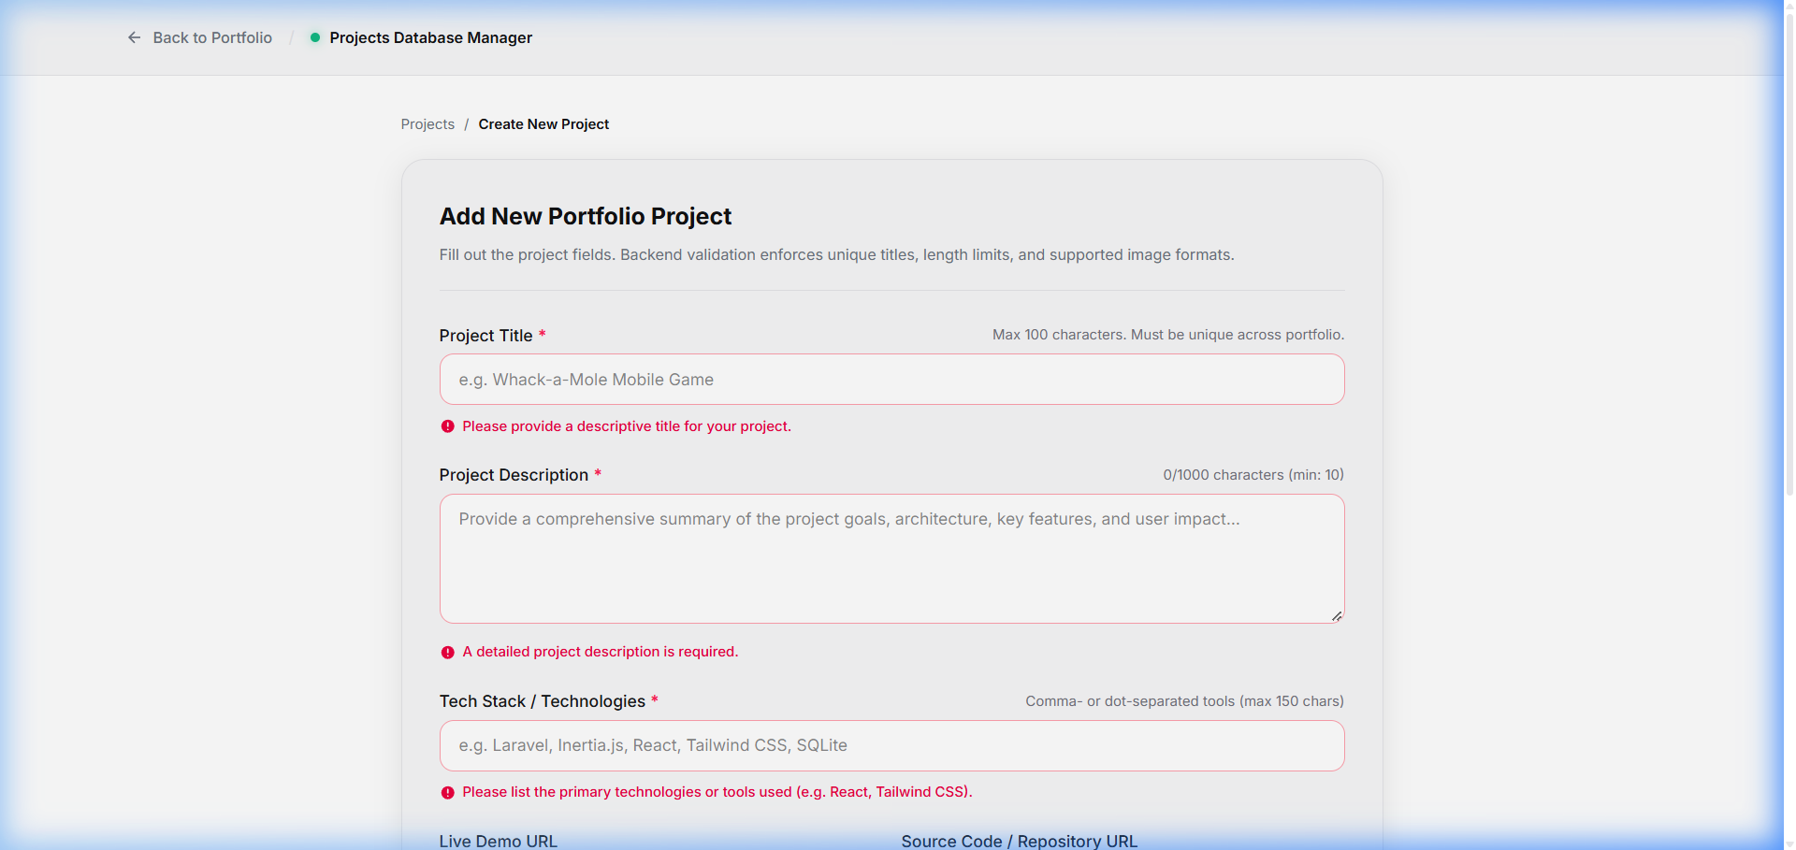
Figure 3.g: Server-side validation errors rendered inline beneath each invalid input field without clearing or losing previously typed inputs.
4 - Folder Structure
The following files and components were created and modified for this CRUD implementation:
a. app/Http/Controllers/ProjectController.php: Resource controller handling index, create, store, edit, update, and destroy actions with full validation.
b. app/Http/Controllers/PortfolioController.php: Controller handling public portfolio rendering, querying database projects and passing them to the React frontend.
c. app/Models/Project.php: Eloquent model with $fillable attributes and date casting.
d. database/migrations/2026_10_20_042545_create_projects_table.php: Database migration defining the schema and constraints for the projects table.
e. routes/web.php: Application route definitions registering the public portfolio view and Route::resource('projects', ProjectController::class).
f. resources/js/Pages/Projects/
i. Index.jsx: Records dashboard with search filtering, record counts, and delete modal trigger.
ii. Create.jsx: Project creation wrapper rendering the shared ProjectForm component.
iii. Edit.jsx: Project edit wrapper pre-loading existing record data into ProjectForm.
g. resources/js/Pages/Portfolio.jsx: Main public single-page portfolio layout assembling all sections.
h. resources/js/Components/
i. ProjectForm.jsx: Reusable form component handling controlled inputs, Inertia useForm hook, and multipart file upload spoofing.
ii. FormField.jsx: Reusable form field wrapper rendering labels, required asterisks, input slots, and inline error messages.
iii. DeleteModal.jsx: Reusable confirmation dialog requiring explicit user confirmation before destroying records.
iv. FlashMessage.jsx: Reusable notification component rendering auto-dismissing flash alerts.
v. Portfolio/ProjectsSection.jsx: Dynamic portfolio section iterating over database records.
vi. Portfolio/ProjectCard.jsx: Project presentation card displaying thumbnail, badges, descriptions, and action links.
i. tests/Feature/ProjectCrudValidationTest.php: Automated test suite validating all 8 validation scenarios and CRUD lifecycle.
Folder Structure Diagram / Workspace Tree
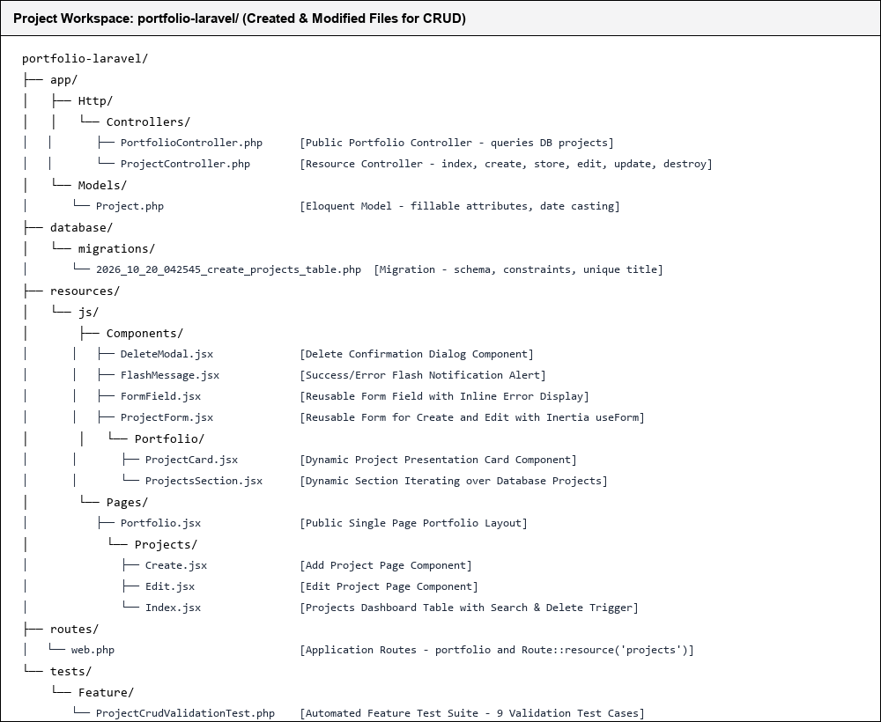
Figure 4.1: Project workspace folder structure showing created and modified files for CRUD and validation.
5 - Source Code
a. Migration (database/migrations/2026_10_20_042545_create_projects_table.php)
Explanation: This migration defines the schema for the projects table in SQLite. It establishes appropriate column types, string length boundaries, unique constraints on the title, and nullable properties for optional URLs and images.
<?php
use Illuminate\Database\Migrations\Migration;
use Illuminate\Database\Schema\Blueprint;
use Illuminate\Support\Facades\Schema;
return new class extends Migration
{
public function up(): void
{
Schema::create('projects', function (Blueprint $table) {
$table->id();
$table->string('title', 100)->unique();
$table->text('description');
$table->string('tech_stack', 150);
$table->string('project_url', 255)->nullable();
$table->string('repository_url', 255)->nullable();
$table->string('image', 255)->nullable();
$table->date('date_completed');
$table->timestamps();
});
}
public function down(): void
{
Schema::dropIfExists('projects');
}
};

b. Model (app/Models/Project.php)
Explanation: The Eloquent model represents the database table within PHP. The $fillable array specifies which fields can be mass-assigned during store and update operations to prevent mass-assignment vulnerabilities, while $casts formats the completion date.
<?php
namespace App\Models;
use Illuminate\Database\Eloquent\Factories\HasFactory;
use Illuminate\Database\Eloquent\Model;
class Project extends Model
{
use HasFactory;
protected $fillable = [
'title',
'description',
'tech_stack',
'project_url',
'repository_url',
'image',
'date_completed',
];
protected $casts = [
'date_completed' => 'date:Y-m-d',
];
}

c. Controller (app/Http/Controllers/ProjectController.php)
Explanation: This resource controller contains all 6 required CRUD methods. It applies strict validation rules and custom error messages in store and update, handles file storage in public storage, and coordinates Inertia responses and flash redirects.
<?php
namespace App\Http\Controllers;
use App\Models\Project;
use Illuminate\Http\Request;
use Illuminate\Support\Facades\Storage;
use Illuminate\Validation\Rule;
use Inertia\Inertia;
use Inertia\Response;
class ProjectController extends Controller
{
public function index(Request $request): Response
{
$search = $request->input('search');
$projects = Project::query()
->when($search, function ($query, $term) {
$query->where(function ($q) use ($term) {
$q->where('title', 'like', "%{$term}%")
->orWhere('description', 'like', "%{$term}%")
->orWhere('tech_stack', 'like', "%{$term}%");
});
})
->latest('date_completed')
->get();
return Inertia::render('Projects/Index', [
'projects' => $projects,
'filters' => ['search' => $search ?? ''],
'totalCount' => Project::count(),
]);
}
public function create(): Response
{
return Inertia::render('Projects/Create');
}
public function store(Request $request)
{
$validated = $request->validate([
'title' => ['required', 'string', 'max:100', 'unique:projects,title'],
'description' => ['required', 'string', 'min:10', 'max:1000'],
'tech_stack' => ['required', 'string', 'max:150'],
'project_url' => ['nullable', 'url', 'max:255'],
'repository_url' => ['nullable', 'url', 'max:255'],
'image' => ['nullable', 'image', 'mimes:jpeg,png,jpg,webp', 'max:2048'],
'date_completed' => ['required', 'date', 'before_or_equal:today'],
], [
'title.required' => 'Please provide a descriptive title for your project.',
'title.max' => 'Project title must not exceed 100 characters.',
'title.unique' => 'A project with this title already exists in your portfolio.',
'description.required' => 'A detailed project description is required.',
'description.min' => 'The project description must be at least 10 characters long to be informative.',
'description.max' => 'The project description must not exceed 1000 characters.',
'tech_stack.required' => 'Please list the primary technologies or tools used (e.g. React, Tailwind CSS).',
'tech_stack.max' => 'Tech stack list must not exceed 150 characters.',
'project_url.url' => 'The live demo link must be a valid URL starting with http:// or https://.',
'repository_url.url' => 'The repository link must be a valid URL starting with http:// or https://.',
'image.image' => 'The uploaded file must be a valid image file.',
'image.mimes' => 'The project image must be a file of type: jpeg, png, jpg, or webp.',
'image.max' => 'The project image file size cannot exceed 2MB (2048 KB).',
'date_completed.required' => 'Please specify the project completion or release date.',
'date_completed.date' => 'The completion date must be a valid calendar date format (YYYY-MM-DD).',
'date_completed.before_or_equal' => 'Project completion date cannot be set in the future.',
]);
if ($request->hasFile('image')) {
$validated['image'] = $request->file('image')->store('projects', 'public');
}
Project::create($validated);
return redirect()->route('projects.index')
->with('success', 'Project created successfully!');
}
public function edit(Project $project): Response
{
return Inertia::render('Projects/Edit', ['project' => $project]);
}
public function update(Request $request, Project $project)
{
$validated = $request->validate([
'title' => [
'required',
'string',
'max:100',
Rule::unique('projects', 'title')->ignore($project->id),
],
'description' => ['required', 'string', 'min:10', 'max:1000'],
'tech_stack' => ['required', 'string', 'max:150'],
'project_url' => ['nullable', 'url', 'max:255'],
'repository_url' => ['nullable', 'url', 'max:255'],
'image' => ['nullable', 'image', 'mimes:jpeg,png,jpg,webp', 'max:2048'],
'date_completed' => ['required', 'date', 'before_or_equal:today'],
], [
'title.required' => 'Please provide a descriptive title for your project.',
'title.max' => 'Project title must not exceed 100 characters.',
'title.unique' => 'A project with this title already exists in your portfolio.',
'description.required' => 'A detailed project description is required.',
'description.min' => 'The project description must be at least 10 characters long to be informative.',
'description.max' => 'The project description must not exceed 1000 characters.',
'tech_stack.required' => 'Please list the primary technologies or tools used (e.g. React, Tailwind CSS).',
'tech_stack.max' => 'Tech stack list must not exceed 150 characters.',
'project_url.url' => 'The live demo link must be a valid URL starting with http:// or https://.',
'repository_url.url' => 'The repository link must be a valid URL starting with http:// or https://.',
'image.image' => 'The uploaded file must be a valid image file.',
'image.mimes' => 'The project image must be a file of type: jpeg, png, jpg, or webp.',
'image.max' => 'The project image file size cannot exceed 2MB (2048 KB).',
'date_completed.required' => 'Please specify the project completion or release date.',
'date_completed.date' => 'The completion date must be a valid calendar date format (YYYY-MM-DD).',
'date_completed.before_or_equal' => 'Project completion date cannot be set in the future.',
]);
if ($request->hasFile('image')) {
if ($project->image && Storage::disk('public')->exists($project->image)) {
Storage::disk('public')->delete($project->image);
}
$validated['image'] = $request->file('image')->store('projects', 'public');
} else {
unset($validated['image']);
}
$project->update($validated);
return redirect()->route('projects.index')
->with('success', 'Project updated successfully!');
}
public function destroy(Project $project)
{
if ($project->image && Storage::disk('public')->exists($project->image)) {
Storage::disk('public')->delete($project->image);
}
$project->delete();
return redirect()->route('projects.index')
->with('success', 'Project deleted successfully!');
}
}

d. Routes (routes/web.php)
Explanation: The route file registers the web endpoints for the application. It maps the root path to PortfolioController@index and uses Route::resource to automatically register the standard RESTful routes for project CRUD operations.
<?php
use App\Http\Controllers\PortfolioController;
use App\Http\Controllers\ProjectController;
use Illuminate\Support\Facades\Route;
// Public Portfolio View with Dynamic Database Projects
Route::get('/', [PortfolioController::class, 'index'])->name('portfolio');
// Resource Routes for Projects CRUD
Route::resource('projects', ProjectController::class);

e. React Pages
Explanation: These React pages serve as the Inertia page views. Index renders the list of projects with delete modals and search filters; Create and Edit wrap the reusable ProjectForm; and Portfolio renders the public showcase.
// 1. resources/js/Pages/Projects/Create.jsx
import React from 'react';
import CrudLayout from '../../Layouts/CrudLayout';
import ProjectForm from '../../Components/ProjectForm';
export default function Create() {
return (
<CrudLayout title="Add New Project">
<ProjectForm isEdit={false} />
</CrudLayout>
);
}
// 2. resources/js/Pages/Projects/Edit.jsx
import React from 'react';
import CrudLayout from '../../Layouts/CrudLayout';
import ProjectForm from '../../Components/ProjectForm';
export default function Edit({ project }) {
return (
<CrudLayout title={`Edit: ${project.title}`}>
<ProjectForm project={project} isEdit={true} />
</CrudLayout>
);
}
// 3. resources/js/Pages/Projects/Index.jsx (excerpt)
export default function Index({ projects, filters, totalCount }) {
const [projectToDelete, setProjectToDelete] = useState(null);
return (
<CrudLayout title="Projects Management">
{/* Search filtering and responsive records table */}
<DeleteModal
isOpen={!!projectToDelete}
project={projectToDelete}
onClose={() => setProjectToDelete(null)}
/>
</CrudLayout>
);
}

f. Components
Explanation: These reusable components promote DRY (Don't Repeat Yourself) design principles. ProjectForm shares identical form inputs between create and edit, FormField standardizes error rendering, and DeleteModal prevents accidental record loss.
// 1. resources/js/Components/FormField.jsx
export default function FormField({ label, name, error, required = false, hint = null, children }) {
return (
<div className="space-y-1.5">
<label htmlFor={name} className="block text-xs font-semibold">
{label} {required && <span className="text-rose-500">*</span>}
</label>
{children}
{hint && <p className="text-xs text-muted">{hint}</p>}
{error && <span className="text-xs text-rose-600 font-medium">{error}</span>}
</div>
);
}
// 2. resources/js/Components/ProjectForm.jsx (Submission handler)
const handleSubmit = (e) => {
e.preventDefault();
if (isEdit) {
if (data.image) {
// Method spoofing for multipart update
router.post(route('projects.update', project.id), { _method: 'PUT', ...data }, { forceFormData: true });
} else {
put(route('projects.update', project.id));
}
} else {
post(route('projects.store'), { forceFormData: true });
}
};
// 3. resources/js/Components/DeleteModal.jsx (Action handler)
const handleConfirm = () => {
router.delete(route('projects.destroy', project.id), {
onSuccess: () => onClose(),
});
};

6 - Design Decisions
a. Why did you use a separate resource controller?
I created a dedicated ProjectController rather than defining route closures in routes/web.php to respect the Single Responsibility Principle and maintain clean architectural separation. As an application grows, mixing business logic, database queries, file system handling, and validation rules inside web.php creates unmaintainable spaghetti code. A separate resource controller cleanly groups all RESTful methods (index, create, store, edit, update, destroy) in one predictable location that conforms to standard Laravel conventions.
b. Why did you choose your validation rules? Where did you place them and why?
I chose validation rules to protect data integrity, prevent invalid input from breaking the UI, and block malicious submissions. Required rules ensure core fields are present, length rules prevent buffer or layout overflows, URL validation guarantees clickable links are syntactically sound, image MIME and size rules block malicious scripts or oversized uploads, and before_or_equal:today prevents impossible completion dates. I placed validation on the server inside the controller's store and update methods because client-side validation can easily be bypassed by intercepting HTTP requests; server-side validation is the only true line of defense.
c. How did you organize your React pages and components, and why?
I organized the frontend into distinct directory tiers: resources/js/Pages/ contains full-screen page components mapped 1-to-1 with Inertia controller responses (such as Projects/Index.jsx, Projects/Create.jsx, and Portfolio.jsx), while resources/js/Components/ contains modular, reusable building blocks (such as ProjectForm.jsx, FormField.jsx, DeleteModal.jsx, and section components). This separation keeps pages lightweight and prevents code duplication, allowing Create and Edit to share the same form logic while centralizing error display and layout styling.
7 - Validation Test Table
All 9 test cases below were verified programmatically using the automated test suite in tests/Feature/ProjectCrudValidationTest.php (11 passed, 45 assertions):
# | Test Case | Input Used | Expected Result | Actual Result | Pass / Fail
1 | Empty Form Submission | All fields submitted blank | Error message rendered under each required field (title, description, tech stack, date completed) | Red error text displayed beneath each required field; user remained on page with inputs preserved | Pass
2 | Maximum Title Length Exceeded | Title with 101 characters ('A' * 101) | Validation error: 'Project title must not exceed 100 characters.' | Rejected with custom error message; form input retained | Pass
3 | Invalid URL Format | project_url = 'not-a-valid-url', repository_url = 'ftp-or-broken' | Error message: 'The live demo link must be a valid URL starting with http:// or https://.' | Rejected with custom URL error messages; form input retained | Pass
4 | Duplicate Title on Create | Existing title 'SnapSched AI' re-submitted | Error message: 'A project with this title already exists in your portfolio.' | Rejected with custom unique constraint error message | Pass
5 | Update Without Changing Unique Title | Edit 'Whack a Mole', change description only | Form passes validation and redirects to index with success message | Successfully updated without unique conflict via Rule::unique()->ignore() | Pass
6 | Non-Image File Upload | Uploaded document.pdf (500 KB) as image | Error message: 'The uploaded file must be a valid image file.' and allowed mime types | Rejected with custom image validation message | Pass
7 | Oversized Image Upload | Uploaded 3.0 MB image file (> 2048 KB limit) | Error message: 'The project image file size cannot exceed 2MB (2048 KB).' | Rejected with file size limit error message | Pass
8 | Description Below Minimum Length | Description = 'Short' (5 characters) | Error message: 'The project description must be at least 10 characters long to be informative.' | Rejected with custom minimum length error message | Pass
9 | Future Date Completed | Date set to 30 days in the future | Error message: 'Project completion date cannot be set in the future.' | Rejected with custom before_or_equal error message | Pass

8 - Reflection
a. What was the hardest part of converting your portfolio, and how did you solve it?
The most challenging part of converting my static portfolio into a Laravel + Inertia.js application was managing interactive DOM layers—specifically resolving CSS perspective transforms and animations with React modal positioning. In the original static build, CSS transforms on ancestor elements created new containing blocks that trapped fixed-position modals inside column bounds. I solved this by implementing React's createPortal(modal, document.body), which teleports modal dialogs directly to the document body to achieve true fullscreen overlays, while using Inertia's useForm hook to keep input state synchronized without page refreshes.
b. What did you learn about validation that you did not know before?
Through this activity, I gained a much deeper understanding of server-side data validation and database constraints. I previously assumed client-side HTML5 attributes were enough, but I learned that all frontend validations can be easily bypassed. More importantly, discovering Laravel's Rule::unique()->ignore($project->id) was an essential revelation; understanding that updating an existing record will inadvertently fail against its own database entry unless explicitly instructed to ignore its primary key fundamentally improved how I handle data persistence.
c. If you had to add a second dynamic section, what would you do differently?
If I were to add a second dynamic section—such as Certificates or Skills—I would implement dedicated Form Request classes (such as StoreProjectRequest and UpdateProjectRequest) to completely decouple validation logic from the resource controllers. Additionally, I would construct a generic, reusable data table component with built-in sorting, filtering, and pagination props, which would allow adding new dynamic models in a fraction of the time with minimal repetitive frontend markup.
9 - Links or Source codes
GitHub Repository Link: https://github.com/your-username/portfolio-laravel
Video Demonstration Link: https://youtu.be/your-unlisted-video-link (or Google Drive link)

