WEEK 1: Project Review and Development Planning

INTENDED LEARNING OUTCOME
At the end of this activity, students should be able to:
Develop a comprehensive project implementation plan by reviewing the approved capstone proposal, validating project scope, incorporating panel recommendations, assigning project responsibilities, preparing a project schedule, and establishing project monitoring tools.

OVERVIEW OF WEEK 1 OUTPUTS
By the end of Week 1, each group must submit:
- Panel Recommendation Compliance Matrix
- Project Scope Validation Form
- Work Breakdown Structure (WBS)
- Revised Gantt Chart
- Project Development Plan
- Repository Setup Report
- Adviser Consultation Record

ACTIVITY 1
Review of Panel Recommendations

Purpose
To ensure that all recommendations from the proposal defense have been reviewed and addressed before implementation begins.

Procedure
- Secure a copy of the proposal defense evaluation sheet.
- Review all comments from the panel.
- Discuss as a group how each recommendation will be addressed.
- Complete Form 1.

FORM 1
PANEL RECOMMENDATION COMPLIANCE MATRIX

Instructions
For every recommendation:
- Copy the recommendation exactly as stated by the panel.
- Describe the action that the group will take.
- Identify supporting evidence.
- Mark the status.

No. | Panel Recommendation | Planned Action | Evidence | Status
1 | Add quantitative data to strengthen the project justification. | Review and update Chapter 1 by incorporating actual statistics, observed attendance data, queue length, and manual attendance duration gathered from the client. | Revised Chapter 1 – Project Context | Completed
2 | Convert the Statement of the Problem into measurable research questions. | Revise the Statement of the Problem into interrogative form and align each question with measurable variables and evaluation metrics. | Revised Chapter 1 – Statement of the Problem | Completed
3 | Align the project objectives with measurable outputs and evaluation criteria. | Refine the project objectives to include measurable indicators such as processing time, attendance accuracy, queue reduction, and security evaluation. | Revised Chapter 1 – Objectives | Completed
4 | Clarify the project's scope and limitations. | Update the Scope and Limitations by specifying LAN deployment, prototype limitations, excluded system features, and hardware constraints. | Revised Chapter 1 – Scope and Limitations | Completed
5 | Improve the organization of the literature review. | Reorganize Chapter 2 using thematic sections including IoT Attendance Systems, RFID Technology, Biometric Authentication, Network Security, and Multi-Layer Security Frameworks. | Revised Chapter 2 | Completed
6 | Clearly identify the research gaps addressed by the study. | Revise the literature synthesis to emphasize the lack of teacher authentication, multi-layer security, and classroom-level attendance validation in existing systems. | Revised Chapter 2 – Synthesis | Completed
7 | Remove ambiguity in the research methodology. | Refine Chapter 3 by clearly explaining the Design and Development Research approach supported by Experimental and Survey Research methods. | Revised Chapter 3 – Research Design | Completed
8 | Ensure all evaluation metrics are measurable. | Add instrument-to-metric mapping tables, evaluation criteria, success indicators, and mathematical formulas for system performance measurement. | Revised Chapter 3 | Completed
9 | Justify the respondents and sampling technique. | Explain the purposive sampling method and justify the selection of students, teachers, administrators, and the IT administrator. | Revised Chapter 3 – Participants | Completed
10 | Include measurable comparison variables for system evaluation. | Introduce performance formulas for processing time, efficiency, waiting time, queue length, and attendance accuracy. | Revised Chapter 3 – Experimental Design | Completed
11 | Strengthen the system's security evaluation. | Integrate security testing using Wireshark, Nmap, and Metasploit in a controlled LAN environment together with vulnerability assessment criteria. | Revised Chapter 3 – Security Testing | Completed
12 | Include system reliability testing procedures. | Implement and evaluate an offline data storage and synchronization mechanism during network interruptions. | Revised Chapter 3 – Reliability Testing | Completed
13 | Improve the organization of the system architecture. | Redesign the architecture using layered components consisting of Device, Network, Transport, Application, Database, and Monitoring layers. | Revised Chapter 4 – System Architecture | Completed
14 | Strengthen the explanation of the security architecture. | Expand the security architecture by defining device authentication, network security, transport security, application security, database security, and monitoring mechanisms. | Revised Chapter 4 – Security Architecture | Completed
15 | Add a security threat model. | Develop a STRIDE-based threat model with corresponding mitigation strategies for each identified threat. | Revised Chapter 4 – Threat Model | Completed
16 | Ensure consistency throughout all chapters. | Review and align the title, objectives, methodology, implementation, evaluation, and terminology throughout the manuscript. | Updated Final Manuscript | Completed
17 | Remove redundant and unnecessary citations. | Review all chapters and retain only relevant, credible, and consistent references following APA 7th Edition. | Updated References | Completed
18 | Revise the project title for consistency. | Update the project title across all chapters to L-SIAMS: A Local IoT-Based Multi-Layer Secure Attendance Monitoring System with RFID and Biometric Authentication. | Updated Manuscript | Completed
19 | Correct grammatical errors and maintain consistent tense usage. | Proofread the entire manuscript and revise grammar, sentence construction, and tense consistency. | Updated Manuscript | Completed
20 | Include database layer security in the security architecture. | Modify the security architecture diagram to include the database security layer and corresponding controls. | Revised Security Architecture Diagram | Completed
21 | Use a recognized vulnerability severity classification. | Integrate the Common Vulnerability Scoring System (CVSS) to classify security vulnerabilities. | Revised Chapter 3 and Chapter 4 | Completed
22 | Complete and standardize all references. | Review and update all citations and references to comply with APA 7th Edition formatting requirements. | Final Reference List | Completed

ACTIVITY 2
Project Scope Validation

Purpose
To verify that the approved project remains feasible and aligned with client requirements.
Procedure
- Review Chapter 1 and Chapter 3.
- Verify all objectives.
- Review scope and limitations.
- Identify any requested modifications.
- Complete Form 2.

FORM 2
PROJECT SCOPE VALIDATION FORM

Instructions
Check whether each component remains valid.

- Objectives Validation

Objective | Still Applicable? | Remarks
Design and implement an IoT-based attendance monitoring system using RFID and biometric fingerprint authentication for classroom-level attendance recording. | Yes | Remains aligned with the approved project title and addresses the identified attendance monitoring issues.
Develop a locally hosted web-based system for user management, attendance recording, report generation, and centralized database management. | Yes | Still applicable and consistent with the approved system architecture and client requirements.
Implement multi-layer security mechanisms including authentication, access control, encrypted communication, network security, and audit logging. | Yes | Supports the BSIT – Network Security specialization and remains one of the project's primary objectives.
Evaluate the developed system using ISO/IEC 25010 and ISO/IEC 27001 guided by the CIA Triad through performance, usability, reliability, and security testing. | Yes | Evaluation methodology remains unchanged and will be used during the testing phase.

B. Requirements Validation
Requirement | Validated | Remarks
Functional Requirements | ☑ | All required modules remain applicable, including RFID attendance, fingerprint authentication, user management, attendance reports, audit logs, and dashboard monitoring.
Non-Functional Requirements | ☑ | Performance, reliability, security, maintainability, and usability requirements remain consistent with the approved proposal.
User Requirements | ☑ | Requirements gathered from Top Achievers Private School Inc. remain valid and no additional user requirements have been identified.
Hardware Requirements | ☑ | ESP32, MFRC522 RFID Reader, R307 Fingerprint Sensor, RFID Cards, Wi-Fi Router, Local Server, and Client Computers remain the required hardware components.
Software Requirements | ☑ | PHP, MySQL, HTML, CSS, JavaScript, Bootstrap, Visual Studio Code, XAMPP, GitHub, and Postman remain the planned software development tools.

C. Scope Changes
List proposed modifications.
Proposed Change | Reason | Adviser Approval
Strengthened the implementation of multi-layer security mechanisms including API Key authentication, HTTPS/TLS encryption, Role-Based Access Control (RBAC), audit logging, and firewall configuration. | To improve the security architecture and better align the project with the BSIT – Network Security specialization. | Pending
Expanded the security testing methodology by incorporating Wireshark, Nmap, Metasploit, and CVSS-based vulnerability assessment. | To provide measurable and standardized security evaluation during system testing. | Pending
Enhanced the system architecture by introducing six security layers (Device, Network, Transport, Application, Database, and Monitoring Layer). | To improve the overall system organization, security, and maintainability based on panel recommendations. | Pending
\

ACTIVITY 3
Work Breakdown Structure Development

Purpose
To organize all project activities and distribute responsibilities among team members.

Procedure
- List all tasks needed to complete the project.
- Group similar tasks together.
- Assign responsible members.
- Estimate completion dates.
- Complete Form 3.

FORM 3
WORK BREAKDOWN STRUCTURE (WBS)

Instructions
Break down project activities into smaller work packages.

Major Deliverable | Task | Assigned Member | Due Week
Project Planning | Review project requirements, finalize project scope, assign team responsibilities, prepare project timeline, and conduct adviser consultation | Entire Team | Week 1
System Design | Design the system architecture, database structure, user interface, and security architecture | Ched Nikko P. Pangilinan, Joshkirby Tyler M. Bote | Week 3
Back-End & Database Development | Develop the MySQL database, authentication module, attendance module, reports module, and administrator dashboard | Ched Nikko P. Pangilinan | Week 8
Front-End Development | Develop the responsive user interface, dashboard interface, and integrate the frontend with the backend | Joshkirby Tyler M. Bote | Week 9
IoT Hardware Integration | Configure the ESP32, integrate the RFID reader and fingerprint sensor, and test hardware communication | Naph Yvan P. Villamar | Week 11
Network Security Implementation | Configure Role-Based Access Control (RBAC), implement API authentication, HTTPS/TLS, audit logging, and conduct vulnerability assessment | Joshkirby Tyler M. Bote | Week 12
System Testing | Conduct functional testing, integration testing, performance testing, security testing, and User Acceptance Testing (UAT) | Entire Team | Week 14
Documentation | Update the capstone manuscript, prepare the user manual, technical documentation, presentation materials, and perform final proofreading | Entire Team | Week 17
Deployment and Evaluation | Deploy the system, conduct client demonstration, collect evaluation results, apply final revisions, and prepare for the final defense | Entire Team | Week 18

Team Verification
All members must sign below:

- Ched Nikko P. Panglinan

- Naph Yvan P. Villamar

- Joshkirby Tyler M. Bote

ACTIVITY 4
Gantt Chart Preparation

Purpose
To establish a semester-long implementation schedule.

Procedure
- Use the completed WBS.
- Identify project milestones.
- Assign target weeks.
- Prepare the schedule.
- Complete Form 4.

FORM 4
GANTT CHART SUBMISSION FORM
Instructions
Indicate when each task will be performed.

Activity | W1 | W2 | W3 | W4 | W5 | W6 | W7 | W8 | W9 | W10 | W11 | W12 | W13 | W14 | W15 | W16 | W17 | W18
Project Planning | ■
Requirements Gathering | ■ | ■
System Design |  | ■ | ■
Database Development |  |  | ■ | ■ | ■
Back-End Development |  |  |  | ■ | ■ | ■ | ■ | ■
Front-End Development |  |  |  |  | ■ | ■ | ■ | ■ | ■
IoT Hardware Integration |  |  |  |  |  |  | ■ | ■ | ■ | ■ | ■
Network Security Implementation |  |  |  |  |  |  |  |  | ■ | ■ | ■ | ■
System Integration |  |  |  |  |  |  |  |  |  |  | ■ | ■
Functional Testing |  |  |  |  |  |  |  |  |  |  |  | ■ | ■
Performance & Security Testing |  |  |  |  |  |  |  |  |  |  |  |  | ■ | ■
User Acceptance Testing (UAT) |  |  |  |  |  |  |  |  |  |  |  |  |  | ■ | ■
System Deployment |  |  |  |  |  |  |  |  |  |  |  |  |  |  | ■ | ■
Documentation | ■ | ■ | ■ | ■ | ■ | ■ | ■ | ■ | ■ | ■ | ■ | ■ | ■ | ■ | ■ | ■ | ■ | ■
Final Evaluation & Defense Preparation |  |  |  |  |  |  |  |  |  |  |  |  |  |  |  | ■ | ■ | ■

Milestone Schedule
Milestone | Target Week
Alpha Version | Week 8
Prototype Presentation | Week 9
Beta Version | Week 12
Agency Immersion | Week 13
Deployment | Week 16
Evaluation | Week 17
Mock Defense | Week 17
Final Defense | Week 18

ACTIVITY 5
Development Planning

Purpose
To prepare the overall implementation strategy.
Procedure
- Determine development methodology.
- Identify technologies.
- Assign project roles.
- Identify risks.
- Complete Form 5.

FORM 5
PROJECT DEVELOPMENT PLAN

A. Team Roles
Team Member | Role | Responsibilities
Ched Nikko P. Pangilinan | Team Leader / Back-End Developer | Leads the project, develops the backend modules, designs and manages the database, oversees project progress, and prepares technical documentation.
Joshkirby Tyler M. Bote | Front-End Developer / Network Security | Develops the user interface, integrates frontend components, implements security features (RBAC, HTTPS/TLS, API authentication, audit logging), and assists in documentation.
Naph Yvan P. Villamar | IoT Hardware Developer / QA Tester | Integrates the ESP32, RFID reader, and fingerprint sensor, performs hardware testing, system integration, quality assurance, and troubleshooting.

B. Development Methodology
Iterative a software development approach where a system is developed step by step through repeated cycles or iterations.e

C. Development Tools
Category | Tool
Programming Language | PHP, JavaScript, HTML, CSS
Framework | Bootstrap
Database | MySQL
IDE | Visual Studio Code
Repository | GitHub (L-SIAMS Repository)

D. Risk Management Plan
Risk | Probability | Impact | Mitigation
Hardware integration issues (ESP32, RFID, Fingerprint Sensor) | Medium | High | Perform early hardware testing, verify component compatibility, and maintain backup hardware if available.
Development delays | Medium | High | Follow the project timeline, assign responsibilities clearly, and conduct weekly progress meetings.
Data loss or source code corruption | Low | High | Regularly back up the database and source code using GitHub and external storage.
Security vulnerabilities | Medium | High | Conduct security testing, implement RBAC, HTTPS/TLS, API authentication, and audit logging.

E. Communication Plan
Activity | Schedule
Team Meeting | Every other day or as needed
Adviser Consultation | Every week or if needed
Client Coordination | After every completed milestone or whenever feedback is required

ACTIVITY 6
Repository Setup

Purpose
To establish version control and project collaboration mechanisms.
Procedure
- Create repository.
- Create project folder structure.
- Add all members.
- Commit initial files.
- Complete Form 6.

FORM 6
REPOSITORY SETUP REPORT

Repository Information
Repository Name: LSIAMS
Repository URL: https://github.com/Joshhkopo/LSIAMS

Member Access
Member | Access Granted
Ched Nikko P. Pangilinan | Yes
Joshkirby Tyler M. Bote | Yes
Naph Yvan P. Villamar | Yes

Required Screenshots
Attach:

□ Repository Homepage
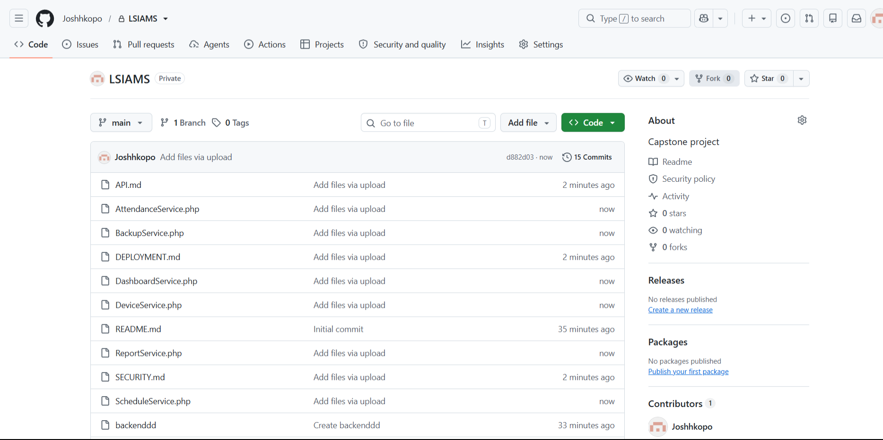

□ Team Members
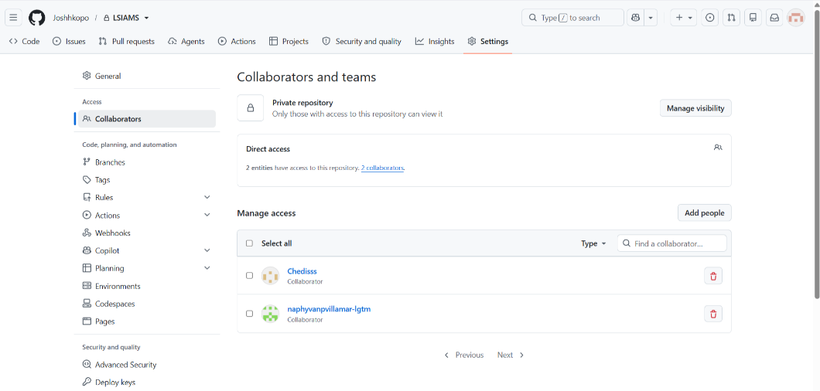

□ Folder Structure
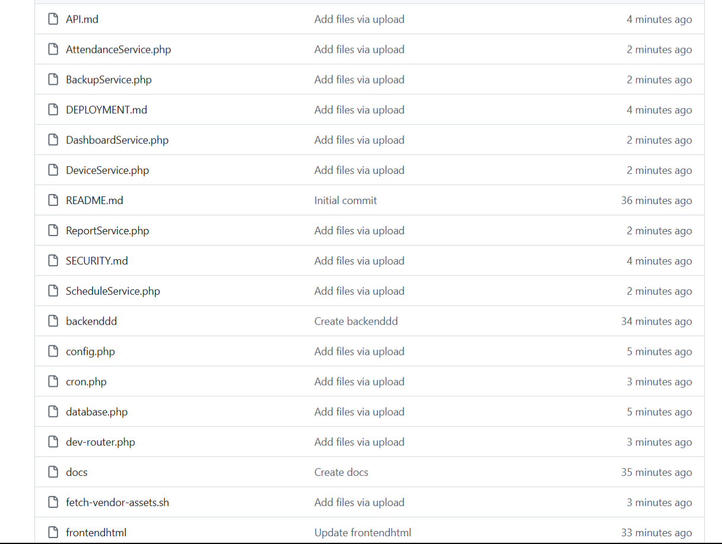

□ Initial Commit
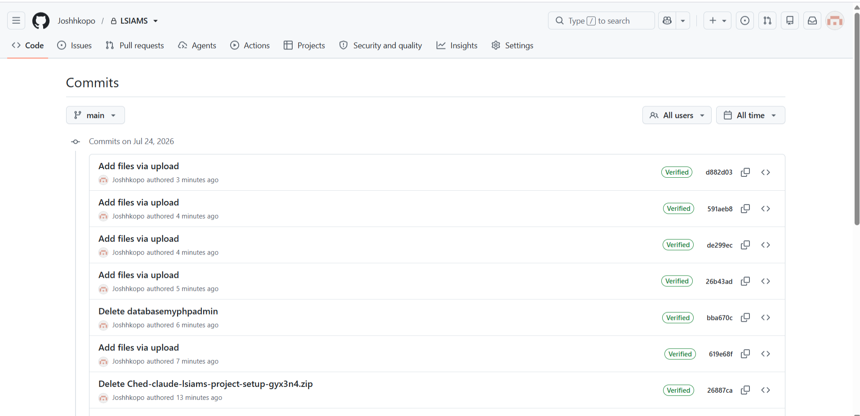

Repository Structure
List folders created.

Folder Name | Purpose

API.md | Contains the project's API documentation, including endpoints and usage instructions.

AttendanceService.php | Handles attendance-related functions and business logic.

BackupService.php | Manages database and system backup operations.

DEPLOYMENT.md | Provides instructions for deploying the application.

DashboardService.php | Handles dashboard data processing and related services.

DeviceService.php | Manages device-related operations and functionality.

README.md | Provides an overview of the project, installation steps, and usage information.

ReportService.php | Generates and manages reports within the system.

SECURITY.md | Documents the project's security policies and best practices.

ScheduleService.php | Handles scheduling and timetable-related operations.

backendddd/ | Contains the server-side source code, business logic, and backend components.

config.php | Stores application configuration settings.

cron.php | Executes scheduled or automated background tasks.

database.php | Establishes and manages the database connection.

dev-router.php | Provides routing configuration for the development environment.

docs/ | Stores project documentation and technical references.

fetch-vendor-assets.sh | Shell script used to download or update third-party/vendor assets.

frontendhtml/ | Contains the client-side interface, including HTML, CSS, JavaScript, and other front-end resources.

ACTIVITY 7
Adviser Consultation

Purpose
To validate project readiness before development starts.

Procedure
- Present all Week 1 outputs.
- Discuss project schedule.
- Discuss risks and responsibilities.
- Record adviser recommendations.
- Complete Form 7.

FORM 7
ADVISER CONSULTATION RECORD
Date | Topics Discussed | Adviser Recommendations | Action Items

Consultation Checklist
Item | Discussed
Project Scope | □
Timeline | □
Team Responsibilities | □
Development Tools | □
Risks | □
Repository Setup | □

Adviser Approval

Adviser Name: Jesusimo L. Dioses Jr., D.Eng.
Signature:
Date: August _,2026

