WEEK 2: Development Environment Setup and Initial Coding

I. INTENDED LEARNING OUTCOME
At the end of this activity, students should be able to:
Develop a functional development environment by configuring required software tools, establishing database structures, implementing foundational system modules, and applying coding standards for collaborative software development.

II. PERFORMANCE TASK
Your capstone project has completed the planning phase. As a development team, you must prepare the software development environment, establish database structures, create the repository framework, implement foundational modules, and adopt coding standards to ensure efficient collaboration and future system expansion.

III. WEEK 2 ACTIVITIES
Activity 1 – Development Environment Configuration
Activity 2 – Database Setup and Implementation
Activity 3 – Framework and Project Structure Setup
Activity 4 – Foundational Module Development
Activity 5 – Coding Standards Establishment
Activity 6 – Repository Initialization and Version Control
Activity 7 – Adviser Validation

ACTIVITY 1
DEVELOPMENT ENVIRONMENT CONFIGURATION

Purpose
To ensure that all required development tools and software components are properly installed and configured.
Procedure
- Install all development tools identified in the Development Plan.
- Verify software versions.
- Configure project workspace.
- Test development environment functionality.
- Complete Form 1.

FORM 1
DEVELOPMENT ENVIRONMENT CHECKLIST

Directions
Check all software successfully installed and configured.
Tool/Software | Required | Installed | Version
Visual Studio Code (IDE) | ✓ | ✓ | 1.104
PHP Runtime | ✓ | ✓ | 8.2.12
XAMPP (Apache & MySQL) | ✓ | ✓ | 3.3.0
Git | ✓ | ✓ | 3.21.3
Bootstrap Framework | ✓ | ✓ | 5.3.8
Postman (API Testing Tool) | ✓ | ✓ | 12.21.2

Environment Test Results
Component Tested | Result
IDE Launch | Pass
Database Connection | Pass
Repository Access | Pass
Framework Execution | Pass

Required Evidence
□ Screenshot of Installed Tools
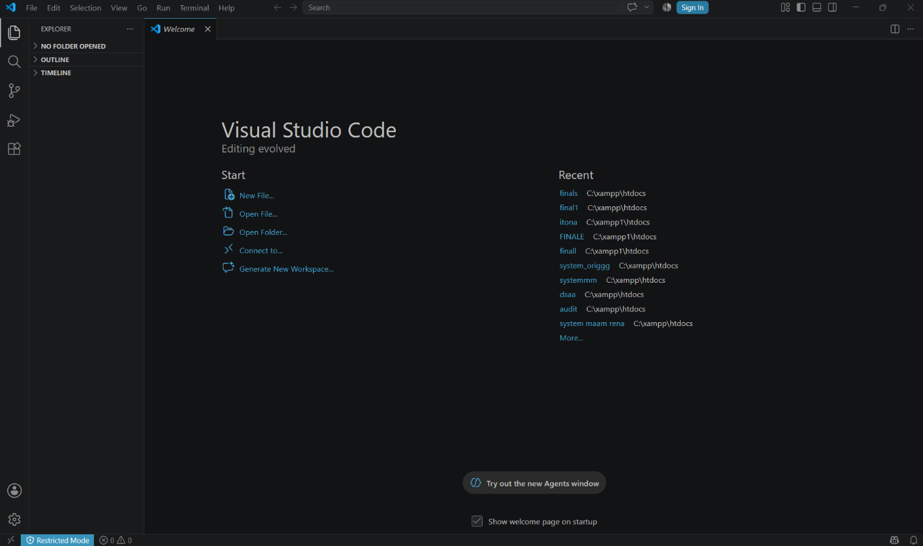

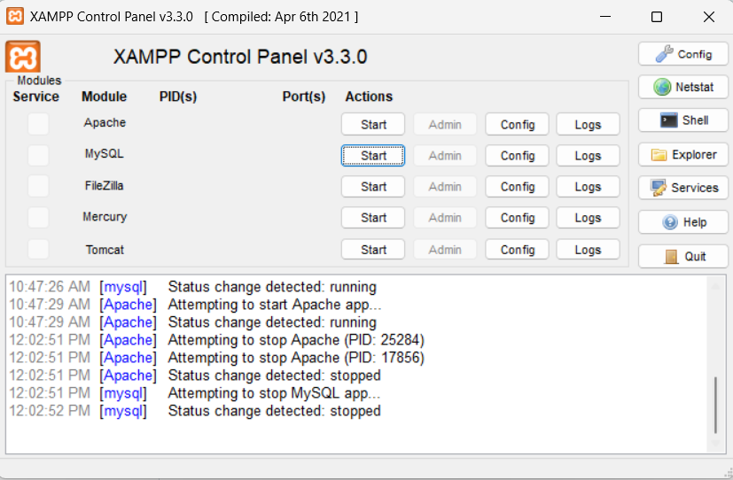

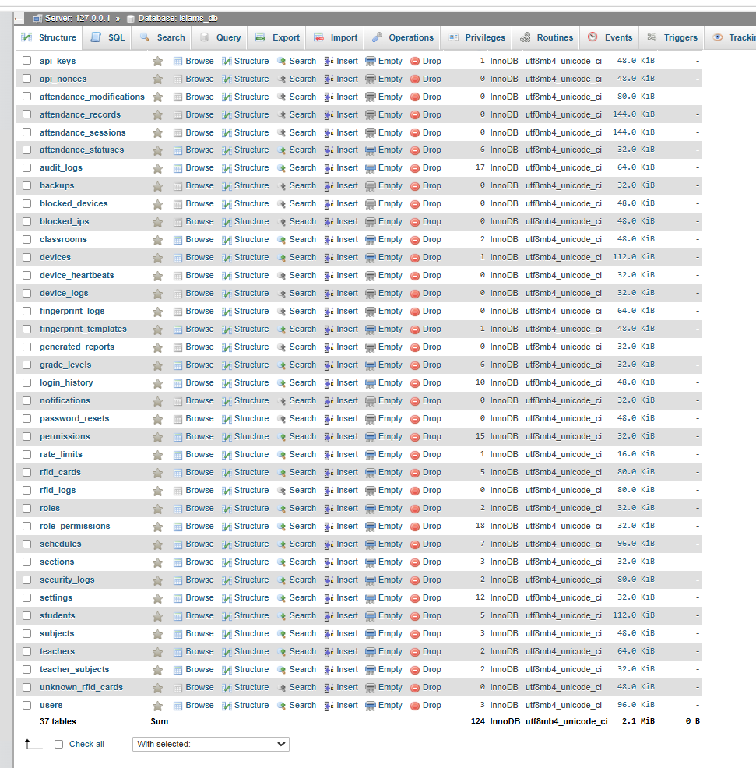
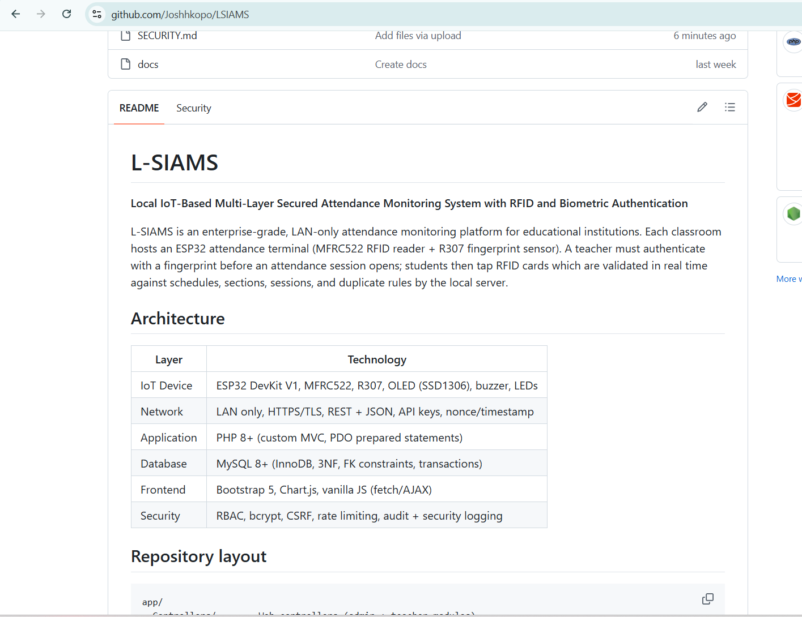
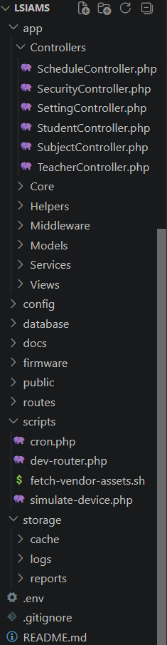

□ Screenshot of Running Development Environment
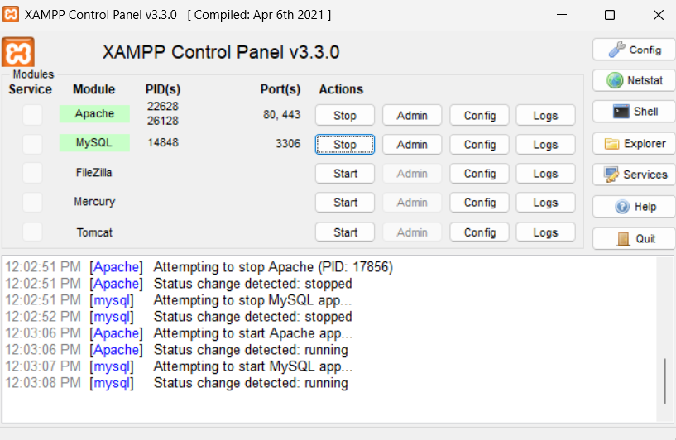

□ Screenshot of Project Workspace
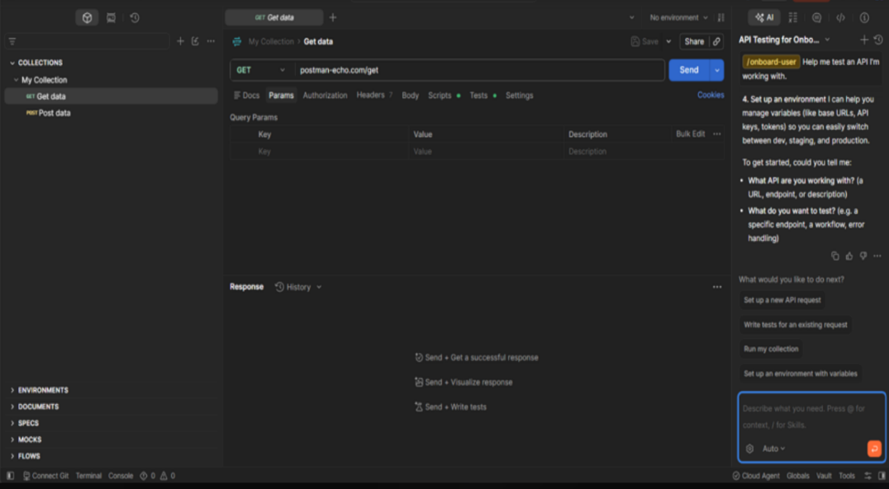


ACTIVITY 2
DATABASE IMPLEMENTATION

Purpose
To create the initial database structure required by the project.
Procedure
- Review the approved ERD.
- Create database schema.
- Create tables and relationships.
- Test database connectivity.
- Complete Form 2.

FORM 2
DATABASE IMPLEMENTATION REPORT

Directions
Document the database created for the project.
Project Database Name: lsiams_db

Database Platform: phpMyAdmin

Database Tables
Table Name | Purpose
api_keys | Stores API keys used to authenticate external systems, devices, or applications communicating with the system.
api_nonces | Stores one-time unique tokens (nonces) to prevent replay attacks during API requests.
attendance_modifications | Records all changes made to attendance records, including who modified them and the reason for the modification.
attendance_records | Stores the actual attendance of students for each attendance session.
attendance_sessions | Stores attendance events linked to scheduled classes, including date, time, and classroom information.
attendance_statuses | Defines the possible attendance statuses such as Present, Absent, Late, Excused, and others.
audit_logs | Records important user activities and system actions for auditing and accountability purposes.
backups | Stores information about system backup files, backup schedules, and restoration history.
blocked_devices | Stores devices that have been blacklisted from accessing the attendance system.
blocked_ips | Stores blocked IP addresses to prevent unauthorized network access.
classrooms | Stores information about classrooms including room number, capacity, building, and availability.
devices | Stores registered attendance devices such as RFID readers, fingerprint scanners, or attendance terminals.
device_heartbeats | Monitors the online status and connectivity of registered attendance devices.
device_logs | Records events generated by attendance devices, including connections, errors, and operational activities.
fingerprint_logs | Stores logs of fingerprint authentication attempts made during attendance recording.
fingerprint_templates | Stores encrypted fingerprint templates linked to students for biometric authentication.
generated_reports | Stores generated reports such as attendance summaries, class schedules, and performance reports.
grade_levels | Stores the available academic grade or year levels (e.g., 1st Year, 2nd Year).
login_history | Records user login and logout history, including timestamps, IP addresses, and login status.
notifications | Stores notifications sent to administrators, teachers, or students regarding schedules, attendance, and announcements.
password_resets | Stores password reset tokens and requests for secure password recovery.
permissions | Stores system permissions that define individual actions users are allowed to perform.
rate_limits | Stores request rate-limiting data to prevent API abuse and brute-force attacks.
rfid_cards | Stores RFID card information assigned to students and teachers for attendance authentication.
rfid_logs | Records all RFID card scan events during attendance and access verification.
roles | Stores user roles such as Administrator, Teacher, and Student.
role_permissions | Maps system roles to their corresponding permissions for role-based access control (RBAC).
schedules | Stores class schedules including assigned teacher, subject, classroom, day, and time.
sections | Stores academic sections assigned to students within specific grade levels or programs.
security_logs | Records security-related events such as failed logins, unauthorized access attempts, and suspicious activities.
settings | Stores configurable system settings including attendance policies, application preferences, and system parameters.
students | Stores student profile information, enrollment details, and account references.
subjects | Stores academic subject information including subject code, title, and units.
teachers | Stores teacher profile information and account references.
teacher_subjects | Defines which subjects are assigned to each teacher.
unknown_rfid_cards | Stores RFID card scans that are not yet registered in the system for administrative review.
users | Stores user account credentials and basic authentication information for all system users.

Relationships Implemented
Relationship | Status
One-to-One | Implemented
One-to-Many | Implemented
Many-to-Many | Implemented

Required Evidence
□ ERD Diagram
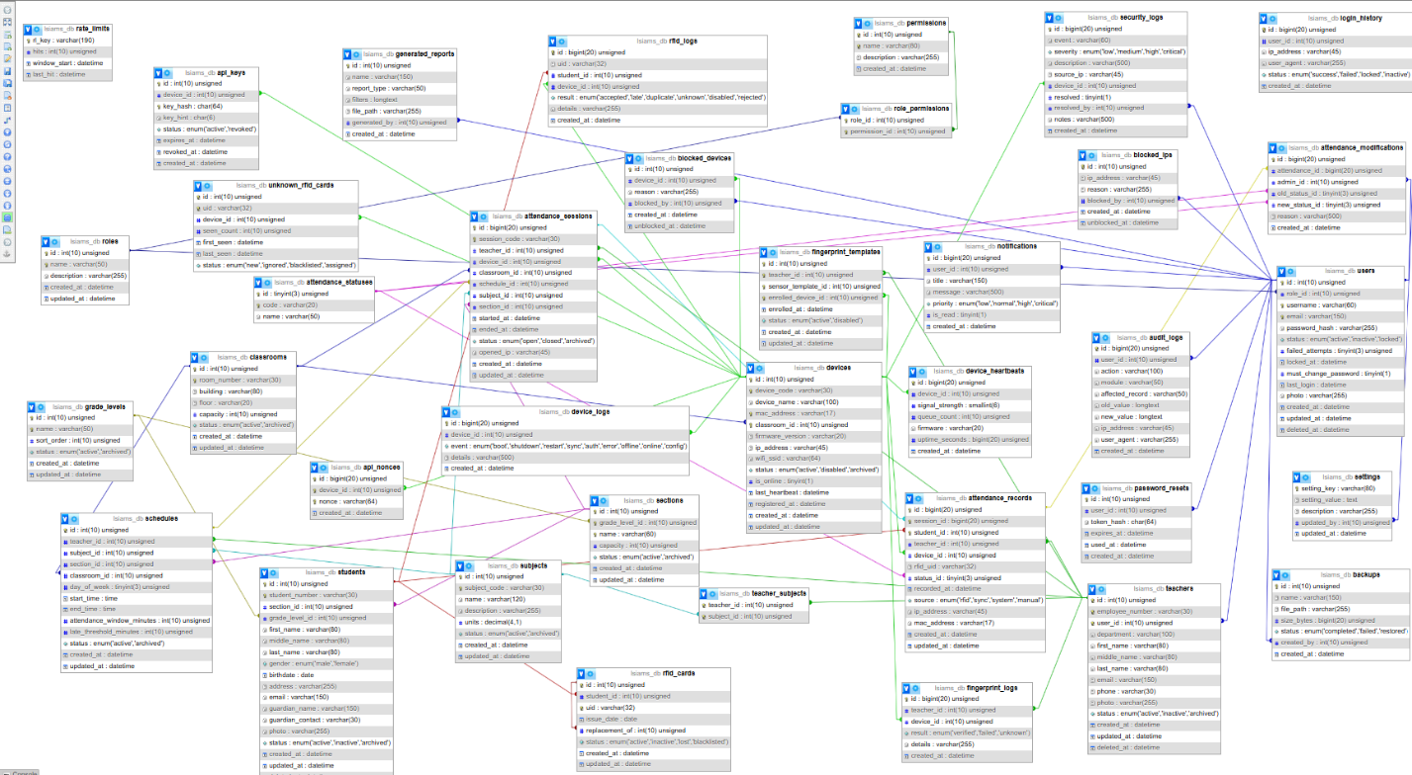

□ Database Screenshot

□ Table Structure Screenshot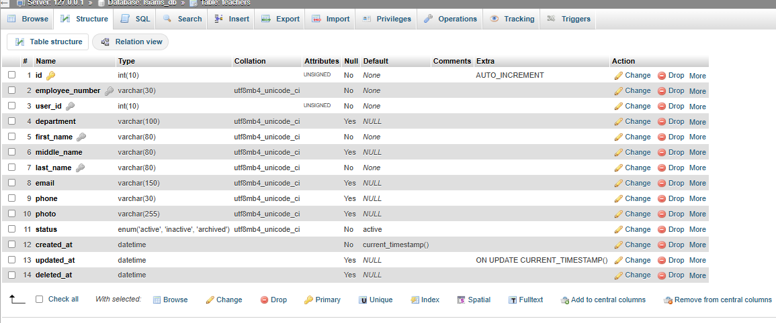
□ Connectivity Test Screenshot


ACTIVITY 3
FRAMEWORK AND PROJECT STRUCTURE SETUP

Purpose
To establish a maintainable project structure for development.
Procedure
- Create application folders.
- Configure framework.
- Create initial configuration files.
- Verify successful project execution.
- Complete Form 3.

FORM 3
PROJECT STRUCTURE REPORT

Directions
Document the project architecture.
Folder | Purpose
frontend | User interface components
backend | Business logic and controllers
database | SQL scripts and database configuration
documentation | Technical documentation
testing | Test files and reports

Framework Configuration
Framework: Custom lightweight MVC framework
Version: PHP 8.2

Project Structure Validation
□ Folder Structure Created 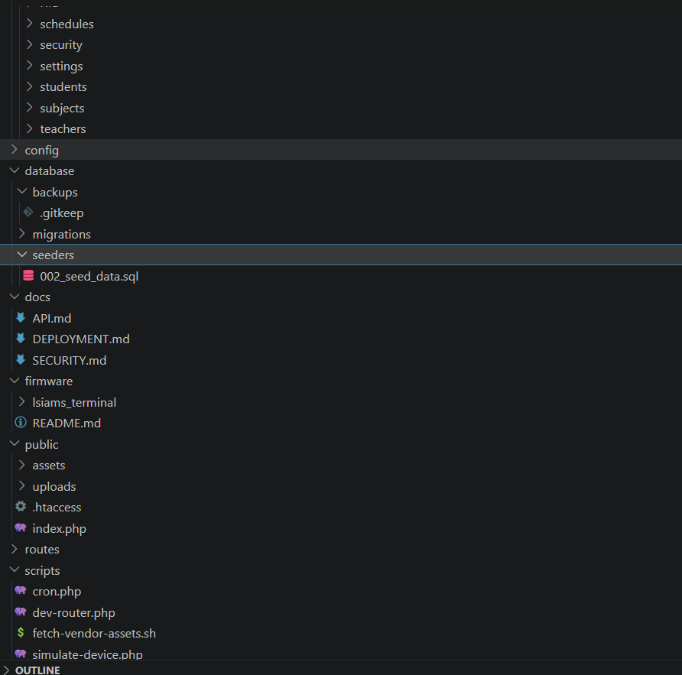
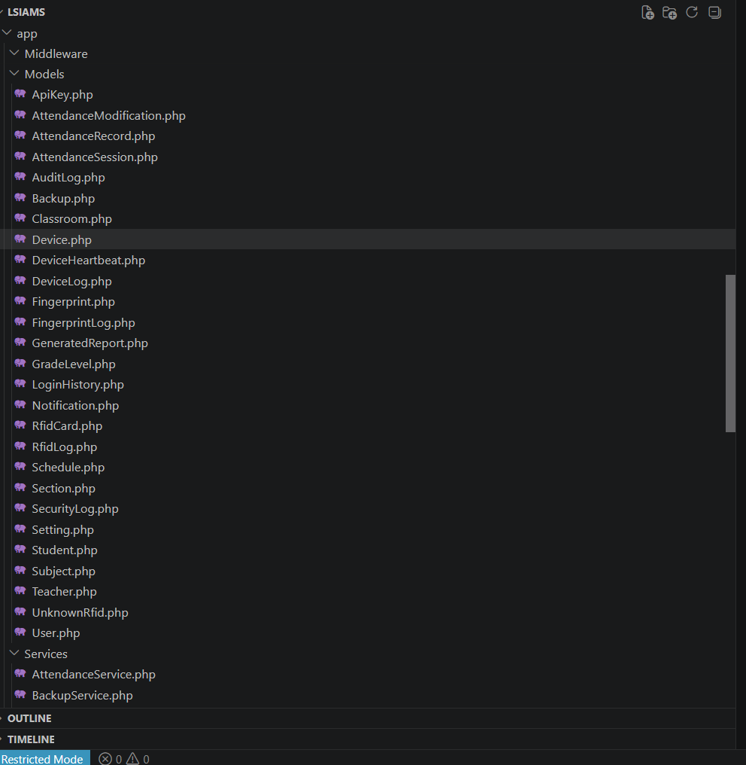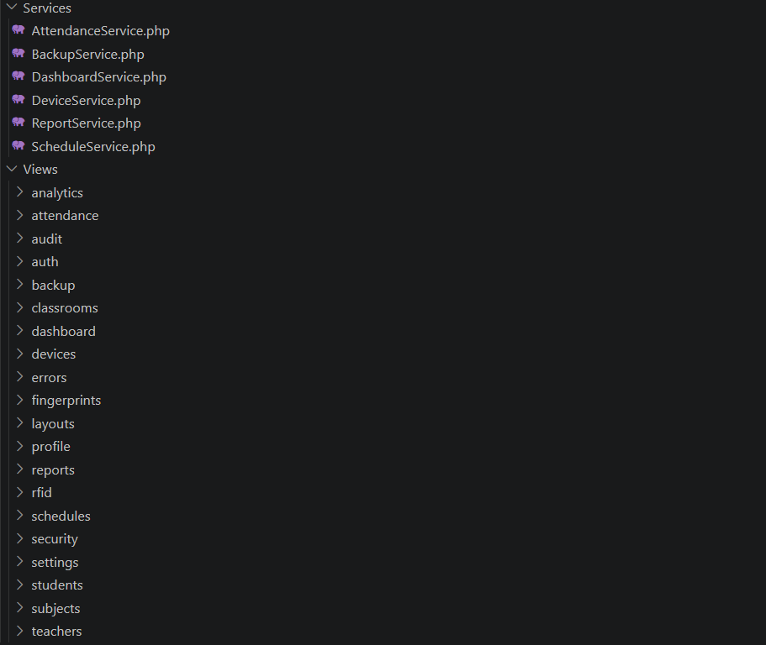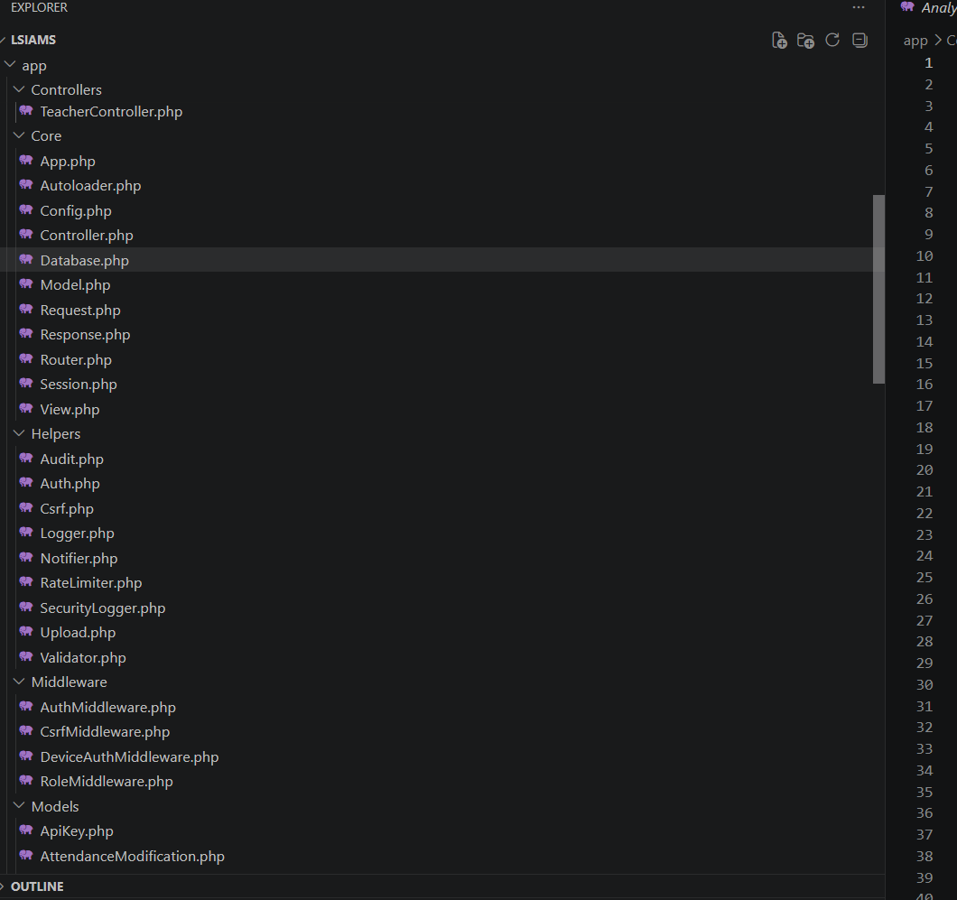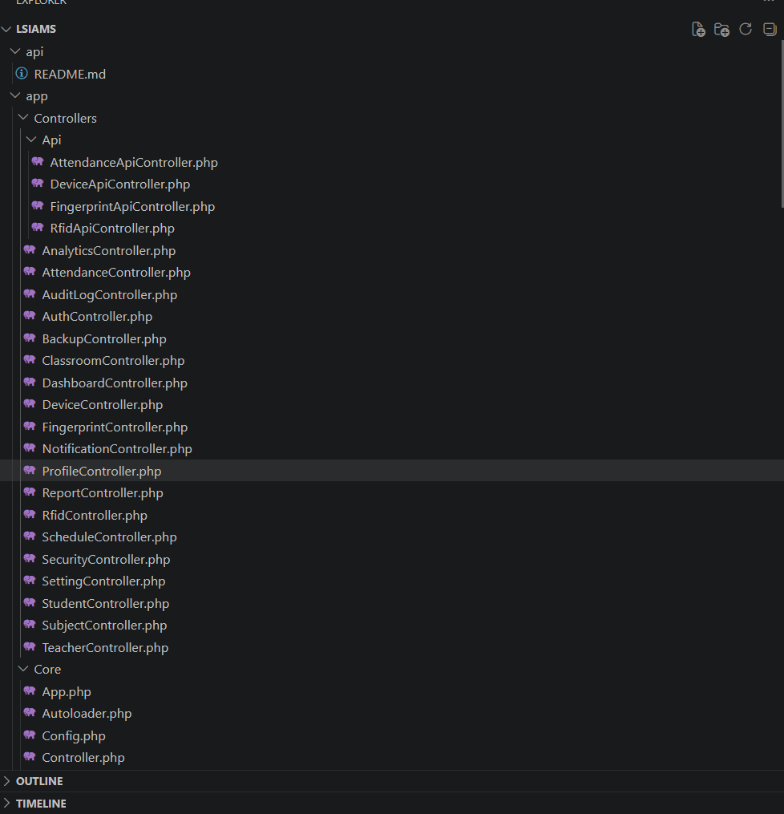

□ Framework Running Successfully

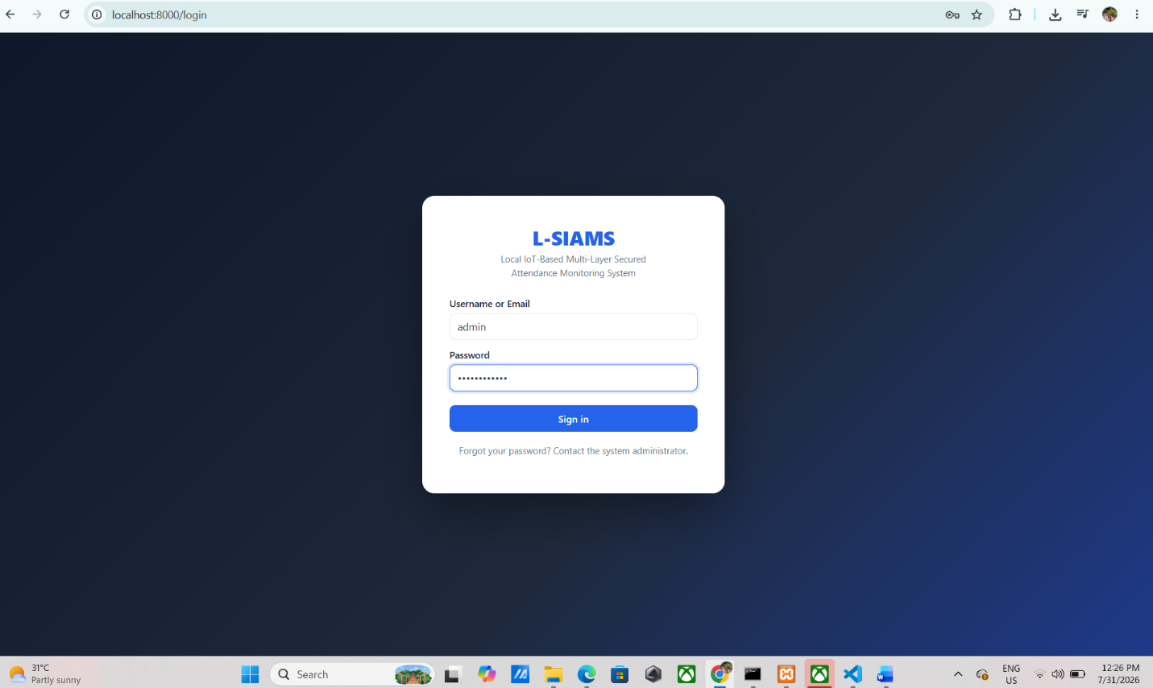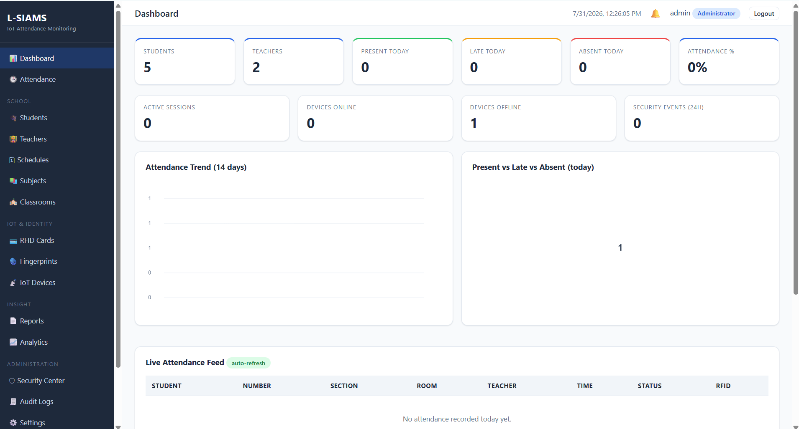

ACTIVITY 4
FOUNDATIONAL MODULE DEVELOPMENT

Purpose
To create the basic modules that will serve as the foundation of the system.
Suggested Foundational Modules
- User Authentication
- Login Page
- User Registration
- Dashboard Layout
- Navigation Menu
- Database Connection Module
Procedure
- Develop at least one foundational module.
- Verify module functionality.
- Upload code to repository.
- Complete Form 4.

FORM 4
INITIAL MODULE DEVELOPMENT REPORT

Directions
Document all foundational modules completed.
Module | Description | Status
Login Module | Administrator and Teacher Authentication | Complete
Database Connection Module | PDO Database Connectivity | Complete
Dashboard Layout | Initial Administrator Dashboard | Complete

Module Testing
Test Performed | Result
Login Function Test | Pass
Database Connection Test | Pass
Navigation Test | Pass

Required Evidence

□ Screenshots of Running Module


□ Source Code Screenshot
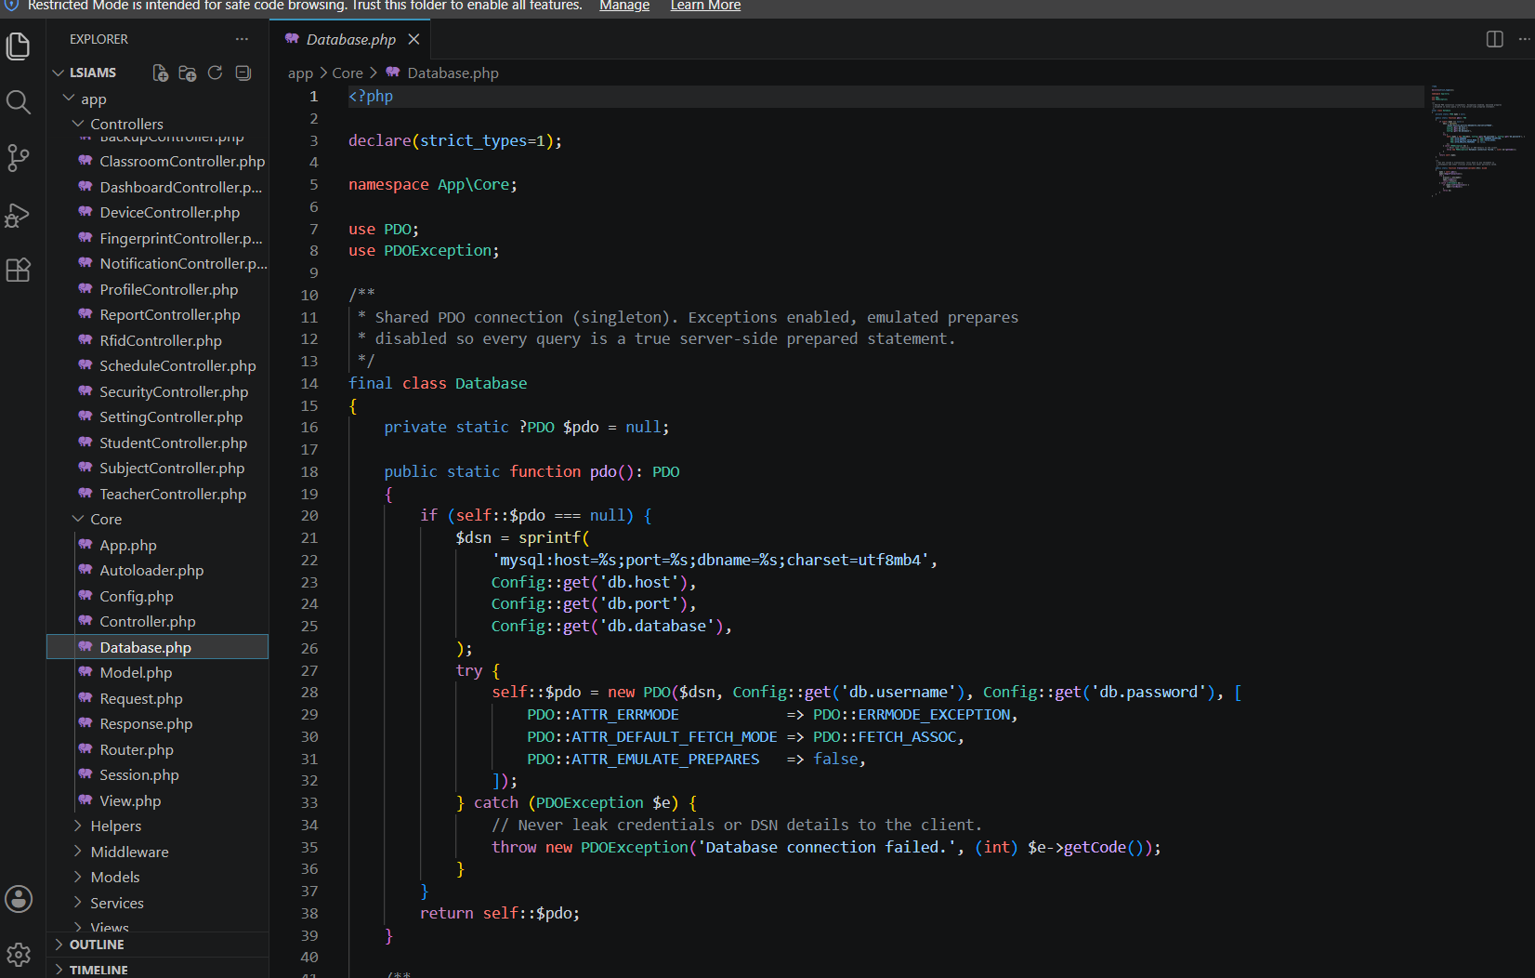
□ Demonstration Screenshot
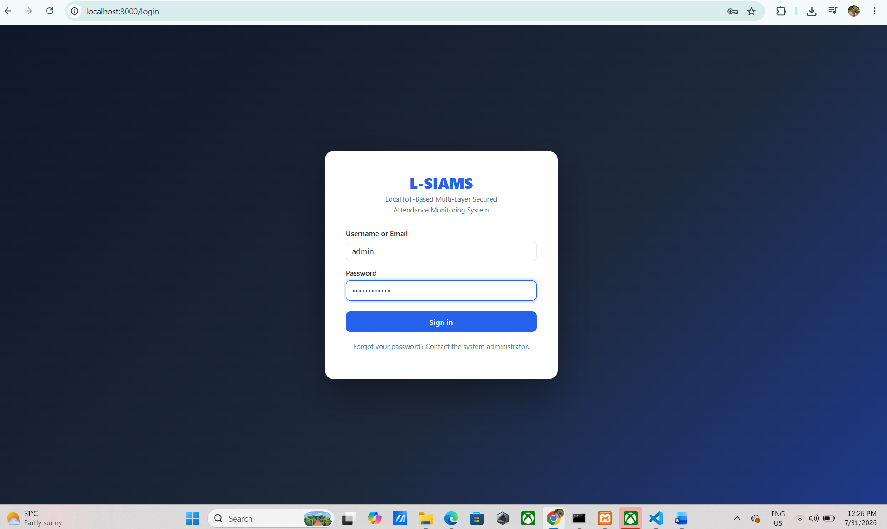

ACTIVITY 5
CODING STANDARDS ESTABLISHMENT

Purpose
To ensure consistency and maintainability of source code.

Procedure
- Agree on naming conventions.
- Define file organization standards.
- Define documentation standards.
- Define commit message standards.
- Complete Form 5.

FORM 5
CODING STANDARDS AGREEMENT

Naming Conventions
Item | Standard
Variables | camelCase
Functions | camelCase
Classes | PascalCase
Tables | snake_case
Files | snake_case

Documentation Standards
□ Function Documentation Required
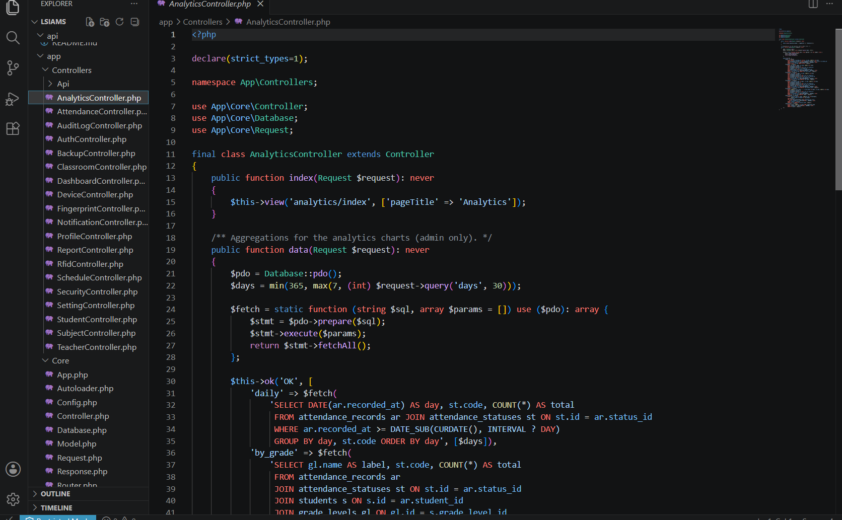
□ Database Documentation Required

Repository Standards
Commit Format: Descriptive, present-tense commit messages summarizing the implemented change.

Branching Strategy: Feature branches are created from the main branch → changes are committed and pushed → a Pull Request (PR) is submitted → the code is reviewed by the team → approved changes are merged into the main branch.

Team Agreement
All members agree to follow the coding standards established above.
Member Signatures:

ACTIVITY 6
REPOSITORY INITIALIZATION

Purpose
To establish version control and collaboration mechanisms.
Procedure
- Create project repository.
- Upload project structure.
- Commit initial files.
- Add team members.
- Complete Form 6.

FORM 6
INITIAL SOURCE CODE REPOSITORY REPORT

Repository Name: LSIAMS

Repository URL: https://github.com/Joshhkopo/LSIAMS

Team Access
Member | Access Granted
Ched Nikko P. Pangilinan | Yes
Joshkirby Tyler M. Bote | Yes
Naph Yvan P. Villamar | Yes

Initial Commits
Commit Description | Date
Initial Project Structure | July 30, 2026
eDatabase Schema Created | July 30, 2026
Login Module Implemented | July 30, 2026

Required Evidence

□ Repository Homepage Screenshot
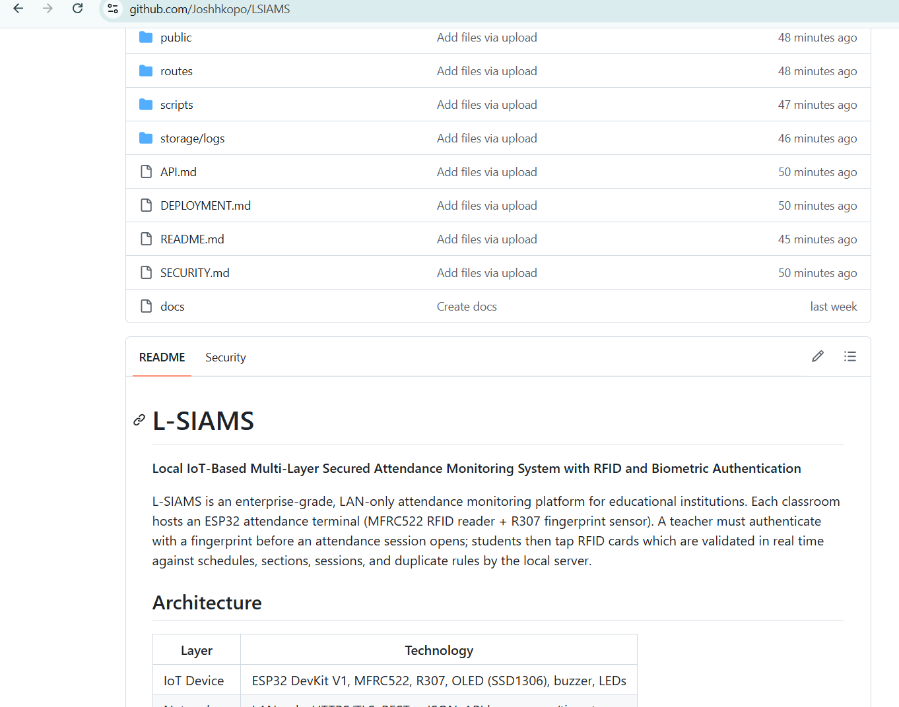

□ Initial Commit Screenshot
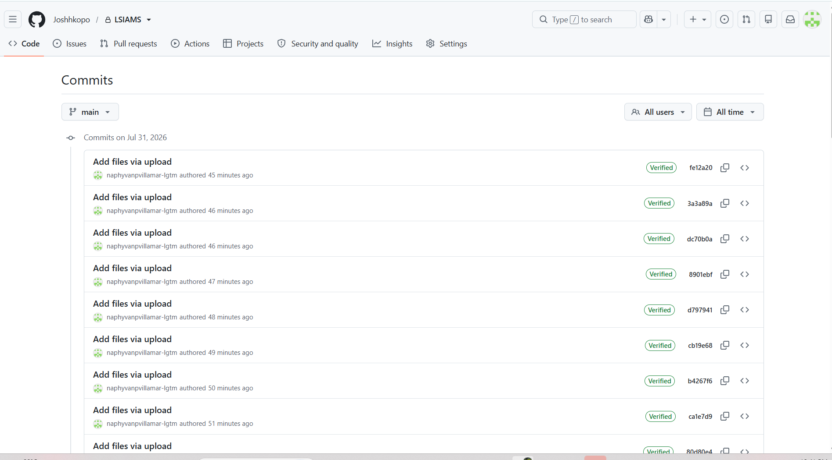
□ Project Structure Screenshot
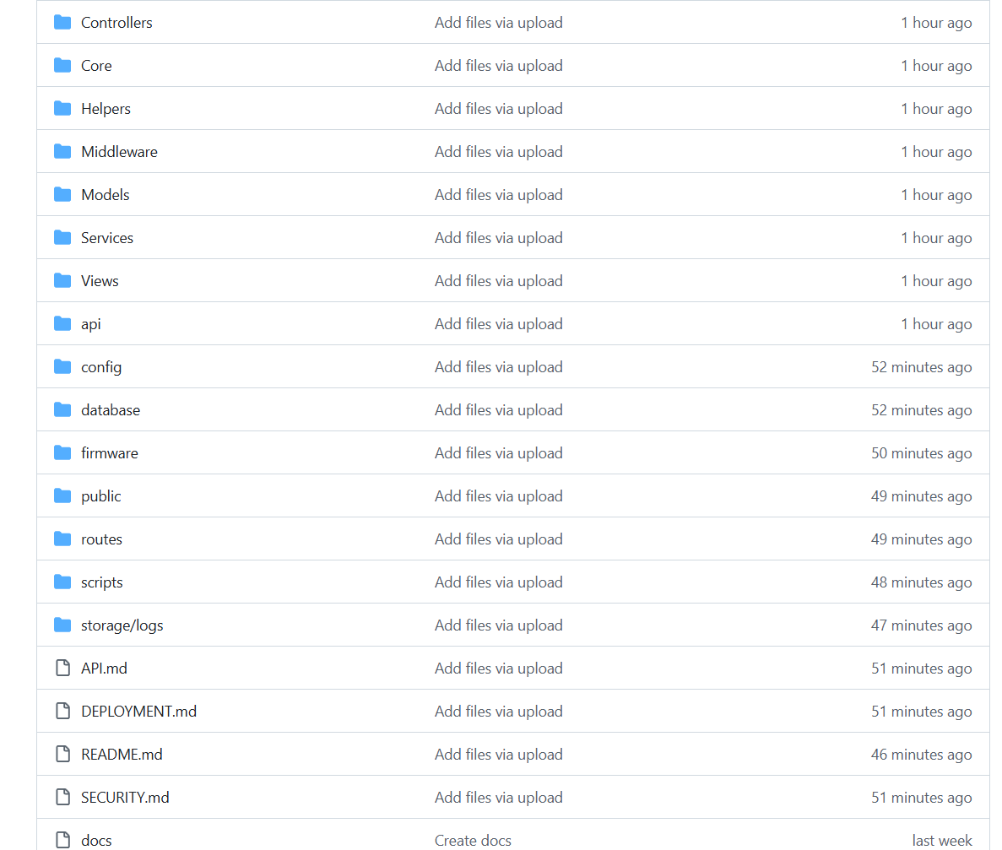

□ Team Access Screenshot
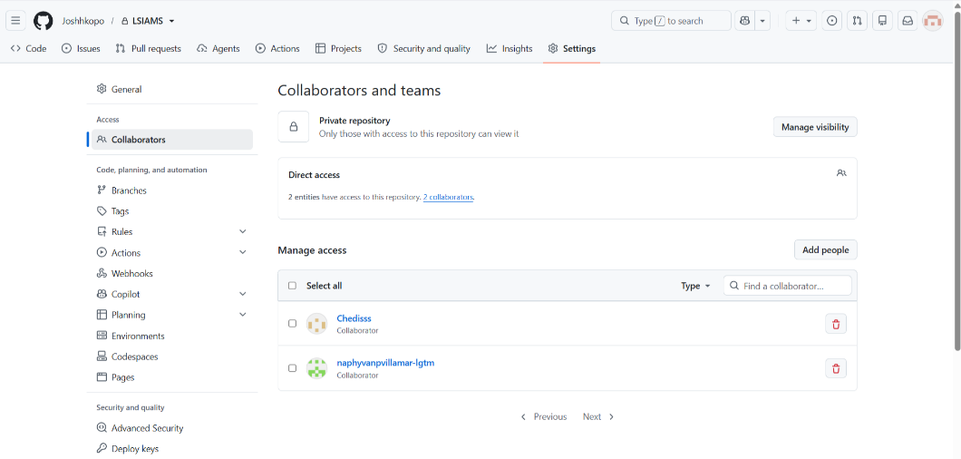

ACTIVITY 7
ADVISER VALIDATION
Purpose
To verify readiness for full-scale system development.
Procedure
- Present all Week 2 outputs.
- Demonstrate development environment.
- Demonstrate database implementation.
- Demonstrate initial modules.
- Obtain adviser approval.

FORM 7
ADVISER VALIDATION RECORD

Item Evaluated | Status
Development Environment | Approved/For Revision
Database Implementation | Approved/For Revision
Initial Modules | Approved/For Revision
Coding Standards | Approved/For Revision
Repository Setup | Approved/For Revision

Adviser Recommendations

Action Items

Adviser Signature: ___________________
Date: August _,2026
V. REQUIRED WEEK 2 SUBMISSION
- Development Environment Checklist
- Database Implementation Report
- Project Structure Report
- Initial Module Development Report
- Coding Standards Agreement
- Initial Source Code Repository Report
- Adviser Validation Record
- Supporting Screenshots and Evidence

VI. WEEK 2 DELIVERABLES
✓ Development Environment Setup Report
✓ Database Implementation
✓ Initial Source Code Repository
✓ Initial Functional Module
✓ Coding Standards Agreement

