WEEK 3: SYSTEM DEVELOPMENT I

I. INTENDED LEARNING OUTCOME (ILO)
At the end of this laboratory activity, students should be able to:
Develop and implement the core functionalities, user interfaces, and system workflows specified in the approved project requirements while applying established coding standards and collaborative development practices.

II. PERFORMANCE TASK
Following the successful completion of the development environment setup and database implementation during Week 2, your team shall begin actual system development.
You are required to implement the project's priority features, develop user interface components, and establish system workflows that demonstrate the project's core functionality.
The outputs produced this week will serve as evidence that the project has transitioned from planning to actual software development.

III. WEEK 3 ACTIVITIES
Activity 1 – Module Development Planning
Activity 2 – Core Functionality Development
Activity 3 – User Interface Development
Activity 4 – Workflow Configuration
Activity 5 – Internal Functionality Verification
Activity 6 – Repository Update and Version Control
Activity 7 – Progress Reporting and Adviser Consultation

ACTIVITY 1
MODULE DEVELOPMENT PLANNING
Purpose
To identify and prioritize the modules that will be developed during Week 3.
Procedure
- Review the approved requirements specification.
- Review the Work Breakdown Structure (WBS).
- Identify priority modules for development.
- Assign responsibilities among team members.
- Complete Form 1.

FORM 1
WEEK 3 MODULE DEVELOPMENT PLAN

Directions
List all modules scheduled for development this week.
Module | Description | Member | Target
User Authentication & Session Management | Login for admin/teacher accounts with bcrypt hashing and secure sessions | Pangilinan | Aug 5, 2026
Role-Based Access Control | Restricts pages and functions by role (Admin/Teacher) | Pangilinan | Aug 5, 2026
Admin User & IoT Device Registration | Registers users and ESP32 devices with unique API key generation | Pangilinan | Aug 6, 2026
Student, Class & RFID UID Enrollment | Encodes students, sections, and binds each to an RFID card UID | Villamar | Aug 6, 2026
Teacher Fingerprint Authentication | R307 enrollment and verification on ESP32 to start attendance session | Bote | Aug 7, 2026
RFID Attendance Capture & Server Endpoint | MFRC522 card reading and transmission to PHP endpoint over LAN | Bote | Aug 7, 2026
Attendance Dashboard & Reports | Displays and filters attendance records by class, date, student | Villamar | Aug 7, 2026
Audit Logging | Logs login attempts, auth failures, attendance transactions | Pangilinan | Aug 7, 2026

Priority Classification
□ High Priority
□ Medium Priority
□ Low Priority

Team Approval
Member Signatures:

ACTIVITY 2
CORE FUNCTIONALITY DEVELOPMENT

Purpose
To develop the major business processes and functions required by the project.
Examples
Depending on project type:
- User Registration
- User Authentication
- Records Management
- Inventory Processing
- Appointment Scheduling
- Reporting Module
- Data Analytics Module
- Security Module
Procedure
- Develop assigned functionality.
- Apply approved coding standards.
- Test functionality locally.
- Commit source code to repository.
- Complete Form 2.
FORM 2
CORE FUNCTIONALITY DEVELOPMENT REPORT

Directions
Document each completed functionality.
Functionality | Description | Status
User Authentication | Validates credentials against users table; bcrypt-hashed passwords | Complete
Role-Based Access Control | Session-based role checking with redirect on unauthorized access | In Progress
Admin User Registration | Admin creates teacher/admin accounts and assigns roles | Complete
IoT Device Registration & API Key | ESP32 registration with random API key stored in device table | In Progress
Student & RFID UID Enrollment | Student encoding with RFID UID binding from MFRC522 | In Progress
Teacher Fingerprint Authentication | R307 enrollment and verification before session activation | In Progress
RFID Attendance Capture Endpoint | Receives UID, device ID, timestamp; writes to attendance table | In Progress
Audit Logging | Inserts log entries for logins and attendance transactions | In Progress

Functionality Verification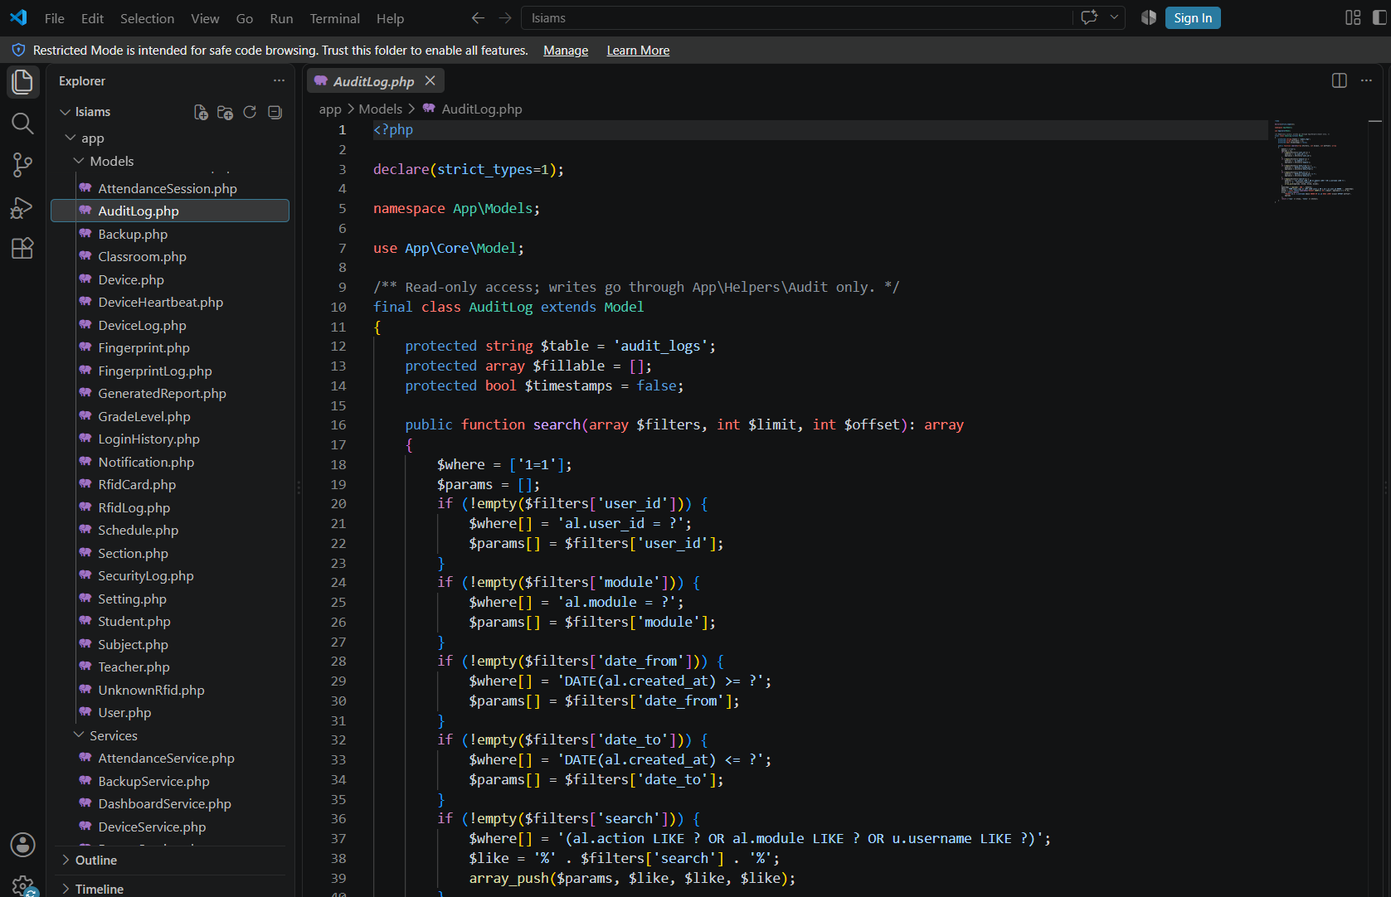
Test Conducted | Result
Input Validation | Pass
Process Execution | Pass
Output Generation | Pass

Evidence Attached
□ Screenshot of Functionality
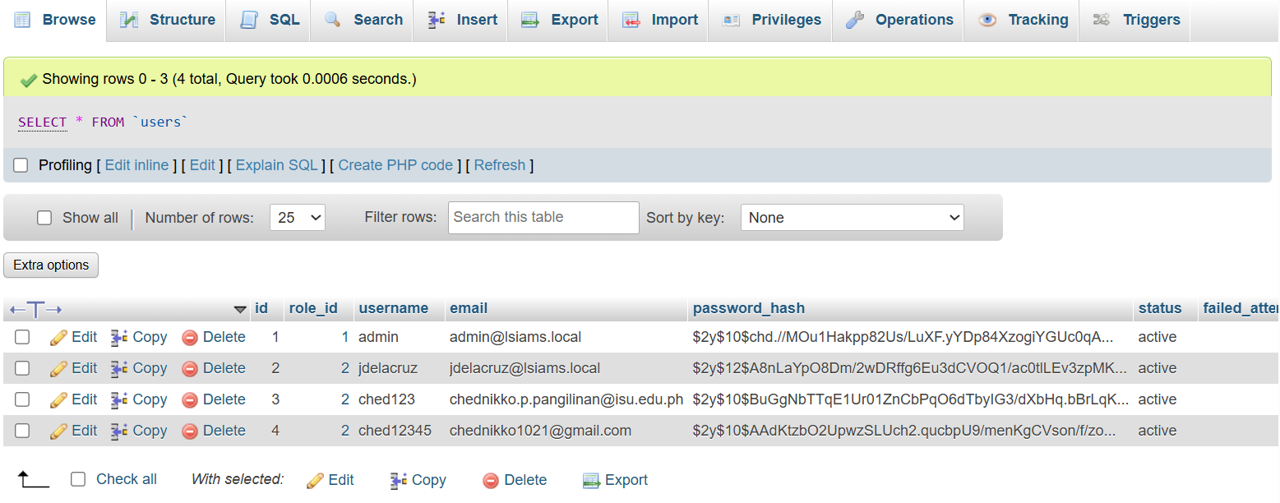
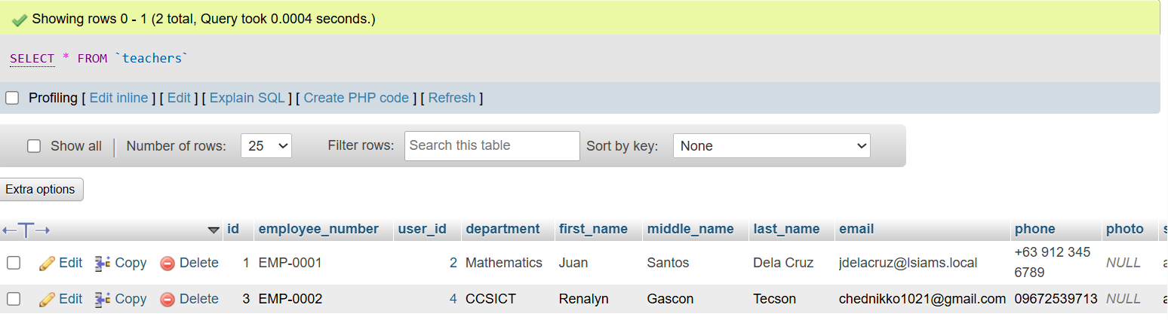
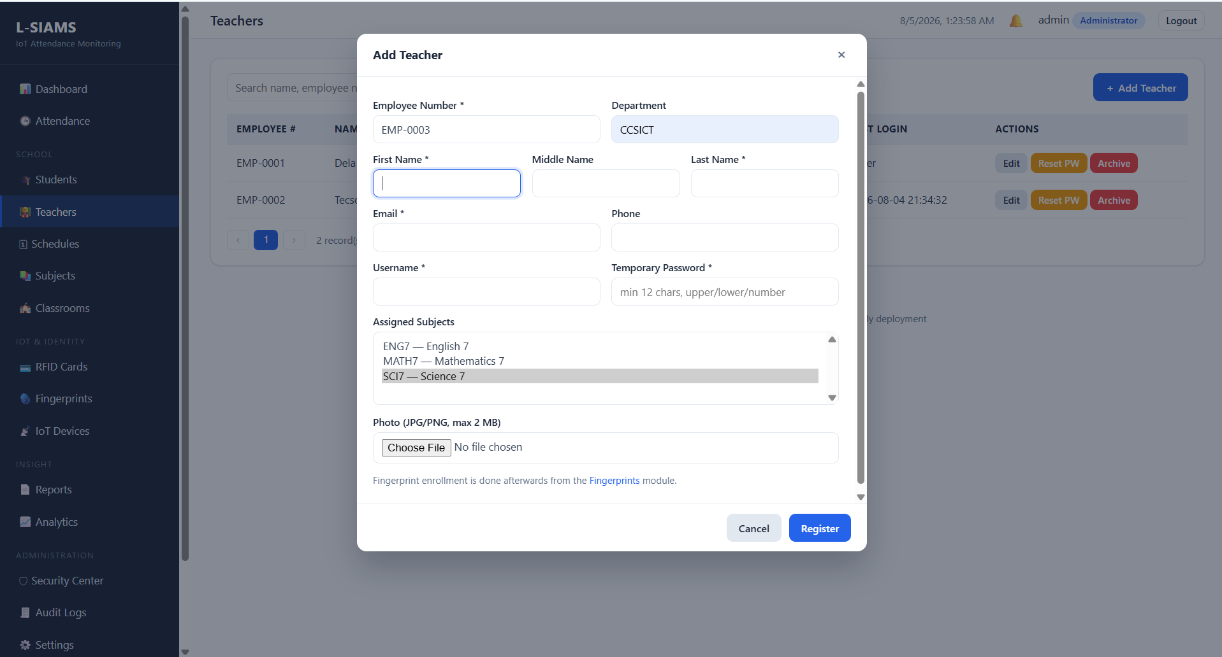
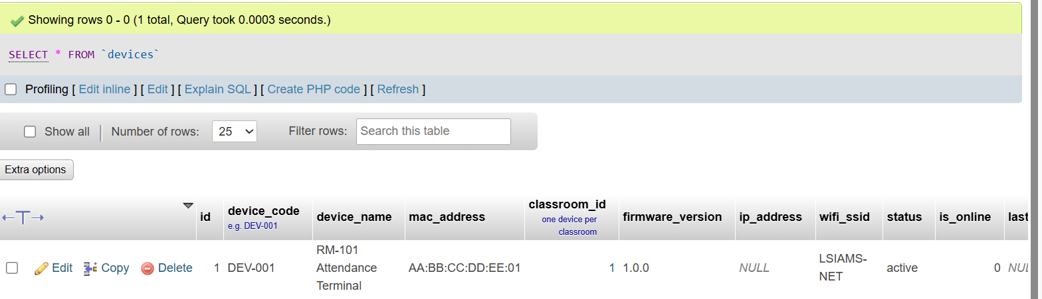
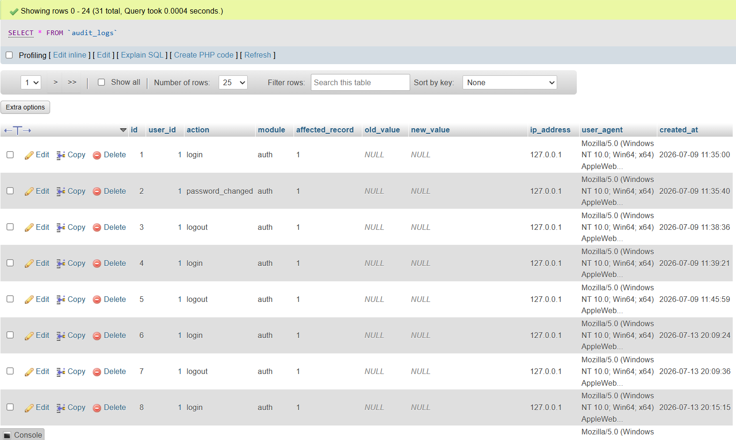
□ Source Code Screenshot
□ Demonstration Screenshot
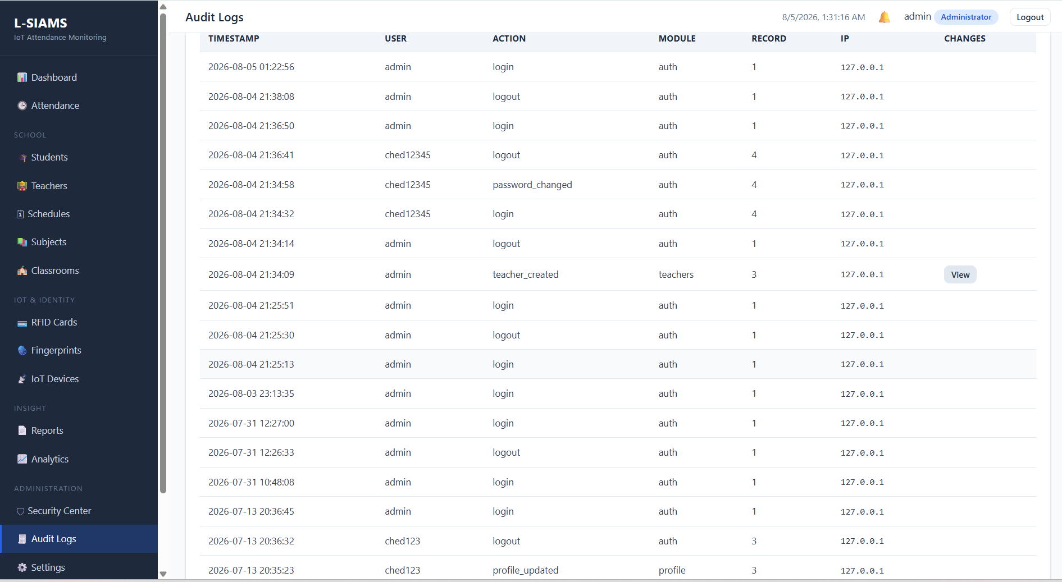
ACTIVITY 3
USER INTERFACE DEVELOPMENT

Purpose
To implement user-friendly interfaces aligned with approved system designs.
Procedure
- Develop system screens.
- Implement navigation menus.
- Apply usability principles.
- Verify screen responsiveness.
- Complete Form 3.

FORM 3
USER INTERFACE DEVELOPMENT REPORT

Directions
List all developed interfaces.
Interface/Page | Purpose | Status
Login Page | Entry point for admin and teachers; initiates secure session | Complete
Dashboard | Attendance summary, recent transactions, device status | In Progress
User Management | Add, edit, deactivate teacher and admin accounts | Complete
Device Registration | Register ESP32 units, view API keys and classroom assignment | In Progress
Student & Class Records | Encode students, assign sections, bind RFID UIDs | In Progress
Attendance Monitoring | Live and historical records filtered by class/date/student | In Progress
Reports Page | Generate and export printable attendance reports | In Progress

User Interface Checklist
Item | Completed
Consistent Design | /
Functional Navigation | /
Responsive Layout | /
Error Messages Implemented | /

Required Evidence
□ Interface Screenshots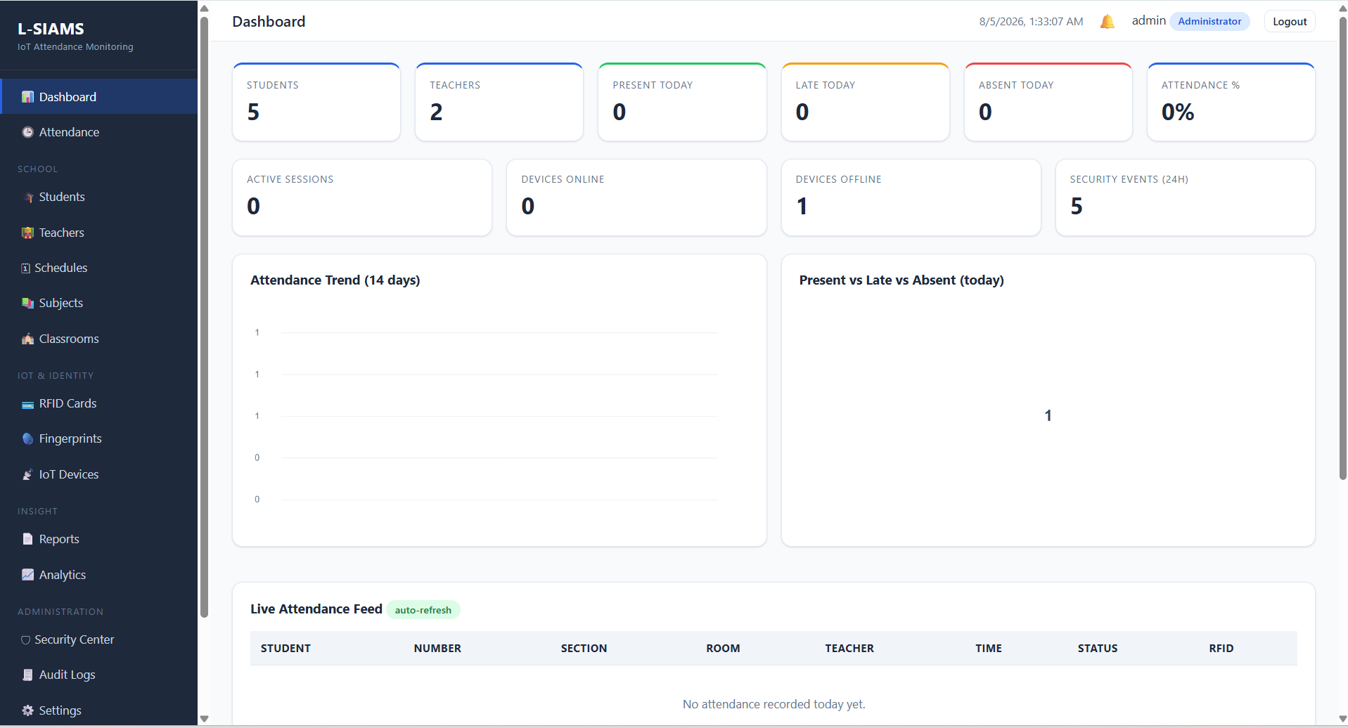
□ Navigation Demonstration
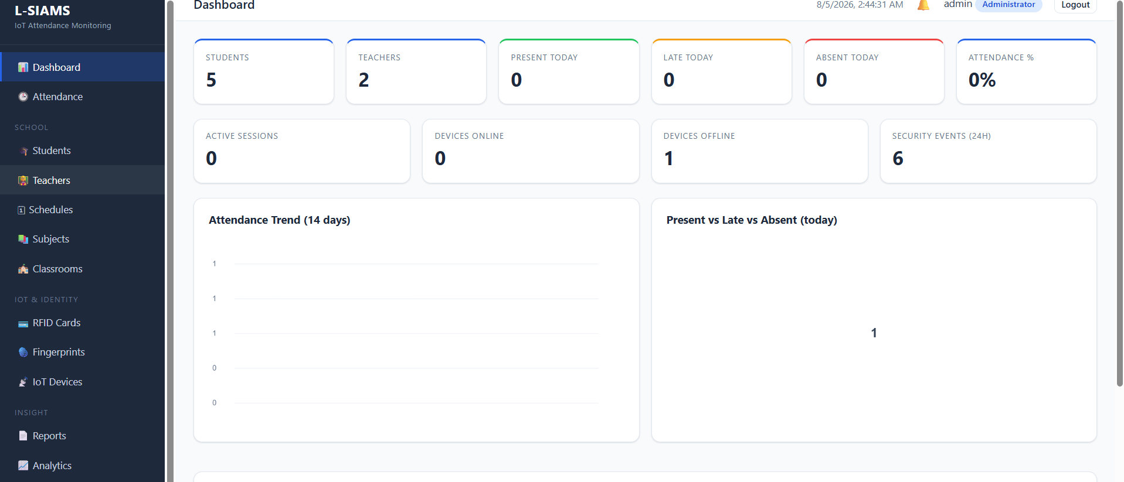
□ Mobile/Responsive View Screenshot (if applicable)

ACTIVITY 4
SYSTEM WORKFLOW CONFIGURATION

Purpose
To establish the logical flow of system processes.
Procedure
- Identify major transactions.
- Configure workflow sequences.
- Test process flow.
- Verify system responses.
- Complete Form 4.

FORM 4
SYSTEM WORKFLOW VALIDATION FORM

Directions
Document workflow implementation.

Workflow | Status | Remarks
Login Process | Implemented | Credential validation, bcrypt check, session creation working; role redirection being refined
Teacher Fingerprint Verification | Not Implemented | Enrollment routine written; server-side verification targeted Aug 7
Data Entry Process (RFID Tap) | Not Implemented | MFRC522 reads UID, ESP32 forwards to server over LAN
Data Processing | Not Implemented | Validates device API key and student UID before writing timestamped record
Report Generation | Implemented | Records retrievable; formatted output moved to Week 4

Workflow Verification
Validation Item | Result
Inputs Accepted Correctly | Pass
Process Executes Correctly | Pass
Output Generated Correctly | Pass

Evidence Attached

□ Workflow Diagram
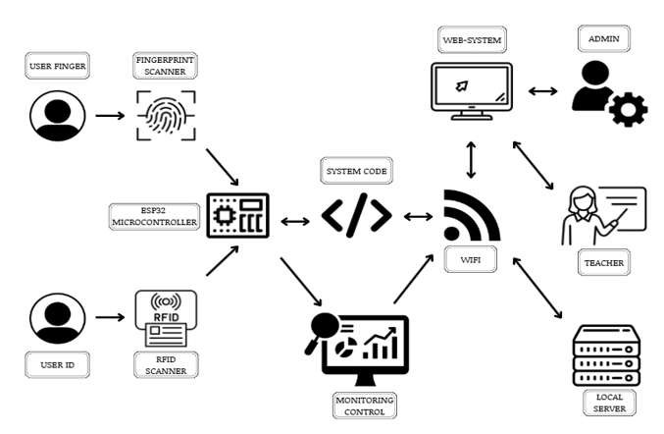
□ Workflow Demonstration Screenshots
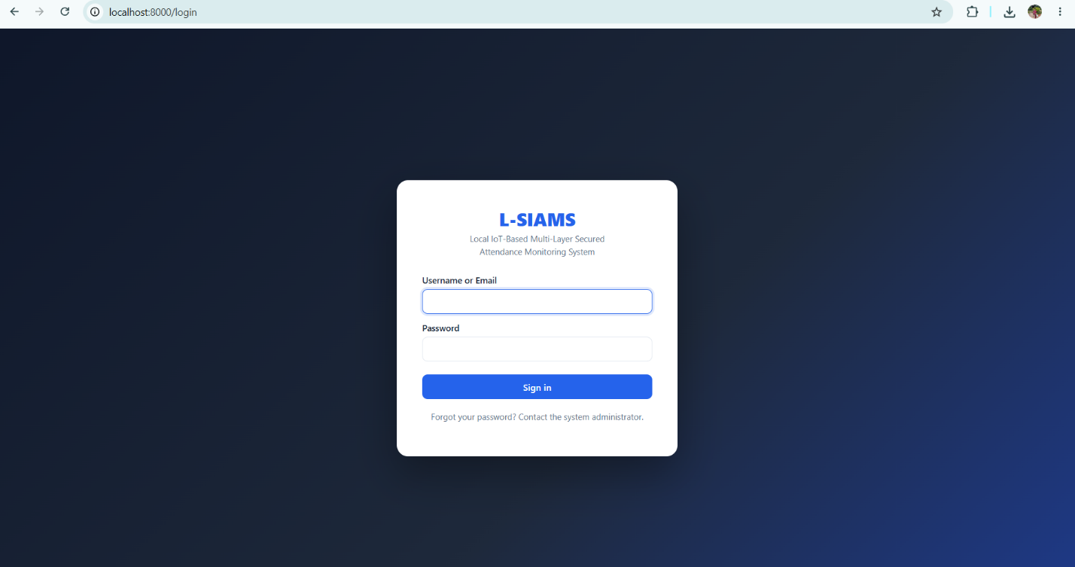

Admin dashboard

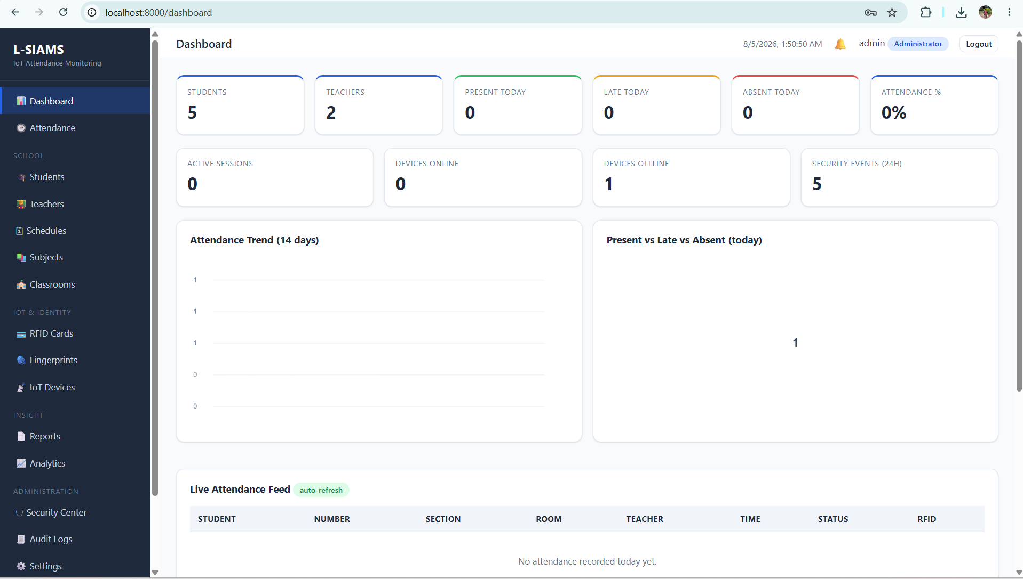

Teachers’ dashboard

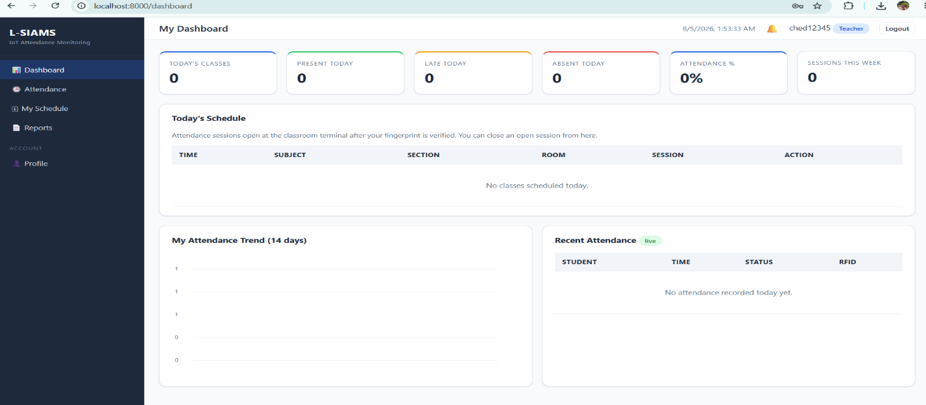

ACTIVITY 5
INTERNAL FUNCTIONALITY VERIFICATION

Purpose
To verify that developed modules are functioning properly before integration.
Procedure
- Conduct peer testing.
- Verify inputs and outputs.
- Identify issues encountered.
- Record findings.
- Complete Form 5.

FORM 5
MODULE VERIFICATION CHECKLIST

Directions
Evaluate each completed module.
Module | Functioning Correctly | Needs Revision
 | □ | /
 | □ | /
 | □ | /

Issues Identified
Issue | Severity | Action Taken
Subject assignment displays all subjects across departments instead of only those under the teacher's assigned department | High | Revising the subject assignment query to filter the list by the teacher's department
No section field in the subject assignment, so attendance cannot be traced to a specific section and teachers cannot identify which section has attended | High | Adding a section field to convert the teacher–subject assignment into a teacher–subject–section relationship, with corresponding database and attendance record updates
Searching by grade level and subject returns all subjects and sections instead of only those matching the selected criteria | Medium | Correcting the search query so the grade level and subject filters are applied to the result set rather than returning unfiltered records

Team Verification
Test Conducted By: Ched Nikko P. Pangilinan

Date: August 6, 2026

ACTIVITY 6
REPOSITORY UPDATE REPORT

Purpose
To document all development activities uploaded to the repository.
Procedure
- Commit all completed work.
- Update repository documentation.
- Record commits made.
- Complete Form 6.

FORM 6
REPOSITORY UPDATE REPORT

Repository URL: https://github.com/Joshhkopo/LSIAMS

Commits Made This Week
Commit Description | Date
Initialize project structure (Core, Controllers, Models, Views, routes, config) | July 31, 2026
Add database schema and connection configuration | July 31, 2026
Add authentication, middleware, and session handling | July 31, 2026
Add teacher records and subject assignment module | July 31, 2026
Add student and class records with RFID UID field | July 31, 2026
Add API endpoints and firmware directory for ESP32 | July 31, 2026
Update system files and fixes | August 5, 2026

Repository Evidence
□ Updated Source Code

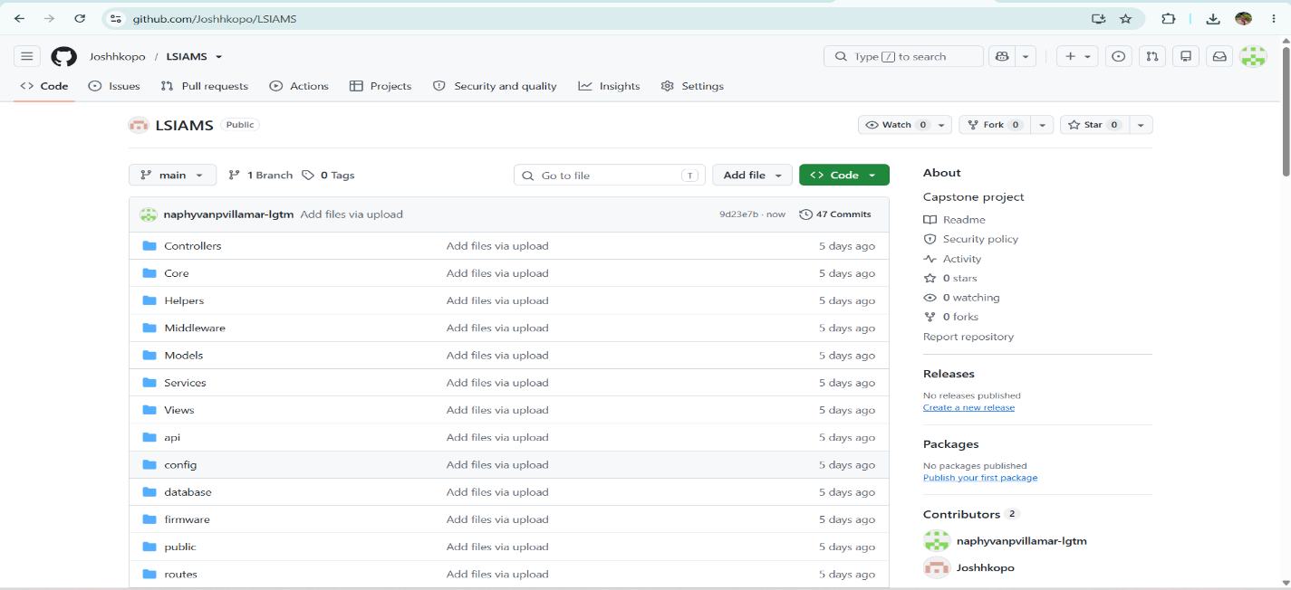
□ Commit History Screenshot
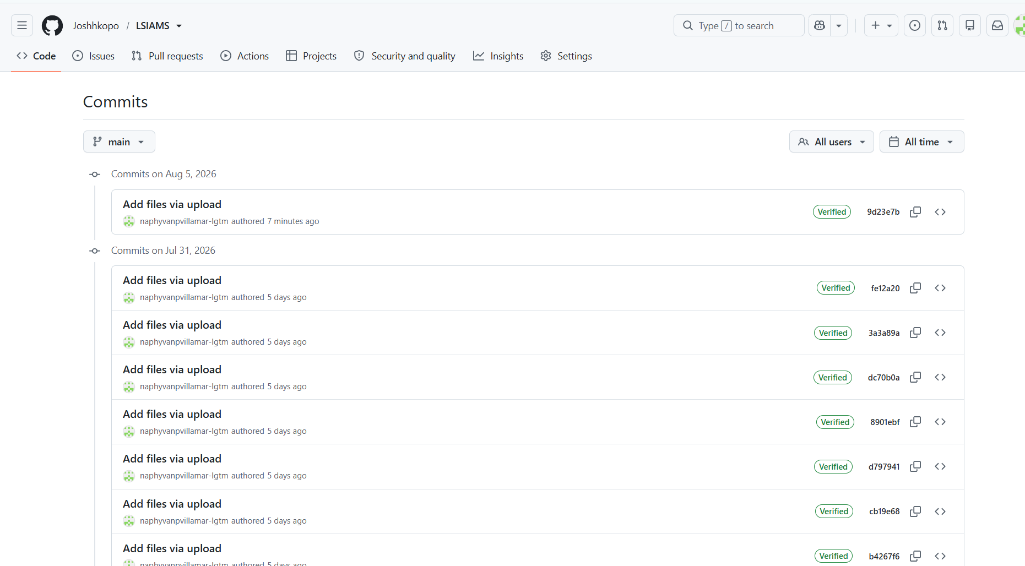
□ Branch Update Screenshot
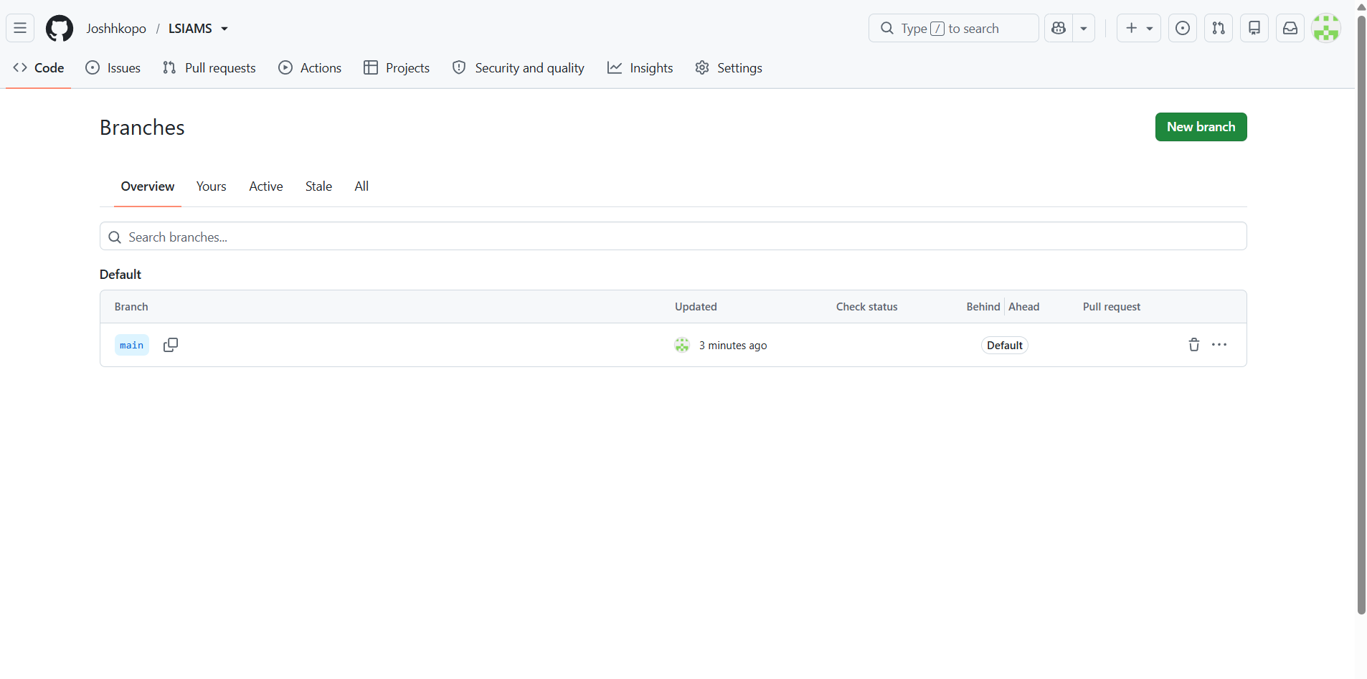
□ Team Contributions Screenshot
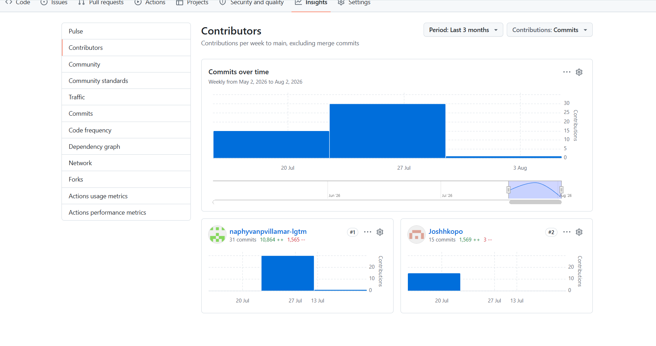

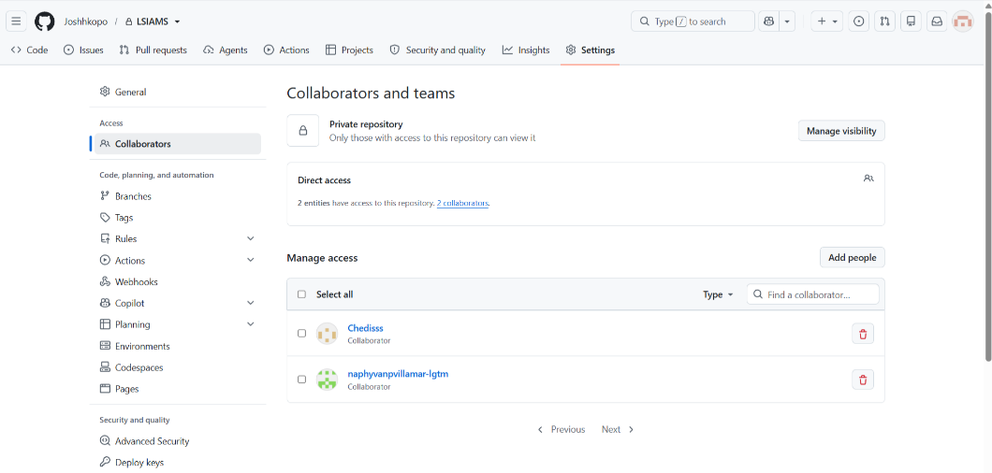

ACTIVITY 7
PROGRESS REPORT NO. 1

Purpose
To summarize development accomplishments during Week 3.
Procedure
- Review all completed activities.
- Summarize accomplishments.
- Identify challenges encountered.
- State plans for Week 4.
- Complete Form 7.

FORM 7
PROGRESS REPORT NO. 1
Project Information
Project Title: L-SIAMS: A Local IoT-Based Multi-Layer Secured Attendance Monitoring System with RFID and Biometric Authentication

Date Submitted: August _, 2026

Accomplishments This Week

Activity | Status
Core Functionality Development | In Progress
User Interface Development | Completed
Workflow Configuration | Completed

Major Accomplishments

The team advanced the project from planning into actual system development. The locally hosted PHP and MySQL platform is now running on the development server, with user authentication implemented using bcrypt password hashing and secure session management. Administrator functions for user registration and role assignment are operational, and the student and class records module now supports binding each student to a unique RFID card UID.

User interface development was completed for all planned pages this week, including the login page, dashboard, user management, device registration, student and class records, attendance monitoring, and reports page. A consistent layout, working navigation, and form-level error messages were applied across all interfaces.

Challenges Encountered

The primary issues encountered this week involved the subject assignment function of the administrator module. When the administrator assigns a subject to a teacher, the system displays the complete list of subjects across all departments rather than limiting the selection to the subjects offered under the teacher's assigned department. This produces an unnecessarily long and unfiltered selection list, increases the likelihood of encoding errors, and permits assignments that do not correspond to the teacher's actual department. Because subject assignment determines which attendance sessions a teacher is authorized to initiate, an incorrect assignment would also propagate into the attendance records.

A related limitation was identified in the same module. The subject assignment record does not include a section field, so a teacher is bound only to a subject and not to the specific section handled. As a result, attendance records cannot be traced to a particular section, and teachers are unable to determine which section has been marked present during a given session. Since the system is intended to record attendance at the classroom level, the absence of section-level association prevents the attendance output from reflecting actual class composition and limits the usefulness of the monitoring and reportin interfaces

Corrective Actions Taken

The subject assignment query is being revised to filter the subject list by the teacher's assigned department, so that only subjects belonging to that department are presented during assignment. A section field is likewise being added to the subject assignment structure, establishing a teacher–subject–section relationship rather than a teacher–subject relationship alone. The corresponding database tables and the attendance capture logic are being updated so that each attendance record stores the section together with the subject, enabling section-level filtering on the attendance monitoring and reporting pages. These revisions are scheduled for completion at the start of Week 4 prior to the resumption of integration testing.

Planned Activities for Week 4

Connect the ESP32 to the MFRC522 RFID reader and complete the firmware for card reading, then transmit captured UIDs to the server endpoint over the LAN. Apply department-based filtering to the subject assignment list and add the section field to the teacher–subject assignment structure. Complete the R307 fingerprint verification module so attendance sessions activate only after teacher authentication. Finalize role-based access control across all restricted pages, complete HTTPS/TLS certificate configuration, implement the offline fallback mechanism, and finish the attendance report generation function. Begin integration testing of the hardware, application, and security layers.

Prepared by:
Group Leader: Ched Nikko P. Pangilinan

Reviewed by:
Project Adviser: Jesusimo L. Dioses Jr., D.Eng.

FORM 8
ADVISER CONSULTATION RECORD

Directions
Present all Week 3 outputs and secure adviser feedback.
Topic Discussed | Recommendation
Module Development
User Interface Development
Workflow Implementation
Repository Progress

Adviser Remarks

Adviser Signature:

Date:

V. REQUIRED SUBMISSION
- Form 1 – Module Development Plan
- Form 2 – Core Functionality Development Report
- Form 3 – User Interface Development Report
- Form 4 – System Workflow Validation Form
- Form 5 – Module Verification Checklist
- Form 6 – Repository Update Report
- Form 7 – Progress Report No. 1
- Form 8 – Adviser Consultation Record
- Screenshots and Supporting Evidence
VI. WEEK 3 DELIVERABLES
✓ Progress Report No. 1
✓ Functional Core Modules
✓ Initial User Interfaces
✓ Workflow Implementation
✓ Updated Source Code Repository

