Role-Based Access Control (RBAC)

Project Introduction
This project simulates a real-world Role-Based Access Control (RBAC) setup for a company named BagmatiCyber Ltd.
As a junior system administrator, my responsibility was to configure Linux users, groups, file permissions, sudo policies, and automated backups to ensure secure and controlled access for different departments: Development, Audit & Compliance, and Operations.
The goal of this project was to apply Linux system administration concepts such as user management, ownership, permissions, SetGID, sudo restrictions, cron jobs, and access control in a practical environment.
Objectives
- Implement RBAC
- Secure access to files
- Configure sudo, cron, aliases

Implementation
- User & Group Setup
- Directory & File Setup
- Permissions & Ownership
- Sudo Configuration
- Testing
- Cron & Aliases
What I Learned
- Linux permissions
- SetGID
- RBAC
- Security best practices

Part 1:User and Group Setup

User Creation and Group Assignment
This task involved creating users and assigning them to their respective departmental groups to implement Role-Based Access Control (RBAC).
Each user was assigned a primary group based on their department to control file ownership, and a secondary group to allow additional access where required:
- Jatil was assigned to the dev_team as the primary group to manage development-related files.
- Mahesh was assigned to the audit_team to handle audit and compliance tasks.
- Lok was assigned to both dev_team and audit_team because his role required access to both development and audit resources.
- Suchana was assigned to the ops_team to manage operational system tasks.
The primary group determines the default group ownership of files created by the user, while secondary groups provide extra access permissions without changing file ownership.
After assigning the groups, the id and groups commands were used to verify group membership for each user. This ensured that all users were correctly assigned to their intended departments and access levels.

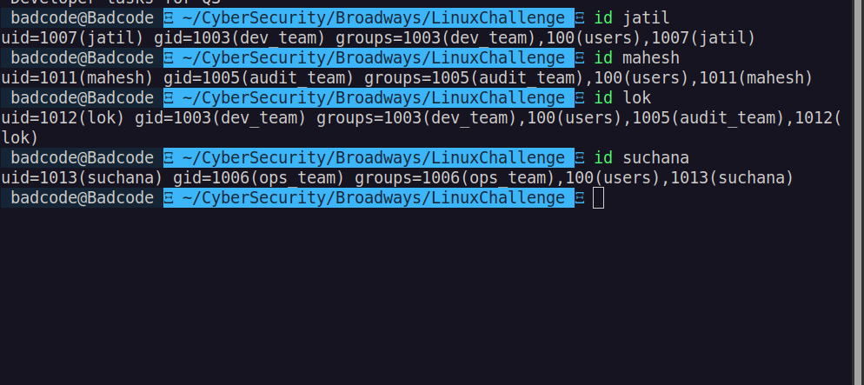

Part 2: Directory and File Setup
In this step, the required directory structure was created inside:
/home/badcode/CyberSecurity/Broadways/LinuxChallenge to organize departmental resources securely for BagmatiCyber Ltd.
Two main directories were created:
- projects – for development-related files
- logs – for audit and compliance records
These directories help separate sensitive data based on department roles, making access control easier to manage.
Next, the following files were created with specific content:
- dev_notes.txt inside the projects directory, containing development task information.
- audit.log inside the logs directory, containing audit trail records.
- README.md in the main LinuxChallenge directory, containing the company’s access control policy.
This structure ensures that:
- Development, audit, and policy files are stored in appropriate locations.
- Permission rules can be applied accurately for each department.
- Sensitive data is logically separated to improve security and management.
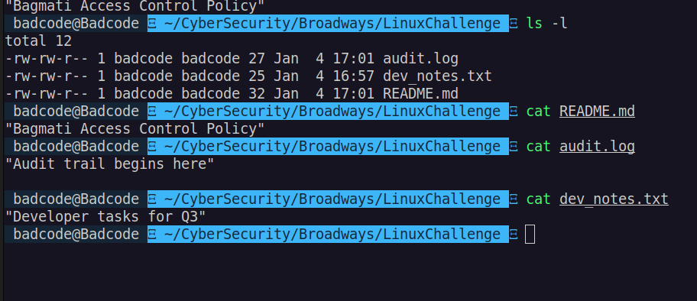
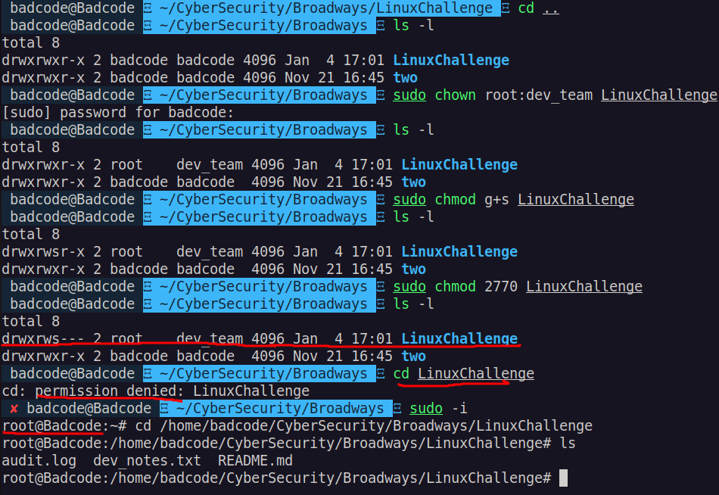

Part 3: Ownership and Permission Configuration

In this step, file ownership was configured to ensure that only the appropriate users and departments could manage specific files.
The following ownership rules were applied:
- dev_notes.txt was owned by Jatil and the group dev_team, allowing the development team to manage development-related tasks.
- audit.log was owned by Mahesh and the group audit_team, ensuring audit records are controlled by the audit department.
- README.md was owned by root and the group ops_team, since it contains important system access policies.
By assigning correct user ownership and group ownership, access control was enforced based on departmental roles. This ensures that:
- Only authorized users can modify sensitive files.
- Each department is responsible for its own data.
- System policies remain protected under administrative control.
This setup is a key part of implementing Role-Based Access Control (RBAC) in the Linux environment.

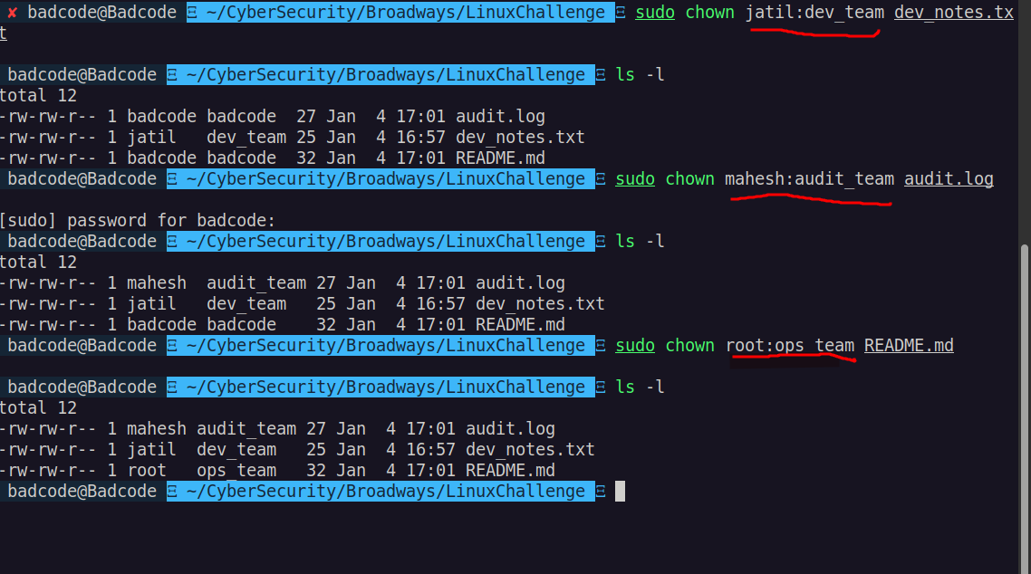

Directory Permissions and SetGID Configuration
In this step, strict access control was applied to the projects and logs directories to protect sensitive departmental data.
The projects directory was configured so that only the root user and members of the dev_team can access it.
The logs directory was configured so that only the root user and members of the audit_team can access it.
The SetGID (Set Group ID) permission was enabled on both directories.
This ensures that any new files created inside these directories automatically inherit the group ownership of the directory.
This is important for maintaining consistent access control within each department.
For the README.md file, special permissions were applied:
- The file is readable by all users, so everyone can view the access policy.
- No user is allowed to write or execute the file, including the owner.
This protects the policy document from being modified or misused.
Overall, these permission settings enforce department-based access, prevent unauthorized changes, and maintain a secure RBAC environment.

In this step, access controls were applied to the -logs directory and README.md file to ensure security and proper access management.
- -logs directory: Access was restricted to the owner and members of the audit_team. The SetGID (Set Group ID) permission was enabled on the directory, ensuring that any new files or subdirectories created inside automatically inherit the group ownership. This maintains consistent group-based access control and prevents unauthorized access to sensitive logs.
- README.md file: The file was made readable by all users so that everyone can view its contents. However, no user—including the owner—can write to or execute the file. This ensures the file remains protected from modification or misuse.
Overall, these permission settings enforce controlled access, preserve data integrity, and maintain a secure environment for team-based collaboration.

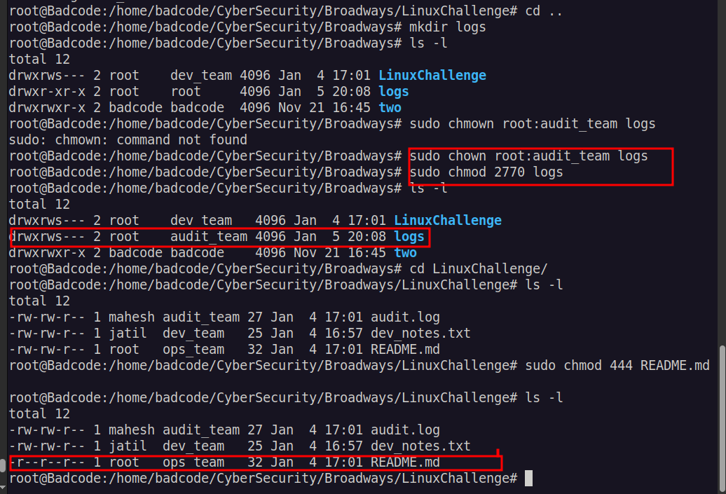

Part 4: sudo Configuration
In this step, user Suchana was configured with specific sudo privileges to allow controlled administrative access. She was added to the sudo group to grant her the ability to run commands with elevated privileges.
Special sudoers rules were applied to enforce security policies:
- Suchana was allowed to restart the networking service without being prompted for a password. This enables necessary administrative tasks to be performed efficiently while maintaining security.
- At the same time, she was explicitly denied the ability to use sudo su or sudo bash. This prevents her from gaining unrestricted root access and ensures that administrative privileges are used only for authorized tasks.
The configuration was validated by attempting the allowed and restricted commands. This approach provides controlled privilege escalation, enforcing the principle of least privilege while maintaining operational flexibility.

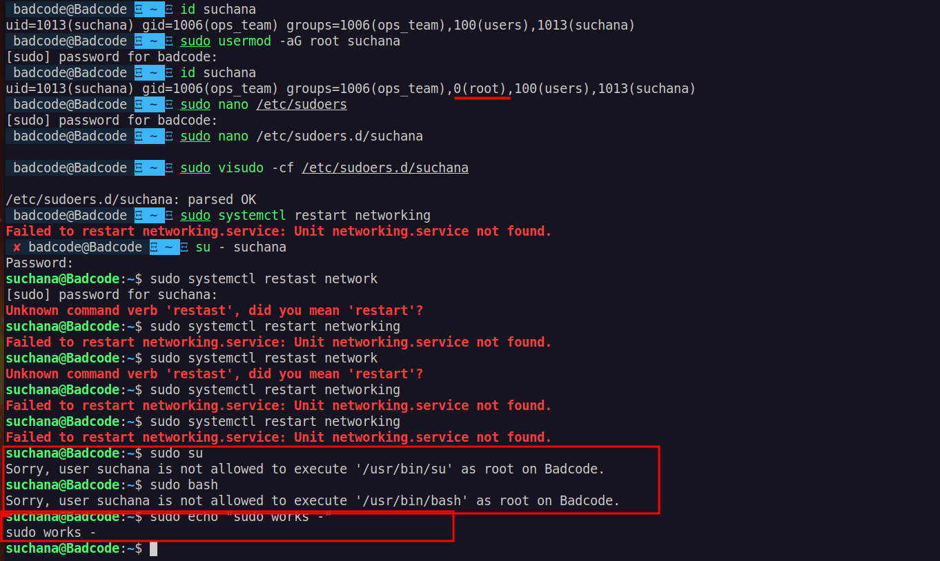

code inside /etc/sudoers.d/suchana

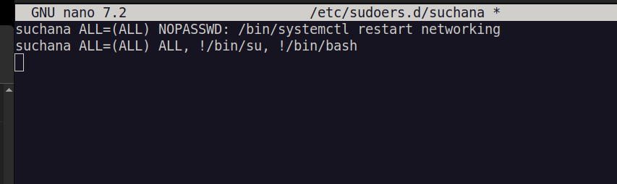
first line make no password required and 2nd code make suchana unable to use ‘sudo su’ and ‘sudo bash’

Part 5: Testing & Validation

-Lok tries to append data to audit.log
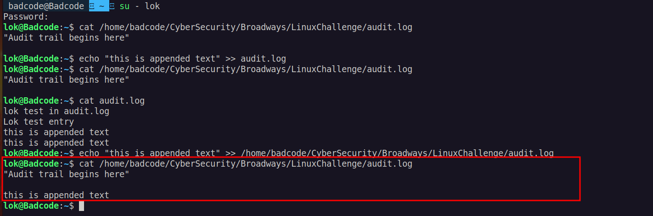
-Mahesh tries to list the contents of /opt/Bagmaticyber/projects
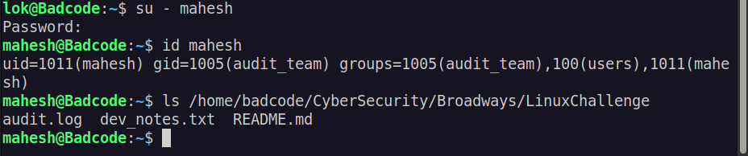
-Suchana restarts the network service
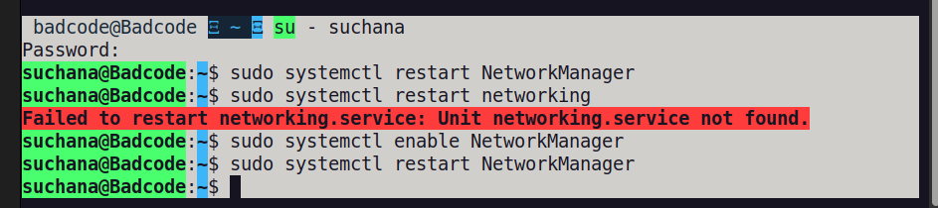

-Suchana tries to open a root shell
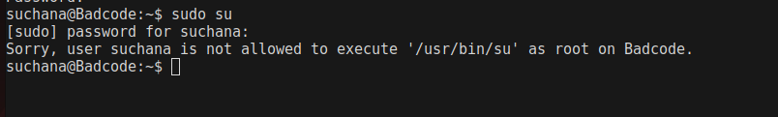

-Jatil attempts to delete README.md
The directory /home/badcode/CyberSecurity/Broadways/LinuxChallenge has write permission for his group (dev_team).Jatil is a member of that group.so, it can remove it.

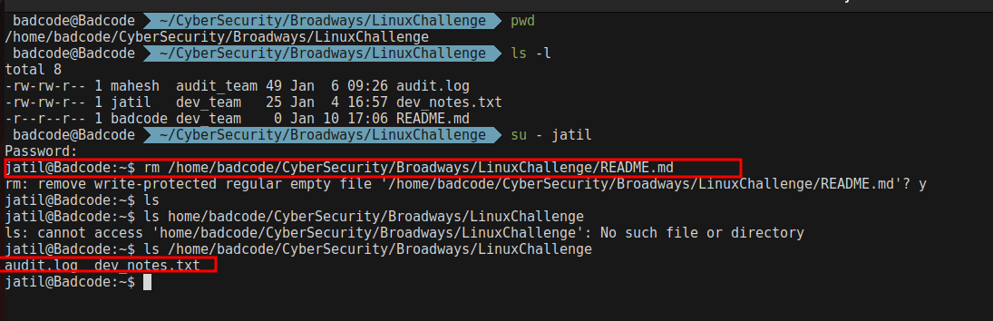
-Lok creates a new file inside /opt/Bagmaticyber/logs

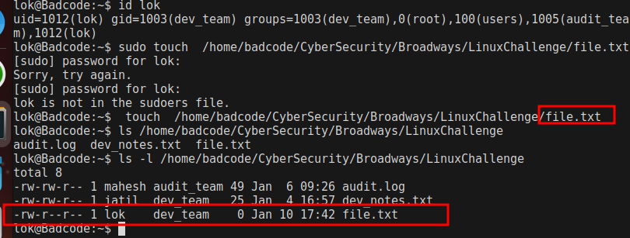

Part 6: Cron Jobs and Aliases

In this step, an automated backup mechanism was configured for the audit.log file. A cron job was set up for the user Mahesh to run hourly. Each execution of the cron job creates a backup of audit.log and saves it with a timestamped filename in the directory /home/badcode/CyberSecurity/Broadways/logs/archive/.
This ensures that a historical record of the audit logs is maintained automatically. Automating the backup process minimizes the risk of data loss, supports auditing and accountability requirements, and provides an easy way to track and restore logs if needed.

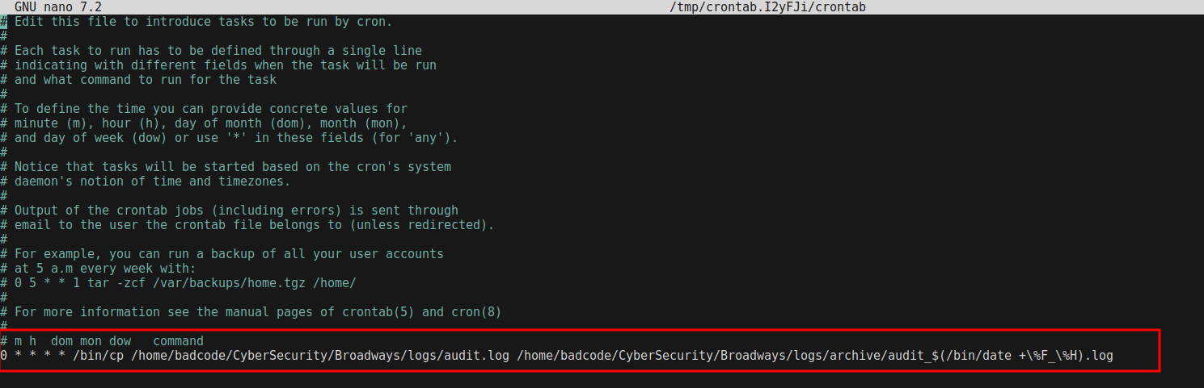
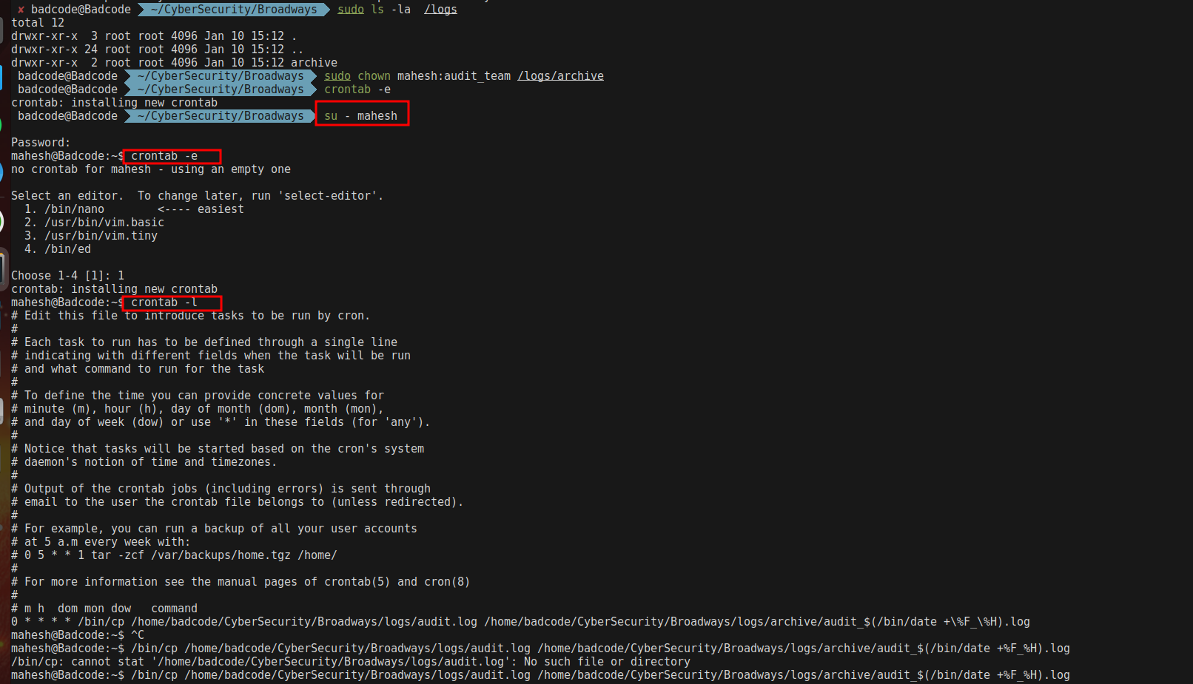

In this step, an alias named devread was created for the user Lok to simplify access to the development notes. The alias allows Lok to quickly view the dev notes without typing the full file path each time. To ensure that the alias remains available in all future sessions, it was added to Lok’s .bashrc file.
By adding it to .bashrc, the alias is automatically loaded whenever Lok starts a new terminal session, improving efficiency and streamlining workflow for accessing important development information.

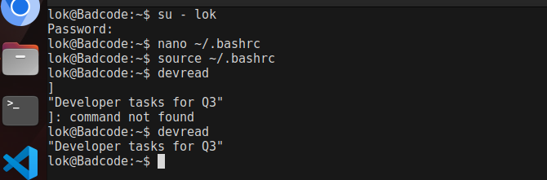
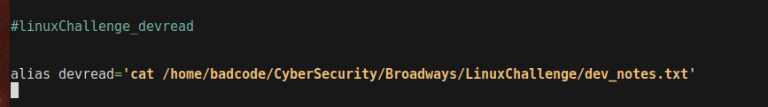

Part 7: Group Reassignment & Cleanup

In this step, the user Lok was reassigned to be a member of only the dev_team. Removing Lok from other groups affects the permissions he inherited from those groups. Specifically, any access that Lok had to files or directories through his previous group memberships is revoked.
For example, if Lok previously had access to certain directories or files via another group (such as audit_team), he would lose that access after being removed from the group. This reinforces controlled access and ensures that users can only interact with resources relevant to their current team, maintaining security and adherence to the principle of least privilege.
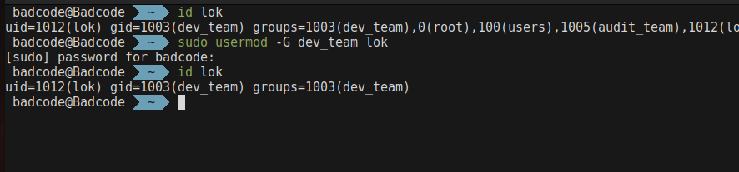

Removing Suchana from the sudo group:
The user Suchana was removed from the sudo group to revoke her administrative privileges. This ensures that she can no longer execute commands with elevated privileges, enforcing stricter access control and reducing the risk of unauthorized system changes.
Resetting all users’ group memberships:
All users were removed from their secondary groups, and their primary group was set to users. This step simplifies group management and ensures a consistent baseline for permissions. Any access previously granted through secondary groups is revoked, limiting users to the minimum required permissions associated with the users group. This cleanup helps maintain a secure and organized environment, preventing unintended access or privilege escalation.

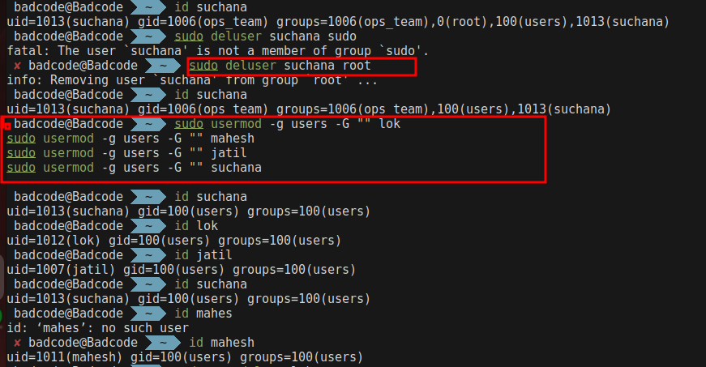

Deleting all users:
All users created during the exercise were deleted along with their home directories. This ensures that no unauthorized accounts remain on the system and that all personal files and configurations associated with these users are removed, maintaining system security and cleanliness.
Deleting all groups and directories:
All groups created for the exercise, as well as directories such as project or log directories, were deleted. This final cleanup ensures that no residual permissions, files, or group associations remain, leaving the system in a clean and secure state.

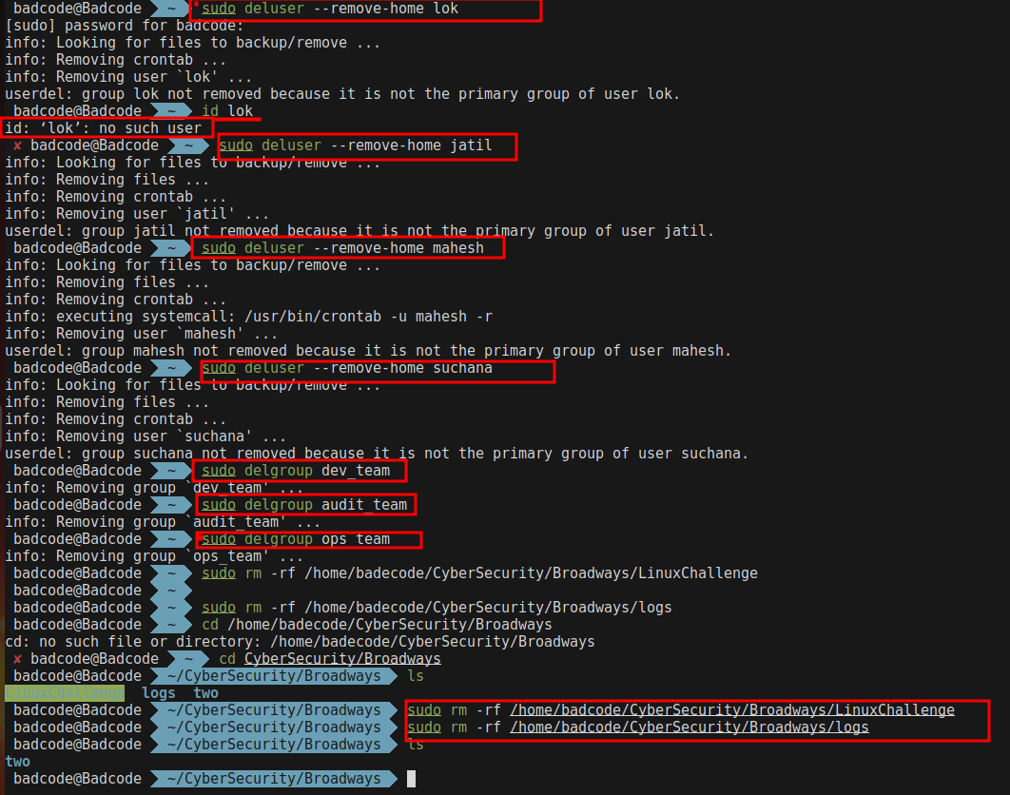

Project Conclusion
Through this project, I gained practical experience in managing Linux users, groups, and file permissions, while implementing secure system administration practices. I successfully created and organized users and groups, applied precise ownership and permission settings to files and directories, and enforced role-based access control using SetGID and sudo rules.
The project also allowed me to test and validate security measures by simulating real-world scenarios, such as restricting unauthorized access, controlling administrative privileges, and automating tasks like log backups with cron jobs. Creating persistent aliases further improved workflow efficiency and demonstrated the importance of user-centric configurations.
Finally, performing a full cleanup by reassigning groups, removing sudo privileges, and deleting temporary users and directories reinforced best practices for maintaining system hygiene and minimizing security risks.
Overall, this project enhanced my understanding of Linux administration, strengthened my ability to implement secure and organized systems, and provided hands-on experience in managing users, permissions, and automated administrative tasks in a professional environment.

