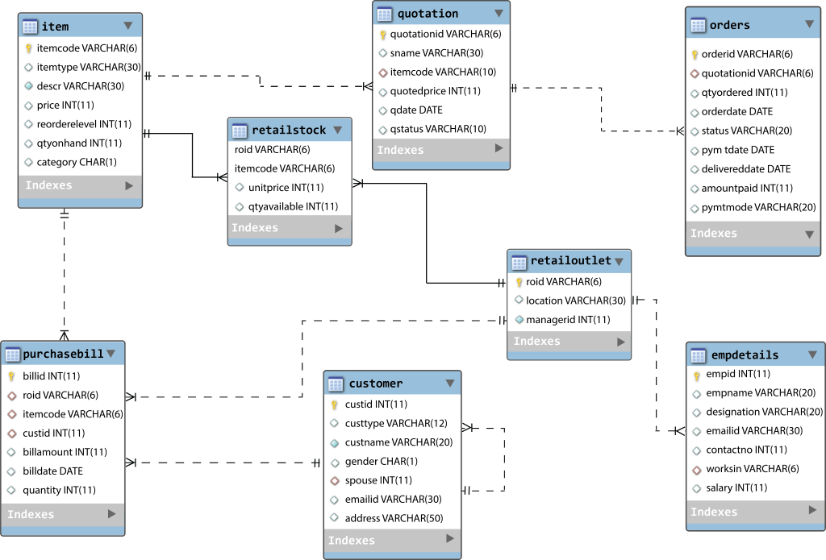

CUSTOMER

|  |  |  |  |  |  |  |
| --- | --- | --- | --- | --- | --- | --- |
| **custid** | **custtype** | **custname** | **gender** | **spouse** | **emailid** | **address** |
| 2001 | Regular | John | M | 2004 | [john@easy.com](mailto:john@easy.com" \t "_blank) | Allen Street, New York |
| 2002 | Regular | Jason | M | 2005 | [jason@adgm.in](mailto:jason@adgm.in" \t "_blank) | Richmond Parkway, California |
| 2003 | Privileged | Sam | M |  | [sam@xyz.corp](mailto:sam@xyz.corp" \t "_blank) | Ann Street, New York |
| 2004 | Privileged | Susan | F | 2001 | [susan@adgm.in](mailto:susan@adgm.in" \t "_blank) | Allen Street, New York |
| 2005 | Privileged | Nancy | F | 2002 | [nancy@xyz.corp](mailto:nancy@xyz.corp" \t "_blank) | East Fork Road, California |
| 2006 | Regular | Rachel | F | 2007 | [rachel1@easy.com](mailto:rachel1@easy.com" \t "_blank) | Charles Street, New York |
| 2007 | Regular | Dexter | M | 2006 | [dexter2@easy.com](mailto:dexter2@easy.com" \t "_blank) | Beak Street, New York |
| 2008 | Regular | Thomas | M | 2009 | [thomas3@easy.com](mailto:thomas3@easy.com" \t "_blank) | Sand Hill Road, California |
| 2009 | Regular | Christina | F | 2008 | [christina4@easy.com](mailto:christina4@easy.com" \t "_blank) | Sand Hill Road, California |
| 2010 | Regular | Megan | F |  | [megan5@easy.com](mailto:megan5@easy.com" \t "_blank) | Richmond Parkway, California |

ITEM

|  |  |  |  |  |  |  |
| --- | --- | --- | --- | --- | --- | --- |
| **itemcode** | **itemtype** | **descr** | **price** | **reorderlevel** | **qtyonhand** | **category** |
| I1001 | FMCG | Britannia Marie Gold Cookies | 20 | 100 | 1000 | C |
| I1002 | FMCG | Best Rice | 120 | 100 | 1000 | C |
| I1003 | FMCG | Modern Bread | 15 | 100 | 1000 | C |
| I1004 | Apparels | Lee T-Shirt | 300 | 100 | 1000 | B |
| I1005 | Apparels | Levis T-Shirt | 1700 | 100 | 1000 | B |
| I1006 | Apparels | Satyapaul Sari | 7300 | 100 | 1000 | A |
| I1007 | Apparels | Allen Solly Tie | 600 | 100 | 1000 | C |
| I1008 | Computer | Xbox gamepad | 1500 | 100 | 50 | B |
| I1009 | Computer | Microsoft Mouse | 700 | 120 | 50 | C |
| I1010 | Computer | Intel C2D Processor | 6500 | 50 | 25 | A |
| I1011 | Computer | Intel Motherboard | 5000 | 50 | 25 | A |
| I1012 | Computer | 500GB Hard disk | 2500 | 150 | 50 | B |
| I1013 | Computer | 320GB Hard disk | 1800 | 150 | 50 | B |
| I1014 | FMCG | Aroma Bread | 17 | 100 | 50 | C |
| I1015 | Apparels | Arrow Jeans | 7300 | 50 | 60 | A |

QUOTATION

|  |  |  |  |  |  |
| --- | --- | --- | --- | --- | --- |
| **quotationid** | **sname** | **itemcode** | **quotedprice** | **qdate** | **qstatus** |
| Q1001 | Giant Store | I1008 | 1500 | 2012-10-10 | Rejected |
| Q1002 | EBATs | I1008 | 1400 | 2012-10-10 | Closed |
| Q1003 | EBATs | I1010 | 6200 | 2012-10-10 | Accepted |
| Q1004 | Shop Zilla | I1010 | 6250 | 2012-10-10 | Rejected |
| Q1005 | Giant Store | I1009 | 850 | 2012-10-10 | Rejected |
| Q1006 | VV Electronics | I1009 | 800 | 2012-10-10 | Closed |
| Q1007 | Shop Zilla | I1012 | 2200 | 2012-10-10 | Rejected |
| Q1008 | Shop Zilla | I1012 | 2150 | 2012-10-10 | Accepted |
| Q1009 | Shop Zilla | I1005 | 1480 | 2012-10-10 | Accepted |
| Q1010 | Giant Store | I1005 | 1490 | 2012-10-10 | Rejected |
| Q1011 | EBATs | I1002 | 120 | 2012-10-10 | Rejected |
| Q1012 | VV Electronics | I1002 | 120 | 2012-10-10 | Rejected |
| Q1013 | Giant Store | I1012 | 2150 | 2012-10-10 | Accepted |
| Q1014 | Giant Store | I1001 | 250 | 2012-11-10 | Rejected |
| Q1015 | VV Electronics | I1001 | 250 | 2012-11-12 | Rejected |
| Q1016 | EBATs | I1001 | 260 | 2012-12-14 | Rejected |
| Q1017 | Shop Zilla | I1001 | 250 | 2014-02-15 | Rejected |

ORDERS

|  |  |  |  |  |  |  |  |  |
| --- | --- | --- | --- | --- | --- | --- | --- | --- |
| **orderid** | **quotationid** | **qtyordered** | **orderdate** | **status** | **pymtdate** | **delivereddate** | **amountpaid** | **pymtmode** |
| O1001 | Q1002 | 100 | 2012-10-10 | Delivered | 2012-10-10 | 2012-10-10 | 140000 | Cash |
| O1002 | Q1006 | 150 | 2012-10-10 | Ordered |  |  |  |  |
| O1003 | Q1003 | 50 | 2012-10-10 | Delivered | 2012-10-10 | 2012-10-10 | 310000 | Cash |
| O1004 | Q1006 | 100 | 2012-10-10 | Delivered | 2012-10-10 | 2012-10-10 | 80000 | Cheque |
| O1005 | Q1002 | 50 | 2012-10-10 | Delivered | 2012-10-10 | 2012-10-10 | 70000 | Cheque |
| O1006 | Q1008 | 75 | 2012-10-10 | Delivered | 2012-10-10 | 2012-10-10 | 161250 | Cash |
| O1007 | Q1009 | 50 | 2012-10-10 | Ordered |  |  |  |  |
| O1008 | Q1013 | 75 | 2012-10-10 | Ordered |  |  |  |  |
| O1009 | Q1014 | 20 | 2013-01-15 | Ordered |  |  |  |  |
| O1010 | Q1015 | 25 | 2013-06-30 | Ordered |  |  |  |  |
| O1011 | Q1016 | 30 | 2016-12-16 | Ordered |  |  |  |  |

RETAILSTOCK

|  |  |  |  |
| --- | --- | --- | --- |
| **roid** | **itemcode** | **unitprice** | **qtyavailable** |
| R1001 | I1001 | 22 | 28 |
| R1001 | I1002 | 112 | 20 |
| R1001 | I1003 | 19 | 20 |
| R1001 | I1004 | 353 | 100 |
| R1001 | I1006 | 7350 | 20 |
| R1001 | I1007 | 709 | 50 |
| R1001 | I1010 | 6199 | 100 |
| R1001 | I1011 | 5340 | 150 |
| R1001 | I1012 | 2510 | 50 |
| R1001 | I1013 | 2204 | 50 |
| R1001 | I1015 | 7700 | 60 |
| R1002 | I1001 | 25 | 25 |
| R1002 | I1002 | 139 | 50 |
| R1002 | I1003 | 21 | 20 |
| R1002 | I1004 | 400 | 110 |
| R1002 | I1005 | 1751 | 60 |
| R1002 | I1006 | 7499 | 50 |
| R1002 | I1007 | 799 | 20 |
| R1002 | I1008 | 2499 | 70 |
| R1002 | I1009 | 903 | 80 |
| R1002 | I1010 | 6801 | 20 |
| R1002 | I1011 | 5402 | 30 |
| R1002 | I1012 | 2901 | 130 |
| R1002 | I1013 | 2301 | 60 |
| R1002 | I1014 | 29 | 75 |
| R1002 | I1015 | 7400 | 65 |
| R1003 | I1008 | 2600 | 30 |
| R1003 | I1012 | 3001 | 50 |
| R1003 | I1015 | 7800 | 40 |

RETAILOUTLET

|  |  |  |
| --- | --- | --- |
| **roid** | **location** | **managerid** |
| R1001 | California |  |
| R1002 | New York | 1006 |
| R1003 | Dallas |  |

EMPDETAILS

|  |  |  |  |  |  |  |
| --- | --- | --- | --- | --- | --- | --- |
| **empid** | **empname** | **designation** | **emailid** | **contactno** | **worksin** | **salary** |
| 1001 | George | Administrator | [george@easy.com](mailto:george@easy.com" \t "_blank) | 904582 | R1001 | 6600 |
| 1002 | Edwin | Billing Staff | [edwin@easy.com](mailto:edwin@easy.com" \t "_blank) | 9820984 | R1002 | 3500 |
| 1003 | Clara | Security | [clara@easy.com](mailto:clara@easy.com" \t "_blank) | 93871093 | R1001 | 3000 |
| 1004 | Allen | Super Manager | [allen@easy.com](mailto:allen@easy.com" \t "_blank) | 904582 |  | 9000 |
| 1005 | Peter | Administrator | [peter@easy.com](mailto:peter@easy.com" \t "_blank) | 8923610 | R1002 | 6000 |
| 1006 | John | Manager | [john@easy.com](mailto:john@easy.com" \t "_blank) |  | R1002 | 6500 |
| 1007 | Sam | Billing Staff | [sam@easy.com](mailto:sam@easy.com" \t "_blank) | 8038106 | R1002 | 3000 |
| 1008 | Megan | Manager | [megan5@easy.com](mailto:megan5@easy.com" \t "_blank) | 9481083 | R1002 | 5000 |
| 1009 | Henry | Billing Staff | [henry@easy.com](mailto:henry@easy.com" \t "_blank) | 7820179 | R1002 | 5000 |
| 1010 | Cris | Billing Staff | [cris@easy.com](mailto:cris@easy.com" \t "_blank) |  | R1001 | 2800 |
| 1011 | Donald | Billing Staff | [donald@easy.com](mailto:donald@easy.com" \t "_blank) | 749072 | R1001 | 2900 |
| 1012 | Edwin | Billing Staff | [edwin@easy.com](mailto:edwin@easy.com" \t "_blank) | 9820984 | R1002 | 2500 |
| 1013 | Clara | Security | [clara@easy.com](mailto:clara@easy.com" \t "_blank) | 93871093 | R1001 | 2000 |
| 1014 | Michael | Security | [michael@easy.com](mailto:michael@easy.com" \t "_blank) | 93871093 | R1002 | 2200 |

PURCHASEBILL

|  |  |  |  |  |  |  |
| --- | --- | --- | --- | --- | --- | --- |
| **billid** | **roid** | **itemcode** | **custid** | **billamount** | **billdate** | **quantity** |
| 5001 | R1001 | I1002 | 2001 | 342 | 2012-10-10 | 3 |
| 5002 | R1001 | I1001 | 2002 | 87 | 2012-10-10 | 4 |
| 5003 | R1001 | I1004 | 2002 | 360 | 2012-10-10 | 1 |
| 5004 | R1002 | I1003 | 2003 | 64 | 2012-10-10 | 3 |
| 5005 | R1002 | I1002 | 2005 | 283 | 2012-10-10 | 2 |
| 5006 | R1002 | I1004 | 2004 | 1223 | 2012-10-10 | 3 |
| 5007 | R1002 | I1013 | 2007 | 2344 | 2012-10-10 | 1 |
| 5008 | R1002 | I1007 | 2002 | 1628 | 2012-10-10 | 2 |
| 5009 | R1001 | I1011 | 2005 | 5441 | 2012-10-10 | 1 |
| 5010 | R1001 | I1013 | 2007 | 8984 | 2012-10-10 | 4 |
| 5011 | R1001 | I1015 | 2002 | 7846 | 2012-10-10 | 1 |
| 5012 | R1002 | I1008 | 2004 | 5093 | 2012-10-10 | 2 |
| 5013 | R1002 | I1010 | 2008 | 6930 | 2012-10-10 | 1 |
| 5014 | R1002 | I1011 | 2005 | 5000 | 2015-11-30 | 2 |
| 5015 | R1001 | I1012 | 2002 | 6000 | 2015-12-17 | 3 |