

FIT9133 Assignment #3

Building a Stylometric Analyzer

Semester 1 2018
Karthik Joshi (29416000)
2018, Monash University

Table of Contents

1. Introduction 1
2. Task #1: Setting up the Pre-Processor 1
3. Task #2-Building a Class to Analyze Characters 1
4. Task #3- Building a Class to Analyze Words 2
5. Task #4- Building a class to Visualize the Analysis 2
6. Task #5- Putting all Classes together 3
7. References 4

Introduction
Stylometry is an application of statistical methods for linguistic style analysis. It is often used to attribute authorship to anonymous or disputed works (often in written language) based on the linguistic behaviors or characteristics manifested in the texts.

In the assignment we are given six files namely,

- Marlowe Edward II Edward_II_Marlowe.tok
- Marlowe The Jew of Malta Jew_of_Malta_Marlowe.tok
- Shakespeare Richard II Richard_II_Shakespeare.tok
- Shakespeare Hamlet Hamlet_Shakespeare.tok
- Shakespeare Henry VI Part 1 Henry_VI_Part1_Shakespeare.tok
- Shakespeare Henry VI Part 2 Henry_VI_Part2_Shakespeare.tok

The files marked in Red had disputes between Marlowe and Shakespeare which were finally attributed to Shakespeare. The assignment re-investigates the case and tries to determine the correct author of the writing.

It consists of four parts each performing individual tasks and a main ( ) function. Details about the tasks are mentioned in the sections 2,3,4,5 and 6.

Task #1: Setting up the Pre-Processor

Variable Description is not mentioned as it is all self-explanatory

Class description: The name of the class is Preprocessor. It consists of four methods namely,

- Constructor: An empty token list has been initialized to store tokes from the input file
- Method __str__overloading: This has been redefined to print only length of the tokenized list.
- Tokenize: This Method accepts the input file as argument and converts it into list of tokens.
- Get_tokenized_list: This get method returns the length of tokenized list

Python file name: preprocessor_29416000

- Task #2-Building a Class to Analyze Characters

Class description: The name of the class is CharacterAnalyser”. It consist of five methods namely
- Constructor: An empty Pandas Dataframe has been initialized to keep track to character count.
- Method __str__ overloading: This has been redefined to print the count of all characters.
- analyze_charcters: The method takes one argument and provides character relative frequencies. This has been achieved by initially assuming zeros for all characters in string.ascii_uppercase ,string.punctuation, and string.digits. The final count has been divided by length of the list to get relative frequency.
- Get_punctuation_frequency: The method extracts only punctuations from above generated character count and returns punctuation frequency.
- Get_char_count: The get method returns final character count in the form of Dataframe.

Python file name: Character_29416000.py

- Task #3- Building a Class to Analyze Words

Class description: The name of the class is ‘WordAnalyser. It consist of six methods namely

- Constructor: An empty Pandas Dataframe has been initialized to keep track to word count.
- Method __str__ overloading: This has been redefined to print only the count of words in the text. It excludes punctuation and digits.
- analyze_words: The method takes one argument and provides word relative frequencies. This has been achieved by storing tokenized list into a numpy array and getting unique word frequency by using unique method in numpy array. At the end this has been converted into dataframe. The final count has been divided by length of the list to get relative frequency.
- Get_stopword_frequency: The method initially reads stopwords stored in text file (from Onix stopwords list) and extracts only stopwords from the above described word count list. Finally it returns only stopwords count from the given text.
- Get_word_length_frequency: The method counts length of each word and how many times the author has used the same length. Initially it is assumed that maximum word length can be 30 and zeros are padded to all. Length of each word is calculated and counts are accumulated in the dataframe.
- Get_word_counts: The get method returns word count in the form of Dataframe.

Python file name: word_29416000.py

- Task #4- Building a class to Visualize the Analysis

Class description: The name of the class is ‘AnalysisVisualiser. It consist of five methods namely

- Constructor: It takes one argument all_text_stats which is derived in the main() program and has been initialized with contents of all_text_stats(statistics of the file given)
- visualise_character_frequency: The method is specific to analyze Marlowe and Shakespeare works. It extracts only character frequencies of both the authors and plots a bar graph between characters and frequency excluding (digits and punctuation). Try and except blocks are written if the user enters only one author’s file(either Marlowe or Shakespeare files)
- visualise_punctuation_frequency: The method is specific to analyze Marlowe and Shakespeare works. It extracts only punctuation frequencies of both the authors and plots a bar graph between punctuation and frequency excluding (characters and digits). Try and except blocks are written if the user enters only one author’s file (either Marlowe or Shakespeare files).
- visualise_word_length_frequency: The method is specific to analyze Marlowe and Shakespeare works. It extracts only word_length frequencies of both the authors and plots a bar graph between word_lengths and frequency. Try and except blocks are written if the user enters only one author’s file (either Marlowe or Shakespeare files).
- visualise_stopword_frequency: The method is specific to analyze Marlowe and Shakespeare works. It extracts stopword frequencies of both the authors and plots a bar graph between stopword and frequencies. Try and except blocks are written if the user enters only one author’s file (either Marlowe or Shakespeare).The Stopword list used here are from
http://www.lextek.com/manuals/onix/stopwords1.html

Python file name: visualizer_29416000.py

- Task #5- Putting all Classes together

Functionality/Flow of the program:

The function prompts the user to enter the correct authorized files (files for which authors are known) in a sequential order as shown in figure. Once completed user has to enter quit (case-sensitive) to terminate. In our case its four files. In between it throws “File not found” error if the file is not read correctly for any reasons. Likewise, it prompts again to enter disputed files and quit to terminate. Once all inputs are completed the program generates graphs for each type of analysis of the correct authorized files and the disputed files from which we predict the authorship of the writings. The graphs and statistical file are also exported as pdfs and csv file.

The pdf and Statistical files are attached along with the submission
Note: ‘quit’ is case sensitive
.
Python file name: Main_29416000.py

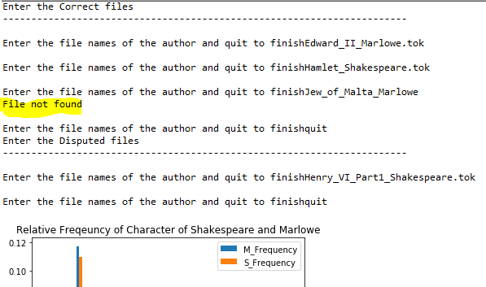

Figure 1- Showing File not error and sequential input of correct authorized files and disputed files

- References

- String Class
https://docs.python.org/2/library/string.html

- Pandas DataFrame
https://pandas.pydata.org/pandas-docs/stable/generated/pandas.DataFrame.html

- Numpy Unique
https://docs.scipy.org/doc/numpy-1.14.0/reference/generated/numpy.unique.html

