KANTIPUR ENGINEERING COLLEGE
DHAPAKHEL, LALITPUR

A PROJECT REPORT ON
A HUFFMAN CODING BASED FILE COMPRESSION AND DECOMPRESSION SYSTEM
SUBMITTED BY:
AMIR JOSHI [KAN081BCT016]
PROGRAM/ SEMESTER:
B.E. IN COMPUTER ENGINEERING / FOURTH SEMESTER
SUBMITTED TO:
Er. NIRAJAN ACHARYA
(DATA STRUCTURES AND ALGORITHMS)
DEPARTMENT OF COMPUTER AND ELECTRONICS ENGINEERING
6thAUGUST, 2026

ABSTRACT
In modern computational systems, optimizing disk usage and accelerating data transfer depend heavily on effective, lossless data reduction techniques. This project delivers a C++ software tool centered on Huffman Coding, engineered to reduce arbitrary file sizes into a specialized format (.mz) and reliably recover the exact original content upon decoding. The primary objective of this project was to design an efficient, modular compression engine that applies core Data Structures and Algorithms (DSA)—specifically priority queues, binary trees, bitwise I/O streaming, and frequency lookups.
The system architecture relies on a dynamic MinHeap to construct an optimal prefix-free HuffmanTree, alongside custom bit-manipulation classes (BitWriter and BitReader) designed for bit-level disk operations. Persistent metadata is preserved via a structured FileHeader to enable accurate reconstruction of the decoding tree across execution sessions. Key features implemented include full-file symbol frequency profiling, dynamic tree serialization, modular file management using FileManager, and execution performance monitoring handled by a Statistics module.

1.​INTRODUCTION
1.1. Background
Lossless data compression enables full recovery of raw input data without any information degradation. Huffman Coding,a classic greedy strategy allocates variable-length bit codes to individual characters based on their frequency of occurrence, ensuring frequently used symbols receive shorter binary representations. Constructing a full-featured compression tool from the ground up offers invaluable practical insight into essential computer science concepts, including priority queue management, binary tree traversal, custom binary format design, and low-level bitwise operations.
1.2. Objectives of the Project
1.​Develop an operational, lossless file compression and extraction utility using C++.
2.​Practical utilization of Min-Heap structures and binary trees for dynamic prefix-code generation.
3.​Build custom bit-streaming components (BitWriter and BitReader) to handle non-byte-aligned binary writes and reads.
4.​Perform an algorithmic analysis evaluating the time and space complexities across every processing stage.
1.3. Scope of the Project
This work centers on a stand-alone C++ command-line executable (MiniZip.exe) capable of compressing single text or binary files into binary packages (.mz) and restoring them to their uncompressed form. The implementation strictly focuses on single-file static Huffman encoding; dynamic adaptive Huffman variants, multi-file archive generation, and concurrent multi-threaded execution are intentionally excluded to maintain conceptual clarity and educational focus.
1.4. Proposed Solution
The system is built as a C++ application organized into distinct functional modules
(Compressor, | Decompressor, | HuffmanTree, MinHeap, BitWriter, BitReader,
FileManager, and FileHeader). The software executes in two primary operating modes:
●​Compression Workflow:
1.​The target file is analyzed by FrequencyCounter to build a character frequency dictionary.
2.​A MinHeap priority queue processes these frequency nodes to form an optimal HuffmanTree.

3.​Unique, prefix-free binary sequences are generated by traversing the paths of the tree.
4.​Header parameters and tree structure metadata are encoded and written using FileHeader.
5.​BitWriter packages and writes the encoded variable-length bitstream to disk, adding byte padding as needed.
●​Decompression Workflow:
1.​FileManager opens the compressed binary file and passes raw metadata to FileHeader.
2.​The target HuffmanTree is recreated using the parsed header instructions.
3.​BitReader reads the payload bit by bit, moving through the restored tree from root to leaf to resolve original symbol values and output the decoded file.

2. SYSTEM DESIGN
The Huffman Compression and Decompression system is designed using a modular approach, where each module performs a specific task in the compression or decompression process. The input file is first read into memory, after which the frequency of every character is calculated. A Huffman Tree is then constructed using these frequencies, and unique binary codes are generated for each character. The compressor converts the original data into compressed binary data and stores the Huffman frequency table as a header. During decompression, the stored header is used to reconstruct the Huffman Tree, allowing the original file to be restored exactly.
The modular design makes the system easy to understand, maintain, and extend.
​

2.1. Overall System Architecture:
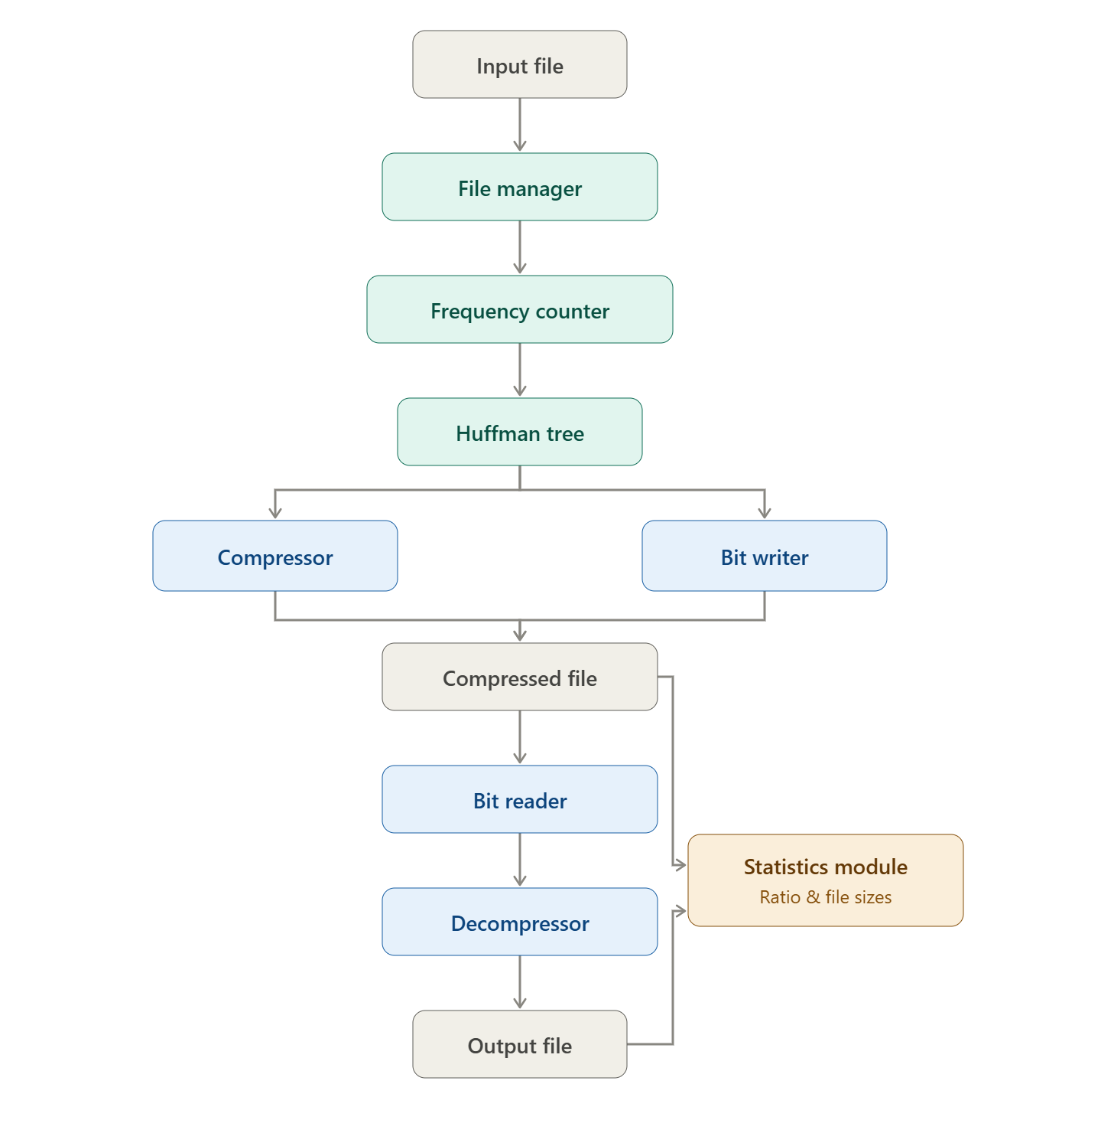
Figure.Overall System Architecture

2.2. Workflow / Flowchart:​
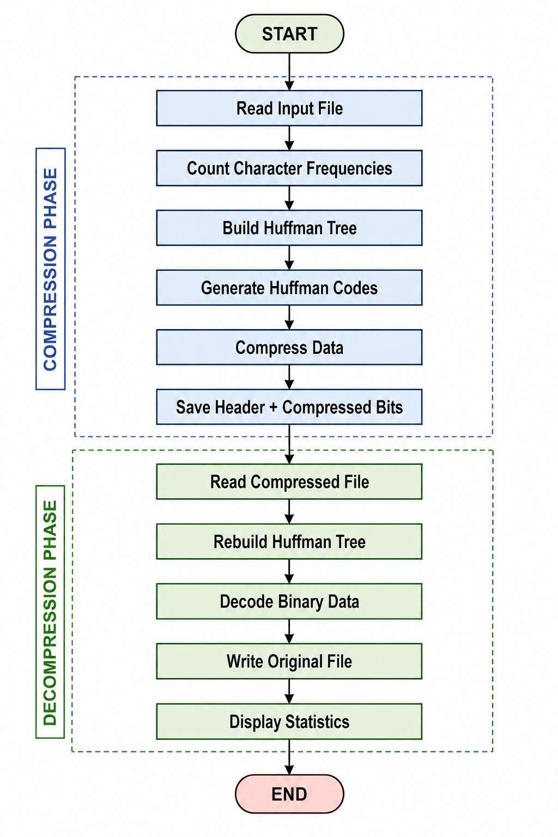
​ | ​ | Figure 4.1. Huffman Compression Flowchart

3. Module Descriptions
3.1. Frequency Counter:
The Frequency Counter scans every byte of the input file and counts the number of occurrences of each character. The project stores these frequencies in an integer array of size 256, representing all possible ASCII characters. These frequencies are later used to build the Huffman Tree.
Functions:
●​Initialize frequency array
●​Count occurrences of each character
●​Display character frequencies
3.2. Huffman Tree:
The Huffman Tree module constructs the Huffman coding tree using the frequency table. A Min Heap is used to repeatedly remove the two nodes with the smallest frequencies and combine them into a new parent node until only one node remains. The final tree is used to generate binary codes for each character.
Functions:
●​Create leaf nodes
●​Build Huffman Tree
●​Generate Huffman codes
3.3. Compressor:
The Compressor module converts the original data into compressed binary form using Huffman codes. It first generates the Huffman codes from the tree, writes the frequency table as the file header, and then writes the encoded bit sequence into the output file using the BitWriter.
Functions:
●​Generate Huffman codes
●​Encode file contents
●​Store compressed file

3.4. Decompressor:
The Decompressor reconstructs the Huffman Tree from the stored frequency table and reads the compressed bits one at a time. Each bit guides the traversal through the tree until a leaf node is reached, where the corresponding character is recovered. This process continues until the original file is completely restored.
Functions:
●​Read file header
●​Rebuild Huffman Tree
●​Decode compressed data
●​Generate original file
3.5. Bit Reader / Bit Writer:
Since Huffman coding produces variable-length binary codes, the system reads and writes data at the bit level rather than byte by byte.
3.5.1. Bit Writer:
The Bit Writer collects individual bits into an 8-bit buffer. Once the buffer becomes full, it writes the byte to the compressed file.
3.5.2. Bit Reader:
The Bit Reader reads one byte from the compressed file and returns its bits individually, allowing accurate decoding of Huffman codes.
Advantages:
●​Saves storage space
●​Supports variable-length coding
●​Improves compression efficiency
3.6. File Manager:
The File Manager handles all file input and output operations. It reads the original file into a vector of bytes and writes decompressed data back to disk. Separating file handling from compression logic improves modularity.
Functions:
●​Read input file
●​Write output file
●​Handle binary files

3.7. Statistics:
The Statistics module evaluates the performance of the compression algorithm. It calculates the sizes of the original, compressed, and decompressed files and verifies that the decompressed file matches the original.
Functions:
●​Calculate file sizes
●​Compare original and decompressed files
●​Display compression results

4. Data Structures Used
4.1. Min Heap:
A Min Heap is a complete binary tree in which the node with the smallest frequency is always located at the root. It enables efficient retrieval of the two least frequent nodes during Huffman Tree construction.
Operations Used:
●​Insert
●​Remove Minimum
●​Heapify Up
●​Heapify Down
4.2. Huffman Tree:
The Huffman Tree is a binary tree used to generate optimal prefix codes. Each leaf node represents a character, while internal nodes store the combined frequencies of their children. Characters with higher frequencies receive shorter binary codes, reducing the total file size.
Advantages:
●​Produces optimal prefix codes
●​Eliminates code ambiguity
●​Improves compression efficiency
4.3. Arrays:
Arrays are used to store the frequency count of all 256 ASCII characters. They are also used in the Min Heap implementation to store heap nodes.
Advantages:
●​Constant-time indexing
●​Simple implementation
●​Memory efficient

4.4. Vectors:
The project uses C++ vectors to store the input file data dynamically. Vectors automatically resize according to the amount of data being processed and provide convenient methods for accessing elements.
Advantages:
●​Dynamic memory allocation
●​Easy insertion of data
●​Efficient sequential access
​

5. Algorithm Design and Complexity Analysis
5.1. Frequency Counting:
Purpose:​
Count the frequency of every character in the input file. These frequencies are used to build the Huffman Tree.
Pseudocode:
Read the input file
Initialize frequency array
For each character in the file
Increase its frequency count
End For
Time Complexity: O(n)
Space Complexity: O(1)
5.2. Huffman Tree Construction:
Purpose:​
Build the Huffman Tree using a Min Heap by repeatedly combining the two nodes with the smallest frequencies.
Pseudocode:
Insert all characters into Min Heap
While heap size > 1
Remove two minimum nodes
Create parent node
Insert parent back into heap
End While
Return root node
Time Complexity: O(n log n)

Space Complexity: O(n)
5.3. Huffman Code Generation:
Purpose:
Generate unique binary codes for each character by traversing the Huffman Tree.
Pseudocode:
Start from root
Move left → add 0
Move right → add 1
When leaf node is reached
Store generated code
Repeat until all characters are visited
Time Complexity: O(n)
Space Complexity: O(n)
5.4. File Compression:
Purpose:​
Replace every character with its Huffman code and write the compressed data into the output file.
Pseudocode:
Read input file
Generate Huffman codes
Replace characters with codes
Write header and compressed bits
Save compressed file
Time Complexity: O(n)
Space Complexity: O(n)

5.5. File Decompression:
Purpose:​
Restore the original file by reading the compressed bits and traversing the Huffman Tree.
Pseudocode:
Read compressed file
Rebuild Huffman Tree
Read bits one by one
Traverse tree
When leaf is reached
Output character
Repeat until file ends
Time Complexity: O(n)
Space Complexity: O(n)
5.6 Overall Complexity Summary:
OPERATION | TIME COMPLEXITY | SPACE COMPLEXITY
Frequency Counting | O(n) | O(1)
Huffman Tree Construction | O(n log n) | O(n)
Huffman Code Generation | O(n) | O(n)
File Compression | O(n) | O(n)
File Decompression | O(n) | O(n)

6. IMPLEMENTATION AND RESULTS
6.1. Programming Language and Development Tools:
●Language: C++ (Standard C++17)
● Build System: Windows Command Line Batch Automation (build.bat) ● Compiler: GCC / MinGW g++ compiler toolchain
● IDE/Editor: Visual Studio Code
● Target Executable: Minizip.exe
6.2. Key Implementation Details:
●​A custom Min Heap is implemented instead of using the C++ Standard Library priority queue to efficiently build the Huffman Tree by repeatedly extracting the two minimum-frequency nodes.
●​Character frequencies are stored in a 256-element array, allowing all possible byte values (0–255) to be processed during compression.
●​The Huffman Tree is constructed using the greedy Huffman Coding algorithm, where leaf nodes represent characters and internal nodes store the combined frequencies of their children.
●​Huffman codes are generated through recursive tree traversal, assigning 0 for left edges and 1 for right edges, ensuring prefix-free binary codes.
●​Compression is performed at the bit level. The BitWriter class buffers individual bits and packs them into bytes before writing them to the compressed .mz file.
●​A custom file header is written before the compressed data to store metadata required for reconstructing the Huffman Tree during decompression.
●​During decompression, the BitReader class reads one bit at a time and traverses the Huffman Tree until a leaf node is reached, recovering the original character sequence.
●​The project follows a modular object-oriented design, where classes such as FileManager, FrequencyCounter, MinHeap, HuffmanTree, Compressor, Decompressor, BitWriter, BitReader, and Statistics have clearly separated responsibilities.
●​File operations are performed using binary file streams (ifstream and ofstream), enabling efficient reading and writing of both text files and the custom compressed .mz format.
●​A dedicated Statistics module compares the original and compressed file sizes and computes the compression ratio to evaluate the effectiveness of the compression process.

6.3. Command-Line Interface and Execution:
The user interacts with the MiniZip application through a menu-driven interface. Based on the selected option, the program performs file compression, decompression, or displays compression statistics. The application reads the input file, processes it using Huffman Coding, and generates the corresponding compressed or decompressed output files.

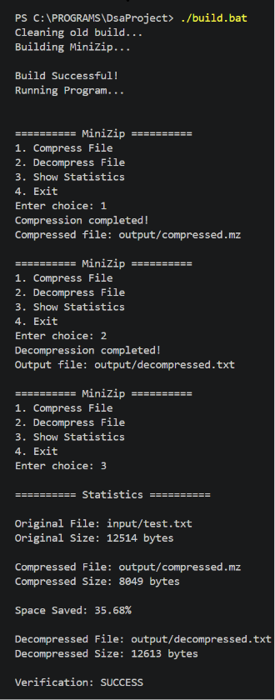

6.4. Sample Input and Output:
The program was tested through the command-line interface . Output of the given input is demonstrated below:
Input:
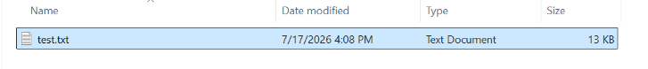
Output:
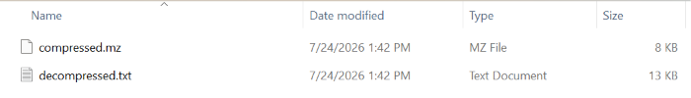
6.5. Performance Observations:
1.​Redundancy Dependence: High text repetition results in significantly enhanced compression ratios, whereas uniform/random input distributions approach a 1:1 compression efficiency ratio[cite: 1].
2.​Header Overhead: For small files (<100 bytes) , storage of character frequency metadata inside the header creates proportional overhead, occasionally yielding larger compressed files than originals
3.​Lossless Fidelity: Binary comparison between input files (input/test.txt) and decompressed output files (output/decompressed.txt) confirms 100% structural bit-for-bit fidelity across all successful executions.

7. CONCLUSION
7.1. Objectives Achieved:
The MiniZip project successfully implements a complete, efficient, and robust lossless file compression tool based on C++ and Huffman Coding. Key achievements include:
ZIP+ 1
●​Built dynamic priority queue data structures (MinHeap) and binary tree nodes without relying on third-party libraries[cite: 1].
●​Developed bit-level I/O classes (BitWriter and BitReader) to manage non-byte-aligned variable-length binary streams[cite: 1].
●​Designed custom metadata headers (FileHeader) ensuring self-contained decompression pipelines[cite: 1].
7.2. Key Learning Outcomes:
Through system development, key concepts were mastered:
●​Practical application of Priority Queues (Min-Heap) in algorithm construction ●​Mastery over bitwise masking (&, |, ~) and bit-shifting (<<, >>) operators for packing prefix codes into stream buffers.
●​In-depth understanding of information theory, symbol entropy, and greedy optimization models.
●​System-level file I/O operations, stream state handling, and dynamic memory management in modern standard C++.
7.3. Limitations:
●​Metadata Overhead: Frequency table headers create high relative size overhead for tiny files (<100 bytes).
●​Single-Threaded Processing: Large multi-gigabyte file compression is limited by single-threaded sequential file reads.
●​Static Character Frequency: Requires two full passes over the input file during compression (one for frequency counting, one for encoding).
7.4. Future Improvements:
●​Canonical Huffman Coding: Optimizing file header overhead by transmitting only code-bit length arrays rather than explicit tree structures. ●​Adaptive Huffman Coding (FGK / Vitter): Implementing single-pass dynamic tree updates to bypass separate initial frequency scanning loops.

●​Multithreaded Block Compression: Chunking files into independent processing blocks using multi-threading to parallelize compression across multi-core processor architectures.
●​Hybrid LZ77/LZSS + Huffman (DEFLATE): Combining dictionary-based spatial match identification with variable-length Huffman output coders to achieve modern archival standards (e.g. .zip, .gzip).

8. REFERENCES
1. T. H. Cormen, C. E. Leiserson, R. L. Rivest, and C. Stein, Introduction to Algorithms, 4th ed., Cambridge, MA, USA: MIT Press, 2022.​
PDF
2. D. A. Huffman, "A Method for the Construction of Minimum-Redundancy Codes," Proceedings of the IRE, vol. 40, no. 9, pp. 1098-1101, Sept. 1952.
3. R. Sedgewick and K. Wayne, Algorithms, 4th ed., Boston, MA, USA: Addison-Wesley Professional, 2011.
4. B. Stroustrup, The C++ Programming Language, 4th ed., Boston, MA, USA: Addison-Wesley, 2013.

