**Practical – 3**

**Aim:** Generating the Prime Numbers

**Source Code:**

<!DOCTYPE html>

<html>

<head>

    <title>Prime Number Generator</title>

    <script type="text/javascript">

        function printPrimes() {

            var input = document.getElementById("input").value;

            var primes = "";

            for (var i = 2; i <= input; i++) {

                var isPrime = true;

                for (var j = 2; j <= Math.sqrt(i); j++) {

                    if (i % j == 0) {

                        isPrime = false;

                        break;

                    }

                }

                if (isPrime) {

                    primes += i + " ";

                }

            }

            document.getElementById("primes").innerHTML = primes;

        }

    </script>

    <style>

        body {

            background-color: antiquewhite;

        }

        #div {

            position: relative;

            left: 638px;

            right: 100px;

        }

        #primes {

            position: relative;

            left: 638px;

            right: 100px;

        }

    </style>

</head>

<body>

    <h1 align="center">Prime Number Generator</h1>

    <h3 align="center">JOSHI ABHISHEK 21IT052</h3>

    <div id="div">

        <input type="number" id="input" min="1" value="10"></input>

        <button onclick="printPrimes()">Generate Prime Numbers</button>

    </div>

    <div id="primes"></div>

</body>

</html>

**Output:**

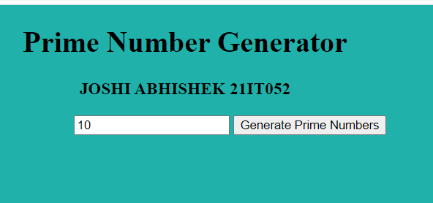

**Write Script to reverse the given input string**

HTML :

<!DOCTYPE html>

<html lang="en">

<head>

    <meta charset="UTF-8">

    <meta http-equiv="X-UA-Compatible" content="IE=edge">

    <meta name="viewport" content="width=device-width, initial-scale=1.0">

    <title>String Reverser</title>

</head>

<body>

    <script src="reversestr.js"></script>

</body>

<h1 align="center">String Reverser</h1>

    <h3 align="center">JOSHI ABHISHEK 21IT052</h3>

    <div id="div">

        <input type="text" id="input"></input>

        <button onclick="reverseString()">Reverse String</button>

    </div>

    <div id="reversed"></div>

</html>

CSS:

#div {

            position: relative;

            left: 638px;

            right: 100px;

        }

        #reversed {

            font-size: 1.5em;

            position: relative;

            left: 638px;

            right: 100px;

        }

        body {

            background-color: antiquewhite;

        }

JAVASCRIPT:

 function reverseString() {

        var input = document.getElementById("input").value;

        var reversed = input.split("").reverse().join("");

        document.getElementById("reversed").innerHTML = reversed;

}

**Output:**

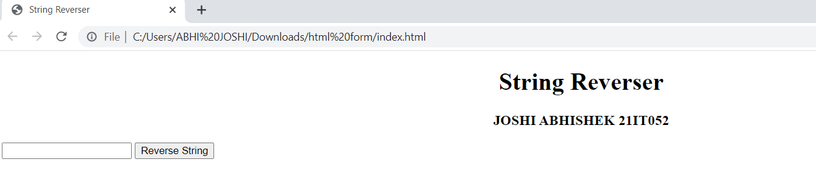

**Create Dynamic Multiplication Table using inputs**

**HTML**

<!DOCTYPE html>

<html>

<head>

    <title>Multiplication Table</title>

    <script type="text/javascript">

        function generateTable() {

            var rows = document.getElementById("rows").value;

            var cols = document.getElementById("cols").value;

            var table = document.createElement("table");

            var tableBody = document.createElement("tbody");

            var row, cell, text;

            for (var i = 0; i <= rows; i++) {

                row = document.createElement("tr");

                for (var j = 0; j <= cols; j++) {

                    cell = document.createElement("td");

                    text = document.createTextNode(i * j);

                    cell.appendChild(text);

                    row.appendChild(cell);

                }

                tableBody.appendChild(row);

            }

            table.appendChild(tableBody);

            document.getElementById("table").appendChild(table);

        }

    </script>

    <style>

        #td {

            border: 2px solid black;

            padding: 5px;

        }

        /* #tab {

            border: 1px;

            color: aquamarine;

            border-style: solid dashed black;

            position: center;

            padding: 5px;

        } */

        body {

            background-color: antiquewhite;

        }

    </style>

</head>

<body>

    <h1>Multiplication Table</h1>

    <h3>JOSHI ABHISHEK (ID-21IT052)</h3>

    <table id="tab">

        <td>

            <tr>

                <label for="rows">Number of Rows:</label>

                <input type="number" id="rows" min="1" value="10"></input><BR><BR>

            </tr>

            <tr>

                <label for="cols">Number of Columns:</label>

                <input type="number" id="cols" min="1" value="10"></input><BR><BR>

            </tr>

            <tr>

                <button onclick="generateTable()">Generate Table</button>

            </tr>

        </td>

    </table>

    <div id="table"></div>

</body>

</html>

**JAVASCRIPT**

 function generateTable() {

            var rows = document.getElementById("rows").value;

            var cols = document.getElementById("cols").value;

            var table = document.createElement("table");

            var tableBody = document.createElement("tbody");

            var row, cell, text;

            for (var i = 0; i <= rows; i++) {

                row = document.createElement("tr");

                for (var j = 0; j <= cols; j++) {

                    cell = document.createElement("td");

                    text = document.createTextNode(i * j);

                    cell.appendChild(text);

                    row.appendChild(cell);

                }

                tableBody.appendChild(row);

            }

            table.appendChild(tableBody);

            document.getElementById("table").appendChild(table);

**Output:**

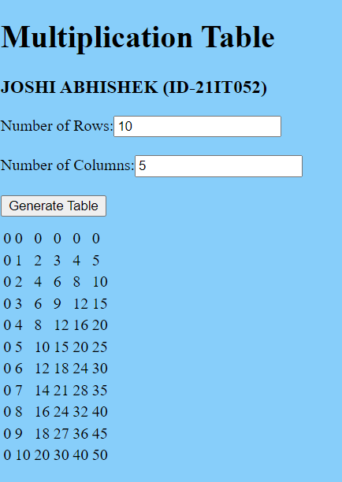

**Find the Age from input date.(Ex. 17 Yrs, 3 Months,13 Days)**

**HTML**

<!DOCTYPE html>

<html>

<head>

    <title>Age Calculator</title>

    <style>

        body {

            margin: 0;

            padding: 0;

            /* color: antiquewhite; */

            background-color: antiquewhite;

        }

        strong {

            position: center;

            color: rgb(248, 116, 191);

            border-style: groove;

            border-color: black

        }

        #button {

            color: black !important;

            background-color: azure;

        }

        #align {

            position: relative;

            left: 500px;

            right: 100px;

        }

        #age {

            position: relative;

            left: 500px;

            right: 100px;

        }

    </style>

    <script type="text/javascript">

        function calculateAge() {

            var input = document.getElementById("input").value;

            var birthdate = new Date(input);

            var today = new Date();

            var ageInMilliseconds = today - birthdate;

            var ageInSeconds = ageInMilliseconds / 1000;

            var ageInMinutes = ageInSeconds / 60;

            var ageInHours = ageInMinutes / 60;

            var ageInDays = ageInHours / 24;

            var ageInMonths = ageInDays / 30.4;

            var ageInYears = ageInMonths / 12;

            var years = Math.floor(ageInYears);

            var months = Math.floor(ageInMonths % 12);

            var days = Math.floor(ageInDays % 30.4);

            var age = years + " Yrs, " + months + " Months, " + days + " Days";

            document.getElementById("age").innerHTML = age;

        }

    </script>

</head>

<body>

    <h3 align="center">JOSHI ABHISHEK (Id-21IT052)</h3>

    <h1 align="center">Age Calculator</h1>

    <div id="align">

        <strong>

            <label for="input">Enter your birthdate (YYYY-MM-DD):</label>

        </strong>

        <input id="input" type="text" id="input"></input>

        <button id="button" onclick="calculateAge()">Calculate Age</button>

    </div>

    <div id="age"></div>

</body>

</html>

**Output:**

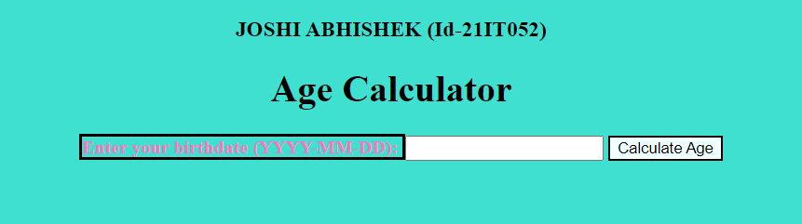

**Find the No. of Days between two given dates**

**HTML**

<!DOCTYPE html>

<html>

<head>

    <title>Date Difference Calculator</title>

    <script type="text/javascript">

        function calculateDifference() {

            var start = new Date(document.getElementById("start").value);

            var end = new Date(document.getElementById("end").value);

            var timeDiff = end - start;

            var diffDays = Math.ceil(timeDiff / (1000 * 3600 * 24));

            document.getElementById("difference").innerHTML = diffDays + " Days";

        }

    </script>

    <style>

        body {

            background-color: antiquewhite;

        }

        #div {

            position: relative;

            left: 500px;

            right: 100px;

        }

    </style>

</head>

<body>

    <h1 align="center">Date Difference Calculator</h1>

    <h3 align="center">JOSHI ABHISHEK Id-21IT052</h3>

    <div id="div">

        <label for="start">Start Date:</label>

        <input type="date" id="start"></input><br><br>

        <label for="end">End Date:</label>

        <input type="date" id="end"></input><br><br>

    </div>

    <div style="position:relative; left: 500px; right: 100px;"><button onclick="calculateDifference()">Calculate

            Difference</button></div>

    <div style="position:relative; left: 500px; right: 100px;" id="difference"></div>

</body>

**Output:**

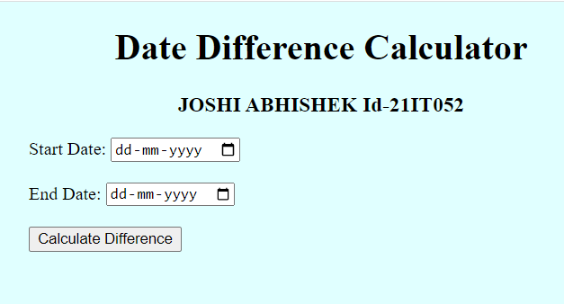

**Conclusion:**

* **JavaScript is an advanced programming language that makes web pages more interactive and dynamic.**
* **HTML is a standard markup language that provides the primary structure of a website**
* JavaScript simply adds dynamic content to websites to make them look good.

**Course Outcome:**

* If we do well in this unit, we should be able to: Insert a dynamic web page in detail.
* We Can Perform any mathematical operation in webpage using javascript language.
* Here We Create calculator and temperature converter and got broader perspective regarding its application.