**AIM:**

Practical – 5

**Demonstrate various Ways to handle Events HTML Source Code:**

<!DOCTYPE html>

<html lang="en">

<head>

<meta charset="UTF-8">

<meta http-equiv="X-UA-Compatible" content="IE=edge">

<meta name="viewport" content="width=device-width, initial-scale=1.0">

<title>Document</title>

</head>

<body>

<h1>Change Message</h1>

<input type="text" id="myInput" onclick="alert('Input was clicked!')" onblur="alert('Input lost focus!')" onmouseover="alert('Mouseover on Input!')" onkeypress="alert('key pressed!')" >

<script src="./Events.js"></script>

</body>

</html>

**Javascript Source code:**

const input = document.querySelector("#myInput"); input.addEventListener("click", handleClick); input.addEventListener("blur", handleBlur); input.addEventListener("mouseover", handleMouseOver); input.addEventListener("keypress", handleKeyPress);

function handleClick() { console.log("Input was clicked!");

}

function handleBlur() { console.log("Input lost focus!");

}

function handleMouseOver() { console.log("Mouseover on Input!");

}

function handleKeyPress(e) { console.log("Key pressed:" + e.key);

}

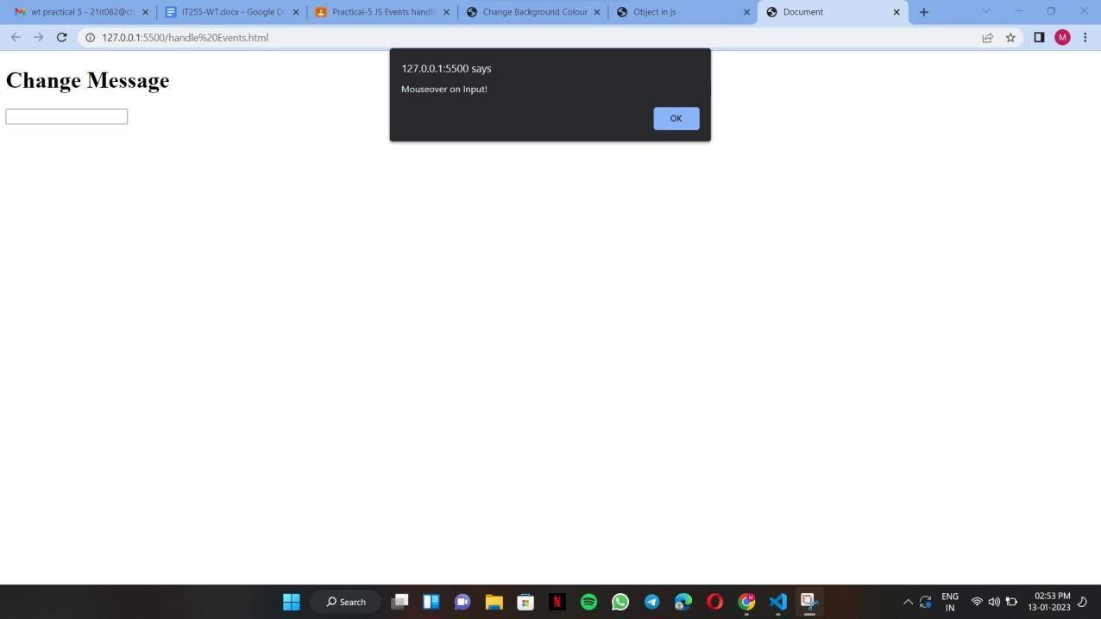**Output:**

**AIM:**

**Write the Script to Change the background color randomly after every 1 mins HTML Source Code:**

<!DOCTYPE html>

<html lang="en">

<head>

<meta charset="UTF-8">

<meta http-equiv="X-UA-Compatible" content="IE=edge">

<meta name="viewport" content="width=device-width, initial-scale=1.0">

<title>Change Background Colour</title>

<script src="./background.js"></script>

</head>

<body>

</body>

</html>

**Javascript Source code:**

let colors = ['red', 'orange', 'yellow', 'green', 'blue', 'indigo', 'violet'];

let currentColorIndex = 0;

function changeColor() {

let body = document.querySelector('body'); body.style.backgroundColor = colors[currentColorIndex];

currentColorIndex = (currentColorIndex + 1) % colors.length;

}

setInterval(changeColor, 60000);

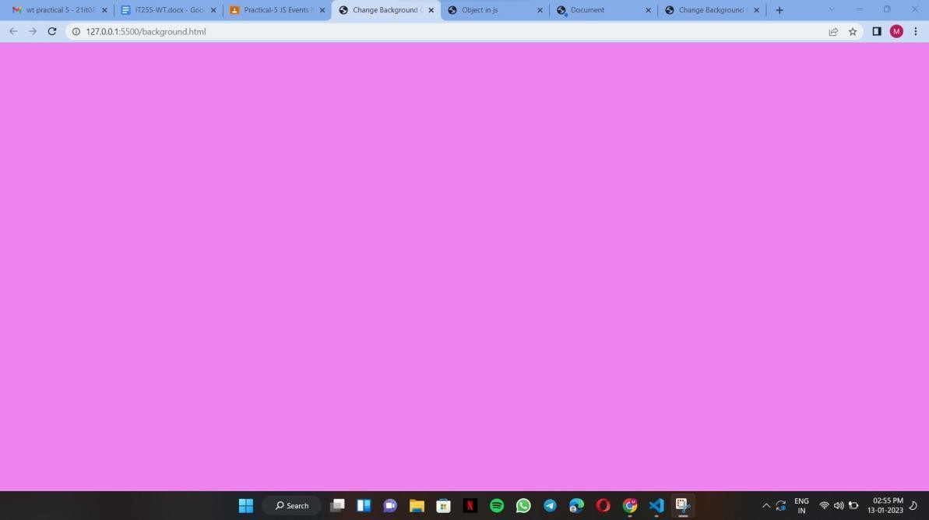**Output:**

**AIM:**

<!DOCTYPE html>

<html lang="en">

<head>

<meta charset="UTF-8">

<meta http-equiv="X-UA-Compatible" content="IE=edge">

<meta name="viewport" content="width=device-width, initial-scale=1.0">

<title>Change Table Colour</title>

<style> table,td{

border: solid black;

}

</style>

</head>

<body>

<h2>Change Table Colour</h2>

<label for="colorInput">Colour Number:</label>

<input type="number" id="colorInput">

<button onclick="changeTableColor()">Change Table Colour</button>

<br><br>

<table id="myTable">

<tr>

<td>ID</td>

<td>Name</td>

<td>Age</td>

</tr>

<tr>

<td>1</td>

<td>abc</td>

<td>19</td>

</tr>

</table>

<script src="./colors in order.js"></script>

</body>

</html>

**Create Arrays of Colors and Apply these colors in order to tr background of table HTML Source Code:**

**Javascript Source code:**

var colors = ["red", "orange", "yellow", "green", "blue", "indigo", "violet"];

var currentColorIndex = 0;

function changeTableColor() {

var table = document.getElementById("myTable");

var colorInput = document.getElementById("colorInput").value; var color = colors[colorInput - 1]; table.style.backgroundColor = color;

}

**Output:**

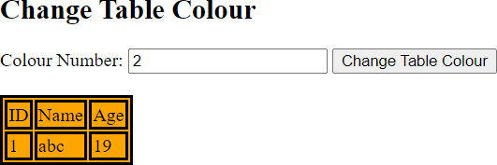

**AIM:**

**Zoom image on mouseover and zoom out on mouse out HTML Source Code:**

<!DOCTYPE html>

<html lang="en">

<head>

<meta charset="UTF-8">

<meta http-equiv="X-UA-Compatible" content="IE=edge">

<meta name="viewport" content="width=device-width, initial-scale=1.0">

<title>Document</title>

</head>

<body>

<img id="myImage"

src="https://images.unsplash.com/photo-1621511101763-32d305e865d4?ixlib=rb

-4.0.3&ixid=MnwxMjA3fDB8MHxzZWFyY2h8MjB8fGhpbGxzfGVufDB8fDB8fA%3D%3D&w=100 0&q=80" onmouseover="zoomIn()" onmouseout="zoomOut()">

<script src="./zoomImage.js"></script>

</body>

</html>

**Javascript Source code:**

function zoomIn() {

var image = document.getElementById('myImage'); image.style.width = "98%";

image.style.height = "98%";

}

function zoomOut() {

var image = document.getElementById('myImage'); image.style.width = "60%";

image.style.height = "60%";

}

**Output:**

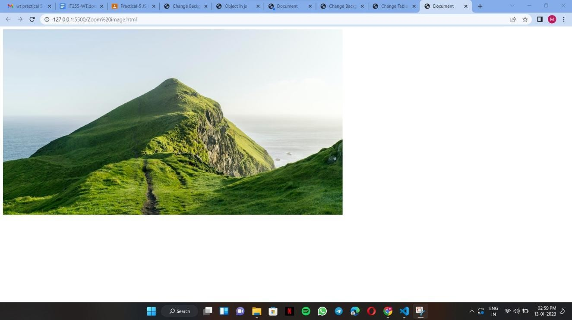

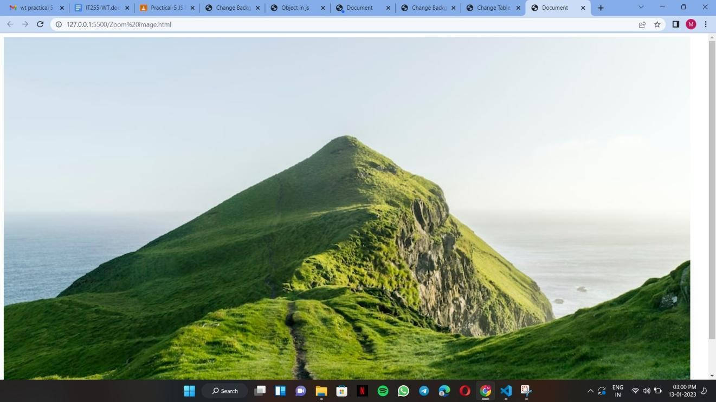

**AIM:**

**Change the location of image based on arrow key of keyboard using callback function HTML Source Code:**

<!DOCTYPE html>

<html lang="en">

<head>

<meta charset="UTF-8">

<meta http-equiv="X-UA-Compatible" content="IE=edge">

<meta name="viewport" content="width=device-width, initial-scale=1.0">

<title>Move Image</title>

</head>

<body>

<img id="myImage" src="https://cdn.pixabay.com/photo/2015/04/19/08/33/flower-729512 340.jpg " style="position: absolute;">

<script src="./locImg.js"></script>

</body>

</html>

**Javascript Source code:**

let img = document.getElementById("myImage"); document.addEventListener("keydown", moveImage);

function moveImage(event) { switch (event.keyCode) {

case 37:

img.style.left = (img.offsetLeft - 10) + "px"; break;

case 38:

img.style.top = (img.offsetTop - 10) + "px"; break;

case 39:

img.style.left = (img.offsetLeft + 10) + "px"; break;

case 40:

img.style.top = (img.offsetTop + 10) + "px"; break;

}

event.preventDefault();

}

**Output:**

**Conclusion:**

A callback function is a function passed into another function as an argument, which is then invoked inside the outer function to complete some kind of routine or action.A timer is used to execute some task after a particular time interval.