**Practical – 6**

**AIM 1:** Demonstrate Class, Properties, Methods and Objects.

**Source Code:**

**(HTML)**

<!DOCTYPE html>

<html lang="en">

<head>

    <meta charset="UTF-8">

    <meta http-equiv="X-UA-Compatible" content="IE=edge">

    <meta name="viewport" content="width=device-width, initial-scale=1.0">

    <title>P6.1</title>

</head>

<body>

    <script src="./6.1.js"></script>

</body>

</html>

**(JAVASCRIPT)**

class Bike {

    constructor(type, avgspeed) {

        this.type = type;

        this.avgspeed = avgspeed;

        document.write(`<br> Type :- ${type}<br> Average-Speed:- ${avgspeed} in bike`);

    }

    displayBike(){

        document.write(`<br> Inside bike class`);

    }

}

class Electric extends Bike {

    constructor(price, model) {

        super(price, model);

        this.price = price;

        this.model = model;

        document.write(`<br> Price :- ${this.price}<br> Model :- ${this.model} in Electric`);

    }

    displayEle(){

        document.write(`<br> Inside Electric class`);

    }

}

let r = new Electric(200000,"20EC");

r.displayEle();

r.displayBike();

**Output:**

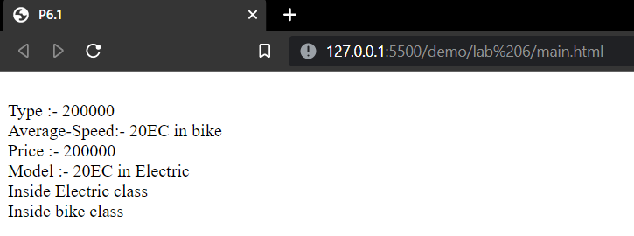

**Conclusion:** In this practical we learnt about Class, Properties, Methods and Objects in detail regarding its implementation.

**Course Outcome:**