**Practical – 7**

**AIM:**

Demonstrate ES6 New Syntax and Test Browser Compatibility.

**1.Arrow Function:**

**Source Code:**

**HTML FILE:**

<!DOCTYPE html>

<html>

<body>

<h1>implematation of Arrow Function</h1>

<p id="demo"></p>

<script src=”script.js”></script>

**JavaScript File:**

let hello = "";

hello = (val,val1) => "Hello " + val + val1;

document.getElementById("demo").innerHTML = hello("Universe"," Of JavaScript!");

**Output:**

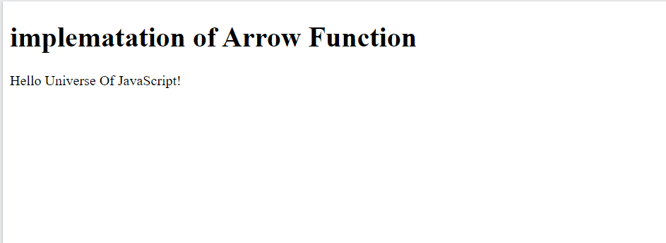

**Aim:**

**2. Destructuring:**

**JavaScript Code:**

<script>

var names = ["alpha", "beta", "gamma", "delta"];

var firstName = names[0];

var secondName = names[1];

console.log(firstName);//"alpha"

console.log(secondName);//"beta"

</script>

**Output:**

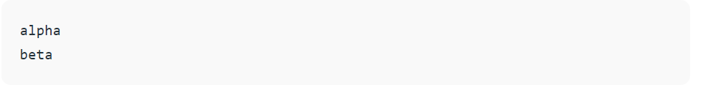

**Conclusion:**

In this practical we where able to learn New syntax of ES6 is Very useful in ReactJS and NodeJS.so this syntax is easy to understand and useful.