FET Practical - 8 (Promises)

**Objective: To understand the usage of promises in EcmaScript.**

**Exercise:**

**My friend Kayo promises to make a cake for my birthday in two weeks.**

**If everything goes well and Kayo doesn't get sick, we'll have a certain number of cakes**. Otherwise, if Kayo gets sick, we'll have no cakes.**

**Either way, we're still going to have a party.**

**For this first task, we'll translate this story into code using Promise concept of EcmaScript.**

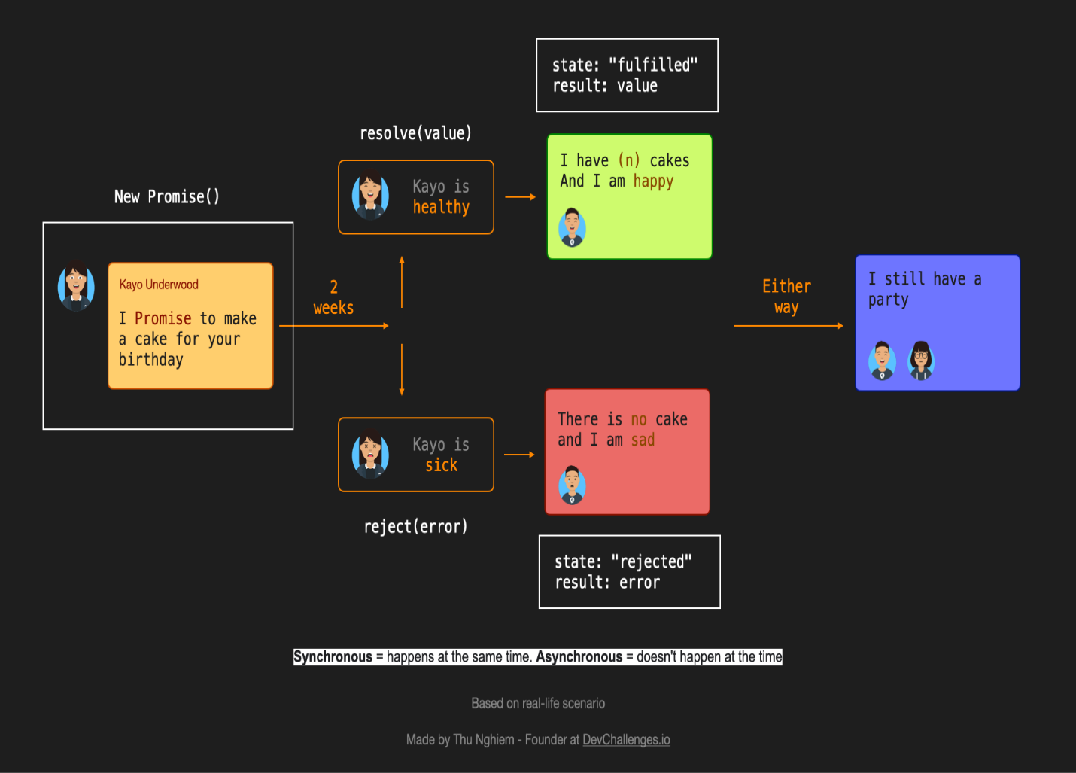

(**You can ask Kayo on runtime if she is healthy or not and the number of cakes she can bake.)

**CODE:-**

<html>

    <head>

        <title>Promises</title>

    </head>

    <body>

        <h1>Kayo's Cake:</h1>

        <p>Kayo: I promise to make a cake for your Birthday.</p>

        Kayo is: <input type="text" id="health"/> <br/><br>

        I have prepared:<input type="number" id="cake"/> cakes<br/><br>

        <button onclick="pari()">Submit</button>

        <p id="pj"></p>

        <p id="jp"></p>

        <script>

            function pari()

            {

                function myDisplay(some)

                {

                    document.getElementById("pj").innerHTML=some;

                }

                let myPromise=new Promise(function(myResolve,myReject)

                {

                    let x=document.getElementById("health").value;

                    let y=document.getElementById("cake").value;

                    if(x=='healthy' && y>0)

                    {

                        myResolve('AS Kayo is healthy.\nI have '+y+' cakes and I am happy.');

                    }

                    else

                    {

                        myReject('As Kayo is sick.\nThere is no cake and I am sad.')

                    }

                });

                myPromise.then

                (

                    function(value) {myDisplay(value);},

                    function(error) {myDisplay(error);}

                );

                document.getElementById("jp").innerHTML='I still have a party!';

            }

        </script>

    </body>

</html>

**OUTPUT:-**



