Questions -

- Give the output for the following commands:
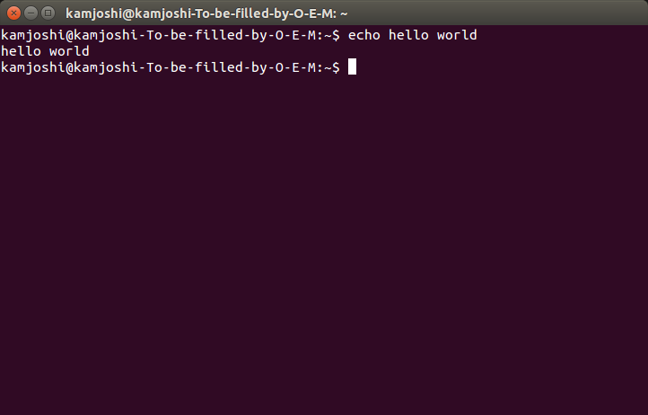
  - echo “hello world”

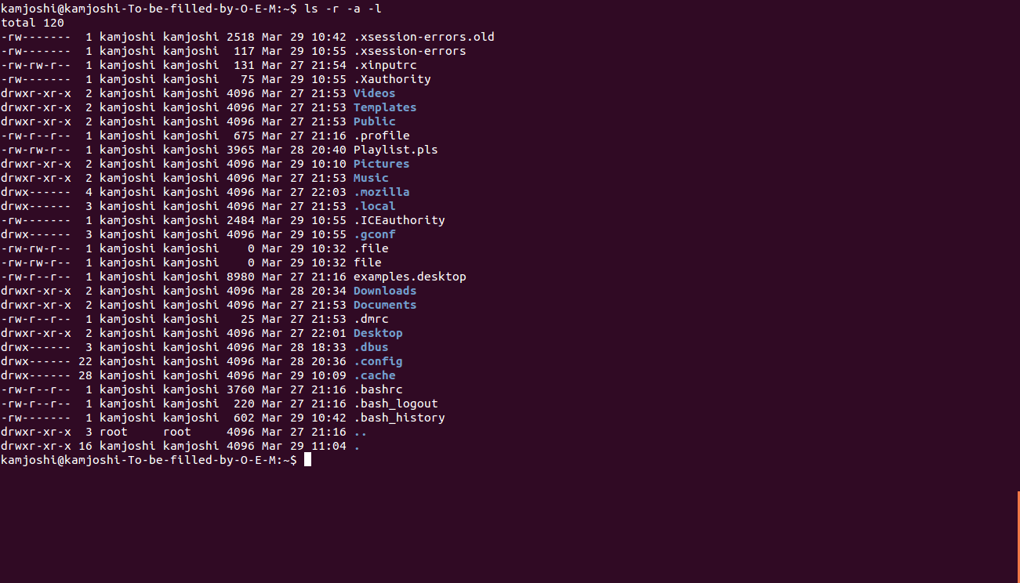
  - List all the files(hidden included) present in the current directory in long format displaying files in reverse order , sorted based on the modification time .

  - Change your current password.

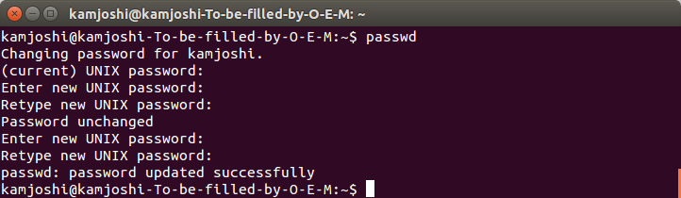
  - How to get the current date

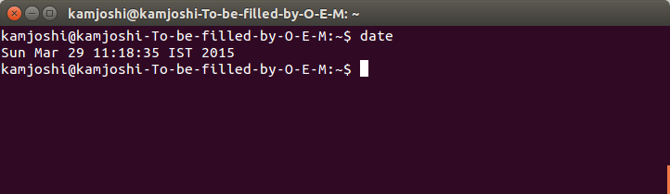
  - How to get the current logged in user

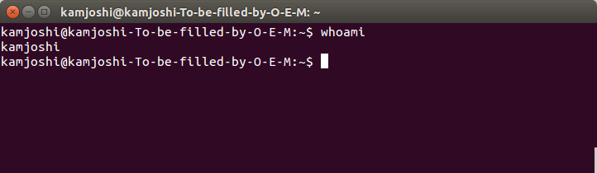
  - How to get the current working directory.

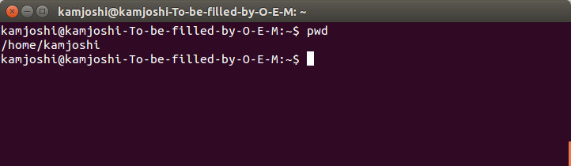
  - How to get the list of all commands that you have typed so far

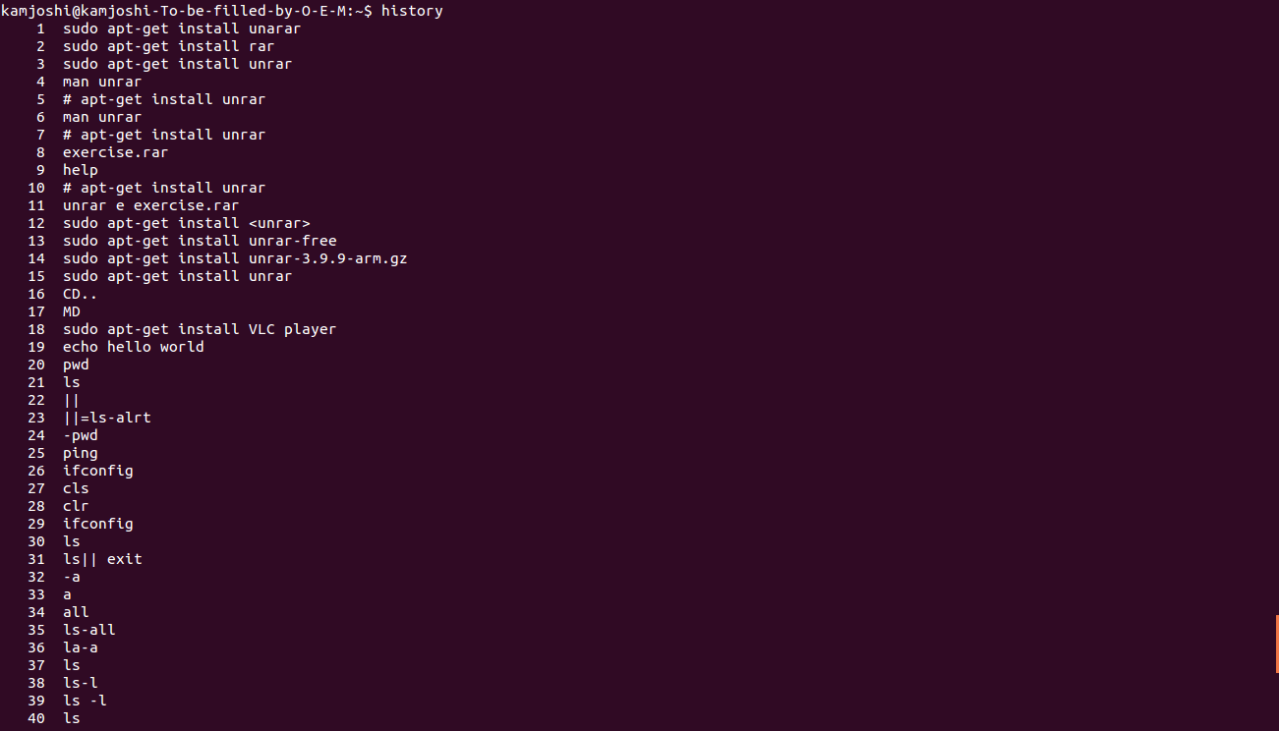

  - To get the information on the tcp ports

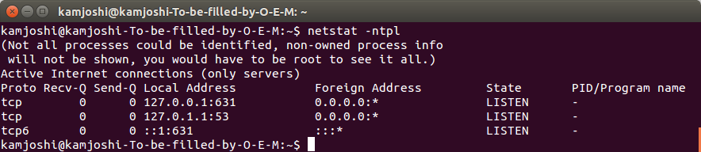

  - To get the information about the running processes.
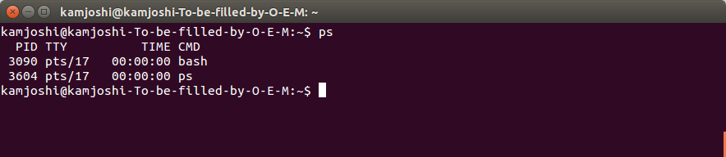

- Create a directory “exercises” inside your home directory. cd to this new directory.
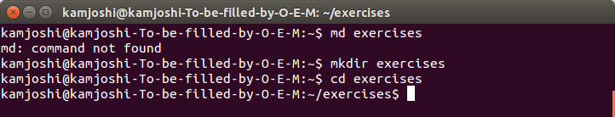

- Create 3 empty files , file1.txt,file2.txt,file3.txt in current directory (exercises).

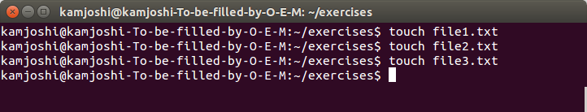

- Add some text to file1.txt and copy this to ~/exercises/files.

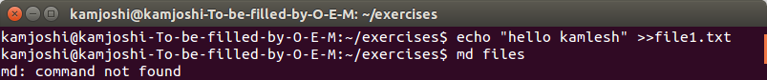

- Create a symlink “testlink” in your home directory that points to this file1.txt i.e. ~/exercises/files/file1.txt.
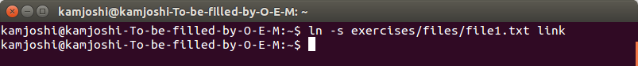

- Difference between soft and hard link.

Answer. A hardlink isn't a pointer to a file, it's a directory entry (a file) pointing to the same inode. Even if you change the name of the other file, a hardlink still points to the file. If you replace the other file with a new version (by copying it), a hardlink will not point to the new file. You can only have hardlinks within the same filesystem. With hardlinks you don't have concept of the original files and links, all are equal (think of it as a reference to an object). It's a very low level concept.

On the other hand, a symlink or soft link is actually pointing to another path (a file name); it resolves the name of the file each time you access it through the symlink. If you move the file, the symlink will not follow. If you replace the file with another one, keeping the name, the symlink will point to the new file. Symlinks can span filesystems. With symlinks you have very clear distinction between the actual file and symlink, which stores no info beside the path about the file it points to.

- Change permissions for files directory such that nobody other than the user who created the directory, can write/update anything in that directory.
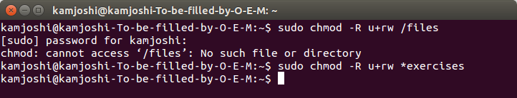

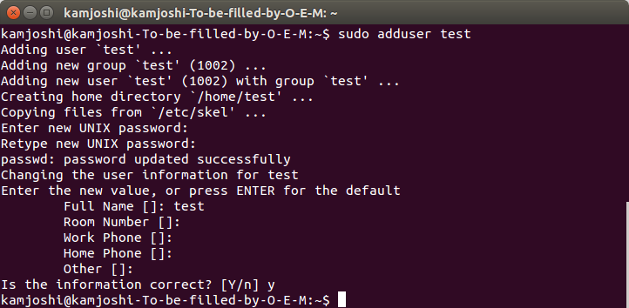
- Create a new user “test”.

- Change the owner of file1.txt to test

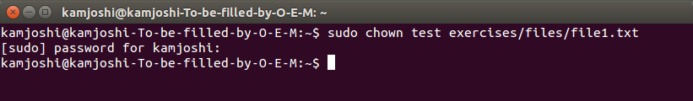

- create following directory structure with single command -
home
|-john
|-work
|-scripts
|-bash

Assume that you are currently in ‘home’ directory.
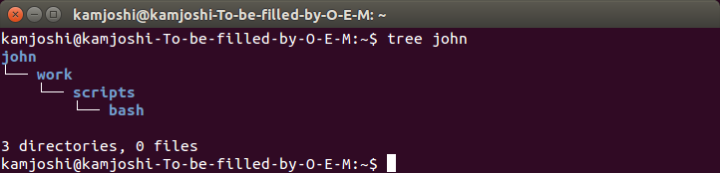

- Try deleting the ~/exercises/files/exercises directory. See what happens.

It gets deleted

- A file named employees.odt has a mode of rw-r- -r- -. If John is not the file's owner but is a member of the group that owns this file, what can he do with it?

Ans. John can only read the file emplooyees.odt

- Create an alias for clearing the screen.

- Create a tar archive of all the files in the current directory.
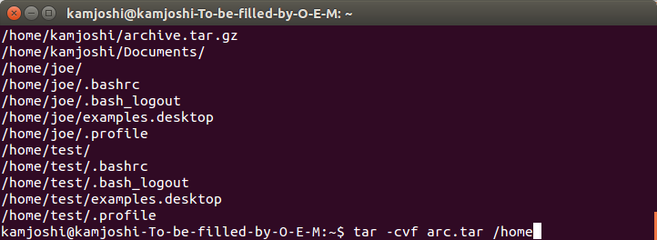

- How to find files greater than a certain size

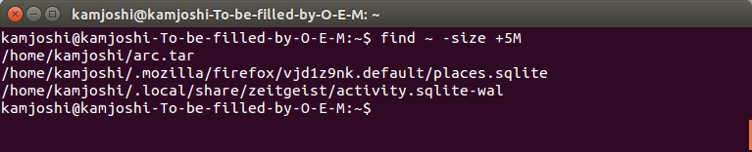

- Install openssh-server on your system

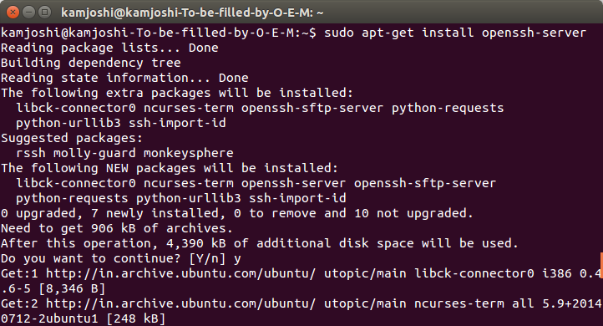

- try remote login to your friend’s machine using ssh.

Ans. ssh user@hostname
ssh is the command – it means that we’re going to be using SSH.
user is the shortname of the user of the target computer.
hostname is the IP address that we’ll be connecting to.

