- Initialize a Git Repository

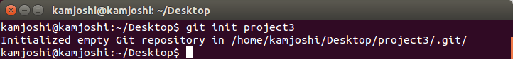

- Add files to the repository

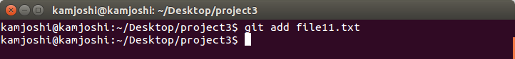
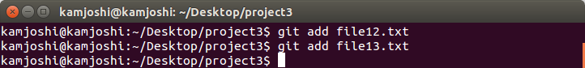

- Unstage 1 file

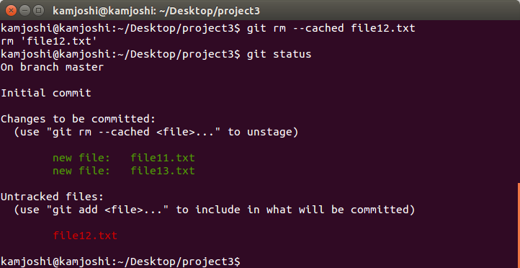

- Commit the files

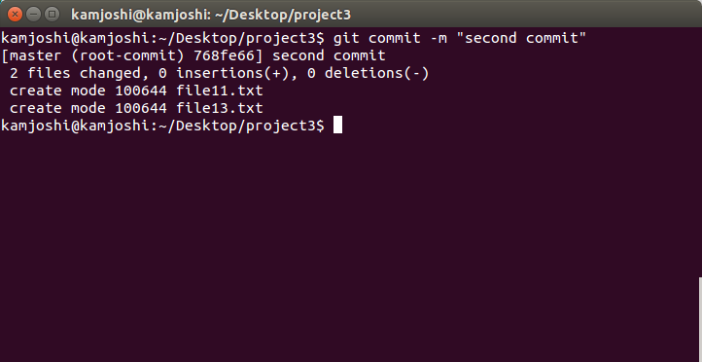
- Add a remote

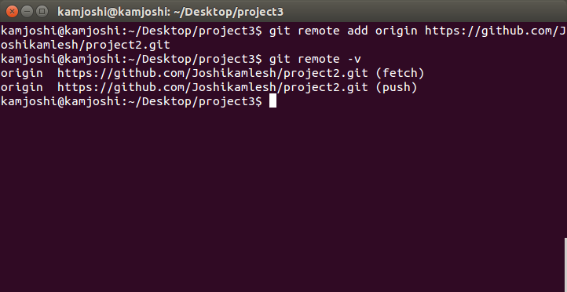

- Undo changes to a particular file

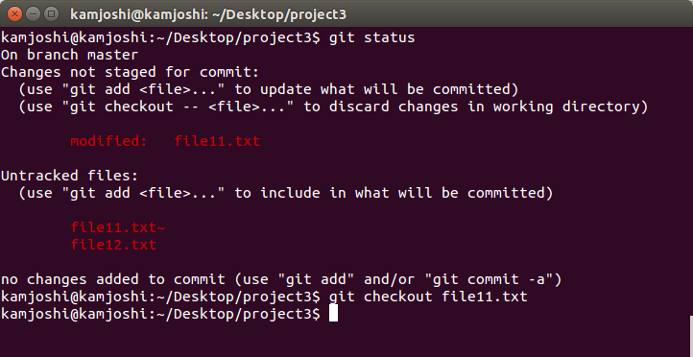

- Push changes to Github

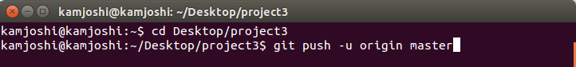

- Clone the repository
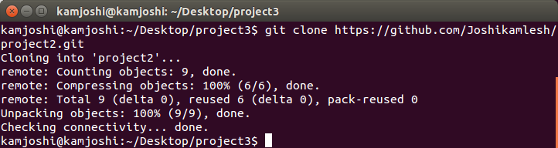
- Add changes to one of the copies and pull the changes in the other.

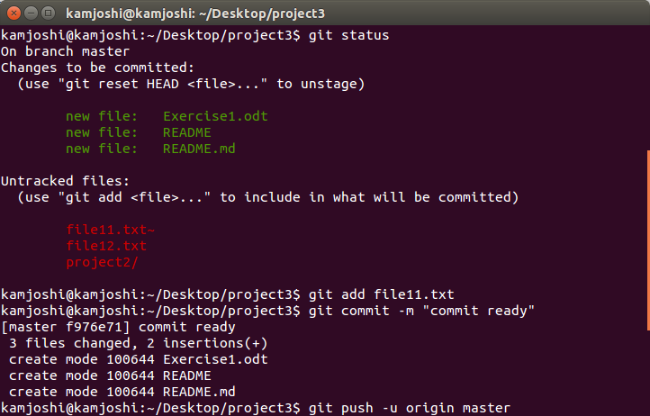
- Add changes to both repos, try to push from both without taking a pull.

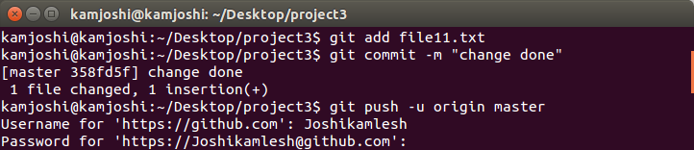
- Check differences between a file and its staged version
- Ignore a few files to be checked in
- Create a new branch. Diverge them with commits

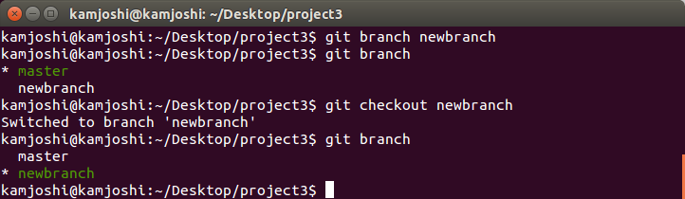

- Edit the same file at the same line on both branches and commit

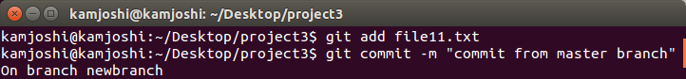

- Try merging and resolve merge conflicts

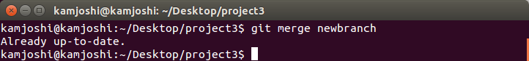

- Stash the changes and pop them

