**Objective**

To create a security group for a instance

**Step 1 :** Security group named **“testaz”** as been created at the time of instance launch.

**Step 2:** **“testaz**” is associated to **AZTEST** Linux machine.

**Step 3:** After creating the security group, you can edit the group by selecting it as shown below

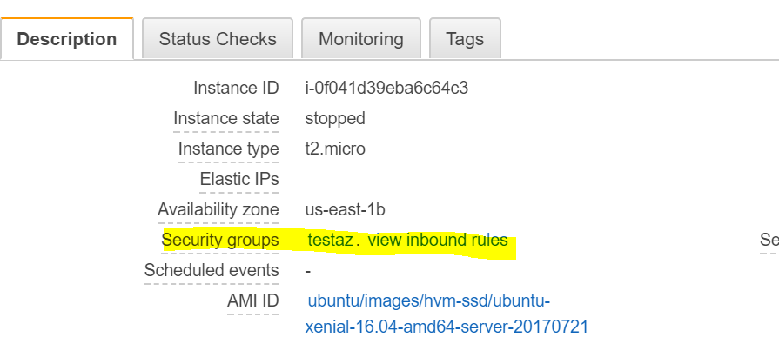

**Step4 :** Go to edit tab, and add the required ports to access the server