Task-1:Business Sales Performance Analysis

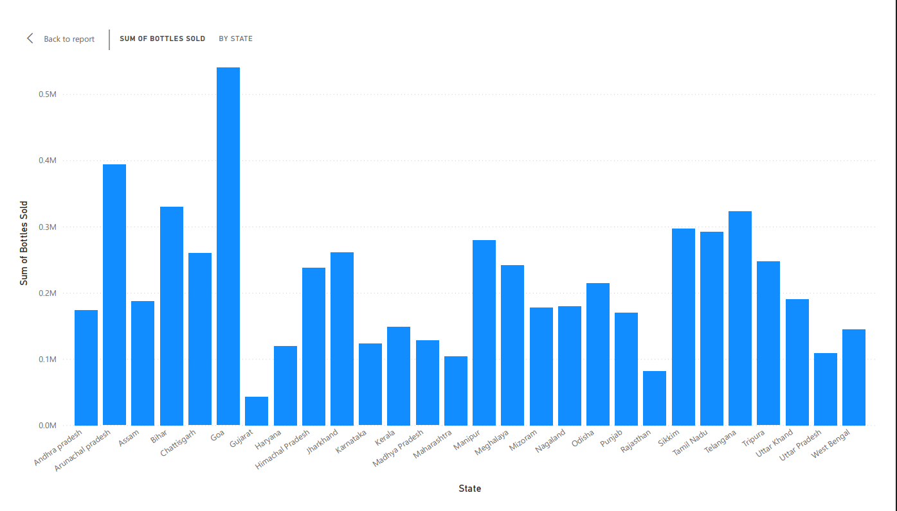

The above graph is analysing the liquor consumption of xyz brand in the all states of India. In the above graph X-axis represents number of bottles sold per year and Y-axis shows the state name.

Insights and Recommendations :
Here are clear,business-style insights and actionable recommendations,written advising xyz liquor brand.
- Sales are highly concentrated in a few large states like Maharashtra, Karnataka, Tamil Nadu, Telangana, Uttar Pradesh, and West Bengal show significantly higher bottle consumption compared to others.
What this means for business:
xyz brand demand is strongest in high-population + high liquor consumption markets
These states are likely contributing a major share of total revenue

- Southern India is a stronghold states like (Tamil Nadu, Karnataka, Telangana, Kerala, Andhra Pradesh) collectively show consistently strong consumption.
What this means:
The brand resonates well with Southern consumer taste preferences,Distribution and brand awareness are already effective in this region.

- Low penetration in North-East and smaller states such as Sikkim, Mizoram, Nagaland, Meghalaya, Arunachal Pradesh, Tripura show very low sales volumes.
Either:
Limited distribution
Lower brand awareness
Regulatory or logistics challenges
These are under-leveraged markets

- Large Hindi belt has mixed performance States like Uttar Pradesh, Rajasthan, Madhya Pradesh, Bihar show moderate to high variation in consumption .
What this means:
Significant untapped growth potential,Demand exists, but execution may not be uniform
Strategic Recommendations (What xyz should do):
Recommendation 1: Defend & deepen core markets (High priority)
➡️ Focus on top-performing states:
- Maharashtra
- Tamil Nadu
- Karnataka
- Telangana
- Uttar Pradesh
➡️ Actions:
- Increase visibility in premium liquor outlets
- Launch state-specific promotions during festivals
- Strengthen distributor incentives
➡️Why:
- These states already trust the brand → highest ROI on marketing spend
Recommendation 2: Grow Southern dominance through premiumization,Since South India is strong.
➡️Actions:
- Introduce premium variants or limited editions
- Position Teacher’s as a “trusted premium everyday whisky”
- Partner with premium bars & restaurants
➡️Why:
- Customers here are already consuming → upselling is easier than acquiring new users
Recommendation 3: Target Hindi belt with affordability & awareness for UP, MP, Rajasthan, Bihar:
➡️Actions:
- Focus on value-for-money messaging
- Improve last-mile availability in Tier-2 & Tier-3 cities
- Run retailer-led schemes (free bottles, discounts)
➡️Why:
- High population + moderate sales = biggest growth opportunity
Recommendation 4: Selective expansion in low-performing states
➡️Actions:
- Pilot programs in one or two North-Eastern states
- Use regional distributors instead of direct expansion
- Test small SKUs first
➡️Why:
- Controls risk while checking real demand

Executive Summary:
- Sales are concentrated in few large states.
- South India is the brand’s strongest region.
- North & North-East show untapped or weak penetration.
- Growth strategy should balance.
- Defending strong markets.
- Expanding selectively into high-population regions.

