Job Aid: Turn-Around Times (TAT) for UM Decisions

Who Performs Task: HLOC CMs

When task is performed: The TAT fields are completed upon the approval of days/sessions in CareAdvance.

Why task is performed: TAT fields are completed in order to document timely decision-making in accordance with BCN/BCSBM and NCQA guidelines.

Standard: The TAT is completed at the time of the decision. Specific examples are illustrated in screenshots below.

Exclusions: N/A.

Process: Complete the TAT questions as part of the CareAdvance case entry process. Refer to your CareAdvance trainings, job aids, and binders for specifics on this process. This job aid illustrates the correct completion of the TAT questions.

Template: Use the relevant InterQual template(s) to complete clinical documentation in CareAdvance.

Additional Information:

1. **Pre-service**: Request date is before the actual date of service.

2. **Expedited**: Case only considered expedited when there is a member or a provider request to expedite **and** the request is pre-service (the service has not occurred yet). All other cases should have “NO” in the *Expedited/Urgent* TAT field.

3. **Retrospective requests** are requests made after services have been provided and the member has been discharged. No prior authorization was requested.

4. **Received date and time**: the received date and time of the call/fax.

5. NCQA definition of 24 hours is **one calendar day**; 72 hours is **three calendar days**.

6. If a clinician receives a faxed request for authorization marked ‘Urgent’ or similar wording which may be interpreted as an Expedited request for service, the clinician should contact the sender by telephone, confirm the request as Expedited or not, then document this in the CareAdvance clinical note with the contact information of the person(s) called. **If unable to reach sender, the request will be treated as an Expedited request.**

7. For all expedited requests: **verbal notification** must be given to the member and the provider regarding the expedited decision. For HLOC requests the case manager must notify the provider/facility of the decision and request that the provider/facility notify the member. The case manager must document this discussion in CCA.

For all screenshots below, note that the date/time used in the ‘CRT Received Date & Time’ are for illustration only; the correct date/time of the request should be entered for each request for service.

**Precertification Requests**

**Initial/Precert - Not Yet Admitted, Non-Expedited Request, All Info. Available**

For cases where a facility calls for precertification authorization, the member is not yet admitted to the psychiatric facility (ex. inpatient psychiatric unit of a hospital; the member is in the ER awaiting admission to the psychiatric unit), and the facility **is not formally requesting an expedited/urgent decision:**

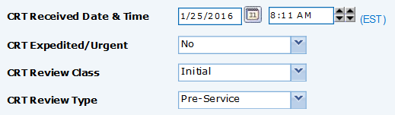

**Initial/Precert - Already Admitted, Non-Expedited Request, All Info. Available**

For cases where a facility calls for precertification authorization, the member is not yet admitted to the psychiatric facility, and the facility **is not formally requesting an expedited/urgent decision:**

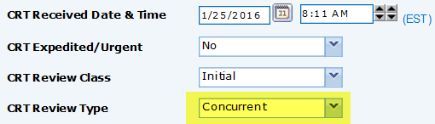

Note that for the purposes of proper TAT completion, the **Review Type** is listed as ‘**Concurrent’**.

**Initial/Precert - Not Yet Admitted, Expedited Request, All Info. Available**

For cases where a facility calls for precertification authorization, the member is not yet admitted to the psychiatric facility/unit, **the facility is formally requesting an expedited/urgent decision, and all clinical information is present/available:**

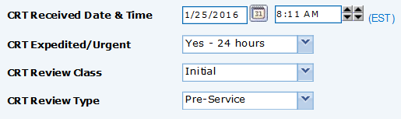

**Expedited:** Cases are only considered expedited when there is a member or a provider request to expedite **and** **the request is pre-service** (the service has not occurred yet.) All other cases should have **No** in the ‘*CRT Expedited/Urgent*’ TAT field.

**Initial/Precert - Not Yet Admitted, Expedited Request, Not All Info. Available**

For cases where a facility calls for precertification authorization, the member is not yet admitted to the psychiatric facility/unit, **the facility is formally requesting an expedited/urgent decision, and not all clinical information is present/available:**

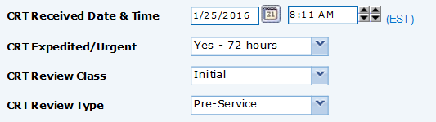

**Expedited:** Cases are only considered expedited when there is a member or a provider request to expedite **and** **the request is pre-service** (the service has not occurred yet.) All other cases should have **No** in the ‘*CRT Expedited/Urgent*’ TAT field.

**Concurrent Review/Requests**

The screenshot below illustrates proper TAT completion for concurrent/on-going service requests where initial authorization has already been granted, and the facility is seeking additional days/sessions.

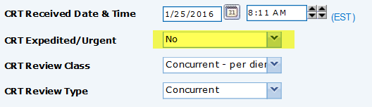

**Retrospective Authorization**

The screenshot below illustrates proper TAT completion for retrospective authorization requests where the member has already been discharged from the facility/unit, no prior authorization was requested, but the facility/unit is requesting authorization for services after discharge. As above, this is applicable to all higher levels of care (inpatient, PHP, IOP.)

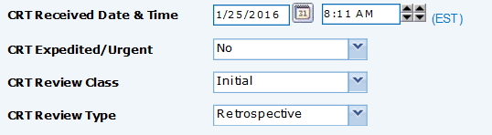

**Documenting Decisions following Medical Review**

**Initial/Precertification Request with MD Review - Non-Expedited**

For example: a clinician may receive a request for inpatient admission (member not yet admitted to unit, non-expedited request) 01/25/2016 at 1:00PM, but then send it for medical review and receive an approval from the medical reviewer the following day, 01/26/2016, at 12:15PM (‘CRT Date & Time of decision’).

We will assume that verbal notification of the approval was given to the facility 01/26/2016 at 12:45PM, and that for the purposes of BCN HLOC procedures the written notification was created 01/26/2016 at 12:30PM **(MA PPO would not complete the written notice fields.)** In that example, the completed TAT fields would be completed as below:

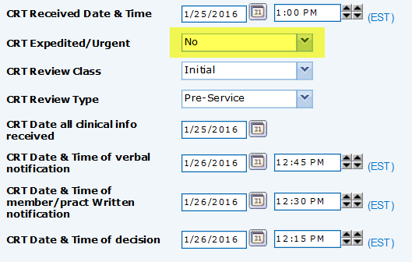

Note that, depending on the dates/times received and decided by the medical reviewer, the CRT dates/times may be different. Enter them as appropriate given individual circumstances.

**Initial/Precertification Request with MD Review - Expedited**

In this example, a clinician receives a request for precertification/authorization for inpatient psychiatry which is send for medical review; the request is received 01/25/2016 at 9:00AM. The medical reviewer makes their decision 01/25/2016 at 1:30PM; the written notification is generated 01/25/2016 at 1:45PM, and the facility is notified 01/25/2016 at 2:00PM. In this instance, the TAT would be completed as below:

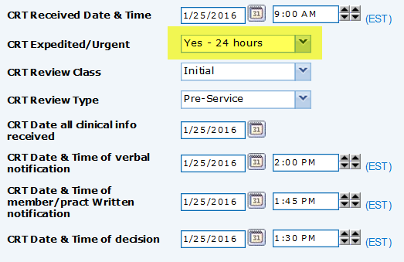

**Expedited:** Cases are only considered expedited when there is a member or a provider request to expedite **and** **the request is pre-service** (the service has not occurred yet.) All other cases should have **No** in the ‘*CRT Expedited/Urgent*’ TAT field.

**Concurrent Request with MD Review**

In the example of a Concurrent Review which was sent for medical review 01/25/2016 1:00PM, approved by a physician 01/26/2016 12:15PM, facility notified 01/26/2016 12:45PM, and for BCN HLOC written notification was created 01/25/2016 12:30PM, the fields would be completed as:

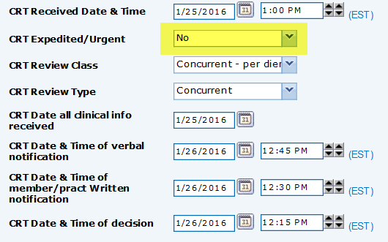

**In short**: follow the precert and concurrent review examples listed previously, then simply adjust the notification and decision dates/times to reflect when the physician made their decision and when notification(s) were give to the facility/member.

**Completing On-Call TAT Entries**

On-Call TAT completion requires precise documentation of all dates/times that requests were made and decisions were reached, along with the dates/times of notification.

For example: if a non-expedited precert request was received 01/25/2016 at 10:00PM, the decision was made 01/25/2016 10:30PM along with notification to the facility, and assuming that the clinician entering the case the next day completed written notification on 01/26/2016 at 8:30AM, the initial fields in CareAdvance (‘Request Received Date’) would be filled out as:

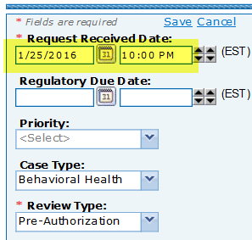

Note that the ‘Request Received Date’ entry reflects the date/time that the on-call clinician received the precert request, not the date/time the case would be entered into CareAdvance the following day.

**See next page for correct completion of the TAT fields for on-call precertifications to match the example above.**

**The TAT for this on-call example would be completed as below**:

