**TEST Documentation**

**Test Environment:**

**URL to TEST :**  <https://www.ratioform.at/>

**Browser Used:** Chrome

**Test Case 1: Navigation to the Ratioform page and Selection of “Faltkartons-sperrgut-optimiert”**

* Goto <https://www.ratioform.at/>
* Fill in "Wellpapp" in the Search Filter -> Displays few option
* Select “Faltkartons-sperrgut-optimiert”
* Displays the page “Faltkartons-sperrgut-optimiert”

**Expected Result:** Should navigate to Ratioform page and should display the page “Faltkartons-sperrgut-optimiert”

**Actual Result:** Navigates to Ratioform page and displays the page “Faltkartons-sperrgut-optimiert”

**STATUS: PASS**

**Screenshots:**

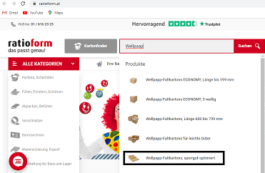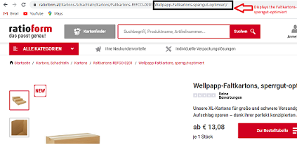

**Test Case 2:** **To Check if “Zur Bestelltabelle” button works**

* Click on the button “Zur Bestelltabelle”
* Displays the table with 3 options

**Expected Result:** Should display a table with 3 options

**Actual Result:** Displays a table with 3 options

**STATUS: PASS**

**Screenshots:**



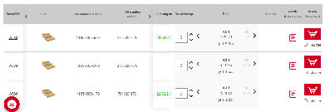

**Test Case 3: To Check if Click on each option should navigate to the respective page**

1. Click on W583 -> Navigates to its corresponding page
2. Click on Browser back button to return to the table
3. Click on W584 -> Navigates to its corresponding page
4. Repeat Step 2
5. Click on W586 -> Navigates to its corresponding page

**Expected Result:** Click on the option should navigate to its corresponding page

**Actual Result:** Click on the option navigates to its corresponding page

**STATUS: PASS**

**Screenshots:**

**W583:**

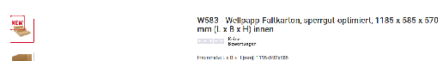

**W584:**

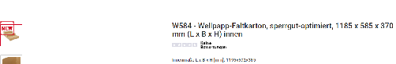

**W586:**

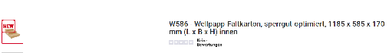

**Test Case 4:** **To Check if W583 can be selected directly from the table list and added to the cart**

**Test Steps:**

1. Choose W583 -> Do not change Default Settings
2. Click on “In den Warenkorb“ button
3. Error Message displayed

**Expected Result:** Should throw an Error message

**Actual Result:** Throws an Error message

**STATUS: PASS**

**Screenshots:**

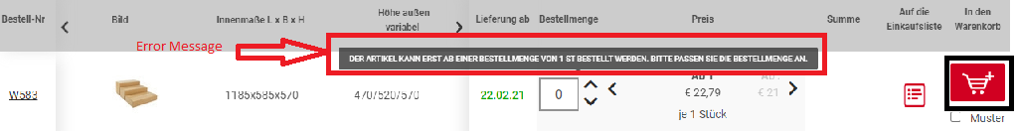

**Test Case 4:** To Check if W583 can be selected directly from the table list and added to the cart

**Test Steps:**

1. Choose W583
2. Change “Bestellmenge” to 1
3. Click on “In den Warenkorb” icon
4. Displays the page „Dieses Produkt wurde zum Warenkorb hinzugefügt“
5. Click on „zum Warenkorb“
6. Throws an Error message “Der Mindestbestellwert von € 25,00 (Netto-Warenwert exkl. Versandkosten) ist nicht erreicht.“ and „Zur Kasse“ button is greyed out.
7. Change “Bestellmenge” to 2
8. “Zur Kasse“ button is highlighted and Click on it
9. Proceed to the next page which is Login Page
10. Click on “Weiter einkaufen” -> Navigates to Homepage

**Expected Result:** W583 Product should be added to the Cart

**Actual Result:** Displays the W583 Product is added to the Cart

**STATUS: PASS**

**Screenshots:**

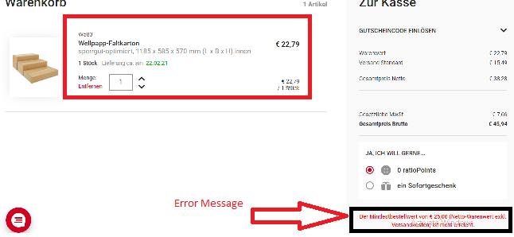

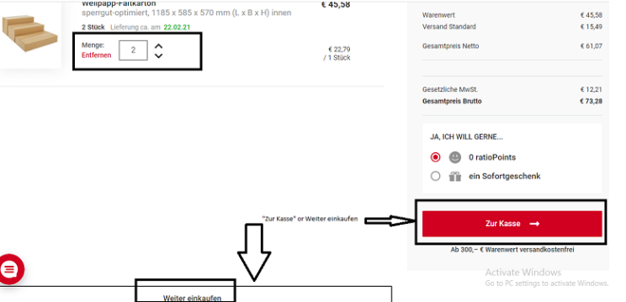

**Test Case 5:** To Check if W583 Clicked and the product can be to the cart from its corresponding page.

**Test Steps:**

1. Click on W583 from the table
2. Navigates to its corresponding page
3. Repeat Test Case 4

**Expected Result:** W583 Product should be added to the Cart from its corresponding Page

**Actual Result:** Displays the W583 Product is added to the Cart from its corresponding Page

**Status: PASS**

**Edge Cases:**

**Test Case 6: To check if the “Summe” is calculated for the “Bestellmenge =** 50000000000”

**Test Steps:**

1. Enter in Bestellmenge the value 50000000000
2. “Summe” is not calculated
3. “Summe” column is reloadng

**Expected Result:** Should calculate the sum for the number of products ordered

**Actual Result:** Did not calculate the sum and it was loading

**Status:** Bug: Performance Issue

**Notes:**

The maximum value for “Bestellmenge” is not known. For this we need the Business Requirement Document

**Screenshots:**

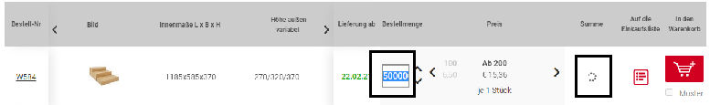

**Test Case 7: To check if negative value can be entered**

**Test Steps:**

1. Try to enter in Bestellmenge the value -1
2. Does not take the negation

**Expected Result:** Should not be able to enter negative number

**Actual Result:** Unable to enter negative number

**Status: PASS**

**Test Case 8: To check if the search results displays only the search items which was entered in the search filter.**

**Test Steps:**

* Goto <https://www.ratioform.at/>
* Fill in "Wellpapp" in the Search Filter -> “Wellpaap”
* Hit “Suchen” button
* Displays a list items even though “Well” is not available in the name of it.

**Expected Result:** Should display only the list of items which was defined in the search filter.

**Actual Result:** Displays all the items irrespective of the search criteria.

**Status:** **BUG : FAIL**

**Screenshots:**

