**App.jsx**

import Header from './Header.jsx'

import Cards from './Cards.jsx'

import Footer from './Footer.jsx'

function App() {

  return (

    <>

      <Header/>

      <Cards />

      <Footer />

    </>

  );

}

export default App

**Header.jsx**

function Header(){

    return(

        <header>

            <div className="head">

                <h1 className="heading">Western Affair</h1>

                <p className="tag-line">"Stay ahead of the fashion curve with our trendy and chic dress collection."</p>

            </div>

        </header>

    );

}

export default Header;

**Cards.jsx**

import React, { useState } from 'react';

function Cards() {

    const [showPrice1, setShowPrice1] = useState(false);

    const [showPrice2, setShowPrice2] = useState(false);

    const [showPrice3, setShowPrice3] = useState(false);

    const [showPrice4, setShowPrice4] = useState(false);

    const [showPrice5, setShowPrice5] = useState(false);

    const [showPrice6, setShowPrice6] = useState(false);

    const [showPrice7, setShowPrice7] = useState(false);

    const [showPrice8, setShowPrice8] = useState(false);

    const [showPrice9, setShowPrice9] = useState(false);

    const [showPrice10, setShowPrice10] = useState(false);

    const [showPrice11, setShowPrice11] = useState(false);

    const [showPrice12, setShowPrice12] = useState(false);

    const handleClick1 = () => {

        setShowPrice1(!showPrice1);

    };

    const handleClick2 = () => {

        setShowPrice2(!showPrice2);

    };

    const handleClick3 = () => {

        setShowPrice3(!showPrice3);

    };

    const handleClick4 = () => {

        setShowPrice4(!showPrice4);

    };

    const handleClick5 = () => {

        setShowPrice5(!showPrice5);

    };

    const handleClick6 = () => {

        setShowPrice6(!showPrice6);

    };

    const handleClick7 = () => {

        setShowPrice7(!showPrice7);

    };

    const handleClick8 = () => {

        setShowPrice8(!showPrice8);

    };

    const handleClick9 = () => {

        setShowPrice9(!showPrice9);

    };

    const handleClick10 = () => {

        setShowPrice10(!showPrice10);

    };

    const handleClick11 = () => {

        setShowPrice11(!showPrice11);

    };

    const handleClick12 = () => {

        setShowPrice12(!showPrice12);

    };

    return (

        <>

            <div className="Card">

                <img className="card-img" src="card_img4.jpeg" alt='Attire Cards'></img>

                <h2 className="card-title">Gocgt Women's Sequin Glitter V Neck Sleeveless Cocktail Evening Bodycon</h2>

                <button className='btn' onClick={handleClick1}>{showPrice1 ? "$ 83.00" : "Show Price"}</button>

            </div>

            <div className="Card">

                <img className="card-img" src="card_img5.jpeg" alt='Attire Cards'></img>

                <h2 className="card-title">Amour-Gothic Hot Sleeveless Dress Metallic Wetlook Clubwear Stripper</h2>

                <button className='btn' onClick={handleClick2}>{showPrice2 ? "$ 78.80" : "Show Price"}</button>

            </div>

            <div className="Card">

                <img className="card-img" src="card_img6.jpeg" alt='Attire Cards'></img>

                <h2 className="card-title">Sexy Short Sequin Mini dress Disco Flapper Club Costume</h2>

                <button className='btn' onClick={handleClick3}>{showPrice3 ? "$ 63.72" : "Show Price"}</button>

            </div>

            <div className="Card">

                <img className="card-img" src="card_img7.jpeg" alt='Attire Cards'></img>

                <h2 className="card-title">Green V Back Sequin Bodycon Mini Dress</h2>

                <button className='btn' onClick={handleClick4}>{showPrice4 ? "$ 91.96" : "Show Price"}</button>

            </div>

            <div className="Card">

                <img className="card-img" src="card_img8.jpeg" alt='Attire Cards'></img>

                <h2 className="card-title">Hot Pink Sequin Tube Bodycon Dress for Women Fanolo</h2>

                <button className='btn' onClick={handleClick5}>{showPrice5 ? "$ 57.72" : "Show Price"}</button>

            </div>

            <div className="Card">

                <img className="card-img" src="card_img9.jpeg" alt='Attire Cards'></img>

                <h2 className="card-title">Red Sequin Strapeless Mini Party Dress</h2>

                <button className='btn' onClick={handleClick6}>{showPrice6 ? "$ 76.72" : "Show Price"}</button>

            </div>

            <div className="Card">

                <img className="card-img" src="card_img10.jpeg" alt='Attire Cards'></img>

                <h2 className="card-title">Women's Shiny metallic Holographic Long Sleeves Sexy Bodycon black</h2>

                <button className='btn' onClick={handleClick7}>{showPrice7 ? "$ 88.80" : "Show Price"}</button>

            </div>

            <div className="Card">

                <img className="card-img" src="card_img11.jpeg" alt='Attire Cards'></img>

                <h2 className="card-title">Under the Disco Ball Sequin Dress - Silver</h2>

                <button className='btn' onClick={handleClick8}>{showPrice8 ? "$ 79.54" : "Show Price"}</button>

            </div>

            <div className="Card">

                <img className="card-img" src="card_img12.jpeg" alt='Attire Cards'></img>

                <h2 className="card-title">Women's Sexy Bodycon Longsleeves Ruched Deep V Neck Wrap Club Mini Dress - White</h2>

                <button className='btn' onClick={handleClick9}>{showPrice9 ? "$ 73.13" : "Show Price"}</button>

            </div>

            <div className="Card">

                <img className="card-img" src="card_img13.jpeg" alt='Attire Cards'></img>

                <h2 className="card-title">Aqua Blue Women's Asymmetrical Sequined Dress</h2>

                <button className='btn' onClick={handleClick10}>{showPrice10 ? "$ 67.46" : "Show Price"}</button>

            </div>

            <div className="Card">

                <img className="card-img" src="card_img14.jpeg" alt='Attire Cards'></img>

                <h2 className="card-title">Women Sequin Halter Neck Mini Dress Body Fit Dress</h2>

                <button className='btn' onClick={handleClick11}>{showPrice11 ? "$ 59.90" : "Show Price"}</button>

            </div>

            <div className="Card">

                <img className="card-img" src="card_img15.jpeg" alt='Attire Cards'></img>

                <h2 className="card-title">Women's Dorthy Perkins Blue Stripe Sequin Wrap Mini Dress</h2>

                <button className='btn' onClick={handleClick12}>{showPrice12 ? "$ 59.90" : "Show Price"}</button>

            </div>

        </>

    );

}

export default Cards;

**Footer.jsx**

function Footer(){

    return(

        <footer>

                <div className="copyright">© 1996-{new Date().getFullYear()}, WesternAffairs.com, Inc. or its affiliates</div>

        </footer>

    );

}

export default Footer;

**index.css**

*{

  margin: 0;

  padding: 0;

  background-color: rgb(230, 230, 250) ;

}

.heading{

  text-align: center;

  font-size: 4rem;

  font-family:'Trebuchet MS', 'Lucida Sans Unicode', 'Lucida Grande', 'Lucida Sans', Arial, sans-serif;

  /* background-color: rgb(142, 194, 20); */

  Background-color: rgb(142, 68, 173);

}

.tag-line{

  text-align: center;

  font-size: medium;

  font-style: oblique;

  font-family: 'Franklin Gothic Medium', 'Arial Narrow', Arial, sans-serif;

  Background-color: rgb(142, 68, 173);

  padding-bottom: 2rem;

}

.Card {

  border: 2px solid black;

  border-radius: 10px;

  box-shadow: 5px grey;

  margin: 40px;

  padding: 20px;

  text-align: center;

  width: 250px;

  display: inline-block;

  background-color: aliceblue;

  height: 330px;

}

.card-img {

  max-width: 100%;

  height: auto;

  margin-bottom: 10px;

}

.card-title {

  font-family: Arial, Helvetica, sans-serif;

  margin: 0;

  color: rgb(2, 34, 61);

  background-color: aliceblue;

  font-size: small;

}

button{

  font-size: 16px;

  font-weight: bolder;

  margin-top:1rem;

  background-color:  rgb(155, 89, 182);

  border: 2px solid rgb(8, 8, 8);

  border-radius: 4px;

  height: 40px;

  padding: 7px;

}

.copyright{

  color: black;

  background-color: grey;

  text-align: center;

  font-style: bold;

}

**Output-**



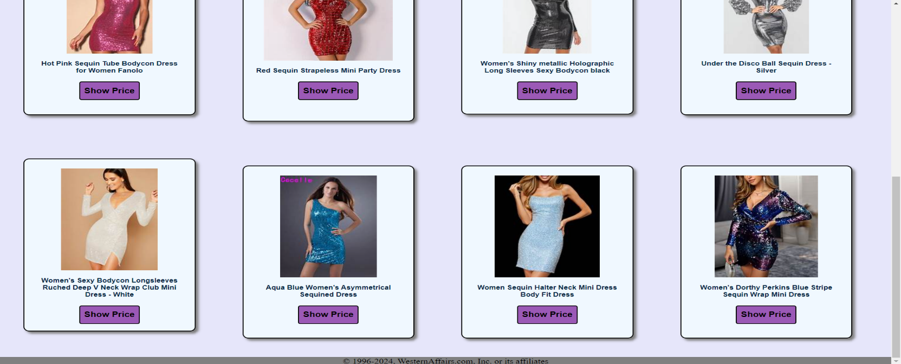

**After Clicking on the Button**

