**Team : ZombieMiners**

Github Repo Link - https://github.com/JoshnaSuresh/CryptoZombies-Midterm

Team Member, CWID, Email

Joshna Suresh, 885146902, joshnasuresh04@csu.fullerton.edu

Susan Dsouza, 809394463, susandsouza@csu.fullerton.edu

Lemmie Carvalho, 870802634, lemmiecarvalho0910@csu.fullerton.edu

Shubham Jakhete, 823597208, sjakhete@csu.fullerton.edu

We have successfully executed the starter code works with create zombie, level up and display zombie functionalities

Improvements

1)We've developed a more interactive and user-friendly website, enhancing its functionality significantly.

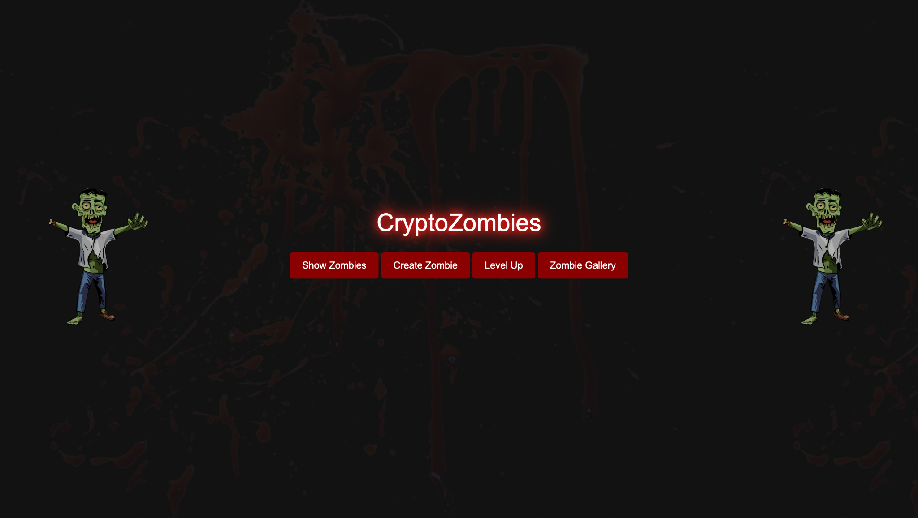

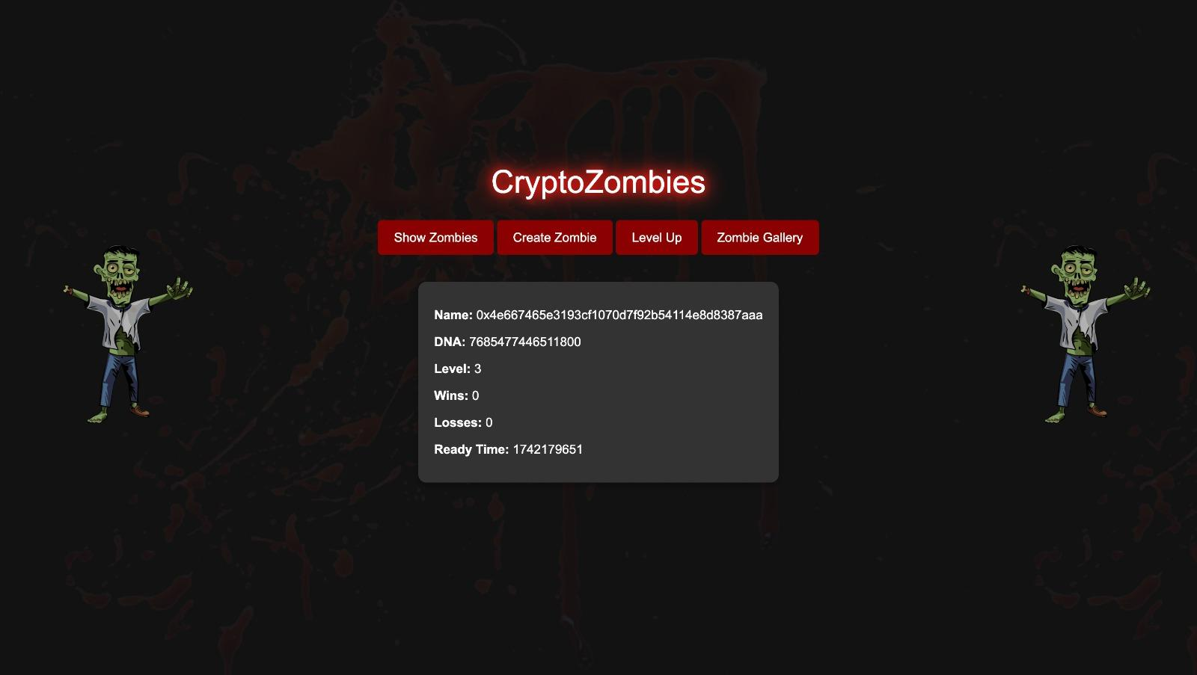

2) Updates were made to the JavaScript code to introduce new features:

i) Add images to demo zombies in a better way

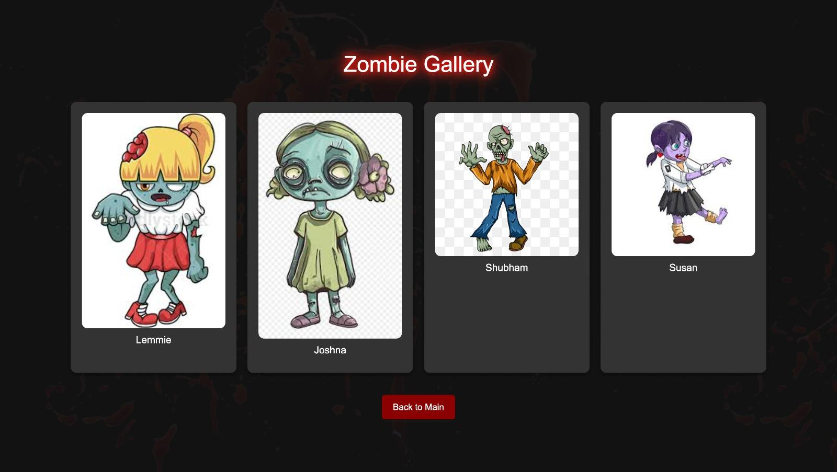

3) Changed the starter code to NOT hard-coded - These changes allow the contract to be more flexible without hardcoded values, giving the owner the ability to adjust these parameters as needed.

i) Modifications have been made such that we have eliminated few hard coded lines:

1. Remove Hardcoded cooldownTime: We can make the cooldown time configurable by allowing the owner to change it.

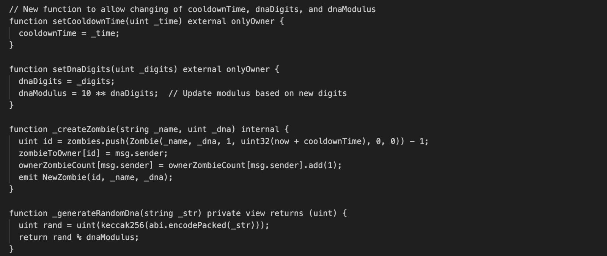

b) Remove Hardcoded levelUpFee: This can be updated dynamically by the contract owner.

levelUpFee: Configurable fee for leveling up zombies, adjustable by the contract owner.

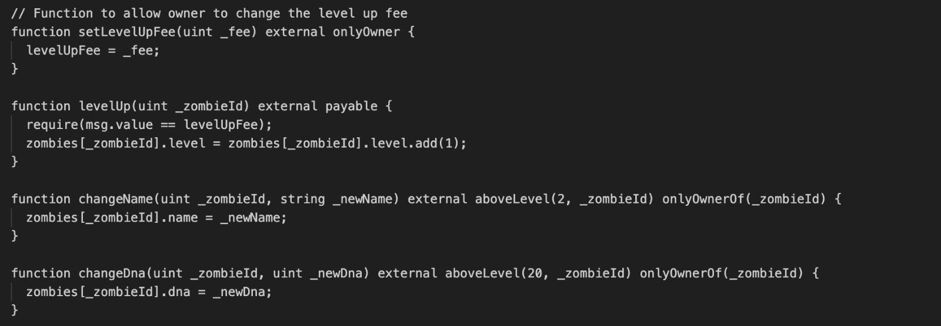

c)Allow configurable dnaDigits and dnaModulus: Instead of hardcoding the DNA digits, we can allow the owner to update them, making it more flexible for future changes.

dnaDigits and dnaModulus: Allow the owner to change the DNA configuration.

