Objective:
Analyze the marketing campaign dataset and identify which marketing channels and campaign strategies should receive greater budget allocation.
Data Preparation:
• No missing values found.
• No duplicate records found.
• Duration converted from text to numeric values.
• Acquisition Cost converted to numeric format.
• Date converted to datetime format.

Key Findings

Marketing Channel Analysis:

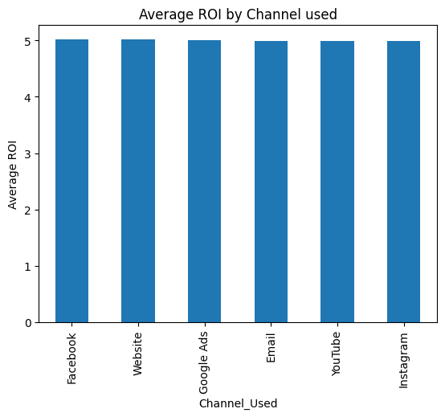
Channel | Avg ROI
Facebook | 5.0187
Website | 5.0142
Google Ads | 5.0031
Email | 4.9965
YouTube | 4.9938
Instagram | 4.9887

