**Phase2 – Practice Project: Assisted Practice**

**Running Tests with Gradle.**

* Create a Gradle project

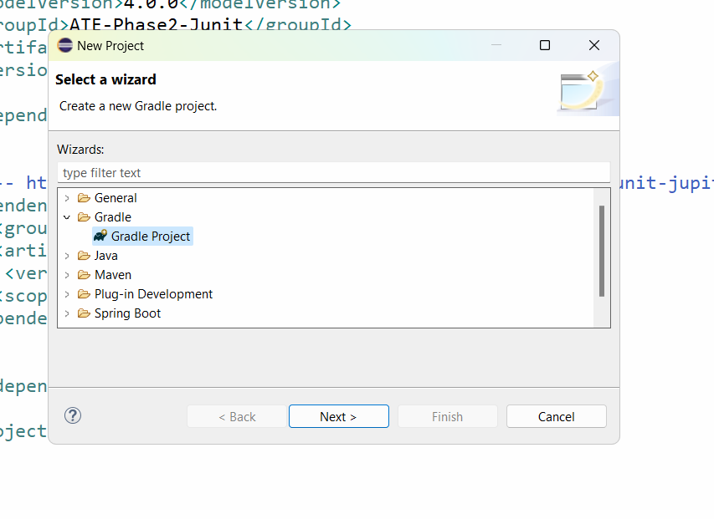

* Press Next button

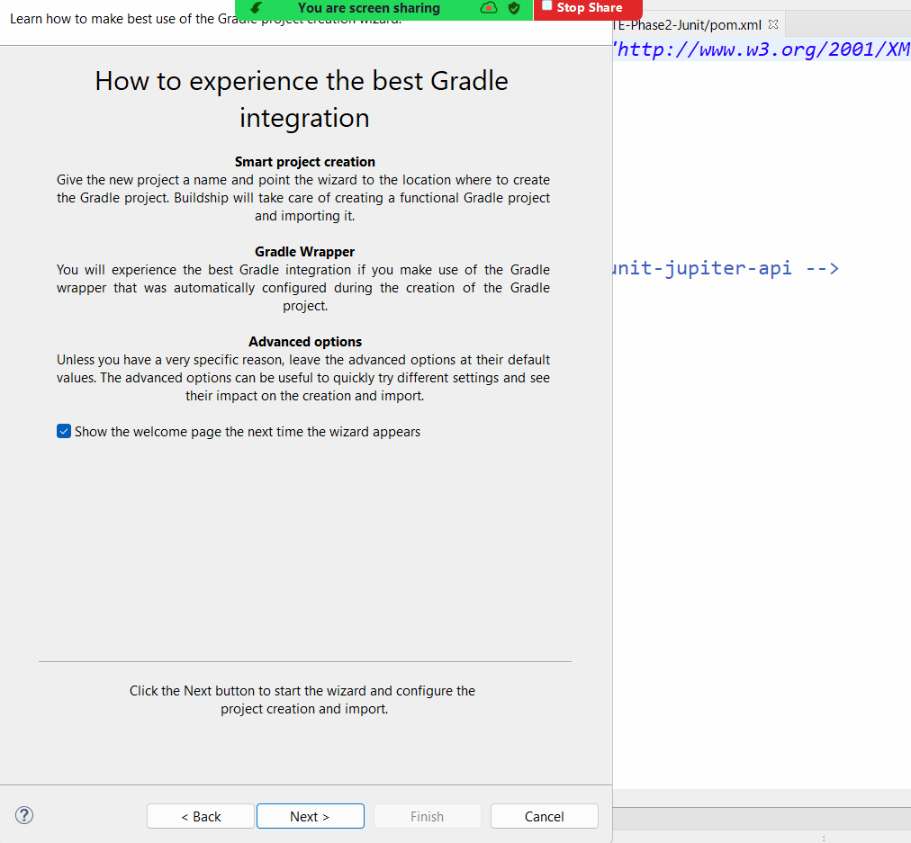

* Press Next button and give a name to the project and click on Finish

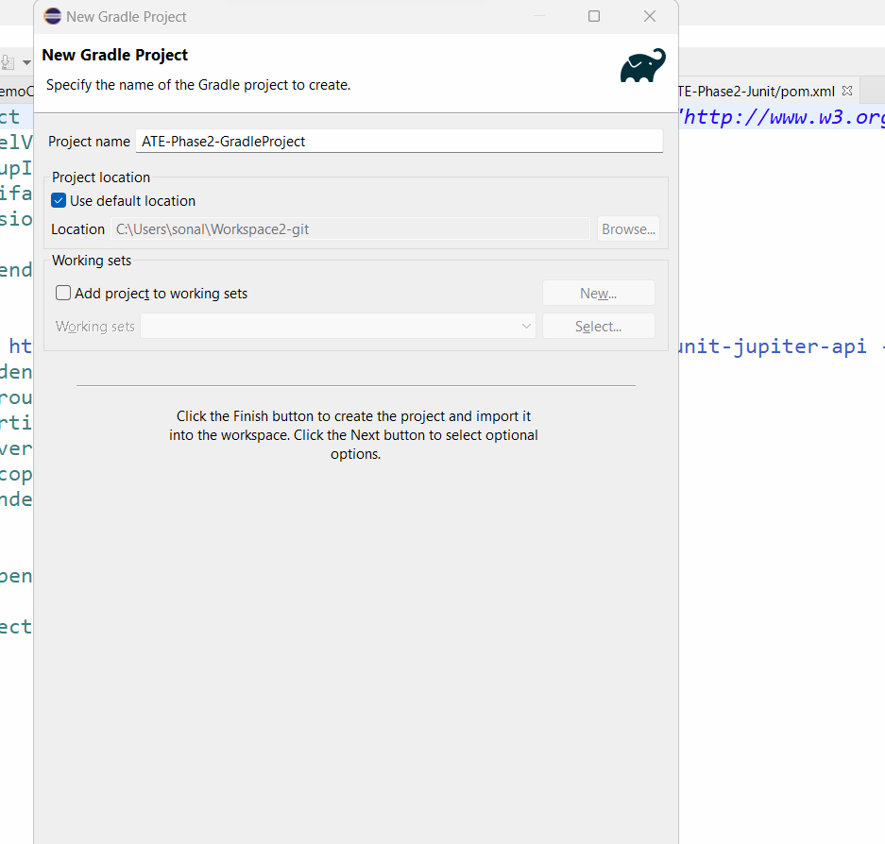

* After Finish, it will create 2 projects

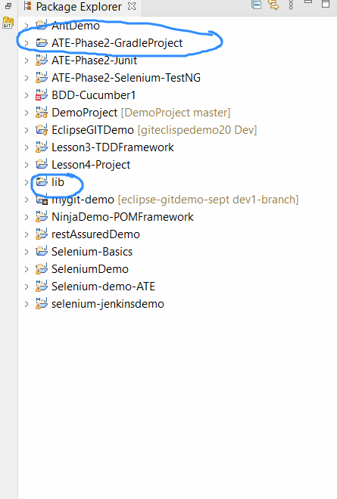

* We have to fix the issue of lib folder should be inside the main gradle project
* So go to properties of your gradle project and get the path of the project created on your local machine

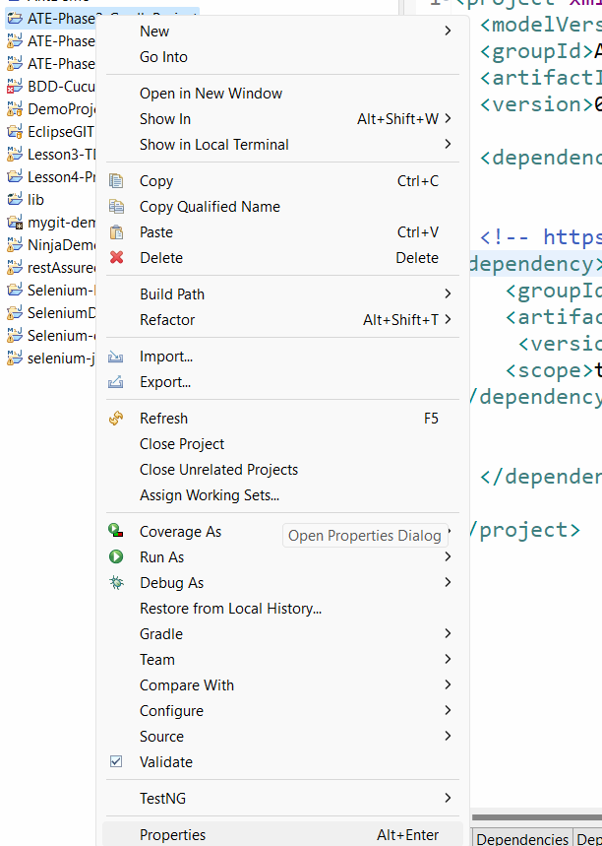

* Copy the location of project on your local machine:

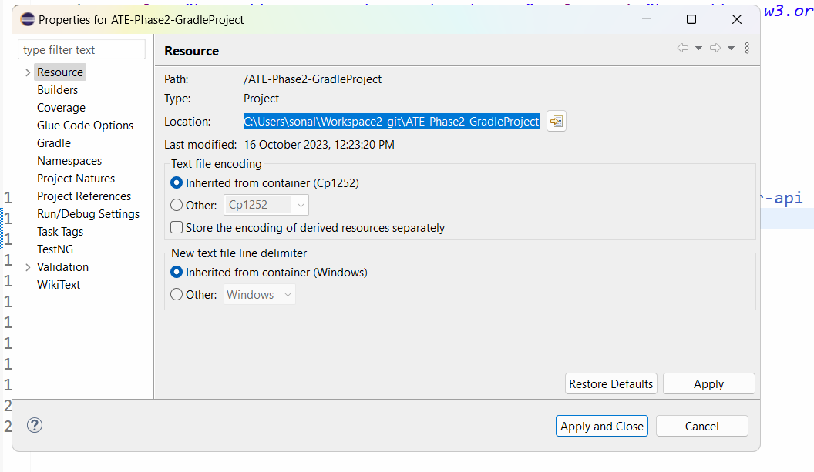

* Open the folder in your local machine by pasting the path of workspace:

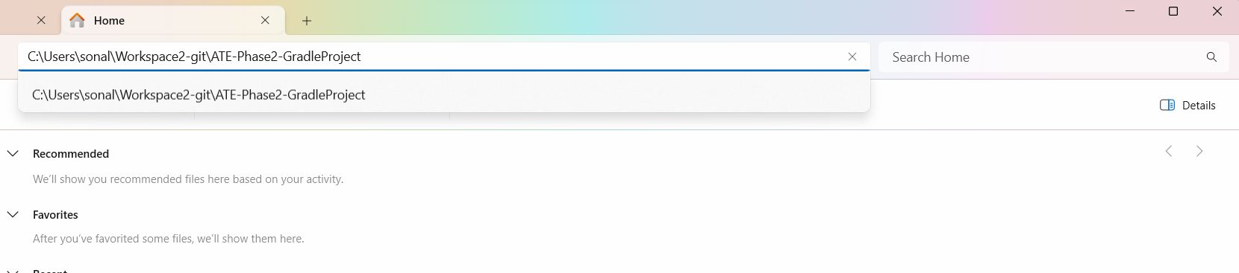

Now the project is open in your local machine

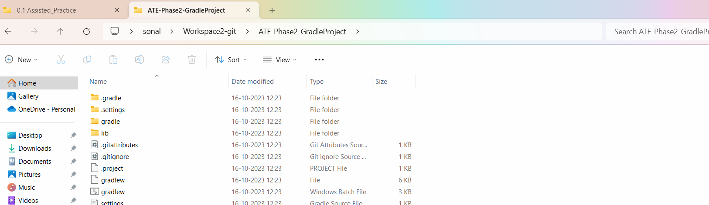

Go inside the lib folder

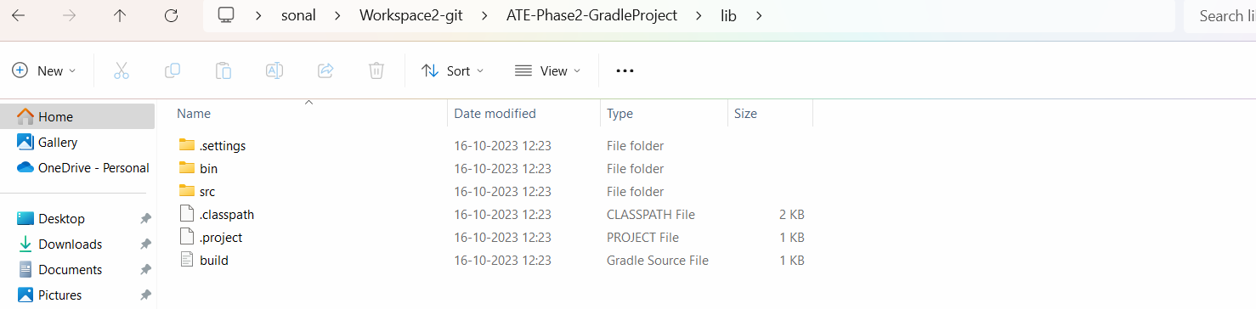

* Select All the items in the lib folder and press CTL X (cut them)

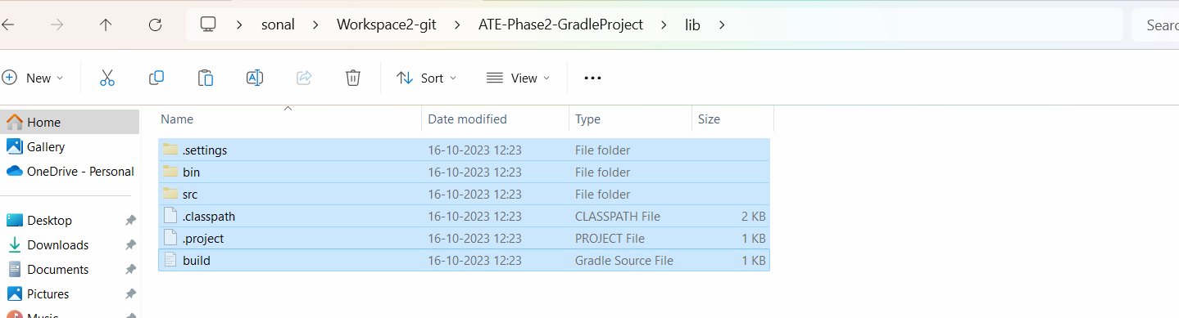

* Now go back to your gradle project directory and paste the contents of lib folder.
* It may ask for replace the files in the destination.
* Select the option of Replace files in the destination

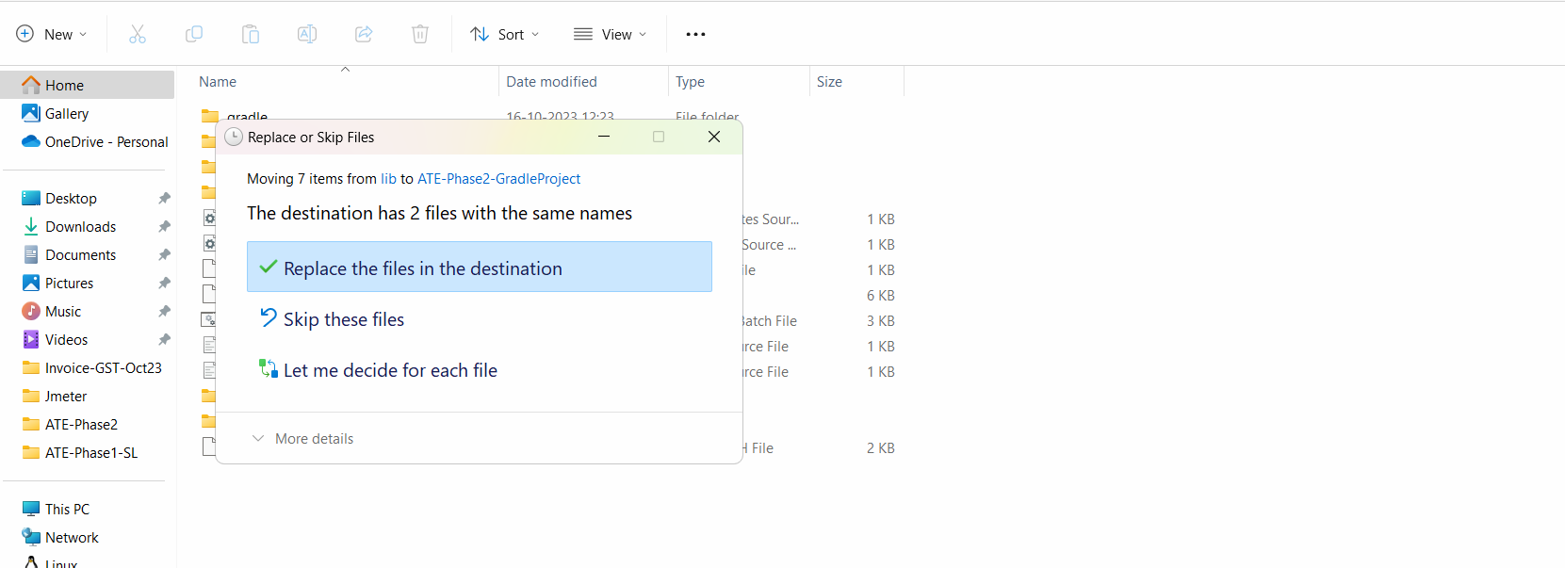

* After this if you will go to lib folder, it will be empty:

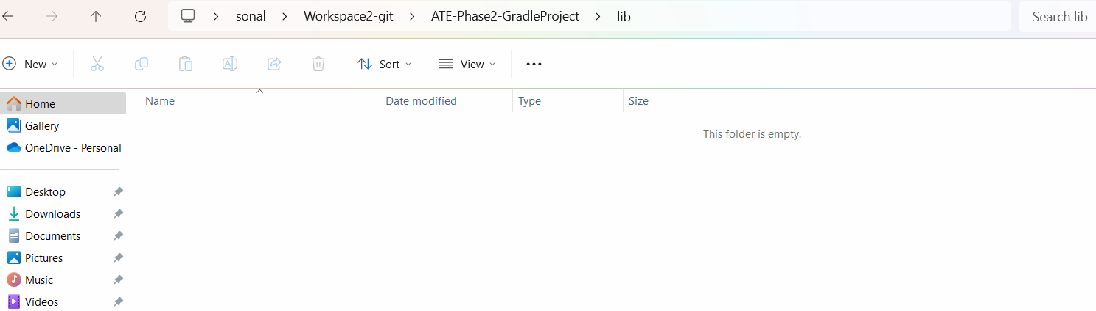

* Delete the Lib folder from gradle folder directory

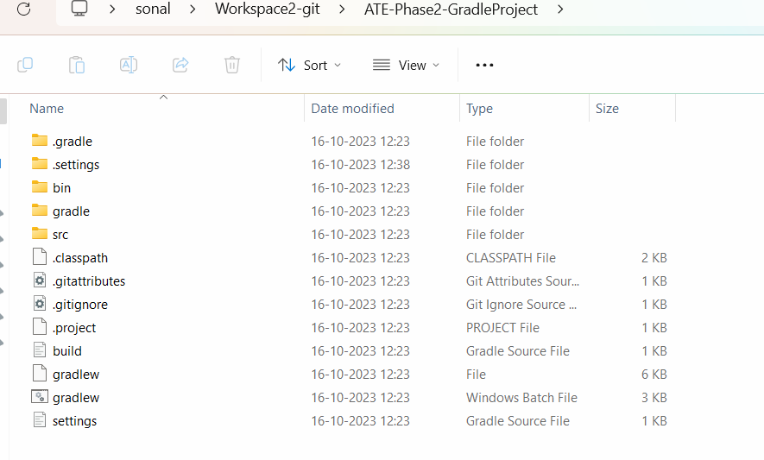

* Now go to eclipse and delete the gradle project and lib project

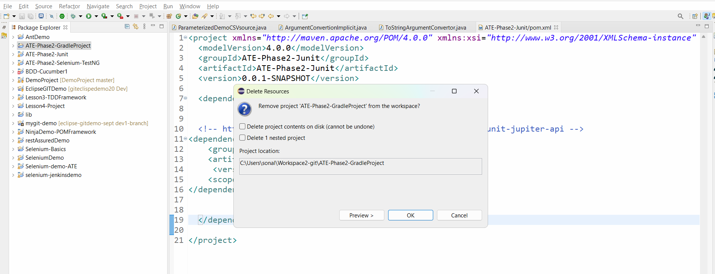

* Press OK
* Delete the lib folder

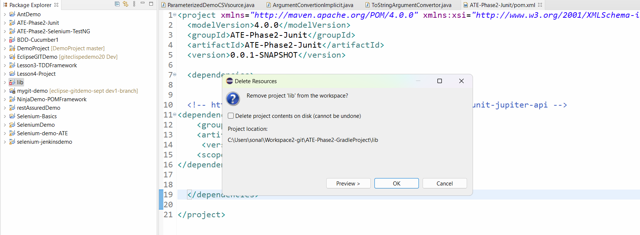

* The gradle project are not there in eclipse but they are present in our local system
* We need to import them to eclipse
* Click on File in eclipse🡪 click on Import

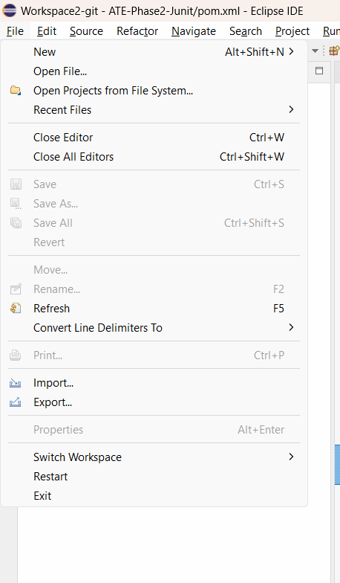

* Select Gradle🡪 importing Exisitng gradle project

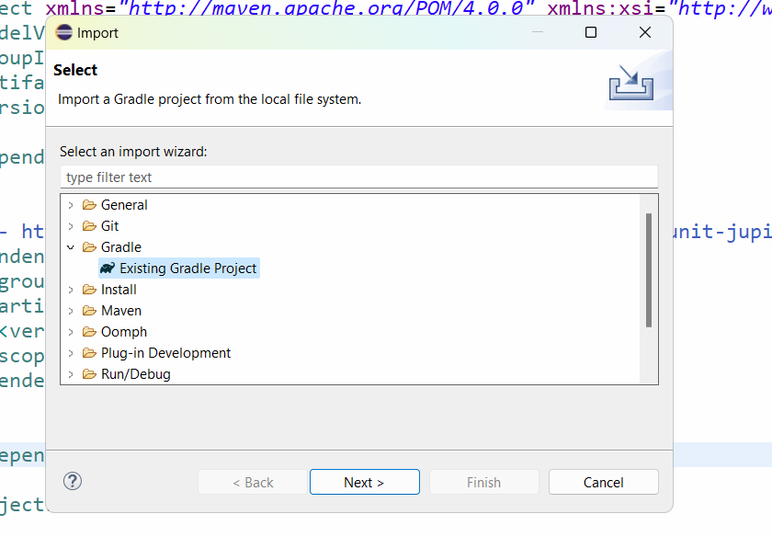

* Press next

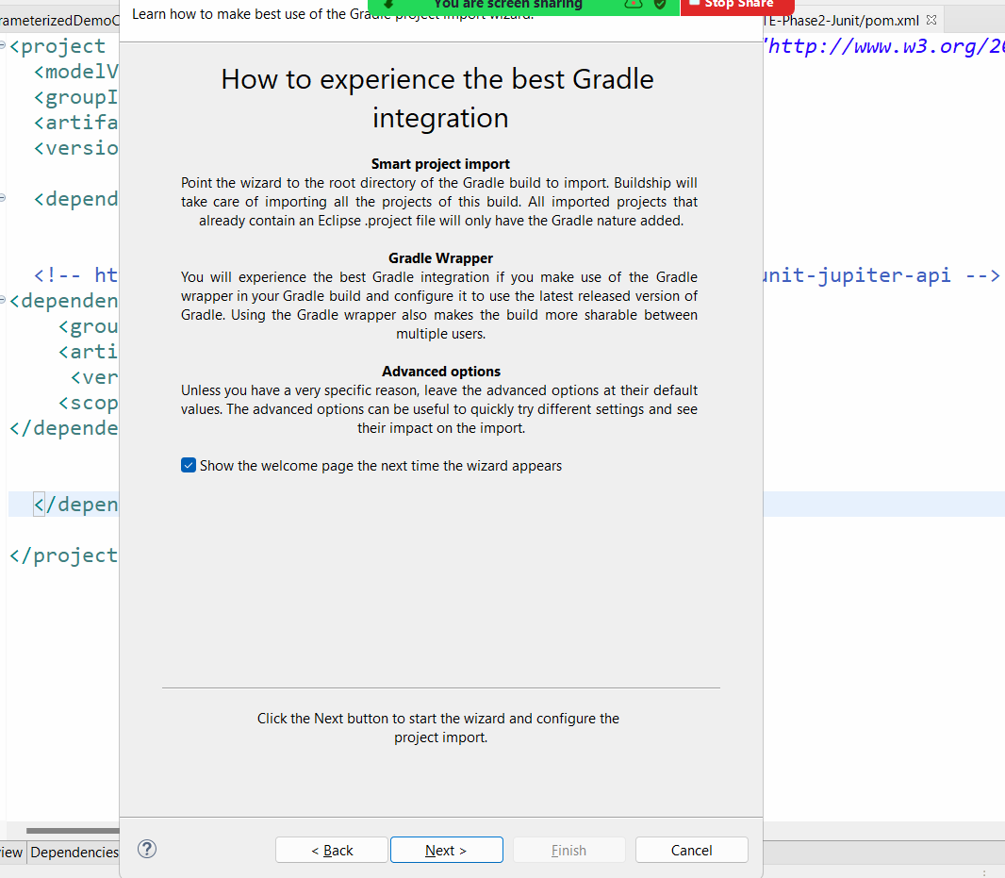

* Press next
* Click on browse button and go to the workspace path >> go to your project folder
* You will have the path of your project populated automatically

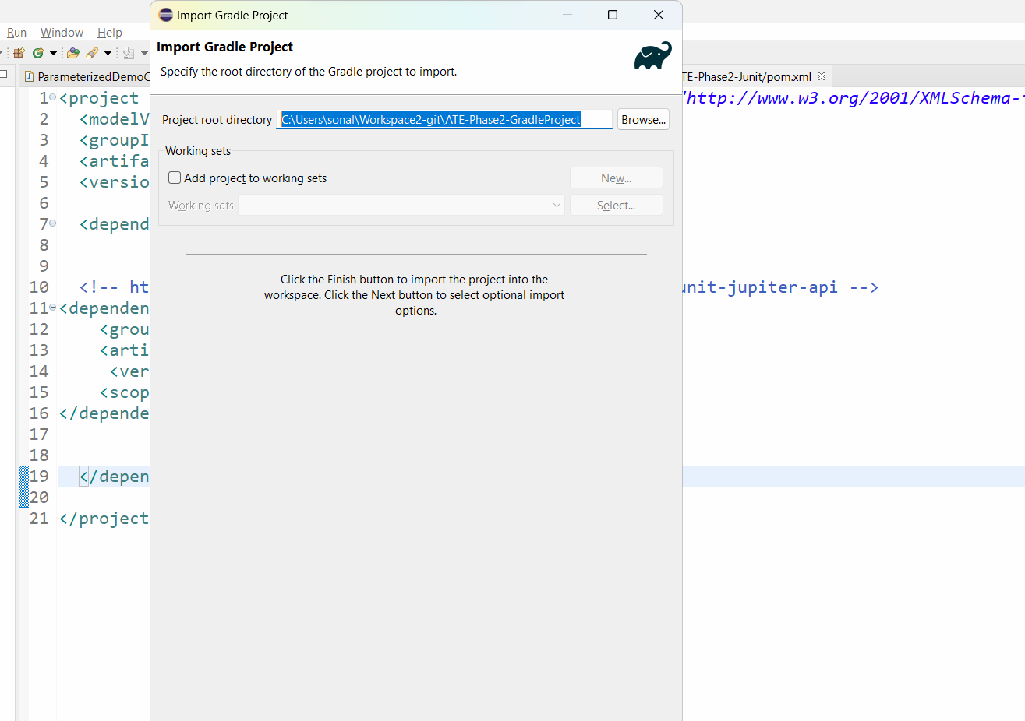

* Press Next and Again press next and click on finish

