Edge Detector Concurrency Experiment

Joshua Crain
December 4th, 2025
CSCI 347

Project Description:

This edge detector project takes in any amount of image files in P6 format to then output a copy named “laplacianX.ppm”, where “X” is an integer beginning from 1, with a Laplacian Filter applied to the image. This is achieved using threading, where each image file is given to a thread and each file thread divides up the work to apply the filter based on N number of additional threads. Each additional thread to divide up the work takes image height divided by the number of threads amount of pixel rows, and then applies the filter to their assigned rows to combine into the full image’s data. Lastly, the program prints the total elapsed time to convert everything, given in seconds rounded to four decimal places.

Two experiments were conducted: One to test different numbers of worker threads (1, 2, 4, 8, 12, …) on one image and how that affects time taken, and another to test the same different thread numbers but on 10 images at once.

Features:

The program is structured as so:
- Main function:
  - This takes the given image file names and initializes an amount of threads equal to the number of image files given. The main function then waits for the processes to complete, and prints the total elapsed time in seconds rounded to four decimal places to convert the given files.
- read file and write file function:
  - These are used to parse the image files for their needed information and to output the filtered image into a new file.
- Manage image file function:
  - This handles the image file assigned to it in a separate process thread. This function calls the functions to read the image file, apply the filters to it, and write the new filtered image file. It also increments the total time taken once finished.
- Apply filters function:
  - This creates N number of threads to divide the work to filter the image. Each thread will take the image height (in pixels) divided by N threads amount of pixel rows. If the number is not evenly divisible, the last thread will convert the remaining amount of work. Once the conversion is done, the time taken is added to the total elapsed time.
- Compute Laplacian function:
  - This function is called from the threads initialized from the apply filters function. It parses through its portion of the image to gather red, green, and blue values for each pixel, and applies the laplacian filter to it based on a 3x3 grid centered on the target pixel. The function then saves these converted values to return towards building the full filtered image.

Data Flow Diagram:

From top to bottom, this diagram represents how data flows through the program, and then chains back up to main once each process completes within manage image file, doing read image, apply filters, and write image in that order.
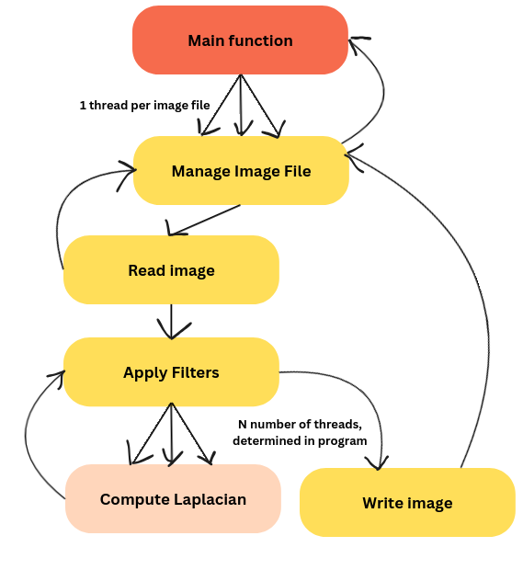
Use of Concurrency:

Threads were used in this project for image processing by processing each inputted image separately and also to divide the workload within each image. One thread per image, and N number of threads to process height in pixels divided by N amount of pixel rows. Synchronization was used in the form of a mutex lock, to safely increment the total elapsed time to filter each image. This was also the only race condition, as the only shared variable between threads is the total elapsed time. The mutex was applied to lock just before incrementing the time taken and unlocked just after to ensure multiple threads cannot update it at once to cause issues, even though it is unlikely as each image can take various amounts of time.

Experiment Setup:

For both experiments, I chose to use the sequence of 1, 2, 4, 8, 16, 20, … number of threads for both one image of input and ten images of input. I also only performed one trial for each thread count, primarily for the time of writing. The same computer was used for consistency. The machine I used was cf164-07 and there are 24 CPU cores on the machine. The amount of threads tested was capped at 32, as there are only 24 CPU cores, but gathering a couple of points of data past that sounded like it would be worth including.

When doing the test on a single image, I incremented the amount of threads between each execution. The same was done for the second test.

Results:

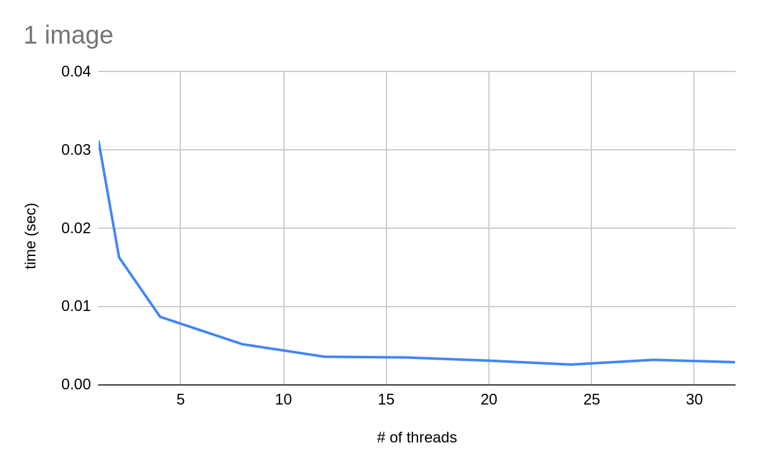
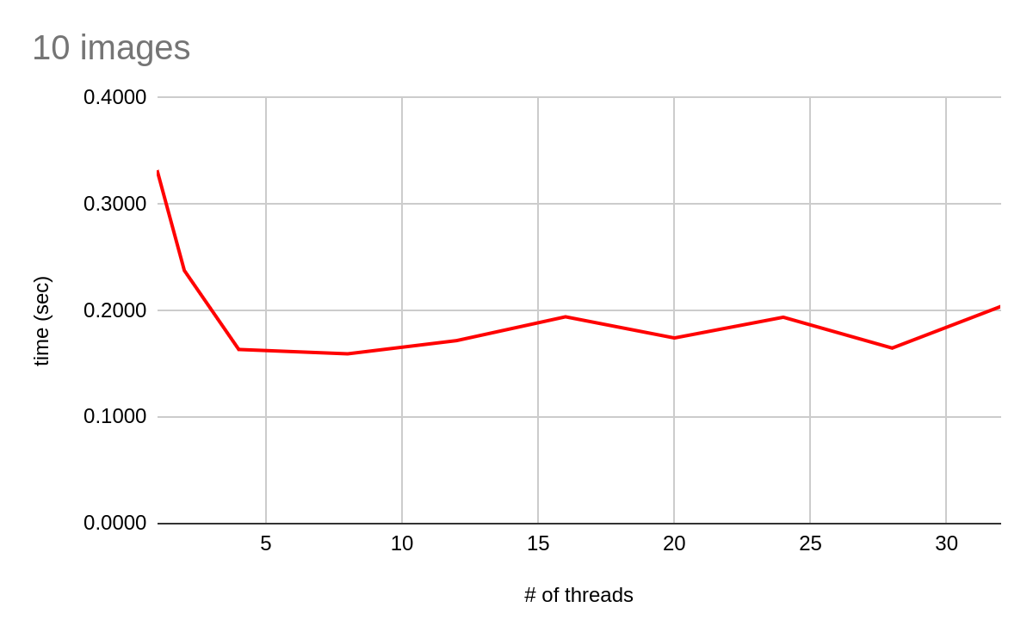
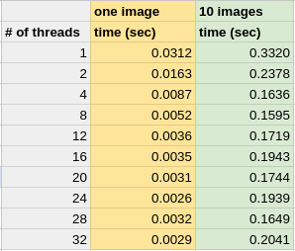
The first graph with a blue line is the # of threads vs. time (sec) graph for doing the test on a single image. The second in red is done on 10 images. A trend for both graphs is that the time taken was exponentially shorter as threads increased, before slowly leveling out at about 14 threads and above. The results look some-what expected to me, as the CPU only has a limited amount of cores. Something I forgot was that there were also more threads being run on the 10 image test, as each image is processed in a thread of its own. This connects to how the time improvement for # of threads with 10 images leveled out sooner, as each image was creating N amount of threads, creating significantly more processes. The thread count that gave the best performance from these tests was 16 threads for one image and 8 for ten images.

According to Amdahl’s law, the speedup of a program will have diminishing returns as resources used increase, with a maximum depending on the amount of work that can be divided. This connects back to the results from the experiments, as the time improvement decreases as the amount of threads increases after a certain point. My implementation and experiment setup also may have influenced the times greatly, due to only completing one trial per thread count rather than averaging multiple of the same trials and my program’s optimizations or lack thereof. The single image benefitted much more and more consistently from the tests than the test with ten images, which I believe is also represented by Ambdahl’s law due to the amount of threads being multiplied by ten.

Conclusion:

From what I learned, there is a benefit to using threads to divide up work in a program, but only up to a certain point. The additional resources required to run additional processes receive diminishing returns after a certain point, requiring more and more resources to achieve an impactful improvement. Threads can be a good way to improve the performance of a program that is doing a long iterative process, such as doing calculations across a matrix of values such as in an image. It’s comparable to loop unrolling where you are dividing chunks of work into bigger segments, which also has a point of diminishing returns.

From my expectations, this experiment was not too surprising, but was interesting to see the rate that a plateau would form for time improvements of the two different experiments. If I was to repeat the project, I would be curious to see how loop unrolling might affect the runtime of the program alongside threads. Would it reach the plateau faster? Would the plateau occur at a lesser amount of time taken? These would be tests I would look into.

