

Computer Games Development CW208

Technical Design Document

Year IV

Joshua Dunne

C00241588

|  |  |
| --- | --- |
| 12/12/2021 | |

# 

Contents

**Technical Design** **2**

**References** **3**

# **Technical Design**

For my custom environment, the Board will be a 2d array of Spaces. This 2d array will be stored within the board class, alongside the Player’s position on the Board, and the Goal.  
The Board will create the 2D array, filling it with Spaces until a specified max column length that is passed in to the constructor.

Each Space will be a simple class that holds an image dictating what type it is visually. The type they are is dictated by what amount they push the Player on the board, and can be changed manually to dictate the start/goal spaces.

The Player’s Robot will be represented independently from the board, but will still adhere to the Board’s position. The Robot will tell the Board which way it wants to move, and will update its visual to face the correct direction. The Board will figure out where the Robot should be placed, and place the Robot in that space.  
If the Robot is over the Goal, the environment ends.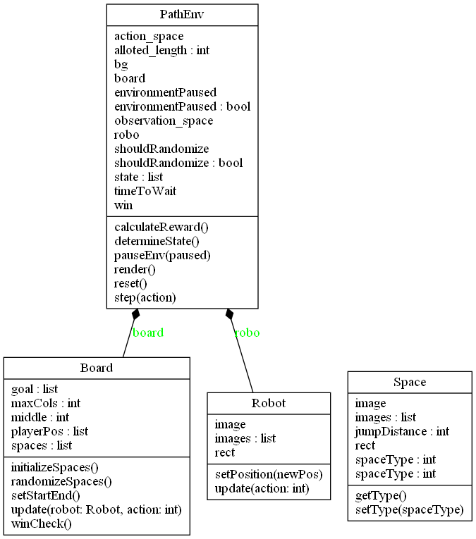

# References

*[1] Renotte, Nicholas. “Reinforcement Learning in 3 Hours | Full Course Using Python.” YouTube, 6 June 2021,* [*https://www.youtube.com/watch?v=Mut_u40Sqz4*](https://www.youtube.com/watch?v=Mut_u40Sqz4)*.*

*[2] Antonin Raffin, Ashley Hill, Adam Gleave, Anssi Kanervisto, Maximilian Ernestus, & Noah Dormann (2021). Stable-Baselines3: Reliable Reinforcement Learning Implementations. Journal of Machine Learning Research, 22(268), 1-8.*

*[3] Greg Brockman, Vicki Cheung, Ludwig Pettersson, Jonas Schneider, John Schulman, Jie Tang, & Wojciech Zaremba. (2016). OpenAI Gym.*

*[4] Tewari, U. (2020, April 14). Which reinforcement learning-RL algorithm to use where, when and in what scenario? Medium.Datadriveninvestor.Com. Retrieved January 27, 2022, from* [*https://medium.datadriveninvestor.com/which-reinforcement-learning-rl-algorithm-to-use-where-when-and-in-what-scenario-e3e7617fb0b1*](https://medium.datadriveninvestor.com/which-reinforcement-learning-rl-algorithm-to-use-where-when-and-in-what-scenario-e3e7617fb0b1)

*[5] Base RL Class — Stable Baselines3 1.5.1a4 documentation. (2020, June 9). Stable-Baselines3.Readthedocs.Io. Retrieved January 27, 2022, from* [*https://stable-baselines3.readthedocs.io/en/master/modules/base.html*](https://stable-baselines3.readthedocs.io/en/master/modules/base.html)

*[6] Moni, R. (2021, December 7). Reinforcement Learning algorithms — an intuitive overview. Medium. Retrieved January 27, 2022, from* [*https://smartlabai.medium.com/reinforcement-learning-algorithms-an-intuitive-overview-904e2dff5bbc*](https://smartlabai.medium.com/reinforcement-learning-algorithms-an-intuitive-overview-904e2dff5bbc)

*[7] Simonini, T. (2019, February 5). Proximal Policy Optimization (PPO) with Sonic the Hedgehog 2 and 3. Medium. Retrieved January 27, 2022, from* [*https://towardsdatascience.com/proximal-policy-optimization-ppo-with-sonic-the-hedgehog-2-and-3-c9c21dbed5e*](https://towardsdatascience.com/proximal-policy-optimization-ppo-with-sonic-the-hedgehog-2-and-3-c9c21dbed5e)

*[8] freeCodeCamp.org. (2018, March 29). An introduction to Deep Q-Learning: let’s play Doom. Retrieved January 27, 2022, from* [*https://www.freecodecamp.org/news/an-introduction-to-deep-q-learning-lets-play-doom-54d02d8017d8/*](https://www.freecodecamp.org/news/an-introduction-to-deep-q-learning-lets-play-doom-54d02d8017d8/)

*[9] Reinforcement Learning Tips and Tricks — Stable Baselines 2.10.2 documentation. (n.d.). Stable-Baselines.Readthedocs.Io. Retrieved January 27, 2022, from* [*https://stable-baselines.readthedocs.io/en/master/guide/rl_tips.html#which-algorithm-should-i-use*](https://stable-baselines.readthedocs.io/en/master/guide/rl_tips.html#which-algorithm-should-i-use)

*[10] Wikipedia contributors. (2022, April 12). Multilayer perceptron. Wikipedia. Retrieved March 24, 2022, from* [*https://en.wikipedia.org/wiki/Multilayer_perceptron*](https://en.wikipedia.org/wiki/Multilayer_perceptron)

*[11] An Overview on Multilayer Perceptron (MLP). (2022, February 21). Simplilearn.Com. Retrieved March 24, 2022, from* [*https://www.simplilearn.com/tutorials/deep-learning-tutorial/multilayer-perceptron*](https://www.simplilearn.com/tutorials/deep-learning-tutorial/multilayer-perceptron)

*[12] Miyoung Han. Reinforcement Learning Approaches in Dynamic Environments. Databases [cs.DB]. Télécom ParisTech, 2018. English. tel-01891805*

*[13] R. S. Sutton and A. G. Barto. Introduction to Reinforcement Learning. MIT Press, 1998.*

*[14] J. Schulman, F. Wolski, P. Dhariwal, A. Radford, and O. Klimov, “Proximal policy optimization algorithms,” arXiv preprint arXiv:1707.06347, 2017.*

*[15] PPO — Stable Baselines3 1.5.1a4 documentation. (n.d.). Stable Baslines 3. Retrieved January 27, 2022, from https://stable-baselines3.readthedocs.io/en/master/modules/ppo.html*