(a) What are the advantages and disadvantages of the client/server and peer to peer multiplayer game architectures?

Client/server’s efficiency depends on the server, and is centralized and less robust than Peer to Peer. All clients accessing the single server can lead to more congestion and slow down the connections for everyone.

Because of the centralized data flow, it’s easier to maintain and allows for better security since all clients must access the same server, as opposed to Peer to Peer where they all have their own copy of a Server.

Client/server architectures can control and record incoming data from other clients, whereas Peer to Peer do not record anything, making it harder to decipher who is doing what.

Client/server allow for a wider coverage for instances, as they all work off the same server. Peer to Peer can potentially cause problems if everyone does not share the same instances, as compatibility will fail.

Client/server all share the one single instance of a server, making it easy for clients to find the server through well known port numbers. Peer to Peer requires everyone to find each other.

(b) In the peer-to-peer network architecture with authoritative host, how the peers communicate with each other? Draw diagrams to aid your explanation if appropriate.

All peers host with well known IPs and Ports to make it easier to find each other for communication. This makes it easy for all Peers to connect to the one Host, and that Host can pass the information of the other Hosts on to the other Hosts as they connect.

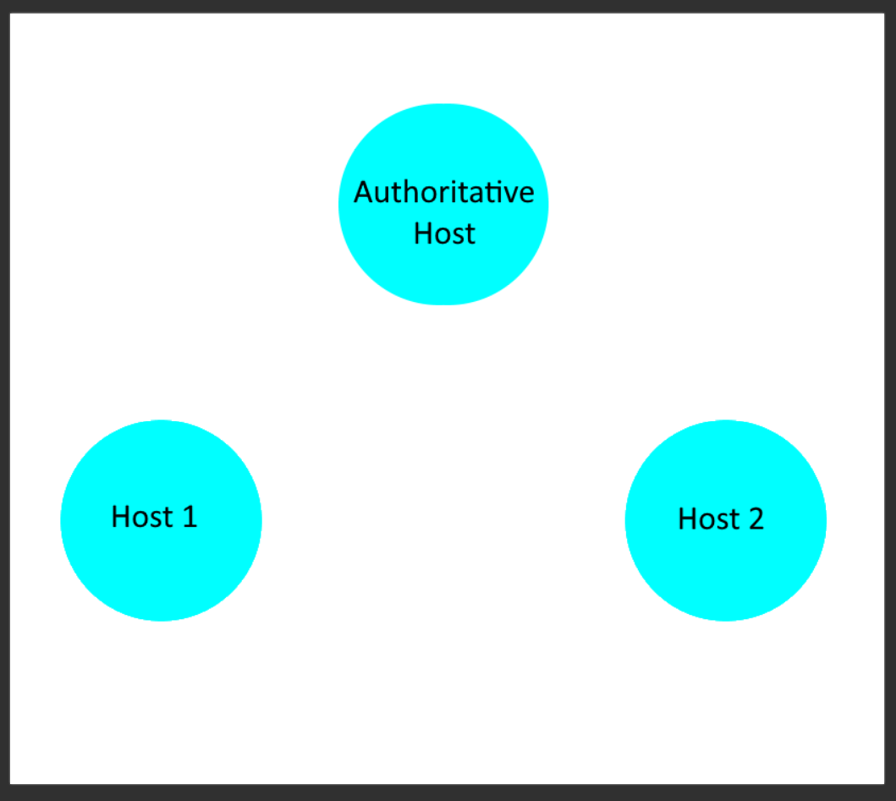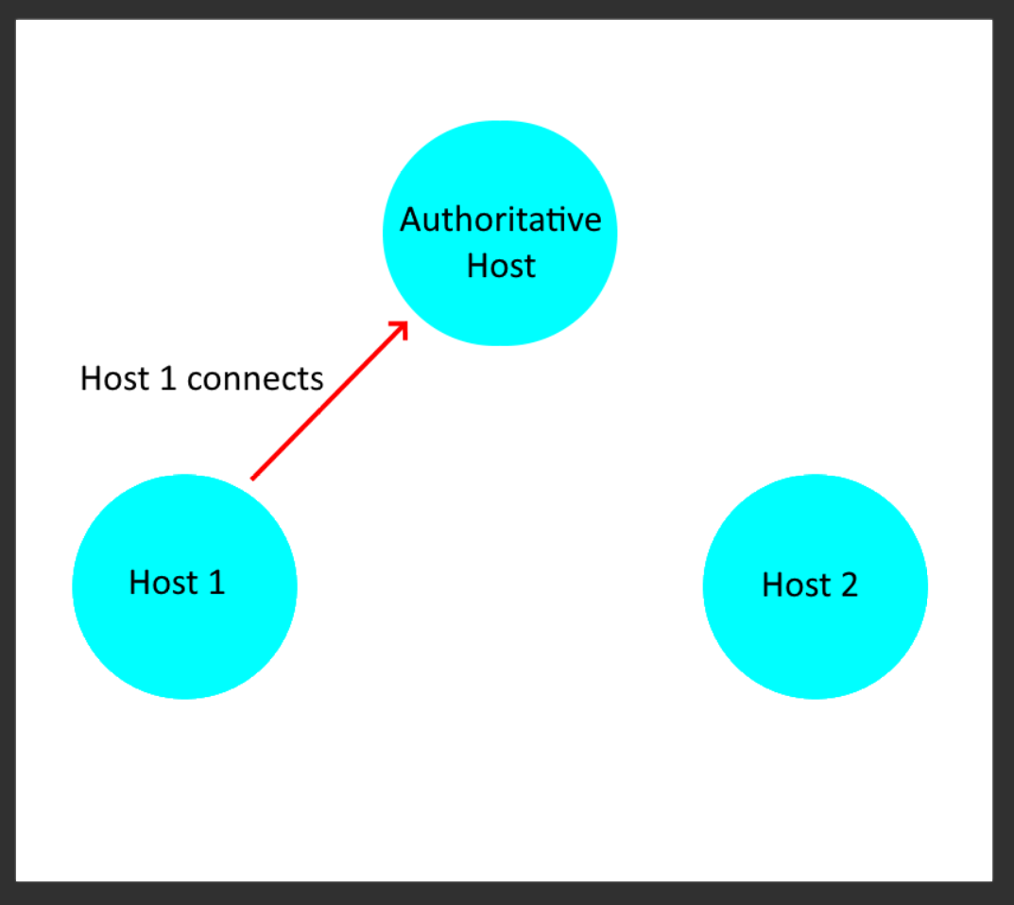

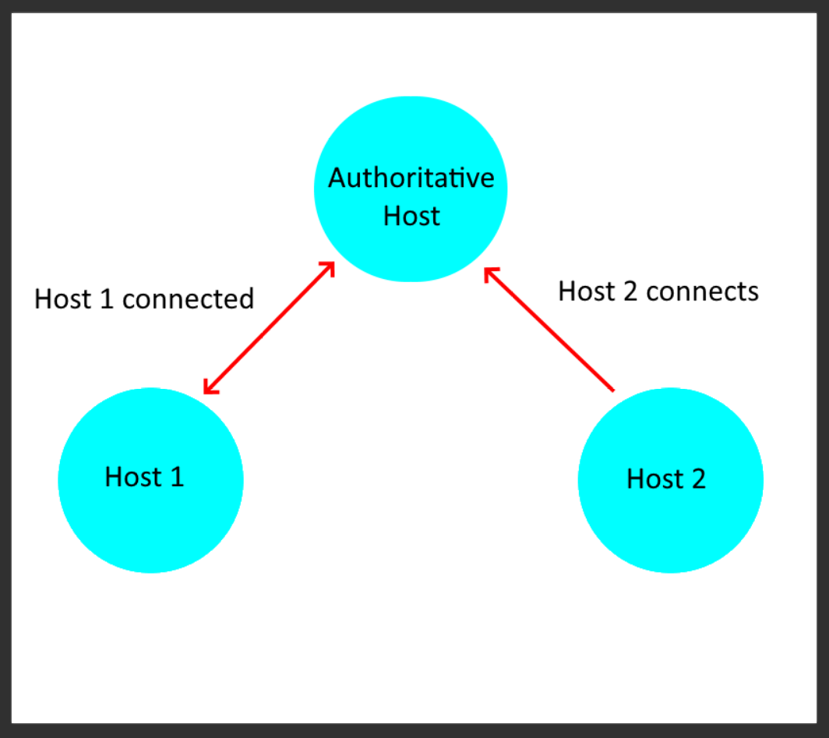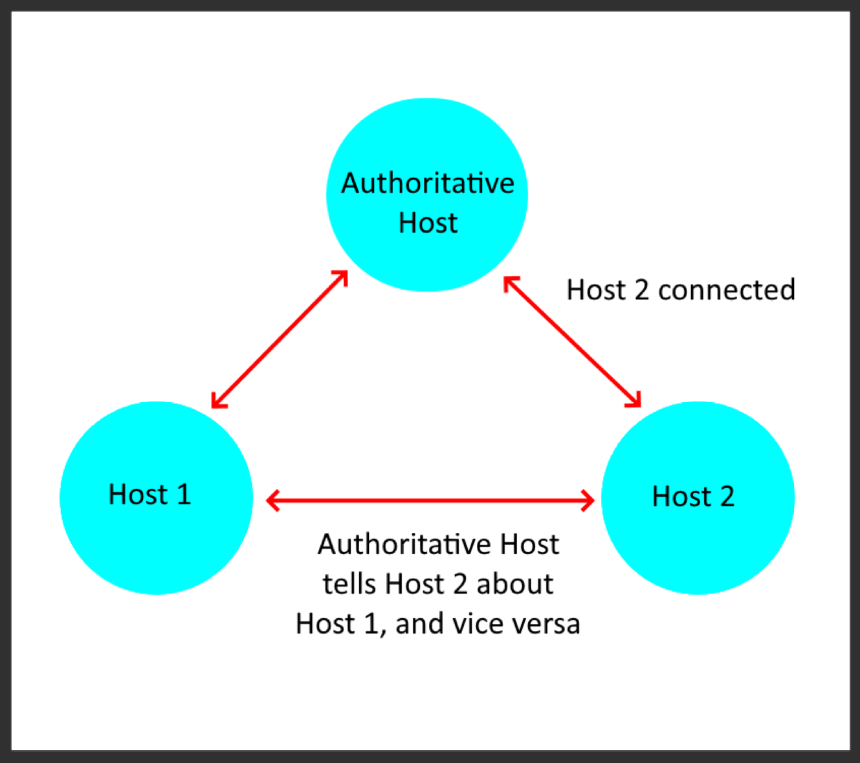

(c) In the context of "port restricted" NAT devices, what does the hole-punching technique do? Describe this technique, using a diagram to aid your explanation if appropriate.