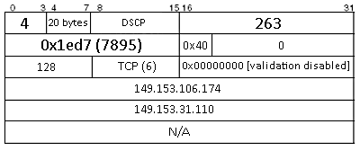3:

4:

IHL: IP Header Length (in 32-bit words)

16-bit total length: Size of datagram (header + data)

-------------------------------------------------------------------------------------

Flags & Fragmentation: Split large messages into series of IP Packets

Flags:

--X More

-X- Don’t fragment

X-- Unused

-------------------------------------------------------------------------------------

TTL: Number of network hops

Protocol: Type of transport protocol to be used

16-bit header checksum: Checksum to detect any corruption of IP header within a router

32-bit source IP address: Address of sending node

32-bit destination IP address: Address of intended receiving node

Options: Timestamp, record route taken, specify list of routers to visit…

Data: Data to be sent to receiving node