1.

TCP segment header

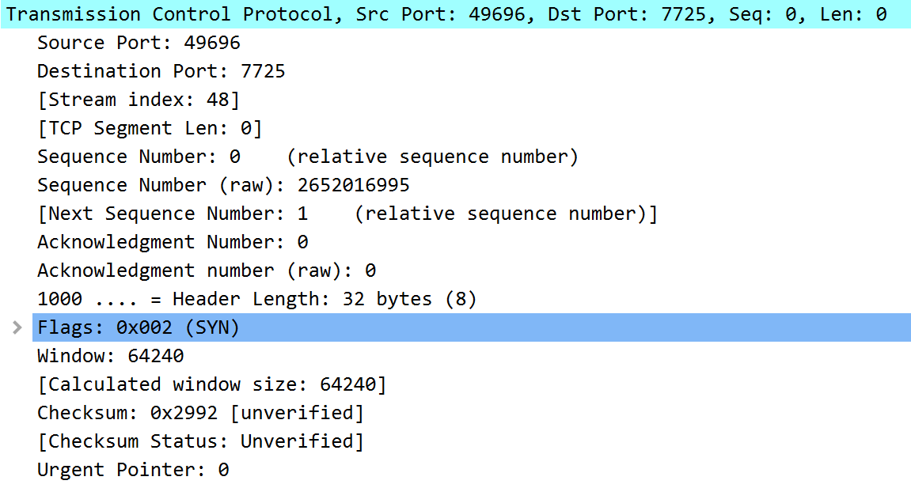

Source Port: Identifies the sending port (16 bits)

Destination Port: Identifies the receiving port (16 bits)

Sequence Number: Contains a SYN flag which dictates it’s role. (32 bits)

If the SYN flag is clear (AKA 0), then this is the accumulated sequence number of the first data byte of this packet for the current session.

If the SYN flag is set (AKA 1), then it is the initial sequence number.

Acknowledgment number: If this flag is set, then the value of this field is the next sequence number that the receiver is expecting. (32 bits)

Data offset: specifies the size of the TCP header in 32-bit words. (4 bits)

The minimum header size is 5 words and the maximum is 15 words, which is a minimum size of 20 bytes and a maximum size of 60 bytes.

Reserved: For future use, usually set to 0 (3 bits)

Flags (AKA Control Bits): Contains 9 1-bit flags. ECE, CRW, NS, URG, ACK, PSH, RST, SYN and FIN.

Window: Size of the receive window, which specifies the number of bytes that the sender of this segment is currently willing to receive (16 bits)

Checksum: Used for error-checking of the header and data. (16 bits)

Urgent Pointer: If the URG Flag is set in the Flags section, this field is an offset from the sequence number indicating the last urgent data byte. (16 bits)

Option: The length of this field is determined by the data offset field.  
(Variable 0-320 bits, divisible by 32)

2.

UDP segment header

🡨------------------ 32 bits --------------------🡪

|---------------------------------------------------------------------------------------------- |  
| Source Port: **57621** | Destination Port: **57621**  |  
|---------------------------------------------------------------------------------------------- |  
| Length: **52** | Checksum: 0x0000462b |  
|---------------------------------------------------------------------------------------------- |  
| Application data (payload) |

| 53706f74556470300eb4b2d2379efeac000100044 |

| 895c203bdda7fbf1f2b9d3d952cd79a5d3746c440bc1fe9 |

|---------------------------------------------------------------------------------------------- |

Source Port: Identifies the sending port (16 bits)

Destination Port: Identifies the receiving port (16 bits)

Length: Length in octets of this user datagram including this header and the data. (This means the minimum value of the length is eight.)

Checksum: The 16-bit one's complement of the one's complement sum of a pseudo header of information from the IP header, the UDP header, and the data, padded with zero octets at the end (if necessary) to make a multiple of two octets.

Application Data: Data sent via UDP

3.

Using Wireshark’s built in verification system for UDP Packet Checksum

Checksum: 0x462b

Binary: 100011000101011

[Calculated Checksum: 0x462b]

[Checksum Status: Good]

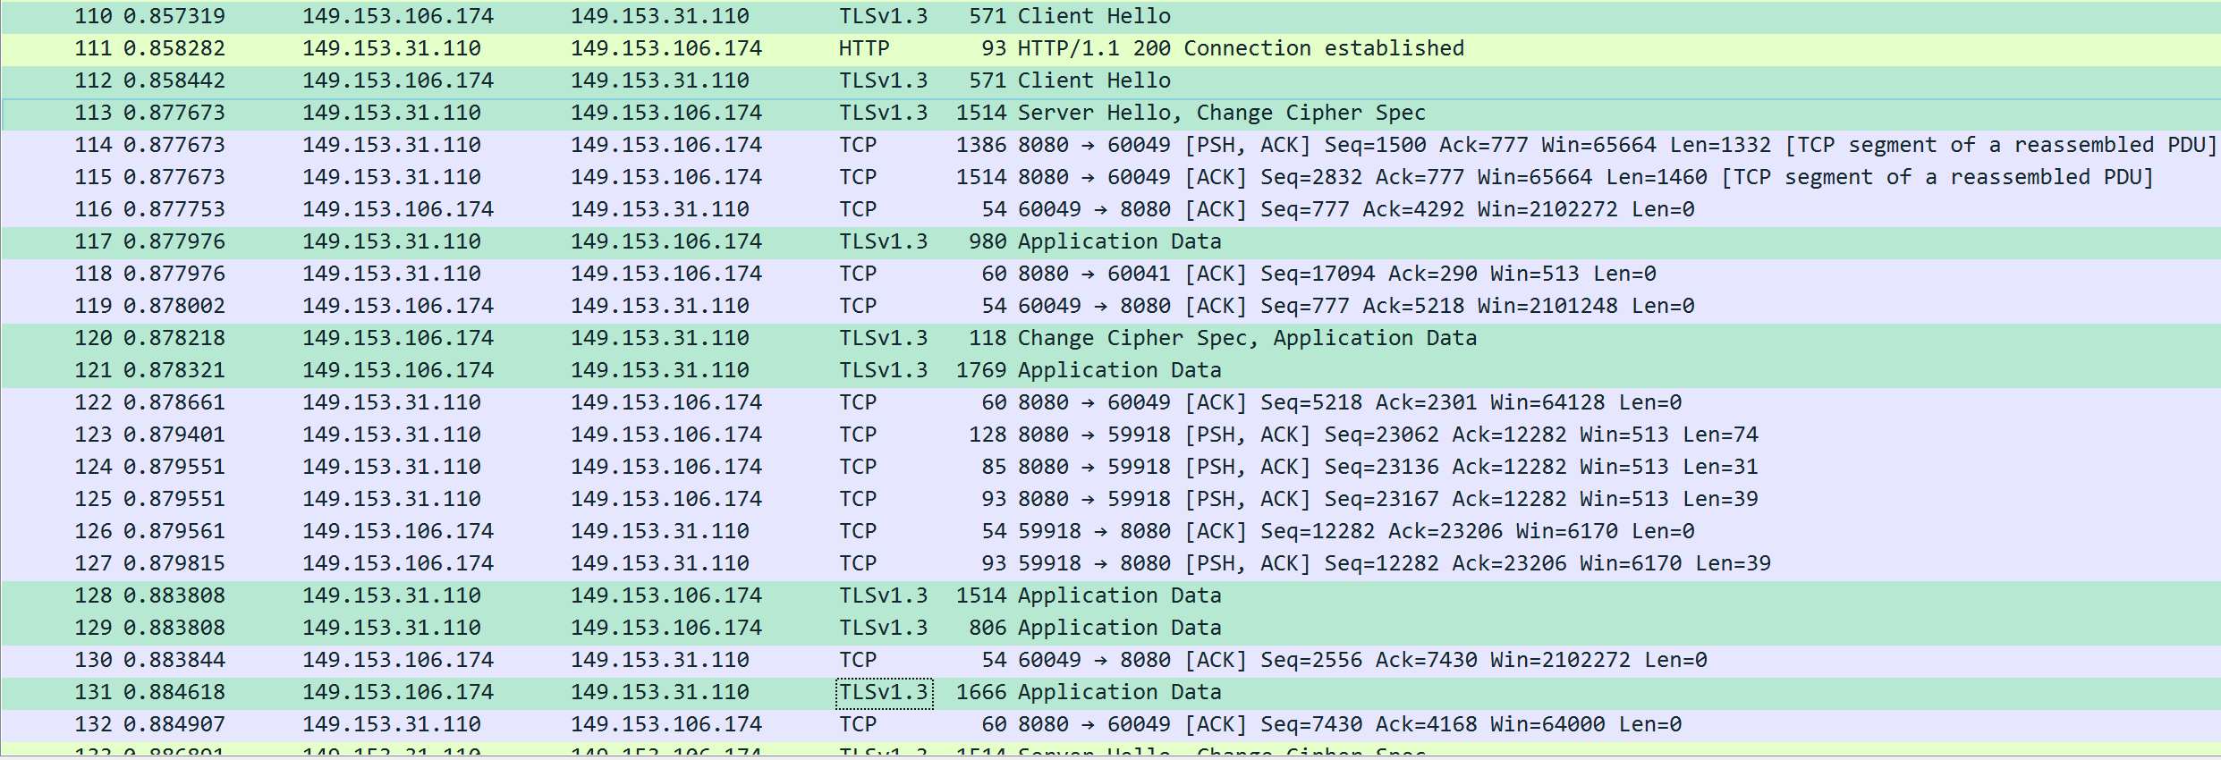4.

While using Youtube streaming a video (screenshot filtered by IPv4 Address of this machine), the most commonly seen packet type was TCP, leading me to believe that this application uses TCP mainly.

5.