FBX Tutorial for Unity

Joshua Gilbert

Step One:

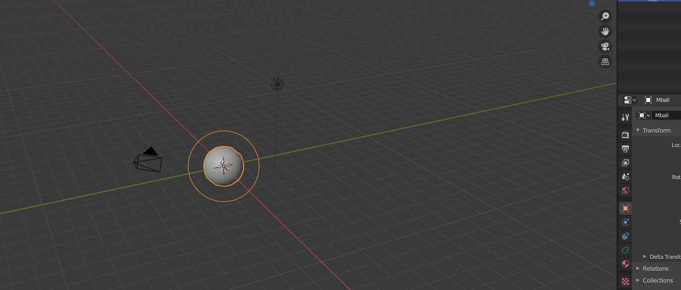

Create object in blender or other rendering software

Step Two:

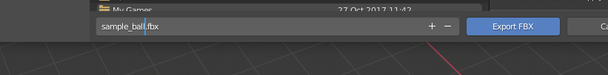

Export as a fbx file.

Step Three: Open Unity and go to import new asset: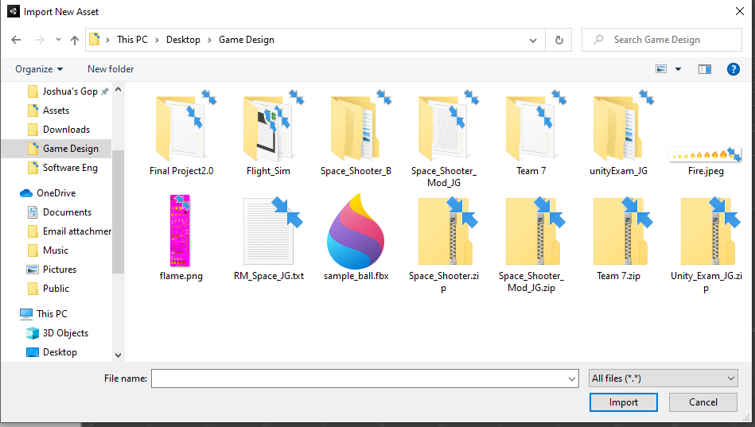

Select Import on the object you want to import and then the object can be used in Unity: