GUIDING DRONE WITH COMPANION COMPUTER
Autonomous Aerial Monitoring and Human-Tracking
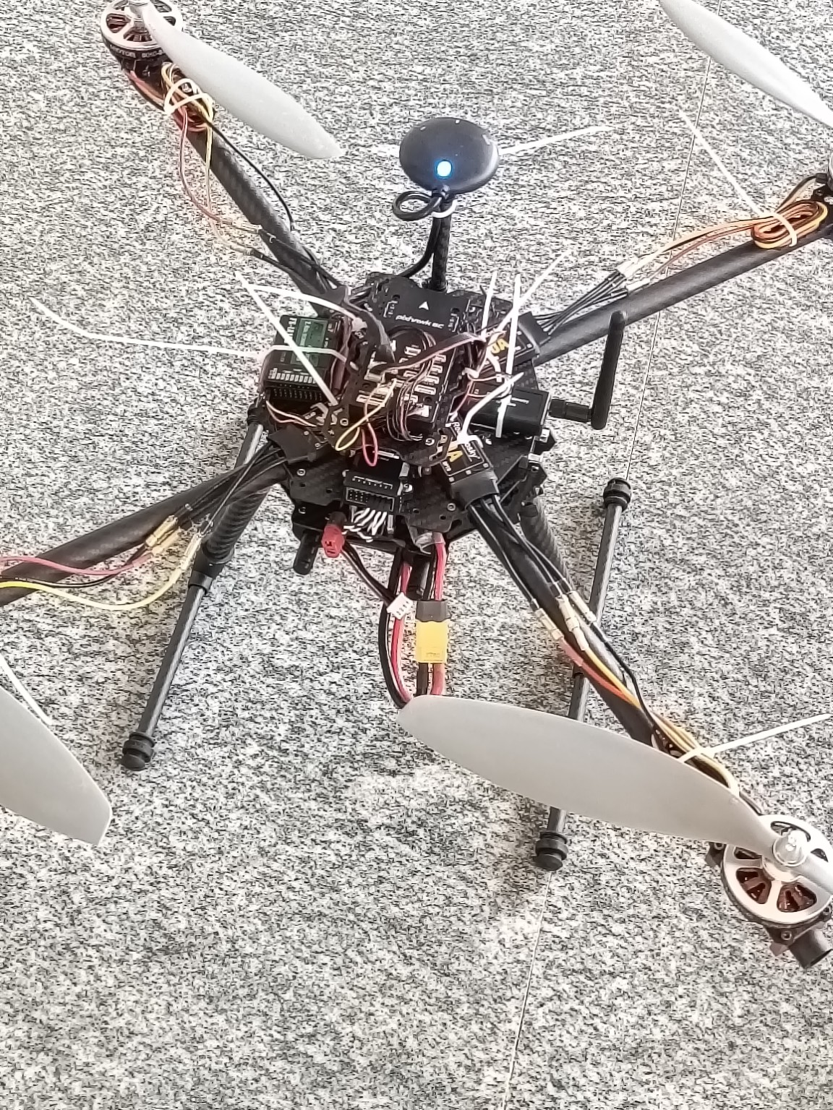
Figure 1. Prototype / final assembled drone

1. Project Overview
The Guiding Drone with Companion Computer is an autonomous quadcopter designed for intelligent aerial monitoring and target-following operations. The drone uses a Raspberry Pi as its companion computer to process camera information and coordinate intelligent functions. A camera module provides visual information, while a video transmission system allows the live aerial view to be monitored on a tablet. The system is intended as a prototype for search, monitoring, and surveillance in areas where direct human access may be difficult.

2. Abstract
The project combines a quadcopter platform with onboard computing and computer vision. The Raspberry Pi receives visual data from the camera and processes it for human detection and target tracking. Based on the programmed guidance logic, the drone can support autonomous search and following operations. The live video link provides situational awareness through a tablet, making the system useful as a foundation for future search-and-rescue, forest monitoring, remote-area observation, and specialized surveillance applications.

3. Components Used
The following components represent the major hardware used in the prototype and its control, power, sensing, communication, and vision subsystems.
No. | Component | Purpose
1 | Raspberry Pi | Companion computer for onboard processing and autonomous control logic.
2 | Raspberry Pi Camera Module | Captures live visual information for monitoring and computer vision.
3 | Flight Controller | Handles the low-level flight stabilization and motor-control interface.
4 | Brushless DC Motors (4) | Provides thrust for the quadcopter.
5 | Electronic Speed Controllers (ESCs) | Drives and regulates the brushless motors.
6 | Propellers (4) | Generates lift and thrust.
7 | GPS Module | Provides positioning information for navigation and location awareness.
8 | Video Transmitter (VTX) | Transmits the camera/video feed wirelessly.
9 | Video Receiver (VRX) | Receives the transmitted video for live monitoring.
10 | Tablet / Display | Displays the live aerial video and supports monitoring.
11 | Quadcopter Frame | Mechanical structure supporting the electronics and propulsion system.
12 | Power Distribution Board (PDB) | Distributes battery power to the drone's electrical subsystems.
13 | Li-Po Battery | Main power source for the drone.
14 | Telemetry / Communication Module | Provides communication and system-status data where configured.
15 | Landing Gear | Supports the drone during take-off and landing.
16 | Wiring, Connectors & Mounting Hardware | Electrical connections and mechanical assembly of the system.

4. Working Flow
The overall operation begins with visual data capture. The Raspberry Pi processes the camera input, performs the programmed detection/tracking functions, and provides guidance information to the flight-control system. In parallel, the video transmission path sends live footage to a receiver and tablet for monitoring.
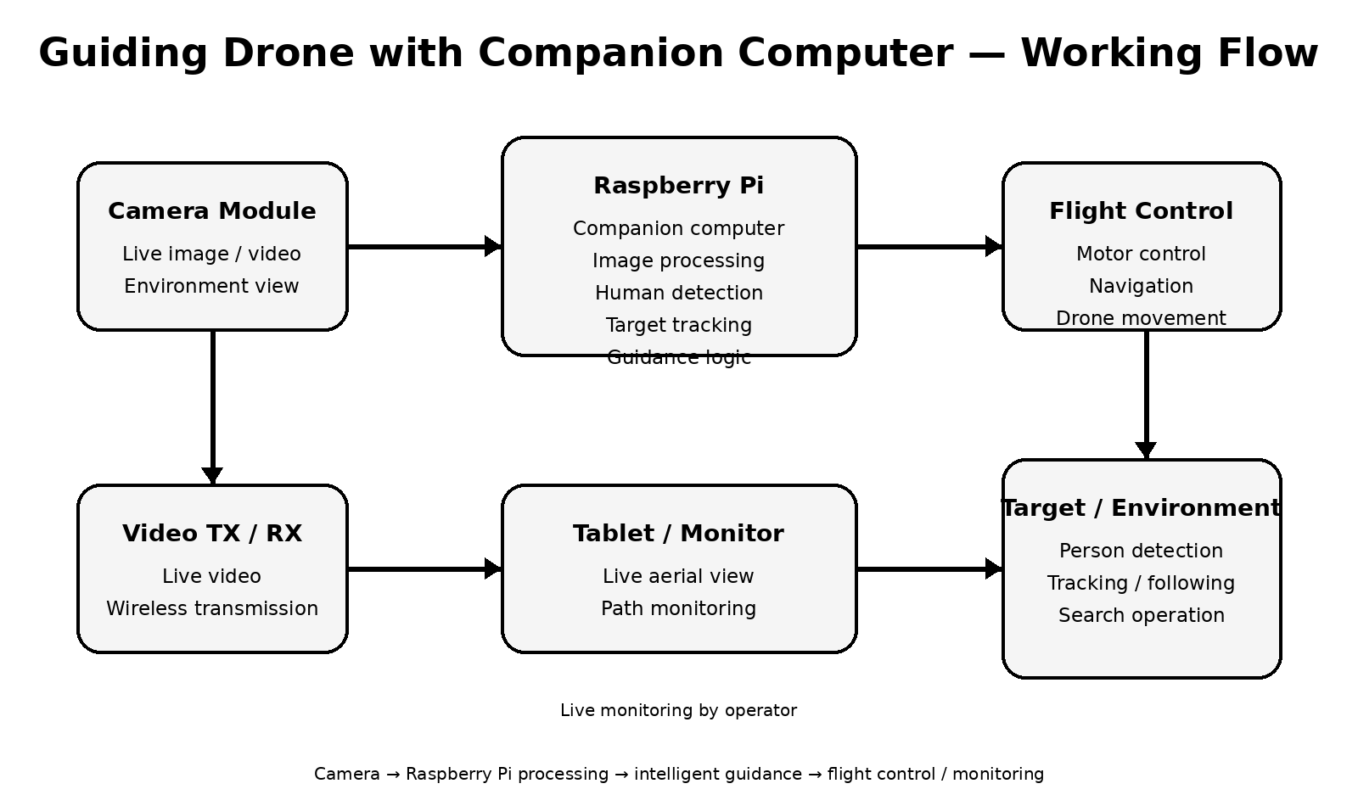
Figure 2. Simplified system working flow

5. Working Principle
- The Raspberry Pi operates as the onboard companion computer.
- The camera module captures the drone's surrounding environment in real time.
- The Raspberry Pi processes the captured visual information using programmed computer-vision logic.
- The system can detect a person and track the selected target when the required vision model and guidance logic are enabled.
- Guidance information is used to support the drone's autonomous movement through the flight-control system.
- The video transmission system sends the live camera feed to the receiver and tablet for aerial monitoring.

6. Potential Applications
- Search-and-rescue assistance
- Forest and remote-area monitoring
- Aerial surveillance and observation
- Human/target search assistance
- Monitoring areas that are difficult or unsafe for direct access

7. Future Scope
Future versions can improve autonomous navigation, obstacle avoidance, GPS-based mission planning, long-range communication, and AI-based detection in challenging environments. The platform can also be adapted for search-and-rescue and other specialized monitoring scenarios by integrating additional sensors and more robust vision models.

8. Project Documentation Note
This document is prepared as a technical project overview suitable for project documentation and a GitHub repository. Component names and system descriptions can be updated to match the exact hardware configuration and software implementation used in the final prototype.

