ECE445L Laboratory Manual
Spring 2026
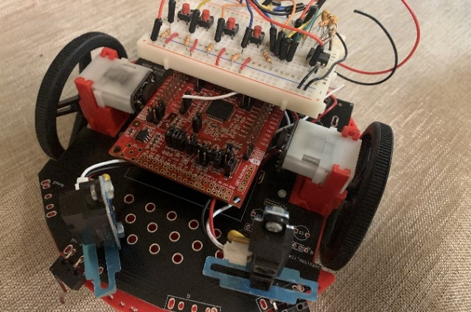

Mark McDermott and Jonathan Valvano
Electrical and Computer Engineering
University of Texas at Austin

In Case of Emergency Dial 911

email: valvano at mail.utexas.edu
web: http://users.ece.utexas.edu/~valvano/
email: mcdermot at ece.utexas.edu
web: http://users.ece.utexas.edu/~mcdermot

This laboratory assignment accompanies the book, Embedded Systems: Real-Time Interfacing to ARM Cortex M Microcontrollers, ISBN-13: 978-1463590154, by Jonathan W. Valvano, copyright © 2024.

ebook: http://users.ece.utexas.edu/~valvano/EE445L/ebook/index.htm

Introduction to ECE445L Laboratory

I.1. Grading Policies (Labs 1, 7A, 7B, 10 have different grading policies)
Groups will consist of exactly two or four students depending on the lab requirements. Lab partners have separate attendance and checkout grades. Lab partners share the preparation, report, software quality, and late penalty grades. For each lab assignment, there are several preparation tasks that must be completed before the laboratory period. The following activities occur in this order at the beginning of lab: you turn in your preparation, the TA will give a short lab lecture, the TA will check your preparation, and if possible, provide feedback to you before you complete the lab. Reports will be due at 11:59pm of the assigned day, submitted to Canvas as a pdf.

Responsibility | Student A | Student B
Attendance  Attendance is an important part of CEE445L. All students must attend all lab sections. | 5 | 5
Preparation  Preparation is a submission on Canvas that is due at the start of lab. Preparation includes both software and hardware. The software should be typed into the computer and compiled with no syntax errors. Preparation does not usually involve running and debugging, but it should not be handwritten. Preparation also includes hardware circuit diagrams. Handwritten diagrams are acceptable for preparation, but diagrams in the report must be generated using a CAD package. Hardware diagrams include chip numbers, pin numbers, resistor/capacitor types and tolerances, and connections to the microcontroller. You are responsible for the procurement of all necessary parts before lab starts. See specific instructions for each lab. | 15
Software Quality (see the section on software style guidelines later on in the lab manual)  - Documentation, comments, choice of good variable and function names  - Proper style, organization, modular structure, ease of understanding | 20
Report  - Final hardware circuit diagrams (must be generated using Eagle)  - Results, performance/data graphs (handwritten/scanned drawings OK) | 25  10  15
Checkout Performance, demonstration to TA  - Performance, correctness of the program function  - Interface to the human operator, menus, error messages | 20
Checkout Understanding, demonstration to TA  - Oral understanding of engineering tradeoffs  - Both students must be present, together, during checkout | 15 | 15
Penalties  - Missing preparation (no late preparations allowed)  - Late report  - Late checkout (no late checkout after 2 days) | -15  -5/day  -2/day
Total | 100 | 100

If a TA other than yours checks out your lab, please email your TA specifying the time, date, lab number, and the other TA’s name. Also, please follow up with both TAs to make sure you got credit for the lab. Please include the following information at the beginning of each of your software files:

1) Students’ names
2) TA name
3) Date of last change
4) Lab assignment number
5) Purpose of the software module
6) Hardware configuration

I.2. Parts

Parts you may need on long term checkout from the lab checkout
3 – Bypass capacitors (any value 0.01 to 0.22uF)
3 – Switches that plug into a protoboard,
1 – 32-ohm speaker or similar (Labs 3, 5)
1 – IRLD024 MOSFET motor driver (Lab 3)
1 – RSLK Robot (Labs 8 and 9)
1 – Microphone (Lab 5)

I.3. Procedures and Policies

FIRST LAB: There are no labs during the first week of classes. Go to your regularly scheduled lab the following week. During this time, you will be introduced to the lab equipment. You will also be instructed on lab procedures and grading policy. If you missed your regularly scheduled lab, attend one of the other lab periods.

LAB PARTNERS: Every student is required to have a lab partner. You will perform all labs with a partner. Students choose their own lab partners during the first week of labs.

LAB EQUIPMENT USAGE: Lab hours are posted in the laboratory. There are no sign-up sheets, but cooperation is expected. If you start debugging on a station, you may stay as long as you like, with three exceptions:
1) You must leave when the ECE labs are closed for the day,
2) You must leave during the first half-hour of the other regularly scheduled lab periods,
3) You may not leave the station unattended for more than 15 minutes.

If you would like to use a station that has been left unattended for more than 15 minutes:
1) Carefully disconnect the hardware,
2) Return all materials (hardware, disks, paper) to the front desk,
3) Leave a note on the station with your name and time,
4) Write a note to the TA describing exact times listing what you turned in.

LAB LECTURE: The purpose of the lab lecture is to provide necessary information to complete the lab. The scope of the lectures will be material relevant to the lab. The lecture will be conducted during the first 15 minutes of each lab session.

LAB PREPARATION: Lab preparation must be performed prior to the regularly scheduled lab period. All software must be written, edited, and designed before coming to the lab. Hardware must be designed down to the pin numbers. Label all resistance and capacitance values and types. For example, 1kΩ 5% carbon, or 0.01µF 5% ceramic. In this way, the lab period may be spent in debugging your system with the TA’s help. The preparation is due at the start of the lab. Preparation includes gathering all the physical components required to perform the lab.

LAB REPORT: There is a Deliverables section that details the specific components required for that lab report. The lab report typically includes the following items:
A) Objectives (1/2 page maximum)
B) Hardware Design. Detailed hardware designs with pin numbers.
Generated using a CAD program like KiCad
Include all external devices used (chips, R’s C’s values and types)
Show connections to the microcontroller board.
C) Software Design (no software printout in the report)
Draw figures illustrating the major data structures used,
A call-graph illustrating the modularity of the software components
Draw data-flow graph showing how data is processed
D) Measurement Data
Whenever appropriate, enter data into MatLab or Excel, or take photographs of the screen. Include graphs and figures as specified in the assignment.
E) Analysis and Discussion (answers to specific questions given in the assignment)

CHECKOUT: A rough draft of your hardware diagrams and your source code listings must be shown to the TA before you demonstrate. If your experiment works, you will be assigned a good score on the performance part. The TA will ask the partners oral questions that test your “understanding” of the computer engineering concepts of the lab. The partners will answer separate questions and receive separate “understanding” grades. You must get your rough draft software listings signed and dated by a TA to prove that the lab was completed in a satisfactory manner. Late checkouts will result in lost points. Ask your TA how to turn in materials.

I.4. SAFETY REGULATIONS

IN CASE OF EMERGENCY DIAL 911

Since there will be times when students will work other than the regularly scheduled lab sections, it is necessary that certain regulations be observed for the convenience and safety of all. Since the possibility of lethal shock exists in those circuits utilizing low potentials, the following should always be observed:
1. Working alone in a lab room is not permitted.
2. Working after regular hours without written permission is not permitted.
3. Work benches must be clear of all coats, knapsacks, and extraneous materials. Coat racks are desired for those desiring this convenience. Otherwise, all materials must be stored under the work area or out of the way.
4. Shoes must be worn in the lab at all times. Shoes represent a significant protection against electrical shock.
5. Smoking, food, and beverages (e.g., coffee) are not permitted anywhere in the lab area.

IN CASE OF INJURY OR SHOCK:
Turn off power, do not move the injured. Start artificial respiration if breathing has stopped. Have someone else call 911 if CPR is needed.

IN CASE OF FIRE:
Turn off the power, call 911, fight fire with available extinguisher, have someone clear the building.

BEHAVIOR CONCERNS:
Are you worried about a student in your class, bothered that your roommate has been acting differently, or concerned about the behavior of a co-worker? Do you have concerns but are not sure what to do? If so, contact the Behavior Concerns Advice line at 512-232-5050.

I.5. Legal Stuff

The opinions expressed in these notes do not necessarily reflect the opinions of the University, its management, or its big-time financial donors. Also, there shall be no bologna, Bevis, mustard, chewing the cables, free lunch, sob stories, running & screaming, whining, hitting, spitting, kicking, biting, or tag backs. Quit it or we’re telling. (Enjoy the course.)

