Observation ID | Time | Location | Region | Notes
91ea9edc-67b4-4211-8532-35deec4a3148 | October 31, 2018 at 18:17 UTC | 5.496N 0.22W | Africa | Useable scene  -Found plastic however it is opposite to the direction of drift. The nearest SAR image is before the planet acquisition however the potential plastic is further out to sea.
86a3fb61-9db1-4df5-82ae-a848e0455a2e | July 4, 2020 at 23:57 UTC | 32.608N 130.558E | Japan | Complete cloud cover around the SAR acquisition (100%) 2 days before there is a useable planet acquisition however no visible plastic potentially before event. Next useable scene after is 8 days later.
cabcd011-9d82-4124-9f9c-120bdc406cf3 | October 12, 2018 at 12:00 UTC | 39.603N 3.468E | Greece | 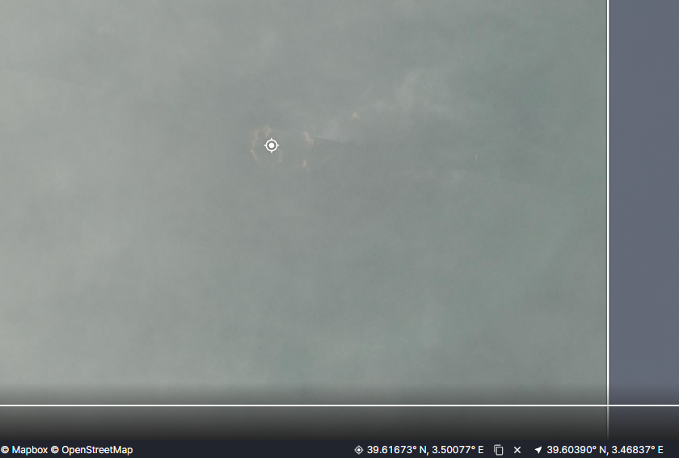
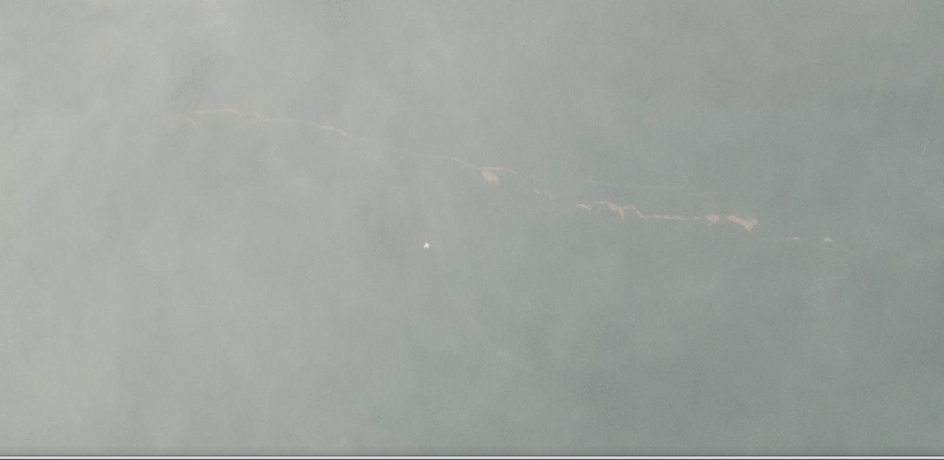

Patches visible along the whole palma de mallorca coast from the 11th of October 2018 onwards.

39.66174° N, 3.46868° E
39.57672° N, 3.42316° E
39.63309° N, 3.54552° E
39.62612° N, 3.37886° E

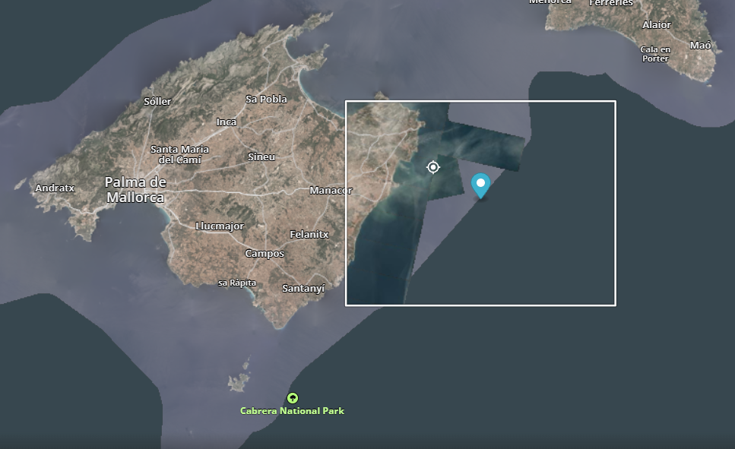
05e7c3bc-2eac-4c4b-ba8a-6bf8aa4c0789 | October 11, 2018 at 12:00 UTC | 39.607N 3.469E | Greece | 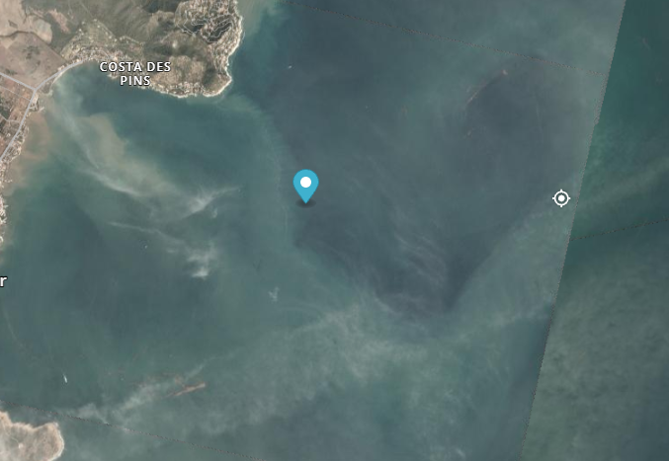
9e17ce98-9eeb-40f6-989e-894dc2be72ea | October 12, 2017 at 23:57 UTC | 16.017N 86.692W | South America | Same debris visible in year after discussed below.
 | October 10-13, 2018 in planet images | 16.17511° N, 86.64093° W  16.26083° N, 86.66296° W  16.16267° N, 86.39596° W  16.08530° N, 86.87297° W | South America | Found by accident – large amounts of visible debris in open ocean.  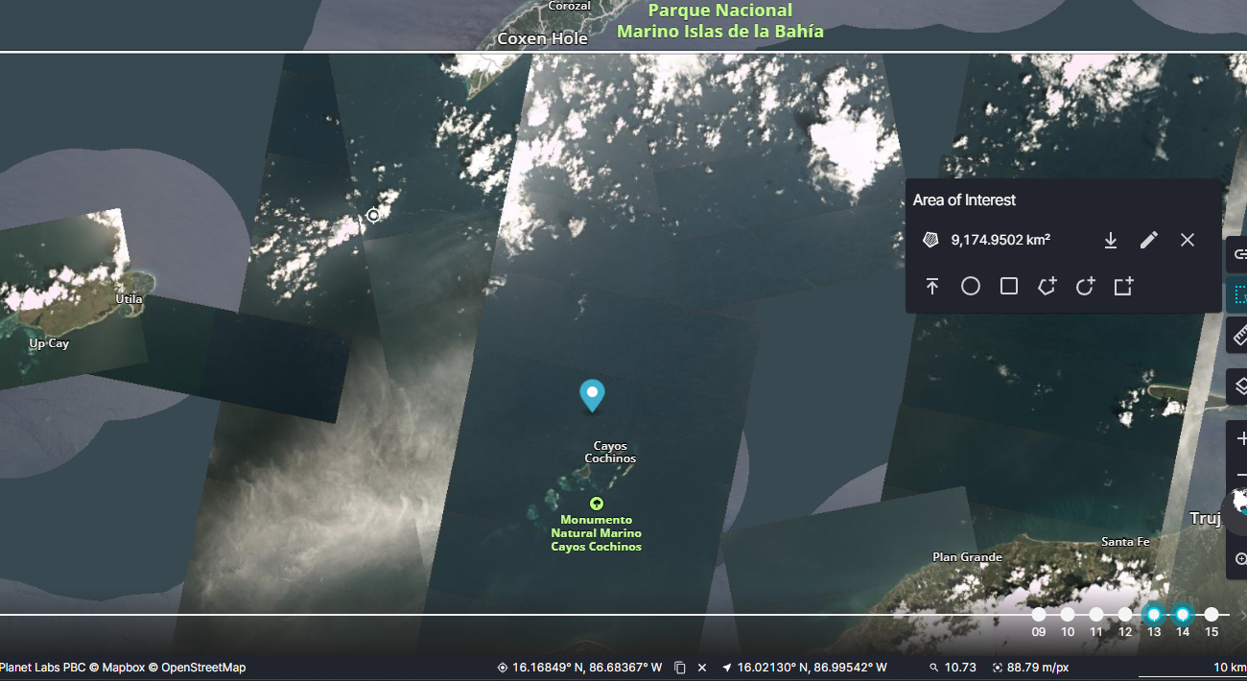
33a32832-fc41-4fdd-8c91-a41844fc1709 | October 17, 2017 at 11:37 UTC | 16.025N 86.392W | South America | Found something at 15.95362° N, 86.77741° W  October 15^{th, 2017,} Planet image.  And 16° 20′ 13″ N 88° 26′ 19″ W  Both difficult to see in the SAR image…  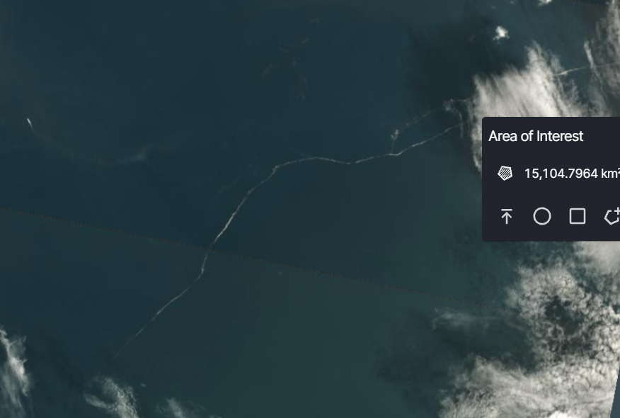

Historical Analysis Findings
Location (BBOX) | Date of planet Image | Notes
29° 49′ 33″ S 31° 15′ 07″ E  29° 48′ 40″ S 31° 15′ 26″ E  29° 47′ 09″ S 31° 16′ 09″ E  29° 45′ 18″ S 31° 17′ 59″ E  29° 45′ 42″ S 31° 04′ 01″ E  29° 45′ 46″ S 31° 19′ 23″ E  29° 59′ 32″ S 31° 07′ 59″ E  (Durban) | 24/04/2019 | Should look 24th onwards..  Big long patch of debris at the mark where river water meets seawater. Thin patch.  Lots of ships around need to watch out for false positives.  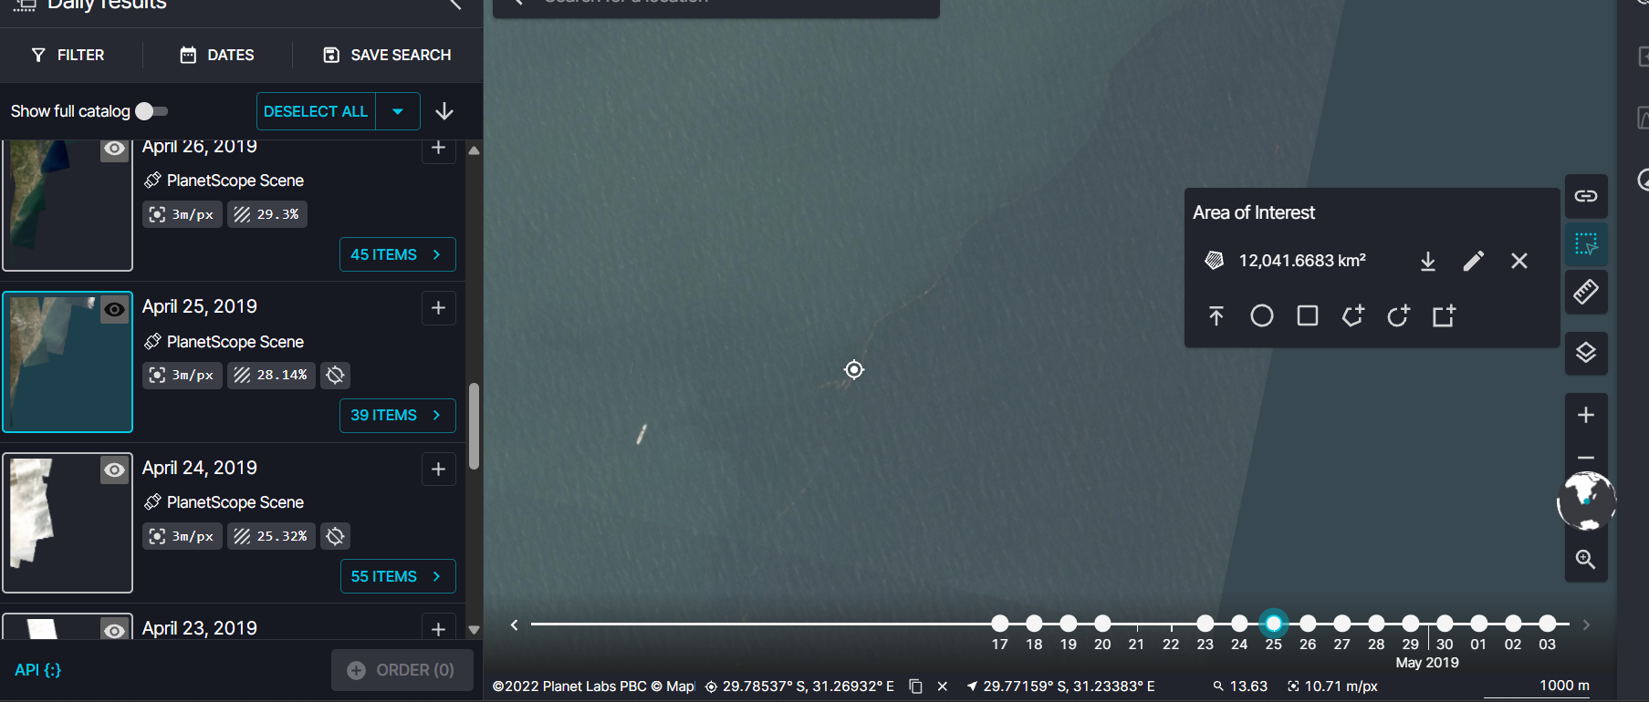
29° 50′ 25″ S 31° 03′ 02″ E  29° 57′ 14″ S 31° 03′ 42″ E  29° 56′ 47″ S 31° 03′ 06″ E  (Durban) | 25/04/2019 | Same as the day before except further south and some accumulation towards the harbour.
29° 34′ 14″ S 31° 16′ 06″ E  29° 34′ 35″ S 31° 16′ 27″ E  29° 41′ 58″ S 31° 15′ 24″ E  29° 42′ 21″ S 31° 13′ 27″ E  29° 47′ 11″ S 31° 13′ 31″ E  29° 47′ 11″ S 31° 13′ 31″ E  29° 49′ 30″ S 31° 10′ 27″ E  (Durban)  On the 15th  29° 43′ 40″ S 31° 19′ 56″ E still some visible | 14/04/2022 | 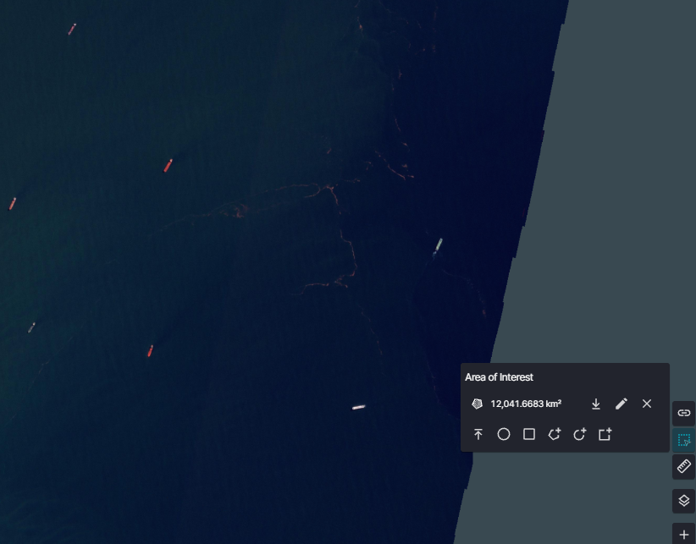  After large amounts of flooding recorded on the 11th of April onwards. So we would expect to see plastic closer to shore on the 11th – 12th and then further out on the 14th which is seen in the planet images. Too much cloud cover during flood though.  But visible debris patches across the area on the 14th out to sea.  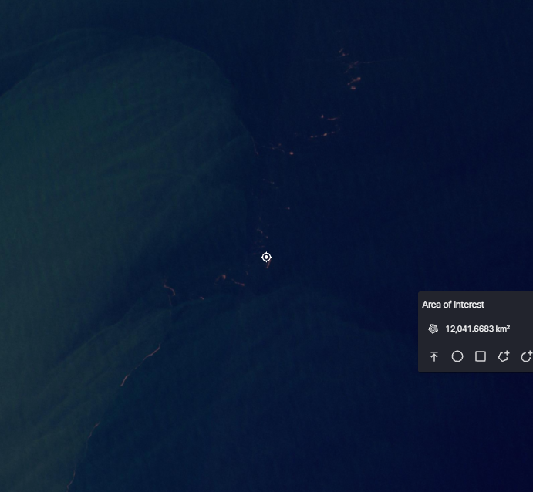
29° 55′ 58″ S 31° 05′ 35″ E  29° 55′ 33″ S 31° 05′ 40″ E  29° 44′ 36″ S 31° 10′ 24″ E | 24/04/2022 | 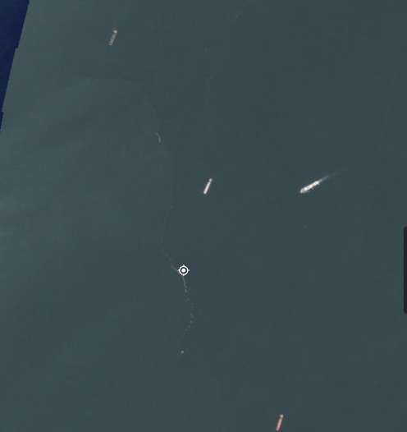  Still visible debris long after the flood event happened. Could be a nice case to track the drift of the debris.
East London  32° 55′ 51″ S 28° 19′ 24″ E  32° 54′ 17″ S 28° 21′ 10″ E | 13/06/2024 | 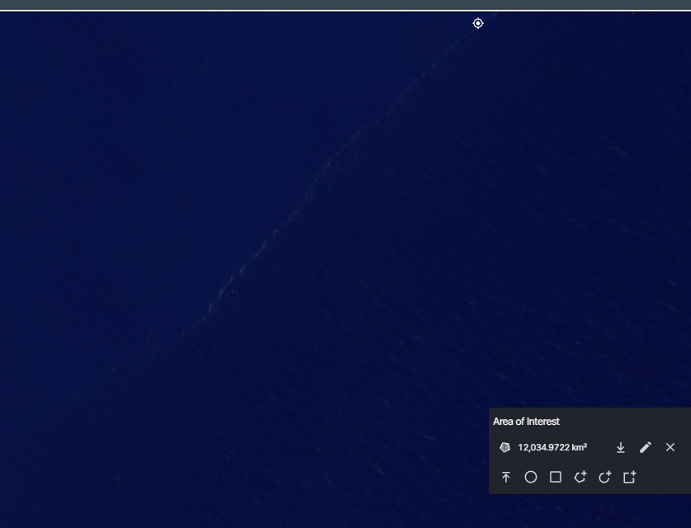  Flood was before the 4th of June but too much cloud cover until the 13^{th.} Still visible on the 13th further out to sea.
33° 13′ 47″ S 27° 35′ 45″ E  33° 07′ 50″ S 27° 44′ 23″ E | 06/06/2024 | 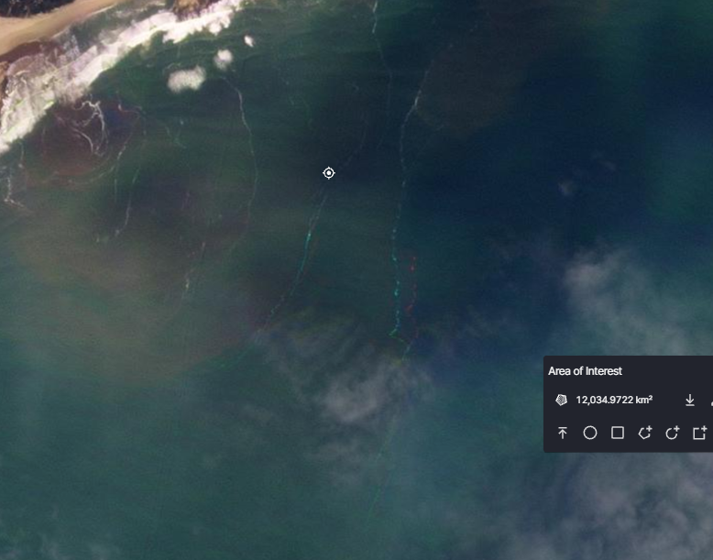  Small section with no cloud cover – could be debris.
33° 14′ 22″ S 27° 43′ 41″ E | 04/06/2024 | Small section with no cloud cover – could be debris
Gqeberha  33° 59′ S 25° 11′ E  34° 03′ 49″ S 25° 26′ 35″ E | 09/06/2024 | 