2.4 Synthetic Aperture Radar (SAR) for Plastic Detection

2.4.1 Synthetic Aperture Radar Overview
Synthetic Aperture Radar (SAR) is an active imaging technology that generates images by emitting microwave signals towards a target area and then capturing the reflected signals, known as backscatter. SAR can operate at any time and in all weather conditions regardless of cloud cover as the formation of an image is not reliant on reflected sunlight but rather on received backscatter after the emitted microwaves from the sensor interact with the target, being a significant advantage over optical sensors.
SAR operates in several frequency bands including, increasing in wavelength, Ka-Band, Ku-Band, X-Band, C-Band, S-Band, L-Band and P-Band. These bands are suited to different applications, longer wavelength bands can penetrate through cloud cover more effectively but operate at a lower spatial resolution while shorter wavelength bands are more affected by cloud cover but can capture finer surface features (Johansson et al., 2017). This trade-off needs to be considered regarding what is required from the SAR imagery and the aim of the application for the choice of an effective band.
SAR systems can be designed with different polarization characteristics including single and dual modes. Single polarisation uses a single polarisation direction, either horizontal or vertical, for both transmitting and receiving signals these are denoted as VV or HH for Vertical-Transmit, Vertical-Receive and Horizontal-Transmit, and Horizontal-Receive respectively. This is the simplest form of SAR and is suited for applications involving smoother surfaces without a large amount of vertical variability such as water or soil monitoring ( NASA-ISRO SAR Mission (NISAR), 2025). Dual polarisation refers to when a sensor transmits in one polarisation either horizontal or vertical and receives in two polarisations, both horizontal and vertical. This polarisation has been shown to be more effective over single polarisation in applications where small vertical changes separate targets, such as vegetation monitoring. The additional cross-polarised channel in dual polarisation imagery provides more information on the target surface allowing for the separation of scattering mechanisms as well as the ability to calculate radar-based indices, such as the cross-correlation index as the division of the VH value by the VV backscatter value (Mandal et al., 2020). Quad polarisation extends dual polarisation by transmitting and receiving in both directions creating all four combinations namely, VV, VH, HV and HH. Quad-pol SAR allows for full polarimetric decomposition, which can separate the dominant form of scattering per pixel (Hajnsek and Desnos, 2021). Decomposition, however, requires phase data to be preserved.
SAR data can be obtained in different product forms, two of the most widely used include Ground Range Detected (GRD) Single Look Complex (SLC) data. SLC data refers to SAR products that are composed of complex valued radar signals meaning each pixel retains information on the amplitude and phase of the returned signal. SLC pixels are represented in a slant-range coordinate system, meaning they retain the full resolution of the sensor (Marghany, 2020). GRD data are SAR products that have been multi-looked and projected to ground range coordinates. Multi-looking refers to the process of averaging neighbouring pixels to improve radiometric resolution while producing square pixels in a regular grid, while this reduces speckle noise in SAR images, it comes at the cost of reducing spatial resolution (Copernicus, 2014). Pixels in GRD images contain only information of the intensity of backscatter, with phase information omitted. Unprocessed Sentinel-1 SAR GRD and SLC scenes are shown in figures 1 & 2 below.
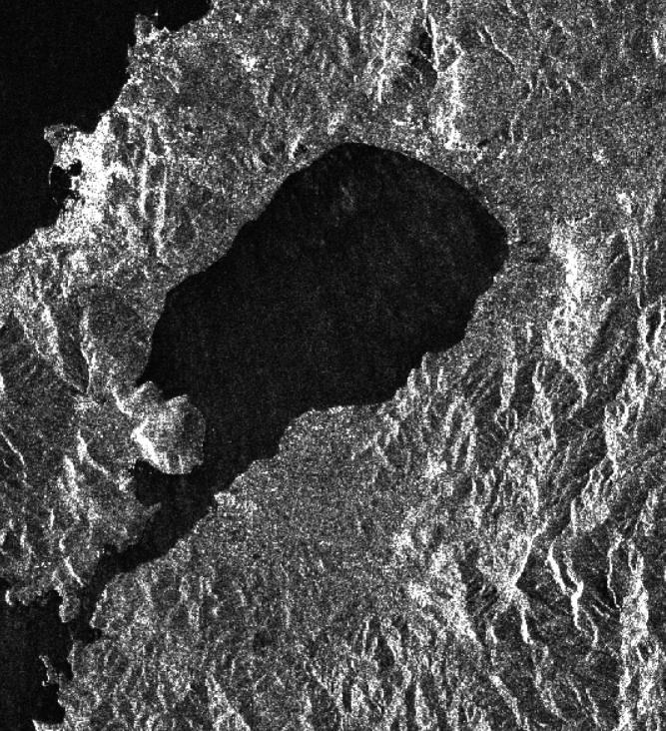  Figure 1: Unprocessed S1 GRD image. | 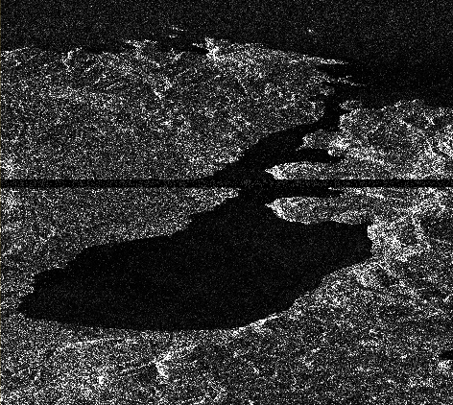  Figure 2: Unprocessed S1 SLC image.

The choice between SLC and GRD data depends on the application and thus the information required. GRD data does not retain phase information meaning it is suitable for applications that only require backscatter intensity values such as general landcover mapping or large object detection. Uniform pixel sizes allows for simpler detection model design as differences in range and azimuth object sizes do not need to be considered (Sørensen, Heiselberg and Heiselberg, 2024). GRD images are more lightweight and have a greater amount of preprocessing applied when compared to SLC data, this makes it preferred for tasks where only backscatter intensity is required, and the resolution lost through multi-looking does not significantly hinder performance. SLC data retains phase, providing more information per pixel, allowing for the derivation of polarimetric information and coherence. The full spatial resolution, while introducing complexity at range views, allows for the detection of finer targets than that in GRD data while using the greater information content, that can be extracted from the retained phase information, to separate targets. With regards to plastic detection using SAR, a case for fine not well contrasted target identification, it was found that including SLC-based parameters such as coherence were beneficial in detecting floating objects (Simpson et al., 2022).
Past backscatter intensity, several different features can be extracted from SAR imagery to improve the separation between targets. Texture features consider the spatial arrangement of pixel intensities rather than single pixel intensities. To derive texture features from SAR imagery a Gray Level Co-occurrence Matrix (GLCM) is calculated which produces measures such as contrast, homogeneity and entropy. These features allow for the spatial context of objects to be considered which can improve object detection accuracy (Li et al., 2022) .
When phase data is retained, as in SLC data, polarimetric features can be derived. Polarimetric decomposition calculates parameters which quantify the dominant form of scattering and the degree of randomness of scattering for an object (Ferro-Famil and Pottier, 2001).
(Not sure here if I should go into the different types of decomposition and the values derived?)

2.4.2 Ocean Surface Physics
- SAR and ocean Scattering mechanisms, from papers on oil and ship detection with SAR.
-In depth on the physics of it (Bragg, Volume, double-bounce)

2.4.2 Floating Plastic and SAR Signal Returns
The principle behind SAR detection of plastics lies in how floating debris alters the roughness of the water surface and thus the received backscatter by the sensor. Floating plastics can both reduce or increase backscatter depending on the type of plastic and the conditions of the surrounding water (de Fockert et al., 2024). Large dense collections of macroplastics tend to increase surface roughness through creating ripples in the surrounding water generating brighter SAR returns. In contrast, microplastics dampen capillary waves causing reduced surface roughness and thus a lower SAR return. The differences in dielectric constants at the boundary between materials also plays a role in the signal received by the SAR sensor. The dielectric constant of water is high while that of air is very low, this allows for the clear separation of water and air in SAR imagery while the dielectric constant of air and plastics are similar. Therefore, for the separation of plastics and water surface roughness would be the dominate physical mechanism influencing the received SAR signal (de Fockert et al., 2024). Wind at the surface of the ocean largely influences surface roughness and thus the backscatter received by the sensor therefore, to accurately separate the influence of surface conditions on the radar signal from that of floating plastics wind speed should be considered and factored into detection methods (Topouzelis, Papakonstantinou and Garaba, 2019). The detection of floating plastics with SAR is thus complex as both dark anomalies, reduced backscatter, and bright anomalies need to be considered as potential litter collections while removing the influence of noise from wind or other unwanted targets. Machine Learning (ML) models can learn these complex patterns in SAR data while accounting for variations in sea surface conditions.

2.4.4 Plastic Lookalikes in SAR

Talk about look alike and why the wind, current and SST data can help reduce false positives
- Windrows
- Oil
- Whitecaps/rough sea
- Current lines

