Developing a Synthetic Aperture Radar based dataset and machine learning model for the detection of Floating Marine Plastics in the South African Exclusive Economic Zone

By Joshua Pretorius
Supervised by:
Dr. Bolelang Sibolla (UP)
Dr. Shelley Haupt (CSIR)
Prof. Terence Van Zyl (UJ)



Submitted in partial fulfilment of the requirements for the degree of Master of Science in Geoinformatics in the Faculty of Natural and Agricultural Sciences University of Pretoria
2025
Contents
1. Introduction 3
1.1 Background 3
1.2 Problem Statement 4
1.3 Aim 4
1.4 Objectives 4
1.5 Research Significance 5
2. Literature Review 6
2.1Chapter Overview 6
2.2 Marine Plastic Pollution 6
2.1.1 Classification of Floating Plastics 6
2.1.2 Sources and Aggregation of Marine Plastics 7
2.1.3 South African Context 8
2.3 Monitoring Marine Plastic Pollution 8
2.3.1 In-Situ Surveys 8
2.3.2 Remote Sensing 9
2.4 Synthetic Aperture Radar (SAR) for Plastic Detection 10
2.4.1 Synthetic Aperture Radar Overview 10
2.4.2 Floating Plastic and SAR Signal Returns 11
2.5 Machine Learning 11
2.5.1 Overview of Machine Learning 11
2.5.2 Computer Vision 12
2.5.3 Self-supervised Learning 12
2.5.4 Attention Mechanisms 12
2.6 Available Labelled Data for Marine Plastic Detection 12
2.7Related Work 14
2.8 Research Gaps 14
3. Methods 15
3.1 Study Area 15
3.2 Data Sources 18
3.3 Pre-processing 22
3.4 Training Data Extraction 24
3.5 Machine Learning Model Development 25
3.7 Ethical Considerations 26
4 References 27
5 Ethical Clearance Forms 32

Introduction

1.1 Background
Marine plastic pollution is a pressing global issue that poses significant environmental, economic and health risks. It is estimated that 8 million tonnes of plastic enter oceans annually (Tanhua, Gutekunst and Biastoch, 2020), with this figure projected to double by 2030 (Goncalves and Faure, 2019).
Plastics are durable and are slow to degrade, therefore once they reach the ocean, they can persist for a long time in marine environments. One of the primary environmental concerns of marine plastic pollution is entanglement and ingestion by marine organisms often resulting in injury and death, this being a direct effect of marine plastic pollution (Arabi and Nahman, 2020). Indirect effects are also of environmental concern, such as plastics acting as a substrate for invasive species, allowing for transport beyond their species reach increasing the risk of invasion. Furthermore, when plastics sink and accumulate on the seafloor benthic smothering can occur, covering species on the seafloor such as corals, preventing filter feeding and light penetration (Naidoo, Rajkaran and Sershen, 2020). These being a few examples of the numerous ecological concerns that arise from plastic in oceans. Beyond ecological impacts, marine plastic pollution poses risks to human health.
An increase in plastic in the environment increases bioaccumulation of plastic in organisms through ingestion down the food chain. Humans with diets rich in seafood ingest significant amounts of microplastics with estimates of individuals ingesting up to 11,000 microplastic particles each year (Alberghini et al., 2022). Plastic in the human brain, lungs and blood has been documented with the amounts of plastic having increased by up to 50% from 2016 to 2024 (Nihart et al., 2025). Marine plastic pollution also carries significant economic costs threatening the blue economy.
The blue economy is a concept that involves the sustainable use of ocean resources for economic growth while protecting marine ecosystems(Fabinyi et al., 2021) . Plastic pollution threatens the blue economy by degrading marine ecosystems while simultaneously hindering economic contributions from oceans. This occurs through the reduction in tourism in coastal areas, decreased fish stocks, increased expenditure on clean-up operations, and threatening the ability of oceans to provide ecosystem services (Nahman, Oelofse and Haywood, 2025). With all these considered factors it is estimated that the cost of marine plastic pollution exceeds 2 trillion USD annually (Iroegbu et al., 2021).
South Africa faces significant challenges with marine plastic pollution. It is estimated that 40000 tonnes enter the ocean from South African land annually (Verster and Bouwman, 2020). In developing countries, such as South Africa, marine plastic pollution is of great concern as economic growth outpaces the ability to manage increased waste and the infrastructure thereof (Issifu & Sumaila, 2020). South Africa’s coast plays an important role in the economy through tourism, fisheries, and ecosystem services. Plastic pollution threatens these economic contributions (Arabi & Nahman, 2020), the total estimated cost of marine plastics is R14.1 billion per year (Nahman, Oelofse and Haywood, 2025). To prevent economic loss, damage to marine ecosystems and minimize the risk to human health it is important to monitor the distribution of floating plastics for targeted clean up and management operations. Remote sensing poses as a potential solution, allowing for large scale and frequent monitoring.
Remote sensing has proven as a valuable tool for the detection of floating marine plastic, particularly the use of Optical imagery (Cernian, 2025). With the development of indices that separate floating plastics from background water, such as the Floating Debris Index (FDI) (Biermann et al., 2020) and the Plastic index (PI) (Topouzelis et al., 2020), as well as sensor specific datasets that allowing for the validation of optical detections (Kikaki et al., 2022). While effective in detecting floating plastics, optical imagery is reliant on clear-sky conditions and therefore, detection is not possible when there is cloud cover. This limitation is particularly disadvantageous with regards to the detection of floating marine plastics as it prevents monitoring at critical times, such as during floods when large amounts of land-based plastic are washed into oceans (Emmerik, 2024). Synthetic Aperture Radar (SAR) could be a promising alternative.
SAR systems can penetrate through clouds, allowing for consistent monitoring regardless of conditions and time of day (Simpson et al., 2022).The detection of floating plastics has been shown to be feasible based on the plastics altering the sea surface texture and thus the backscatter received by the sensor (Simpson et al., 2024). However the use of SAR for the detection of marine plastics is largely underexplored, with little available labelled data for SAR detections (Danilov and Serdiukova, 2024). Limited labelled data prevents the training of models to distinguish between floating plastic from other targets as well as the validation of models trained using SAR data (Janga et al., 2023).

1.2 Problem Statement
South Africa faces environmental, economic and health threats should the issue of marine plastic pollution not be addressed. There is limited research on the scalable detection of floating marine plastics using remote sensing in the South African Exclusive Economic Zone, which limits the ability to plan well-targeted clean-up operations and prevention strategies. In the existing literature, there is a reliance on optical imagery for the detection of marine debris, which is hindered by cloud cover. This prevents monitoring during critical times, such as during floods, when large amounts of plastic enter oceans. To overcome this constraint there is a need to explore the use of data sources that can operate regardless of cloud cover, such as Synthetic Aperture Radar (SAR). However, the use of SAR for detecting marine debris is largely undeveloped. The absence of annotated training datasets for SAR data prevents the development and validation of marine plastic detection methods for consistent monitoring.

1.3 Aim
Building on the need for consistent, reliable marine plastic detection methods, this study aims to develop a SAR-based method to detect floating marine debris in the South African EEZ.

1.4 Objectives
- Conduct a systematic literature review on the use of SAR to detect marine plastics with a focus on AI-based methods.
- Create a labelled dataset for SAR marine plastic detection in the SA EEZ.
- Augment the created dataset to increase the dataset size and improve the generalisation of models trained using the dataset.
- Train and evaluate machine learning models for the detection of marine plastics using SAR.
- Integrate biophysical variables into the detection framework to enhance accuracy.

1.5 Research Significance
The importance of addressing marine plastic pollution stems from the numerous adverse impacts on the economy, environment and human health as a result of its accumulation. Having the ability to accurately and consistently monitor floating marine debris would allow for better-targeted mitigation efforts. By creating a training dataset for SAR observations this study will contribute to the development of SAR-based methods for continuous observation, enhancing the ability to respond to marine plastic pollution in South Africa and globally.

Literature Review

2.1Chapter Overview
This chapter examines the existing literature on the detection of Marine Plastics using remote sensing and machine learning. It begins by providing context on the problem of Marine Plastic Pollution globally and then within the SA EEZ. Thereafter remote sensing approaches applied in previous studies to the detection of marine plastics are described and their shortcomings are noted. SAR is then introduced as a potential alternative and how it is suitable for the detection of marine plastics is discussed. The importance of machine learning coupled with high quality labelled data is then explored. Finally, research gaps in the consulted literature are identified to justify this study.

2.2 Marine Plastic Pollution

2.1.1 Classification of Floating Plastics
Plastic is lightweight, durable and inexpensive, making it the material of choice in numerous applications (Nayanathara Thathsarani Pilapitiya and Ratnayake, 2024). While the durability of plastic makes it highly suitable for applications such as packaging, it leads to its long-term persistence in the environment. Polypropylene (PP) and polyethylene (PE) due to their mouldability and lightweight properties are the two most common plastics produced and therefore the most found in oceans as pollutants. These plastics are not biodegradable and therefore can persist for centuries in oceans making them of large environmental concern. The composition of plastics influences whether they are more likely to float on the ocean surface or accumulate on the seafloor. PP and PE are less dense than seawater which allows them to float and disperse on the sea surface, thus may be detected by satellite imagery. Denser plastic polymers such as Polyvinyl Chloride (PVC) and Polyethylene Terephthalate (PET) are more likely to sink accumulating lower in the water column (Thushari and Senevirathna, 2020).
Plastic pollution found floating in marine environments can be classified based on size, ranging from tiny nano-plastics to large macro-plastics. This classification is shown in Table 1 below.
Table 1: Classification of plastic pollution (Thushari and Senevirathna, 2020)
Plastic Type | Size Range | Description
Megaplastic | > 1000 mm | Very large items such as buoys and nets.
Macroplastic | 20 mm – 1000 mm | Large visible items such as bottles and plastic bags.
Mesoplastic | 5 mm – 20mm | Intermediate fragments; degraded macroplastics.
Microplastic | < 5mm | Primary Microplastic are small, manufactured plastics such as cosmetic beads.  Secondary Microplastics are degraded mesoplastic.
Nanoplastic | < 1 µm | Extremely small plastic particles, formed through microplastic fragmentation.

Plastics floating on the surface do not tend accumulate alone, marine debris is a term that refers to collections of plastic and associated materials such as driftwood and floating vegetation (Danilov and Serdiukova, 2024) the factors driving this accumulation are discussed in Section 2.1.2 below. In this study the focus is primarily on collections of macroplastic, which make up more than 95% of plastic mass in the ocean (Kaandorp et al., 2023), and associated features as marine debris. While microplastics pose significant ecological risks their size and tendency to disperse on the surface make monitoring collections with satellite imagery unviable.

2.1.2 Sources and Aggregation of Marine Plastics
Most plastics that occur in oceans originate from land-based activities from which plastics are transported by rivers, run-off or direct dumping accounting for 70-80% of marine plastic (Thushari and Senevirathna, 2020). Rivers are considered the largest transporter of plastic into oceans, specifically those that run through urban areas before discharging into the ocean (Meijer et al., 2021). Natural disasters such as floods that cause an increase in run off mobilise plastics on the ground and allow for transport into rivers and eventually into oceans (Lincoln et al., 2022). Once plastics reach the ocean from one of these pathways, they have two primary fates namely floating on the ocean surface or sinking to the sea floor where they will ultimately degrade into microplastics (Jamali and Mahdianpari, 2021). It is estimated that only 1% of the plastic present in oceans is floating on the surface while the remaining 99% is on the seafloor or in the sea’s interior (Fauvelle et al., 2021).This is a disheartening statistic as once lost from the surface it is largely more difficult to detect and manage. Plastics that reach the seafloor are more likely to persist for longer as they are no longer affected by wind or UV rays which speed up degradation (Oluwoye et al., 2023). It is therefore important to have strategies in place to detect floating plastics before they are lost from the surface. On the surface plastics are exposed to several ocean surface dynamics that influence their movement and where they accumulate.
Floating material on the ocean surface, including plastics, accumulate where surface flow converges (Nakakuni et al., 2024). Surface flow converges through several different mechanisms at different scales, these include windrows, tidal and frontal convergence and on a large-scale ocean gyres. Windrows refer to long streaks of marine debris that align with wind. These form where under sustained wind Langmuir Cells converge, causing surface downwelling, trapping debris on the surface while forming narrow patterns of debris accumulations that can extend kilometres in length. Plankton also tend to accumulate in windrows making them biologically active zones, increasing the risk of plastic ingestion and entanglement by marine organisms (Aliani et al., 2022). At the boundaries between water masses that differ in salinity, temperature or density, frontal convergence zones are formed which can hold floating marine debris (Shanks, 2021). This may occur where currents meet or near rivers mouths where water fresh water converges with ocean water. Frontal convergence zones form predictable zones of short-term aggregations of floating debris which could point to areas that need immediate observation (van Sebille et al., 2020). Near to the coast dynamics are complex and the movement of floating plastics is dependent on tides, reefs, shelfs and local currents which influence wheter plastics beach, sink or are carried out into open ocean (Shanks, 2021). At a large-scale ocean gyre from large garbage patches in open ocean. Ocean gyres are large circular systems of ocean currents driven by global wind patterns, forming predictable loops of surface flow accumulating floating plastics (Leal Filho, Hunt and Kovaleva, 2021). There are six major ocean gyres which each have an associated garbage patch, with the Great Pacific Garbage Patch being the largest covering 1.6 million km² (Leal Filho, Hunt and Kovaleva, 2021). Understanding the processes that drive the accumulation of marine debris are important for identifying areas where plastic is most likely to accumulate and thus where monitoring is most needed.

2.1.3 South African Context
Research on marine plastic pollution has been an area of focus in South African research of recent (Naidoo, Rajkaran and Sershen, 2020). This has been focused on the effects of plastics on marine ecosystems and the economy from a South African context. South Africa is rich in marine diversity, with a coastline stretching over 2800 km in length. There are 41 Marine Protected Areas (MPAs) which make up 5.4% of the SA EEZ, dedicated to protecting the marine diversity of the country (Field et al., 2025). Marine plastics threaten these environmentally important areas as while human activity is limited, floating plastics can be transported from other areas and settle in MPAs. Marine plastics in South African oceans threaten marine organisms through entanglement and ingestion, the blue economy through reduction in tourism and clean-up costs, as well as human health through the ingestion of plastics accumulated in fish (Arabi and Nahman, 2020).
Floating plastics emitted from South African land-based sources are expected to be most concentrated near costal urban areas before being transported further out to the Atlantic or Indian Ocean (Ryan, 2020). Locally, this narrows down the areas with the highest need for monitoring to ocean areas near large coastal cities in South Africa such as Durban, Gqeberha and Cape Town. There is little research conducted on the detection and monitoring of marine plastics within South Africa at a large scale, with studies focusing on individual beaches or river systems to sample. Monitoring of the Umgeni river in Durban, which is a major contributor to ocean plastic in the region, found large amounts of floating macro-plastic wate that significantly increased during flooding events (Gutsa et al., 2024). River systems that run through urban areas, such as the Umgeni, serve as pathways for the transport of plastic into oceans which call for monitoring where these rivers meet oceans, specifically after flooding. Remote sensing has the potential to pose a solution to the lack of large-scale plastic monitoring in South Africa with the ability to cover and monitor large areas.

2.3 Monitoring Marine Plastic Pollution

2.3.1 In-Situ Surveys
In situ methods refer to ground-based surveys of marine plastic where data is collected through direct contact with the environment. These methods allow for accurate monitoring providing quantification of plastics at a local scale. Beach surveys are the simplest way to identify potential sources of marine plastics while estimating the amount of plastic present in the coastal zone from where the litter washes up on (Ryan et al., 2020) while identifying local marine plastic hotspots (Slimane et al., 2025). Beach surveys have dominated studies on marine plastic monitoring, due to the simplicity and effectiveness on a local scale (Haarr, Falk-Andersson and Fabres, 2022). However, these surveys are largely limited in the area that can be monitored and the time it takes for monitoring to be done.
Research ships can tow trawl nets at the surface to collect floating and subsurface debris for an estimation of plastic concentrations. This method of plastic monitoring is advantageous in that it is able to collect plastics both at and below the sea surface (Ryan et al., 2020). However, ship-based trawling for marine plastic monitoring is limited in where nets can be pulled as well as the high cost involved with fuel and crew in trawl sampling (Pasquier et al., 2022). Instead of trawling nets ships can be fitted with camera systems that continuously capture images of the ocean surface. An object detection algorithm can then be applied to the captured images to recorded floating plastic (de Vries et al., 2021). This has an advantage over trawling in that images can be captured consistently without planned trawls on specialised vessels as well as this method being less invasive to marine life than trawling nets on the surface. However, the same limitations faced in trawling in fuel costs and crew are present in this method of sampling.
Biological monitoring is a form of indirect in-situ monitoring. Marine organisms can serve as bio-indicators of plastic pollution by measuring the amount of ingested plastics (Sacco et al., 2024). While this method can produce insights into pollution levels in the ocean as a whole and the risk of ingestion by humans it does not pin-point the location of plastics for their subsequent removal.
In situ surveys provide ground truth data with high accuracy for understanding marine plastic distribution. However, these methods are labour intensive and largely limited in scalability. It is infeasible for in situ methods to cover large ocean areas, which highlights the need for more scalable monitoring methods such as Remote Sensing.

2.3.2 Remote Sensing
Remote Sensing involves using sensors to capture information at the surface of the earth from a distance, without being in contact with the surface (Read and Torrado, 2009). Platforms such as satellites, aircrafts and drones can carry sensors to capture information on a target at different levels of detail and scalability.
Optical remote sensing is a technology that involves the detection and interpretation of electromagnetic energy reflected from the Earth's surface. Sensors are passive meaning that they rely on energy from the sun to hit a target surface before it is reflected and recorded by the sensor. The principle behind using optical imagery for the identification of a feature is because different materials reflect or absorb light in different ways. The pattern of reflection and absorption that a material demonstrates across different wavelengths of light is known as its spectral signature. Optical sensors capture data across different bands of the electromagnetic spectrum allowing for the identification of surface features based on how intense the light is reflected from a surface across different bands.
Certain regions in the electromagnetic spectrum are more sensitive in distinguishing a target feature from a background surface. When applied to detecting marine plastics this would be a region which best separates floating plastics from background ocean water. Waqas et al.(2023) noted that the Red, Near-Infrared (NIR) and Short-Wave Infrared (SWIR) were useful in the detection of marine plastics where there was low absorption by plastics and high absorption by the background ocean water. This was further validated in a study by Knaeps et al., (2021), where the reflective characteristics of marine plastics were measured in a controlled environment.
Spectral indices provide a means of enhancing the detection of a target by using a mathematical combination of bands that separates a specific target material from other background materials. There have been studies that have seen the development of spectral indices specifically to enhance the spectral separation of plastics from background water. Themistocleous et al. (2020) developed the Plastic Index (PI) which makes use of the red and NIR bands for the calculation of the index and was applied to Sentinel-2 Imagery. Biermann et al. (2020) developed the Floating Debris Index (FDI) which too used the red and NIR bands, while including a thresholding technique using SWIR bands to further separate the materials within patches of floating marine debris.
While optical imagery is a well-established data source used to detect marine debris, it faces a large limitation in that it cannot be used in an area with cloud cover, which is particularly prevalent in marine settings (Danilov and Serdiukova, 2024).
Unmanned Autonomous vehicles (UAVs) such as drones have also been used for the detection of marine plastics. Themistocleous et al. (2020) demonstrated the use of UAV high spatial resolution imagery for the detection of plastics in Greece. The classification of plastics was performed on both Sentinel-2 medium-resolution imagery and the UAV high-resolution imagery. It was highlighted that the use of very high-resolution imagery significantly improved the detection and classification accuracy of marine plastics over that of medium spatial resolution of Sentinel-2. Further, Cortesi et al. (2022) presented a study on the detection of river plastic in Italy using a multispectral camera, having the same spectral bands as Sentinel-2, mounted on an aerial UAV, allowing for extremely high spatial resolution. The high spatial resolution allowed the authors to develop an object-based classification, identifying individual pieces of plastic. These results showed very high accuracy in the identification and classification of floating plastics. While these studies have shown high accuracy in detecting floating marine plastics using UAV imagery their practical application to this study is limited. This study aims to develop methods for plastic detection that could be applied to the extent of the SA EEZ, this would not be possible to do with a UAV which offers limited coverage due to maximum flight times. Additionally, UAVs are affected by adverse weather conditions and would not be able to fly during times of heavy winds or rainfall.

2.4 Synthetic Aperture Radar (SAR) for Plastic Detection

2.4.1 Synthetic Aperture Radar Overview
Synthetic Aperture Radar (SAR) is a radar imaging technology that generates images by emitting microwave signals towards a target area and then capturing the reflected signals, known as backscatter. SAR has the ability to operate at any time and in all weather conditions regardless of cloud cover as the formation of an image is not reliant on reflected sunlight but rather on received backscatter after the emitted microwaves from the sensor interact with the target, being a significant advantage over optical sensors.
SAR operates in several frequency bands including, increasing in wavelength, Ka-Band, Ku-Band, X-Band, C-Band, S-Band, L-Band and P-Band. These bands are suited to different applications, longer wavelength bands can penetrate through cloud cover more effectively but often operate at a lower spatial resolution while shorter wavelength bands are more affected by cloud cover but can capture finer surface features (Johansson et al., 2017). This trade-off needs to be considered regarding what is required from the SAR imagery and the aim of the application for the choice of an effective band.
SAR systems can be designed with different polarization characteristics including single and dual modes. Single polarisation uses a single polarisation direction, either horizontal or vertical, for both transmitting and receiving signals these are denoted as VV or HH for Vertical-Transmit, Vertical-Receive and Horizontal-Transmit, and Horizontal-receive respectively. This is the simplest form of SAR and is suited for applications involving smoother surfaces without a large amount of vertical variability such as water or soil monitoring (Polarimetry | Get to Know SAR – NASA-ISRO SAR Mission (NISAR), 2025). Dual polarisation refers to when a sensor transmits in one polarisation either horizontal or vertical and receives in two polarisations, both horizontal and vertical. This polarisation has been shown to be more effective in applications where there is large variability in the cover being analysed, such as in agricultural applications, and is sensitive to small vertical changes(Karjalainen, Kaartinen and Hyyppä, 2008).

2.4.2 Floating Plastic and SAR Signal Returns
The principle behind SAR detection of plastics lies in how floating debris alters the roughness of the water surface and thus the received backscatter by the sensor. Floating plastics can both reduce or increase backscatter depending on the type of plastic and the conditions of the surrounding water (de Fockert et al., 2024). Large dense collections of macroplastics tend to increase surface roughness through creating ripples in the surrounding water generating brighter SAR returns. In contrast, microplastics dampen capillary waves causing reduced surface roughness and thus a lower SAR return. The differences in dielectric constants at the boundary between materials also plays a role in the signal received by the SAR sensor. The dielectric constant of water is high while that of air is very low, this allows for the clear separation of water and air in SAR imagery while the dielectric constant of air and plastics are similar. Therefore, for the separation of plastics and water surface roughness would be the dominate physical mechanism influencing the received SAR signal (de Fockert et al., 2024). Wind at the surface of the ocean largely influences surface roughness and thus the backscatter received by the sensor therefore, to accurately separate the influence of surface conditions on the radar signal from that of floating plastics wind speed should be considered and factored into detection methods (Topouzelis, Papakonstantinou and Garaba, 2019). The detection of floating plastics with SAR is thus complex as both dark anomalies, reduced backscatter, and bright anomalies need to be considered as potential litter collections while removing the influence of noise from wind or other unwanted targets. Machine Learning (ML) models are able to learn these complex patterns in SAR data while accounting for variations in sea surface conditions.

2.5 Machine Learning
Machine Learning (ML) is a branch of Artificial Intelligence (AI) which involves the development of algorithms that are able to progressively improve in performance without having to be programmed to do so (Danilov and Serdiukova, 2024). ML algorithms relevant to detection and classification can be broadly grouped into three different types based on the strategy that is used to learn from data; these include supervised learning, unsupervised learning and semi-supervised learning algorithms. Supervised learning algorithms are trained on labelled data with known outcomes and then predict outcomes for new, unknown, data based on what was learnt from the training data. Unsupervised learning algorithms are used to discover patterns within unlabelled data meaning the algorithm is not trained on known training data. Semi-supervised learning combines both labelled and unlabelled data to make predictions on unknown data, combining the supervised and unsupervised approaches (Yang et al., 2023). ML models can be further divided into deep and shallow models based on architecture. Deep learning models are comprised of a number of nonlinear stacked layers that are able to learn complex representations from data while shallow models contain few layers that depend on input features to learn patterns within data (DeLancey et al., 2020). Shallow ML models have been widely applied to Remote Sensing studies, classifying objects on a pixel by pixel basis, including marine debris monitoring however, based on the complexity of SAR data this study would benefit from the inclusion of deep learning models (Janga et al., 2023). Convolutional Neural Networks (CNNs) are a type of deep learning that consider spatial context by classifying objects at a patch level rather than using individual pixels. This patch based approach allows for the model to take the shape of a debris collections into account rather than just the pixel level information (Aires, Boucher and Pellet, 2021). While deep learning models have the advantage of considering spatial information as well as understand complex patterns from data they require much more training data than shallow learning models (Taye, 2023). Given the limited availability of training data for marine debris methods such as Self-supervised Learning (SSL) can be used to supplement labelled data allowing the model to learn from unlabelled data before being fine-tuned on the limited labelled datasets.
SSL involves pertaining models on unlabelled data to learn patterns within the data, through assigning tasks that do not require labelled data such as predicting the rotation of an image or reconstructing a removed region. In the case of detecting floating marine debris with satellite imagery a deep learning model would learn the representations of the ocean surface patterns by solving the tasks in SSL (Li et al., 2024). The model could then be fine-tuned on the smaller labelled dataset to detect marine debris.

2.6 Available Labelled Data for Marine Plastic Detection
To train and fine-tune machine learning models to detect floating marine debris, training data should be used that allows for models to learn and distinguish between floating debris and other targets. This data also allows detections to be validated against true labels. However, collecting in-situ data for marine debris is challenging, due to the dynamic nature of plastic debris. Plastics are influenced by currents, wind drift and waves which means that it is difficult to observe plastics at fixed positions unless the data collected is at the same time of a satellite overpass, which is rarely achievable. To try and overcome this challenge studies have employed other approaches for data creation over traditional in-situ data collection. This includes, manually labelling pixels in satellite images that appear as debris or coincide with reported floating litter, as well as deploying synthetic targets at sea during the time of a satellite overpass (Topouzelis et al., 2020; Kikaki et al., 2022). The training data available for marine plastic debris detection with remote sensing is shown in Table 2 below.

Table 2: Labelled datasets for floating marine plastic detection using remote sensing.
Dataset | Collection Method | Labels | Sensor | Resolution | Applicability to SAR Detection
(Savastano et al., 2021a) | Used the FDI to identify plastic on S2 Images that had a 4-hour gap between a S1 acquisition. Then manually labelled S1 pixels. | Pixel-wise binary (plastic vs non – Plastic) | Sentinel -1 SLC | 10 m | Used for detection with SAR Imagery – Directly Applicable
(Mifdal, Longépé and Rußwurm, 2021a) | Manual labelling on S2 Images using NDVI, FDI and visual identification. | Pixel-wise binary (floating vs non-floating objects) | Sentinel -2 | 10 m | Does not separate floating materials. Sentinel-2 images are labelled, could be applicable if temporal gap between acquisitions is low.
Plastic Litter Project (PLP) –  (Papageorgiou, 2022) | Deployed synthetic targets, plastic bottles and mixed debris according to S2 Pixel sizes. | Pixel-wise binary (plastic vs non – Plastic) | Sentinel -2 and UAV | 10 m | Aimed at optical imagery. However, if targets were out at sea during a S1 overpass could be used to train SAR models.
Marine Debris Dataset (MARIDA) –  (Kikaki et al., 2022) | Manual labelling on S2 Images using NDVI, FDI and visual identification from experts. | Pixel-wise multi-class  (marine debris, wakes, water etc.) | Sentinel -2 | 10 m | Large dataset with multiclass features could be applicable if temporal gap between S1 and S2 is low corresponding to the training dataset.
CYGNSS L3 Ocean Microplastic Concentration - (Evans and Ruf, 2022) | Calculated microplastic concentration map based on deviations of expected sea surface roughness at given windspeeds. | Continuous – Microplastic Concentration per km² | CYGNSS (Radar) | 25 km (Grids) | Data is at a coarse scale but could be used for the detection of plastic hotspots detection to identify areas for higher resolution monitoring.

2.7Related Work
There has been a surge in the number of studies aiming to develop methods to accurately identify and classify floating marine plastics. This has seen the development of numerous methods developed based on data from an array of sensors (Waqas et al., 2023). This growth in the field of research points to the importance of being able to monitor plastics effectively.
Kikaki et al.,(2022) introduced one of the first publicly available, large scale, datasets for marine debris, based on Sentinel-2 imagery. The Marine Debris Archive (MARIDA) contains 837 thousand labelled pixels providing ground truth labels corresponding to 15 different classes of common floating ocean features, including marine debris. The study also set a baseline for the detection of marine debris with optical imagery and machine learning using a U-Net architecture. While focused on Sentinel-2 optical imagery this study sets a precedent for the dataset that will be created in this study. By including co-existing floating features into the dataset, a model can distinguish marine debris from other floating anomalies. This dataset has paved the way for the development of ML models to accurately detect marine debris (Rußwurm, Venkatesa and Tuia, 2023; Alì et al., 2024). In the context of this study the MARIDA data could be used to train models for optical detection to set a baseline to assess the performance of models developed using SAR data. Where there is a corresponding Sentinel-1 acquisition within 24 hours of a Sentinel-2 acquisition SAR data could be extracted from the MARIDA dataset with manual intervention due to the drift of features over the temporal gap.
Booth, Ma and Karakuş, (2023) developed an automated tool for marine debris mapping using Sentinel-2 imagery with deep neural networks. They developed a base model called MAP-Mapper to detect marine debris with optical imagery achieving an overall accuracy of approximately 85%. They produced Marine Debris Map (MDM) index to identify floating plastic densities over time as a form of information dissemination. This work demonstrates the ability of satellite imagery to provide practical information on marine plastic concentrations and hotspots, illustrating best practices for automated plastic monitoring. The reliance on optical imagery, however, highlights its limited applicability to this study which focusses on SAR detection to overcome the limitations of clouds in optical imagery.
The Plastic Litter Project (PLP), is an ongoing project consisting of field experiments with artificial floating plastic targets to quantify their spectral signatures and appearance on Sentinel-2 imagery (Topouzelis, Papakonstantinou and Garaba, 2019). Plastic targets where placed on the ocean and were left over a period of three months to allow for multiple satellite acquisitions of the targets. This allows for the extraction of data past just Sentinel-2, allowing for validated measurements of plastic targets with Sentinel-1 SAR. This data can be used in this study to assess the initial ability of SAR data to detect collections of plastic as well as a proof of concept for placing artificial targets out to sea to create data where floating debris collections are scarce.
Simpson et al. (2022) demonstrated the use of SAR to monitor plastic islands in a river environment. They used change detection algorithms to on Sentinel-1 SLC and GRD data to monitor floating plastic build up achieving high accuracy. It was found that SLC data performed better than GRD data, due to the higher native spatial resolution and the retention of phase information allowing for the calculation of coherence. While this study provides valuable information on the potential of SAR to detect floating plastics, translating methods to a marine environment would involve significant differences to account for the more dynamic nature of the ocean and vaster area.
Qi et al.,(2022) assessed what SAR can detect and what it can’t among floating marine features. This was done by comparing Sentinel-1 and Sentinel-2 observations for different floating features such as macroalgae, cyanobacteria blooms, organic matter and marine debris. It was found that only dense collections of macroalgae consistently appeared as bright patches in SAR images effectively increasing backscatter, while marine debris varied between dark and light patches on Sentinel-1 images. This was reinforced by the findings of de Fockert et al., (2024) in which the backscatter received by a SAR sensor from floating plastic was dependent on the surrounding surface conditions. This research highlights a major limitation of SAR in that the signature of plastics is not consistent and is weak in raw SAR images. Therefore, in this study to detect marine debris with SAR, sophisticated methods that consider the surface conditions and as much information from the SAR image as possible need to be implemented to go beyond what the raw image provides in terms of floating plastic detection.
Savastano et al.,(2021) were the first to apply SAR and AI methods to detect floating marine plastics. A small, labelled SAR dataset was created by using Sentinel-2 detections. The Floating Debris Index (FDI) was applied to detect floating debris collections in Sentinel-2 acquisitions that had a short temporal gap to a corresponding Sentinel-1 acquisition, the collections detected in the Sentinel-2 image were then located in the Sentinel-1 image and were labelled. Shallow machine learning classifiers were then trained on the SAR data to classify floating plastics. Although this approach was preliminary, it demonstrated the feasibility of using SAR to detect floating marine debris and sets the platform for this study to address the limitations of their approach. Small scale shallow models were used; by implementing deep learning in this study more complex patterns could be discovered for more reliable detection. The data created by Savastano et al.,(2021) was approximated from Sentinel-2 detections, by creating a ground truth SAR-based dataset for marine debris detections could be better validated in SAR images.

2.8 Research Gaps
Through this literature review, there were several research gaps found and recommendations for future work on the methods for the detection of floating marine plastics. There is a large reliance on the use of optical imagery, such as Sentinel-2, to detect floating marine debris. This has led to the development of large datasets and base models for accurate monitoring and detection (Waqas et al., 2023). However, optical imagery faces a major limitation in that monitoring cannot take place when there is cloud cover, which is often the case during and after events that release large amounts of plastic into the ocean such as during floods. To overcome this limitation other data sources that operate regardless of cloud cover need to be investigated, such as SAR. The use of SAR for the detection of marine debris is largely unexplored and is still in research infancy, posing as a major gap in the literature on marine plastic detection (Savastano et al., 2021). With little research on SAR-based methods there are few existing training datasets and base models that would allow for the development of practical SAR-based detection methodologies to overcome the limitation of cloud cover in optical imagery moving toward more consistent plastic monitoring. Aside from the work by Savastano et al.,( 2021) using shallow classifiers for a binary classification, there have been no published deep learning models for plastic detection with SAR imagery. This could overcome the challenges faced in trying to visually identify marine debris in SAR data highlighted by Qi et al.,(2022), by learning complex patterns in SAR signals and interactions with surface conditions.

South Africa
SAR
Data
Deep learning

Methods

Study Area

The proposed study area covers three cities namely, Durban, Gqeberha and Cape Town which form the largest urban areas along the coast of the SA EEZ. As the majority of plastic in oceans originates from land-based sources (Meijer et al., 2021), these three areas are expected to be the largest contributors into South African seas and thus serve as test sites to evaluate the methodology developed in this study. The geographic spread of the sites along the SA EEZ allows for the methods developed to be evaluated under different costal dynamics enhancing the applicability to the broader SA EEZ.

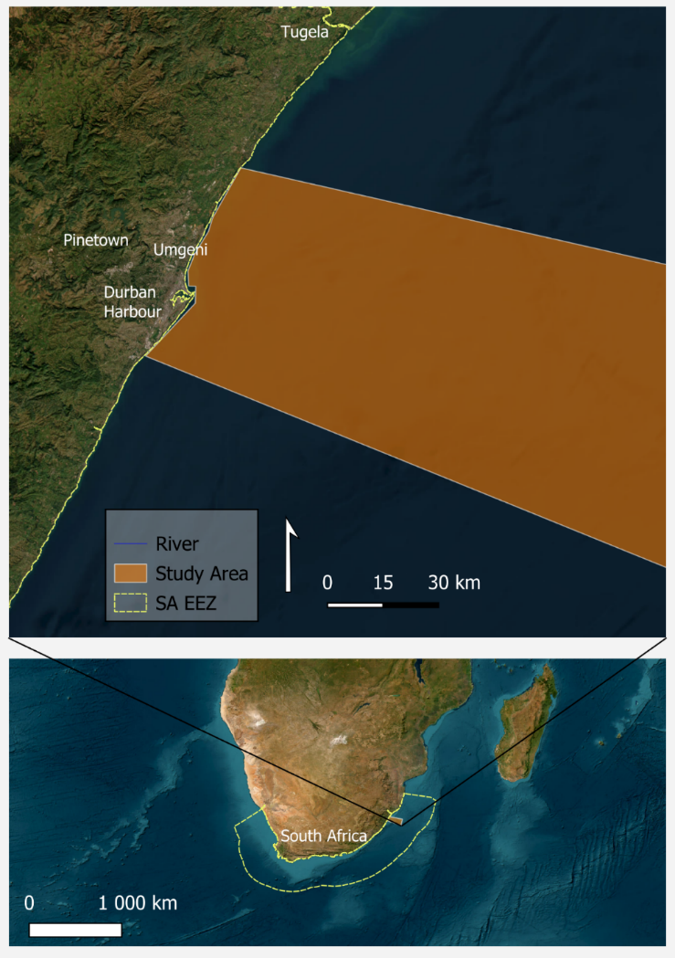
Figure 1: Durban Study Area
Durban, located on the eastern coast of South Africa, is a densely populated metropolitan home to 3.8 million inhabitants. The economy of Durban takes a large focus on the port and shipping industry, hosting the busiest container port in South Africa (Ryan, 2020). The area of South Durban, hosting the harbour, consists mainly of industries such as petrochemicals and plastics and packaging falling in the Durban industrial basin. It is well established that the area is troubled with pollution, specifically that of aquatic environments, with South Durban having the status as one of the most polluted regions in Southern Africa (Preston-Whyte et al., 2021).Two potential pathways for plastics are identified in the region, Durban Harbour and the Umgeni River. Durban Harbour is surrounded by shipping industry and receives inputs from the Umbilo River to which it is attached. This river flows through a mix of industrial and residential areas along its banks, both acting as channels for the input of land-based plastics into the river and therefore the harbour as it is carried further downstream. Furthermore, there is a high density of activity on the banks of the harbour with large amounts of human traffic which may support the direct release of plastic into the harbour’s waters. The Umgeni River hosts industry and informal settlement on its banks before meeting the Indian ocean at Blue Lagoon River Mouth, which may act as pathways for plastic into the Durban’s coast. This study area is shown in Figure 1 above.

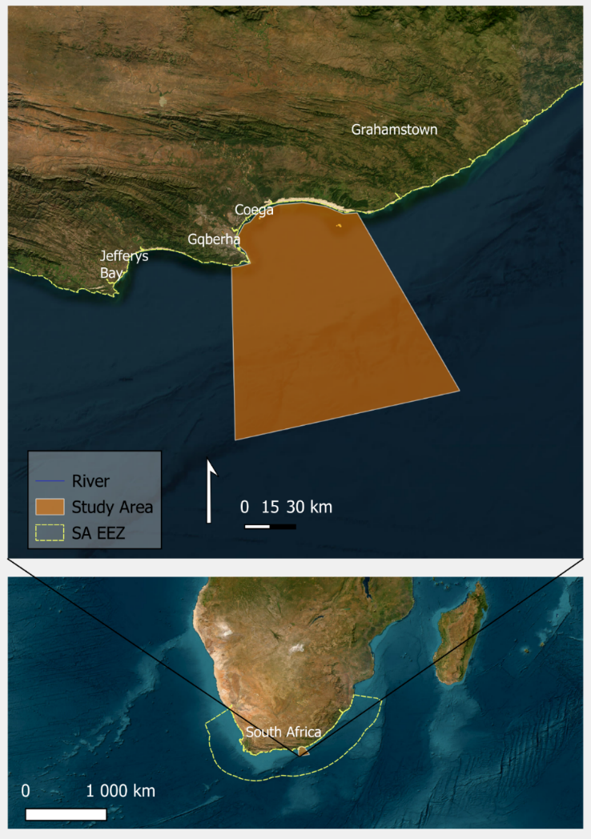
Figure 2: Gqeberha study area

Gqeberha is in the Eastern Cape province on the Southern East coast of South Africa and is home to 1.3 million people. The Coega Industrial Zone is found north of the city and hosts the second largest Port in South Africa. A major pathway for marine plastic in the area is the Braakens river which has several tributaries that run through the city, informal settlement and agricultural areas before draining into the Indian Ocean. The Chatty river is one of these tributaries which carries a high load of pollution reviving input from settlement and industry on its banks (Matalanga and Armitage, 2025). This study area is shown in Figure 2 above.

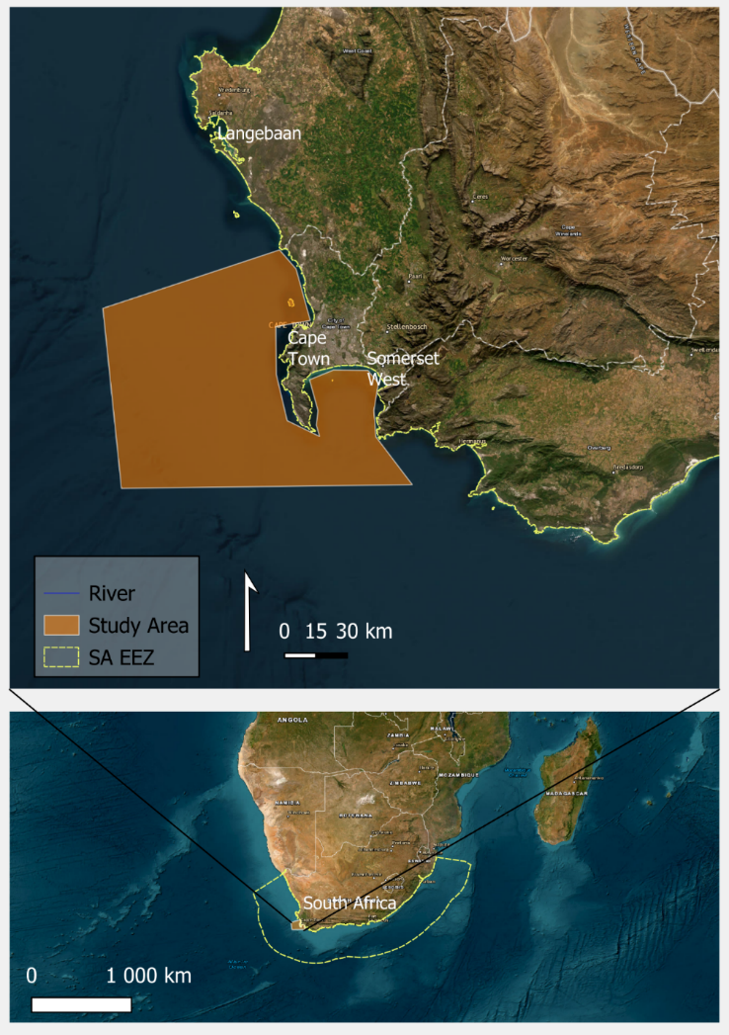
Figure 3: Cape Town study area

Cape Town with a population of 4.6 million people lies on the Southwestern Coast of South Africa. The city’s economy relies largely on the ocean including fishing, tourism and activities surrounding the Port of Cape Town. Plastics from Cape Town are able to enter the Atlantic ocean through direct run-off after heavy rainfall as well as through storm water outlets (Ariefdien et al., 2024). This study area is shown in Figure 3 above.

3.2 Data Sources

3.2.1 Sentinel-2
Sentinel-2 is a component of the Copernicus program, from the European Union's Earth observation project. The mission is made up of two satellites, Sentinel-2 and Sentinel-2B, launched in June 2015 and March 2017, respectively. These satellites are equipped with the Multispectral Instrument (MSI) that captures data in 13 spectral bands ranging from the visible and Near-Infrared (NIR) to the Shortwave Infrared (SWIR) spectrum. The choice to make use of sentinel imagery is rooted in its spatial and spectral resolution and its proven suitability in previous studies in detecting marine plastics. The use of Sentinel-2 in previous studies of this nature has led to the development of sensor specific indices that may be useful in the detection of floating marine plastics. Two of these indices being the PI and FDI. By making use of an optical sensor with proven capability in detecting marine debris, a baseline can be established to compare the methods developed using less explored SAR data. The characteristics of the sensor are shown in the table below (Kaplan and and Avdan, 2017).
Sentinel-2 L2A data will be downloaded for dates corresponding to events that see a potential influx of plastics into the ocean, such as during flooding and the dates corresponding to the training data used in this project, from the Copernicus browser available at https://browser.dataspace.copernicus.eu/ .
Table 3: Sentinel-2 Characteristics
Band | Description | Central Wavelength (µm) | Resolution (m)
Band 1 | Coastal aerosol | 0.443 | 60
Band 2 | Blue | 0.490 | 10
Band 3 | Green | 0.560 | 10
Band 4 | Red | 0.665 | 10
Band 5 | Vegetation Red Edge | 0.705 | 20
Band 6 | Vegetation Red Edge | 0.740 | 20
Band 7 | Vegetation Red Edge | 0.783 | 20
Band 8 | NIR | 0.842 | 10
Band 8A | Vegetation Red Edge | 0.865 | 20
Band 9 | Water vapour | 0.945 | 60
Band 10 | SWIR – Cirrus | 1.375 | 60
Band 11 | SWIR | 1.610 | 20
Band 12 | SWIR | 2.190 | 20

3.2.2 Sentinel-1
Sentinel-1 also falls under the Copernicus program, comprising two satellites, namely Sentinel-1A and Sentinel-1B, launched in April 2014 and April 2016, respectively. Sentinel 1-B has since had an internal failure and is no longer in operation therefore only Sentinel-1A will be considered for use in this project. These satellites make use of a C-band SAR to acquire imagery, making it an active sensor. The inclusion of SAR data in this project is largely beneficial as it is not affected by weather conditions and monitoring can take place at any time of the day regardless of light conditions. This is very important in this study with cloud cover being a large concern in the observation of coastal areas from optical imagery. By including SAR imagery not only may observations take place regardless of weather conditions, but new data is also introduced, with new variability, which may enhance the sensitivity of an algorithm to identify floating plastics.
While other SAR data options operate at a finer spatial resolution and with more SAR bands, which may prove useful to the detection of floating plastics, Sentinel-1 was selected for the balance that it presents in the ability to capture detail while allowing for widespread coverage which enables greater scalability for its application. Further, this data falls under open data being included freely, without any licensing constraints, aligning with the requirements of the project.
Sentinel-1 Single-Look-Complex (SLC) data will be downloaded over the study areas using the closest acquisitions to the downloaded Sentinel-2 data. SLC data will be used over Ground Range Detected (GRD) data as it maintains the native resolution of the sensor of 5m X 20m as opposed to 20m x20m in multi-looked GRD data. SLC data also allows for the extraction of amplitude information which was found to be advantageous in the detection of floating plastics(Simpson et al., 2022) .

3.2.3 Biophysical Data
The backscatter characteristics of floating debris in SAR are not solely a result of the debris itself but are also influenced by the conditions on the ocean surface such as windspeed and currents (Simpson et al., 2024). To account for this influence, biophysical variables will be included alongside SAR imagery providing the ability to discern between the effect of surface conditions on backscatter and that of the debris collections themselves. Two Biophysical variables will be considered, surface wind speed and direction and surface currents. These two variables will be downloaded from Copernicus Marine Data Store, available at: https://data.marine.copernicus.eu/. The datasets downloaded at the time of any considered S1 acquisitions are shown in Table 4 below.

Table 4: Biophysical Datasets
Variables | Dataset Name | Temporal Resolution | Spatial Resolution
Wind Speed and Direction | Global Ocean Hourly Sea Surface Wind and Stress from Scatterometer and Model | Hourly | 0.125° × 0.125°
Current Speed and Direction | Global Ocean Physics Analysis and Forecast | Hourly | 0.083° × 0.083°

For each SAR image, the biophysical variables will be spatially matched to the SAR image grid. These variables will then be included as additional input features in the machine learning models trained downstream, providing context to reduce false positives and better distinguish plastic debris from noise created by surface conditions.

3.2.4 Existing Training Data
To train accurate, transferable, models all existing training data applicable to the detection of floating marine debris is considered. Two existing datasets, the Plastic Litter Project and the Marine Debris Archive (MARIDA), have been identified that will be used to add to the collection of data in this project.

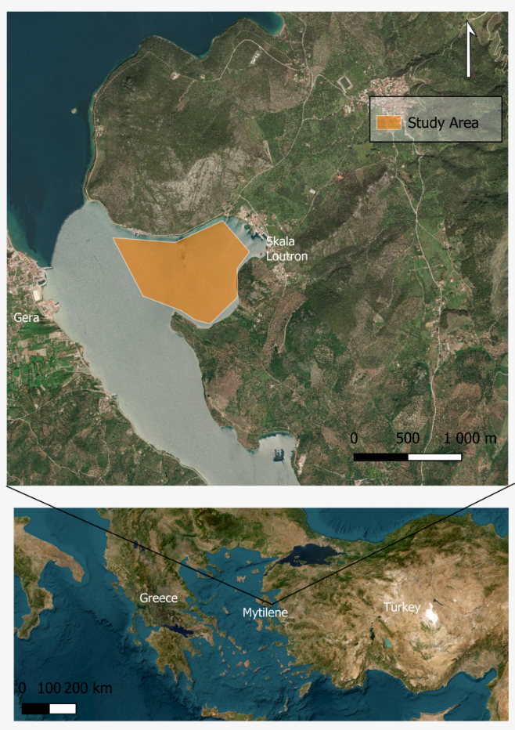
Figure 4: Plastic Litter Project training data study area
The Plastic Litter Project (PLP) is a program conducted by the Department of Marine Sciences at the University of the Aegean in Greece which aims to create a reference dataset for marine debris monitoring with remote sensing. From 2018 – 2025 different plastic targets have been placed in the Gulf of Gera allowing for the measurement of these targets with satellites and thus the creation of reference data for plastic detection (Topouzelis et al., 2020). Sentinel-1 and 2 acquisitions over the targets will be downloaded and data will then be extracted for pixel values for the targets as well as patches around the targets to be used in training and validating machine learning models developed in this project. The area where the plastic targets have been deployed is shown in Figure 4 above.
The Marine Debris Archive (MARIDA) is a benchmark dataset for detecting marine debris using Sentinel-2 imagery. Developed by Kikaki et al. in 2022, the dataset contains annotated pixels spanning between 2015 to 2021, covering 63 Sentinel-2 scenes including tile 36JUN which covers the Durban study area considered for this project. This dataset will be downloaded and will be used as data to train models using Sentinel-2 optical imagery as baseline detections. In cases where there is a corresponding Sentinel-1 acquisition, with a short temporal gap, to the Sentinel-2 training patch data, patches will be extracted for Sentinel-1 adding to the data that can be used to train models for debris detection with SAR. The distribution of the MARIDA training patches is shown in Figure 5 below.

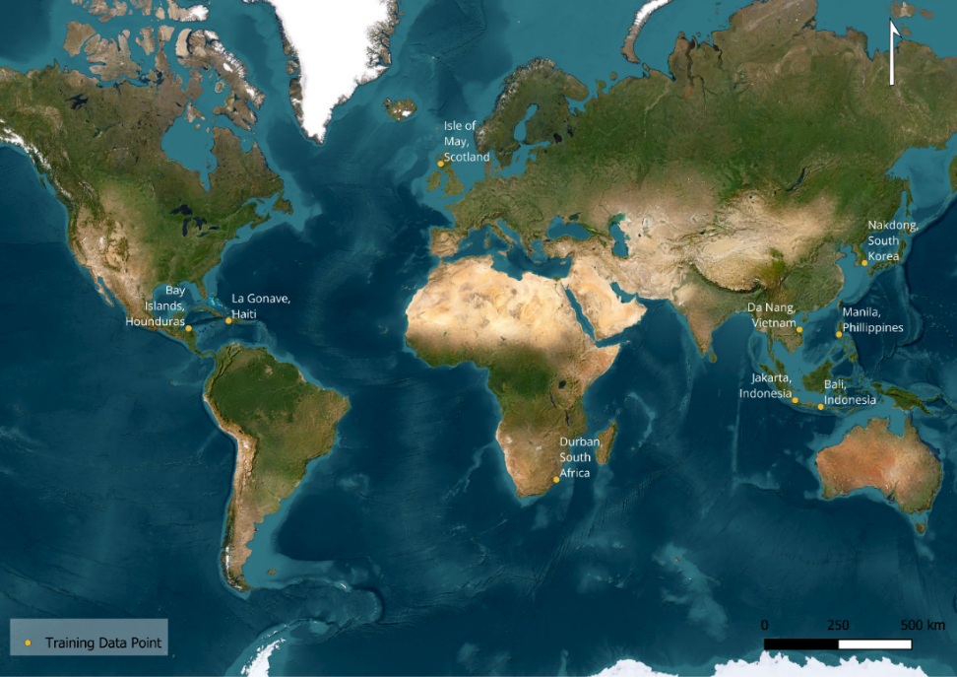
Figure 5: MARIDA study sites

3.2.5 Creation of Training Data in the SA EEZ
In partnership with the Department of Environment, Forestry and Fisheries (DEFF) a training dataset will be created for marine debris in the SA EEZ. This will aim to fill the gap of labelled data for marine debris detection with SAR as well as the limited data available in the SA EEZ. Two methods will be employed to create the training dataset; opportunistic floating plastic sampling and controlled target drops.
For opportunistic sampling, on the days of Sentinel-1 or Sentinel-2 overpasses, DEFF patrol teams will use a drone to locate collections of debris at sea. When a collection is sighted a position and time is recorded as well as wind speed and surface current direction. This information is then used to approximate the location of the collection at the time of the nearest Sentinel-1 and Sentinel-2 overpasses. Patches and pixels will then be extracted from the imagery for the identified collections.
Where natural debris slicks are scare, controlled targets will be deployed. 10 m x 5 m bundles of mixed plastic debris will be deployed, and the same information will be recorded, and data will be extracted as in opportunistic sampling. After the satellite overpass the target will be retrieved to avoid pollution.

Pre-processing
Raw satellite data is prone to noise, geometric inaccuracy and missing data. Pre-processing is an essential step to ensure noise is removed, geometric accuracy and consistency between observations from different dates or sensors. By pre-processing data only high-quality data is included in further processing steps such as machine learning. The pre-processing steps for SAR and optical data are shown in Figure 6 below.
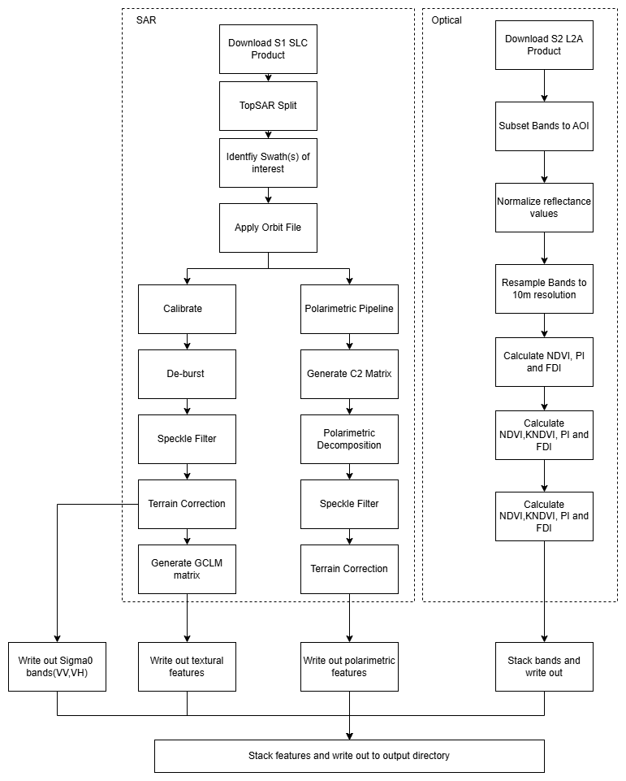

Figure 6: Preprocessing workflow

SAR Pre-processing
From the raw Sentinel-1 SLC data three outputs namely, the Sigma0 bands (VV and VH), the Grey-Level Coherence Matrix (GCLM), and polarimetric features (alpha, entropy and anisotropy) will be extracted which require different preprocessing steps. SNAP eXtensible Markup Language (XML) graphs will be created and then called in different combinations in Juptyer notebooks corresponding to the output product required. The preprocessing steps start with TopSAR split which divides the SLC image into individual swaths. The swath that covers the area of interest is then identified and selected for further processing. The orbital file is then applied, which contains information on the position of the satellite at the time of image acquisition, satellite velocity and the exact timestamp of image acquisition. This information can be used to ensure that the imagery is aligned with its geographical location. These first two steps are common to all three output products and are done before the process is split into two sub processes.
To create the GCLM and Sigma0 bands the product is first calibrated which involves converting raw intensity values into backscatter values (Sigma0). This allows for the comparison of backscatter values across different acquisition dates and sensors, removing any unwanted influence from the sensor or conditions at the time of acquisition. Thereafter the image is de-bursted which removes the edges effects and merges each burst. A speckle filter will then be applied to the debursted image. Speckle is a common noise found in SAR imagery which occurs when reflected radar signals combine constructively or destructively causing a granular appearance on images. This makes SAR images difficult to interpret and cause inaccurate backscatter values and therefore should be removed for accurate processing downstream. SLC products are in the slant-range geometry which is distorted by the look angle of the sensor, terrain correction will be applied to geocode the data into side-look geometry so that points on the image accurately reflect their geographic location. At this point in the pipeline the Sigma0 bands are written out as a product. The GCLM matrix is will then be generated which produces textural features including energy, contrast and dissimilarity.
The polarimetric features can only be created from a full SLC product meaning that it cannot be calibrated, therefore the polymetric pipeline starts using the orbit-apply graph output. The covariance matrix (C2) is then generated which are the correlation between phases across the polarisation channels. Thereafter polarimetric decomposition will be performed on the C2 matrix to calculate the alpha, entropy and anisotropy bands. This output will then be speckle filtered, and terrain corrected as in the previous sub-process.

Optical Imagery Pre-processing
The Sentinel-2 product will be first clipped to the area of interest to reduce the size of the data for further processing. Min-Max normalisation will then be applied to standardize the reflectance values across different spectral bands, allowing for an accurate comparison of reflectance values across the images. Normalisation removes the effects of non-surface target effects on reflectance at the time of image capture while allowing for reflectance values to be on a consistent scale between 0-1. This prepares the images for further analysis such as index calculation while allowing the results to be compared across images of different acquisition dates. The equation for Min-Max normalisation is shown in Equation 1 below.

$Normalised value=Pixel Value-MinMax-Min$ (1)

Spatial resolution is not consistent across Sentinel-2 bands, with spatial resolution ranging from 10 – 60 m. To do a pixel-by-pixel analysis across bands, such as calculating an index, resampling to a common resolution needs to be performed (Zheng et al., 2017). Band 2, having the finest resolution of 10m, will be used to resize other bands to a common resolution of 10m.
The calculation of indices from the Sentinel-2 imagery allows for more targeted detection by enhancing the contrast between floating plastics and the water background. The three indices included that will be calculated and stacked with the resampled bands in this study are the Plastic index (PI) (Themistocleous et al., 2020) highlighting differences in the NIR and Red reflectance of plastics, the Floating Debris index (FDI) (Biermann et al., 2020) which includes aa thresholding technique for NIR reflectance using the SWIR and Red bands and the Normalized Difference Vegetation Index (NDVI) (Rouse et al.,1973). These have all been proven effective in discriminating between plastics and a water background in previous studies (Gonzaga et al., 2021) and therefore will be useful in the inclusion of a detection algorithm. These are shown as Equations 2-4 below.

$PI = NIR+ RED$ (2)
$FDI = NIR - (RE2 + (SWIR1 - RE2) ×(λNIR- λRED)(λSWIR1 - λRED)×10$ (3)
$NDVI= NIR-REDNIR+RED$ (4) Where:
NIR = Near Infrared Band
RED = Red Band
SWIR = Red Band
RE2 = Red Edge 2 Band
$λ$ = Wavelength of a respective band

Training Data Extraction
To make use of the data provided by the PLP, MARIDA and the dataset curated in this study, described in Section 3.2, the values for the SAR and optical features at the training points need to be extracted. Two different types of training data will be extracted from each dataset namely pixel values and patches to be used in pixel-based and patch-based visual models respectively this process is shown in Figure 7.
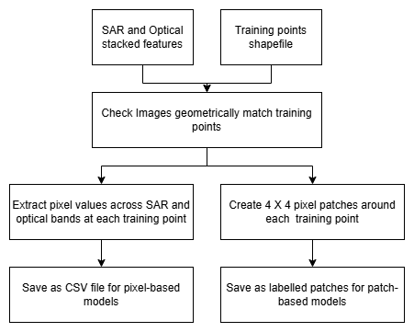
Figure 7: Data Extraction Process

Machine Learning Model Development

3.5.1 Pixel-Based
Pixel based models make use of pixel values for each optical and SAR feature as an individual sample, without considering spatial context. This is a limitation for this class of models however, they do not require extensive training data, which is often not available for marine plastic (Savastano et al., 2021a). Pixel-based models will serve as a baseline to compare the performance of the more complex patch based-models. Two pixel-based models will be considered in this study namely Random Forest (RF) and Support Vector Machine (SVM).
Random Forest (RF) is a machine learning classifier that operates by constructing multiple decision trees at training which are trained on a random subset of the data, the mean prediction of each tree is used to decide the class of a pixel. This model can handle large datasets well, with large amounts of dimensionality. This is advantageous for this project as there is high dimensionality in the spectral information of the optical imagery which is further increased by the inclusion of SAR data. This has proven to be effective in classifying marine plastics (Themistocleous et al., 2020).
Support Vector Machine (SVM) is a classification algorithm that is suited to a binary classification by finding the most suitable hyperplane to separate two classes, in this case, which would be plastics and background water. This has been shown to perform well for the detection of floating plastics in previous studies (Sannigrahi et al., 2022). This method will be included as a contrast to the other method used by providing a binary classification.

3.5.1 Patch-Based
Patch-based models refer to learning approaches that process imagery in small regions called patches. This can be advantageous over pixel-based models as a model considers the feature and the surrounding contextual features as one sample allowing for the spatial context to be considered (Mifdal, Longépé and Rußwurm, 2021). This project will use a patch-based U-Net deep learning model for the detection of marine debris. U-net is a well-established base architecture that has shown strong performance in the detection of floating marine debris using Sentinel-2 imagery (Kikaki et al., 2022).U-Net architecture consist of an encoder and a decoder that are connected by skip connections. The encoder is comprised of convolutional blocks that down sample the input image allowing for the model to learn high-level features. The decoder reconstructs the image back to its original resolution where further convolution layers refine the detected high-level features. Skip connections between the encoder and decoder allow for the model to reconstruct small features from the encoder (Yin et al., 2025).
To improve the model’s ability to detect and separate debris from a noisy ocean background, attention mechanisms will be incorporated into the U-Net architecture. Attention mechanisms point the model to the most relevant regions of an image by assigning weight to important features, simulating human attention (Niu, Zhong and Yu, 2021). Attention Gates (AGs) will be placed at each skip connection in the U-Net model which will filter the encoder features before they are combined with the decoder features focussing on marine debris rather than background noise, following the architecture of Oktay et al., (2018).The introduction of AGs into deep learning with satellite imagery has shown to increase a model’s ability to capture sparse features that otherwise would have been missed (John and Zhang, 2022).
To create a base model that is suited to floating debris detection with limited labelled data, Self-supervised Learning (SSL) will be used to pretrain the U-Net model. A contrastive learning framework will be applied which will train the model to distinguish between similar and dissimilar patches. Patches are augmented through rotation, cropping, noise addition and flipping generating positive pairs which the model will learn to distinguish from negative pairs which are patches from different regions in the image, following the framework of Pei et al., (2023) where SSL was applied to SAR imagery. Through this process the model is able to learn general ocean features in SAR imagery before it is fine-tuned on labelled data which will supervise the classification of patches as debris or non-debris.

3.7 Limitations

3.8 Ethical Considerations
The main ethical consideration for this research would be the proper attribution to the authors of any research that has been consulted through proper referencing. To maintain integrity of the research any findings will be reported accurately as has been found during the project. Any methods used will be documented in detail to ensure transparency in the research. The satellite data used for this project are aimed at capturing environmental variables and are not of high enough spatial resolution to capture sensitive or personally identifiable information. The project does not involve any human subjects. All the data obtained for this project are from open sources under open-science frameworks and therefore there are no licensing constraints.
This research will feature a field-based component for the collection of training data. This will be designed to be as low impact on the marine environment as possible. Only visual marine debris will be surveyed and does not involve the collection or harm of marine organisms. If materials are deployed into the ocean as artificial targets they will be retrieved immediately after the satellite overpass.
This research will be conducted purely for academic purposes, with no commercial interests or funding from parties that may have an interest in the outcomes. There are no financial or personal relationships that could influence the findings of this project, removing any conflicts of interest.

References
Aires, F., Boucher, E. and Pellet, V. (2021) ‘Convolutional neural networks for satellite remote sensing at coarse resolution. Application for the SST retrieval using IASI’, Remote Sensing of Environment, 263, p. 112553. Available at: https://doi.org/10.1016/j.rse.2021.112553.
Alberghini, L. et al. (2022) ‘Microplastics in Fish and Fishery Products and Risks for Human Health: A Review’, International Journal of Environmental Research and Public Health, 20(1), p. 789. Available at: https://doi.org/10.3390/ijerph20010789.
Alì, M. et al. (2024) ‘Assessment of Spectral based Solutions for the Detection of Floating Marine Debris’. arXiv. Available at: https://doi.org/10.48550/arXiv.2408.10187.
Aliani, S. et al. (2022) ‘Editorial: Marine Litter Windrows’, Frontiers in Marine Science, 8. Available at: https://doi.org/10.3389/fmars.2021.827907.
Arabi, S. and Nahman, A. (2020) ‘Impacts of marine plastic on ecosystem services and economy: State of South African research’, South African Journal of Science, 116(5/6). Available at: https://doi.org/10.17159/sajs.2020/7695.
Ariefdien, R. et al. (2024) ‘Stormwater outlets: A source of microplastics in coastal zones of Cape Town, South Africa’, Marine Pollution Bulletin, 198, p. 115800. Available at: https://doi.org/10.1016/j.marpolbul.2023.115800.
Biermann, L. et al. (2020) ‘Finding Plastic Patches in Coastal Waters using Optical Satellite Data’, Scientific Reports, 10(1), p. 5364. Available at: https://doi.org/10.1038/s41598-020-62298-z.
Booth, H., Ma, W. and Karakuş, O. (2023) ‘High-precision density mapping of marine debris and floating plastics via satellite imagery’, Scientific Reports, 13(1), p. 6822. Available at: https://doi.org/10.1038/s41598-023-33612-2.
Cernian, A. (2025) ‘Advances in Detecting and Identifying Marine Plastic Waste: A Comprehensive Review’, Journal of Coastal Research, 113(SI), pp. 1076–1081. Available at: https://doi.org/10.2112/JCR-SI113-210.1.
Danilov, A. and Serdiukova, E. (2024) ‘Review of Methods for Automatic Plastic Detection in Water Areas Using Satellite Images and Machine Learning’, Sensors (Basel, Switzerland), 24(16), p. 5089. Available at: https://doi.org/10.3390/s24165089.
DeLancey, E.R. et al. (2020) ‘Comparing Deep Learning and Shallow Learning for Large-Scale Wetland Classification in Alberta, Canada’, Remote Sensing, 12(1), p. 2. Available at: https://doi.org/10.3390/rs12010002.
Emmerik, T.H.M.V. (2024) ‘The impact of floods on plastic pollution’, Global Sustainability, 7, p. e17. Available at: https://doi.org/10.1017/sus.2024.14.
Evans, M.C. and Ruf, C.S. (2022) ‘Toward the Detection and Imaging of Ocean Microplastics With a Spaceborne Radar’, IEEE Transactions on Geoscience and Remote Sensing, 60, pp. 1–9. Available at: https://doi.org/10.1109/TGRS.2021.3081691.
Fabinyi, M. et al. (2021) ‘China’s Blue Economy: A State Project of Modernisation’, The Journal of Environment & Development, 30(2), pp. 127–148.
Fauvelle, V. et al. (2021) ‘Organic additive release from plastic to seawater is lower under deep-sea conditions’, Nature Communications, 12(1), p. 4426. Available at: https://doi.org/10.1038/s41467-021-24738-w.
Field, L.C. et al. (2025) ‘Assessing South Africa’s marine protected area quality and progress towards conservation goals: An application of The MPA Guide framework’, Marine Policy, 173, p. 106513. Available at: https://doi.org/10.1016/j.marpol.2024.106513.
de Fockert, A. et al. (2024) ‘Assessing the detection of floating plastic litter with advanced remote sensing technologies in a hydrodynamic test facility’, Scientific Reports, 14(1), p. 25902. Available at: https://doi.org/10.1038/s41598-024-74332-5.
Goncalves, L. and Faure, M. (2019) ‘International Law Instruments To Address The Plastic Soup’, William & Mary Environmental Law and Policy Review, 43(3), p. 871.
Gutsa, T. et al. (2024) ‘Wasted shores: Using drones to monitor the spatio-temporal evolution of debris accumulation hotspots on South Africa’s Umgeni River’, Science of The Total Environment, 955, p. 176791. Available at: https://doi.org/10.1016/j.scitotenv.2024.176791.
Haarr, M.L., Falk-Andersson, J. and Fabres, J. (2022) ‘Global marine litter research 2015–2020: Geographical and methodological trends’, Science of The Total Environment, 820, p. 153162. Available at: https://doi.org/10.1016/j.scitotenv.2022.153162.
Iroegbu, A.O.C. et al. (2021) ‘Plastic Pollution: A Perspective on Matters Arising: Challenges and Opportunities’, ACS omega, 6(30), pp. 19343–19355. Available at: https://doi.org/10.1021/acsomega.1c02760.
Jamali, A. and Mahdianpari, M. (2021) ‘A Cloud-Based Framework for Large-Scale Monitoring of Ocean Plastics Using Multi-Spectral Satellite Imagery and Generative Adversarial Network’, Water, 13(18), p. 2553. Available at: https://doi.org/10.3390/w13182553.
Janga, B. et al. (2023) ‘A Review of Practical AI for Remote Sensing in Earth Sciences’, Remote Sensing, 15(16), p. 4112. Available at: https://doi.org/10.3390/rs15164112.
Johansson, A.M. et al. (2017) ‘Combined observations of Arctic sea ice with near-coincident colocated X-band, C-band, and L-band SAR satellite remote sensing and helicopter-borne measurements’, Journal of Geophysical Research: Oceans, 122(1), pp. 669–691. Available at: https://doi.org/10.1002/2016JC012273.
John, D. and Zhang, C. (2022) ‘An attention-based U-Net for detecting deforestation within satellite sensor imagery’, International Journal of Applied Earth Observation and Geoinformation, 107, p. 102685. Available at: https://doi.org/10.1016/j.jag.2022.102685.
Kaandorp, M.L.A. et al. (2023) ‘Global mass of buoyant marine plastics dominated by large long-lived debris’, Nature Geoscience, 16(8), pp. 689–694. Available at: https://doi.org/10.1038/s41561-023-01216-0.
Kaplan, G. and and Avdan, U. (2017) ‘Object-based water body extraction model using Sentinel-2 satellite imagery’, European Journal of Remote Sensing, 50(1), pp. 137–143. Available at: https://doi.org/10.1080/22797254.2017.1297540.
Karjalainen, M., Kaartinen, H. and Hyyppä, J. (2008) ‘Agricultural Monitoring Using Envisat Alternating Polarization SAR Images’, Photogrammetric Engineering & Remote Sensing, 74(1), pp. 117–126. Available at: https://doi.org/10.14358/PERS.74.1.117.
Kikaki, K. et al. (2022) ‘MARIDA: A benchmark for Marine Debris detection from Sentinel-2 remote sensing data’, PLOS ONE, 17(1), p. e0262247. Available at: https://doi.org/10.1371/journal.pone.0262247.
Knaeps, E. et al. (2021) ‘Hyperspectral-reflectance dataset of dry, wet and submerged marine litter’, Earth System Science Data, 13(2), pp. 713–730. Available at: https://doi.org/10.5194/essd-13-713-2021.
Leal Filho, W., Hunt, J. and Kovaleva, M. (2021) ‘Garbage Patches and Their Environmental Implications in a Plastisphere’, Journal of Marine Science and Engineering, 9(11), p. 1289. Available at: https://doi.org/10.3390/jmse9111289.
Li, W. et al. (2024) ‘Predicting gradient is better: Exploring self-supervised learning for SAR ATR with a joint-embedding predictive architecture’, ISPRS Journal of Photogrammetry and Remote Sensing, 218, pp. 326–338. Available at: https://doi.org/10.1016/j.isprsjprs.2024.09.013.
Lincoln, S. et al. (2022) ‘Marine litter and climate change: Inextricably connected threats to the world’s oceans’, Science of The Total Environment, 837, p. 155709. Available at: https://doi.org/10.1016/j.scitotenv.2022.155709.
Matalanga, A. and Armitage, N. (2025) ‘Reduction of pollution levels in the Chatty River, Gqeberha, South Africa, through sustainable drainage systems: Bethelsdorp sub-catchment case study’, Water SA, 51(2), pp. 107–124. Available at: https://doi.org/10.17159/wsa/2025.v51.i2.4122.
Meijer, L.J.J. et al. (2021) ‘More than 1000 rivers account for 80% of global riverine plastic emissions into the ocean’, Science Advances, 7(18), p. eaaz5803. Available at: https://doi.org/10.1126/sciadv.aaz5803.
Mifdal, J., Longépé, N. and Rußwurm, M. (2021a) ‘TOWARDS DETECTING FLOATING OBJECTS ON A GLOBAL SCALE WITH LEARNED SPATIAL FEATURES USING SENTINEL 2’, ISPRS Annals of the Photogrammetry, Remote Sensing and Spatial Information Sciences, V-3–2021, pp. 285–293. Available at: https://doi.org/10.5194/isprs-annals-V-3-2021-285-2021.
Mifdal, J., Longépé, N. and Rußwurm, M. (2021b) ‘TOWARDS DETECTING FLOATING OBJECTS ON A GLOBAL SCALE WITH LEARNED SPATIAL FEATURES USING SENTINEL 2’, ISPRS Annals of the Photogrammetry, Remote Sensing and Spatial Information Sciences, V-3–2021, pp. 285–293. Available at: https://doi.org/10.5194/isprs-annals-V-3-2021-285-2021.
Nahman, A., Oelofse, S. and Haywood, L. (2025) ‘The economic impacts of marine plastic debris in South Africa: A preliminary estimate’, Marine Pollution Bulletin, 212, p. 117461. Available at: https://doi.org/10.1016/j.marpolbul.2024.117461.
Naidoo, T., Rajkaran, A. and Sershen (2020) ‘Impacts of plastic debris on biota and implications for human health: A South African perspective’, South African Journal of Science, 116(5/6). Available at: https://doi.org/10.17159/sajs.2020/7693.
Nakakuni, M. et al. (2024) ‘Convergence zones of coastal waters as hotspots for floating microplastic accumulation’, Marine Pollution Bulletin, 206, p. 116691. Available at: https://doi.org/10.1016/j.marpolbul.2024.116691.
Nayanathara Thathsarani Pilapitiya, P.G.C. and Ratnayake, A.S. (2024) ‘The world of plastic waste: A review’, Cleaner Materials, 11, p. 100220. Available at: https://doi.org/10.1016/j.clema.2024.100220.
Nihart, A.J. et al. (2025) ‘Bioaccumulation of microplastics in decedent human brains’, Nature Medicine, 31(4), pp. 1114–1119. Available at: https://doi.org/10.1038/s41591-024-03453-1.
Niu, Z., Zhong, G. and Yu, H. (2021) ‘A review on the attention mechanism of deep learning’, Neurocomputing, 452, pp. 48–62. Available at: https://doi.org/10.1016/j.neucom.2021.03.091.
Oktay, O. et al. (2018) ‘Attention U-Net: Learning Where to Look for the Pancreas’. arXiv. Available at: https://doi.org/10.48550/arXiv.1804.03999.
Oluwoye, I. et al. (2023) ‘Degradation and lifetime prediction of plastics in subsea and offshore infrastructures’, Science of The Total Environment, 904, p. 166719. Available at: https://doi.org/10.1016/j.scitotenv.2023.166719.
Pasquier, G. et al. (2022) ‘An innovative approach for microplastic sampling in all surface water bodies using an aquatic drone’, Heliyon, 8(11), p. e11662. Available at: https://doi.org/10.1016/j.heliyon.2022.e11662.
Pei, H. et al. (2023) ‘Self-Supervised Feature Representation for SAR Image Target Classification Using Contrastive Learning’, IEEE Journal of Selected Topics in Applied Earth Observations and Remote Sensing, 16, pp. 9246–9258. Available at: https://doi.org/10.1109/JSTARS.2023.3321769.
Polarimetry | Get to Know SAR – NASA-ISRO SAR Mission (NISAR) (no date). Available at: https://nisar.jpl.nasa.gov/mission/get-to-know-sar/polarimetry/ (Accessed: 25 June 2025).
Preston-Whyte, F. et al. (2021) ‘Meso- and microplastics monitoring in harbour environments: A case study for the Port of Durban, South Africa’, Marine Pollution Bulletin, 163, p. 111948. Available at: https://doi.org/10.1016/j.marpolbul.2020.111948.
Qi, L. et al. (2022) ‘On the capacity of Sentinel-1 synthetic aperture radar in detecting floating macroalgae and other floating matters’, Remote Sensing of Environment, 280, p. 113188. Available at: https://doi.org/10.1016/j.rse.2022.113188.
Read, J.M. and Torrado, M. (2009) ‘Remote Sensing’, in R. Kitchin and N. Thrift (eds) International Encyclopedia of Human Geography. Oxford: Elsevier, pp. 335–346. Available at: https://doi.org/10.1016/B978-008044910-4.00508-3.
Rußwurm, M., Venkatesa, S.J. and Tuia, D. (2023) ‘Large-scale detection of marine debris in coastal areas with Sentinel-2’, iScience, 26(12), p. 108402. Available at: https://doi.org/10.1016/j.isci.2023.108402.
Ryan, P.G. et al. (2020) ‘Monitoring marine plastics - will we know if we are making a difference?’, South African Journal of Science, 116(5–6), pp. 1–9. Available at: https://doi.org/10.17159/sajs.2020/7678.
Ryan, P.G. (2020) ‘The transport and fate of marine plastics in South Africa and adjacent oceans’, South African Journal of Science, 116(5/6). Available at: https://doi.org/10.17159/sajs.2020/7677.
Sacco, V.A. et al. (2024) ‘What are the global patterns of microplastic ingestion by fish? A scientometric review’, Environmental Pollution, 350, p. 123972. Available at: https://doi.org/10.1016/j.envpol.2024.123972.
Sannigrahi, S. et al. (2022) ‘Development of automated marine floating plastic detection system using Sentinel-2 imagery and machine learning models’, Marine Pollution Bulletin, 178, p. 113527. Available at: https://doi.org/10.1016/j.marpolbul.2022.113527.
Savastano, S. et al. (2021a) ‘A First Approach to the Automatic Detection of Marine Litter in SAR Images Using Artificial Intelligence’, in 2021 IEEE International Geoscience and Remote Sensing Symposium IGARSS. 2021 IEEE International Geoscience and Remote Sensing Symposium IGARSS, pp. 8704–8707. Available at: https://doi.org/10.1109/IGARSS47720.2021.9737038.
Savastano, S. et al. (2021b) ‘A First Approach to the Automatic Detection of Marine Litter in SAR Images Using Artificial Intelligence’, in 2021 IEEE International Geoscience and Remote Sensing Symposium IGARSS. 2021 IEEE International Geoscience and Remote Sensing Symposium IGARSS, pp. 8704–8707. Available at: https://doi.org/10.1109/IGARSS47720.2021.9737038.
van Sebille, E. et al. (2020) ‘The physical oceanography of the transport of floating marine debris’, Environmental Research Letters, 15(2), p. 023003. Available at: https://doi.org/10.1088/1748-9326/ab6d7d.
Shanks, A.L. (2021) ‘Observational Evidence and Open Questions on the Role of Internal Tidal Waves on the Concentration and Transport of Floating Plastic Debris’, Frontiers in Marine Science, 8. Available at: https://doi.org/10.3389/fmars.2021.621062.
Simpson, M.D. et al. (2022) ‘Monitoring of Plastic Islands in River Environment Using Sentinel-1 SAR Data’, Remote Sensing, 14(18), p. 4473. Available at: https://doi.org/10.3390/rs14184473.
Simpson, M.D. et al. (2024) ‘Using Ground Radar Measurements to Measure Plastisphere-Based Surfactant Dampening’, in IGARSS 2024 - 2024 IEEE International Geoscience and Remote Sensing Symposium. IGARSS 2024 - 2024 IEEE International Geoscience and Remote Sensing Symposium, pp. 1643–1646. Available at: https://doi.org/10.1109/IGARSS53475.2024.10641644.
Slimane, E.B. et al. (2025) ‘Efficient Beach Litter Monitoring: Accelerated Surveys of Pollution Hotspots—A North African Case Study’, Journal of Marine Science and Engineering, 13(1), p. 71. Available at: https://doi.org/10.3390/jmse13010071.
Tanhua, T., Gutekunst, S.B. and Biastoch, A. (2020) ‘A near-synoptic survey of ocean microplastic concentration along an around-the-world sailing race’, PLOS ONE, 15(12), p. e0243203. Available at: https://doi.org/10.1371/journal.pone.0243203.
Taye, M. (2023) ‘Understanding of Machine Learning with Deep Learning: Architectures, Workflow, Applications and Future Directions’, Computers [Preprint]. Available at: https://doi.org/10.3390/COMPUTERS12050091.
Themistocleous, K. et al. (2020) ‘Investigating Detection of Floating Plastic Litter from Space Using Sentinel-2 Imagery’, Remote Sensing, 12(16), p. 2648. Available at: https://doi.org/10.3390/rs12162648.
Thushari, G.G.N. and Senevirathna, J.D.M. (2020) ‘Plastic pollution in the marine environment’, Heliyon, 6(8), p. e04709. Available at: https://doi.org/10.1016/j.heliyon.2020.e04709.
Topouzelis, K. et al. (2020) ‘Remote Sensing of Sea Surface Artificial Floating Plastic Targets with Sentinel-2 and Unmanned Aerial Systems (Plastic Litter Project 2019)’, Remote Sensing, 12(12), p. 2013. Available at: https://doi.org/10.3390/rs12122013.
Topouzelis, K., Papakonstantinou, A. and Garaba, S.P. (2019) ‘Detection of floating plastics from satellite and unmanned aerial systems (Plastic Litter Project 2018)’, International Journal of Applied Earth Observation and Geoinformation, 79, pp. 175–183. Available at: https://doi.org/10.1016/j.jag.2019.03.011.
Verster, C. and Bouwman, H. (2020) ‘Land-based sources and pathways of marine plastics in a South African context’, South African Journal of Science, 116(5/6). Available at: https://doi.org/10.17159/sajs.2020/7700.
de Vries, R. et al. (2021) ‘Quantifying Floating Plastic Debris at Sea Using Vessel-Based Optical Data and Artificial Intelligence’, Remote Sensing, 13(17), p. 3401. Available at: https://doi.org/10.3390/rs13173401.
Waqas, M. et al. (2023) ‘Marine plastic pollution detection and identification by using remote sensing-meta analysis’, Marine Pollution Bulletin, 197, p. 115746. Available at: https://doi.org/10.1016/j.marpolbul.2023.115746.
Yang, X. et al. (2023) ‘A Survey on Deep Semi-supervised Learning’, IEEE Transactions on Knowledge and Data Engineering, 35(9), pp. 8934–8954. Available at: https://doi.org/10.1109/TKDE.2022.3220219.
Yin, L. et al. (2025) UNet--: Memory-Efficient and Feature-Enhanced Network Architecture based on U-Net with Reduced Skip-Connections. Available at: https://doi.org/10.1007/978-981-96-0963-5.

5.AI and Plagiarism Declaration

