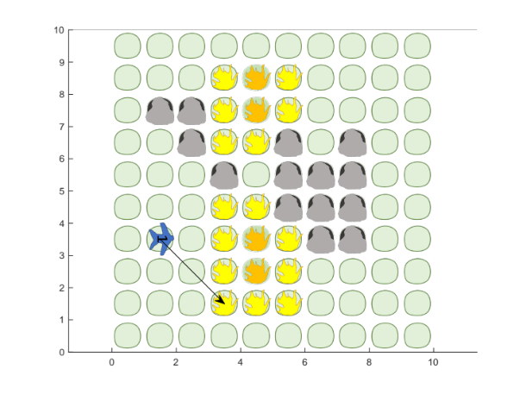
Fill-in figure showing the current goal.

Will replace with the success case for scenario 6 (this would be only one row of the scenario results)

