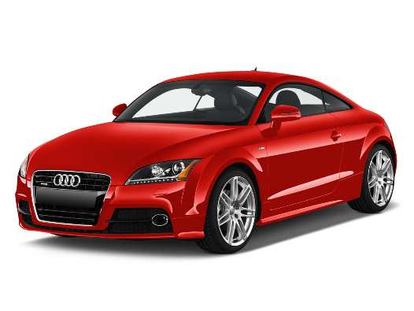

**To access your Google please download the app from your device’s app store or go to** [**https://google.com**](https://google.com)

**The device should be logged on under the Google account (you may need to create one)**

**The Google log-in is:**

**First name:**

**Last name:**

**Class:**

**Username:**

**Password:**