WPAD & Web Proxy
Configuration with IPFire
Automatic proxy detection in a Windows network via WPAD/PAC, an Apache vhost on IPFire, and a DNS entry in Active Directory

Document type: Technical guide / How-to
Target systems: IPFire (Linux), Windows Server (DNS / DHCP)
Date: June 2026
Version: 1.0

Table of Contents
1. Introduction 3
1.1 Prerequisites 3
2. Setting Up the Apache Virtual Host on IPFire 4
3. Enabling the Web Proxy in IPFire 6
4. Configuring DHCP Options for WPAD 7
5. Creating the DNS Host Entry on the Windows Server 9
6. Verifying the Configuration 12
7. Summary 13
7.1 Quick Reference of Key Paths 13

1. Introduction
This documentation describes how to set up automatic proxy detection (Web Proxy Autodiscovery Protocol, WPAD) in a Windows network using an IPFire firewall. As a result, clients on the network automatically receive the proxy configuration without it having to be entered manually in every browser.
The following components are set up as part of this guide:
- An Apache virtual host on IPFire that serves the PAC file (Proxy Auto-Config)
- The IPFire Web Proxy service
- DHCP options through which clients automatically receive the WPAD URL
- A DNS host entry “wpad” on the Windows Server, used in addition to DHCP-based detection
- An adjustment to the Windows DNS block list (GlobalQueryBlockList), so that the WPAD entry can be resolved at all

1.1 Prerequisites
- A working IPFire installation with access to the web interface
- SSH access to IPFire (root account) and an SSH/SFTP client
- A Windows Server with the DNS role installed (e.g. an Active Directory domain controller)
- Administrative rights on both IPFire and the Windows Server
Recommended Tools
Two free tools are recommended for accessing the IPFire console and file system:
PuTTY – SSH client for console access
WinSCP – graphical SFTP client for editing configuration files

2. Setting Up the Apache Virtual Host on IPFire
In the first step, a dedicated virtual host is set up on IPFire, which will later serve the PAC file and the WPAD file.

Step 1: Connect to IPFire
Log in to the IPFire console via SSH using PuTTY and sign in with the root account.

Step 2: Create the directory for the proxy
Run the following command in the console to create the required directory:
mkdir /srv/web/ipfire/wpad

Step 3: Create the vhost configuration file
The empty configuration file for the new virtual host is created with the following command:
touch /etc/httpd/conf/vhosts.d/wpad.conf

Step 4: Edit the vhost configuration
Open the newly created file using WinSCP. The path to the file is:
/etc/httpd/conf/vhosts.d/wpad.conf
Insert the following content into the file:
Listen 80
<VirtualHost *:80>
DocumentRoot "/srv/web/ipfire/wpad"
ServerName wpad.localdomain
ServerAlias wpad
Alias /wpad.dat /srv/web/ipfire/html/proxy.pac
Alias /proxy.pac /srv/web/ipfire/html/proxy.pac
</VirtualHost>
Important Note
In ServerName wpad.localdomain, localdomain must be replaced with your own domain (e.g. wpad.company.local).

Step 5: Create the symbolic links
To make the PAC file accessible under both /proxy.pac and /wpad.dat, two symbolic links are created:
ln -s /srv/web/ipfire/html/proxy.pac /srv/web/ipfire/wpad/proxy.pac
ln -s /srv/web/ipfire/html/proxy.pac /srv/web/ipfire/wpad/wpad.dat

Step 6: Restart Apache
For the new configuration to take effect, the Apache service must be restarted:
/etc/init.d/apache restart

3. Enabling the Web Proxy in IPFire
The proxy service is enabled in the IPFire web interface so that clients can actually use it.
- In the IPFire web interface, navigate to Network → Web Proxy.
- Enable the Enabled on Green option.
- Enable the Transparent on Green option so that traffic is automatically routed through the proxy.
- Save the settings.
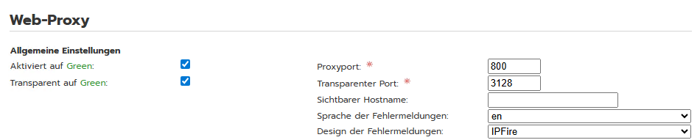
Figure 1: Web Proxy settings in the IPFire web interface

4. Configuring DHCP Options for WPAD
So that clients automatically receive the proxy configuration via DHCP, additional DHCP options are created in the IPFire web interface.
- In the IPFire web interface, navigate to Network → DHCP, then to DHCP Options.
- Create three new DHCP options as follows:
Option 1 – Defining the option code
- Option Name: wpad
- Option Value: code 252=text
- Enabled: on
Option 2 – proxy.pac
- Option Name: wpad
- Option Value: “http://[IPFire's own IP]:81/proxy.pac”
- Enabled: on
- Green: on
Option 3 – wpad.dat
- Option Name: wpad
- Option Value: “http://[IPFire's own IP]:81/wpad.dat”
- Enabled: on
- Green: on
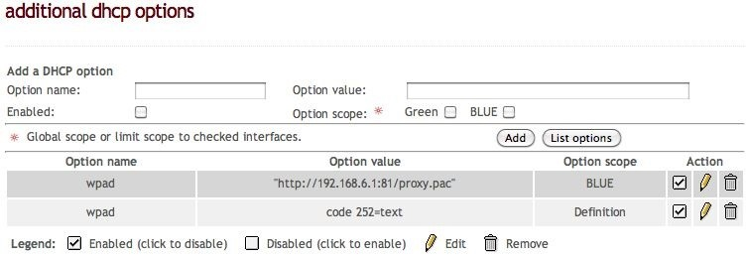
Figure 2: Example of a configured WPAD DHCP option
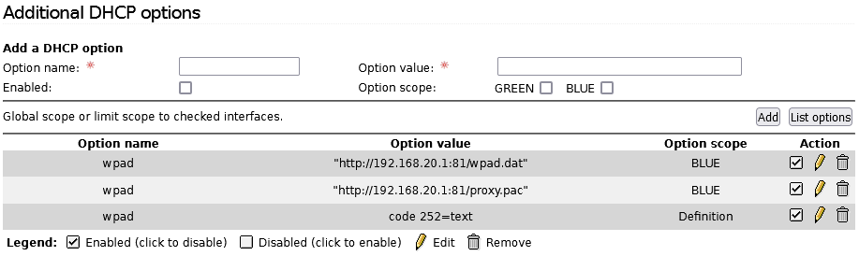
Figure 3: Complete list of WPAD DHCP options (wpad.dat, proxy.pac, option code)

5. Creating the DNS Host Entry on the Windows Server
In addition to the DHCP option, a DNS host entry for “wpad” is created on the Windows Server. This ensures that the name “wpad” can be resolved to IPFire's IP address within the internal network.

Step 1: Open DNS Manager
In Server Manager, under Tools, select DNS to open DNS Manager.
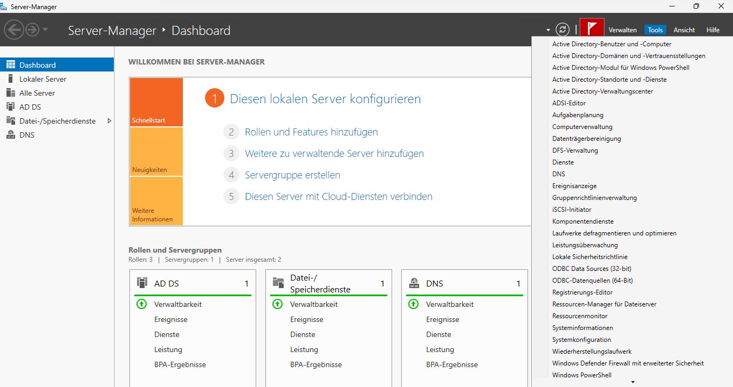
Figure 4: Opening DNS Manager via Server Manager → Tools → DNS

Step 2: Create a new host
In DNS Manager, under your server, open the relevant domain inside Forward Lookup Zones. Right-click the domain and select New Host (A or AAAA)…
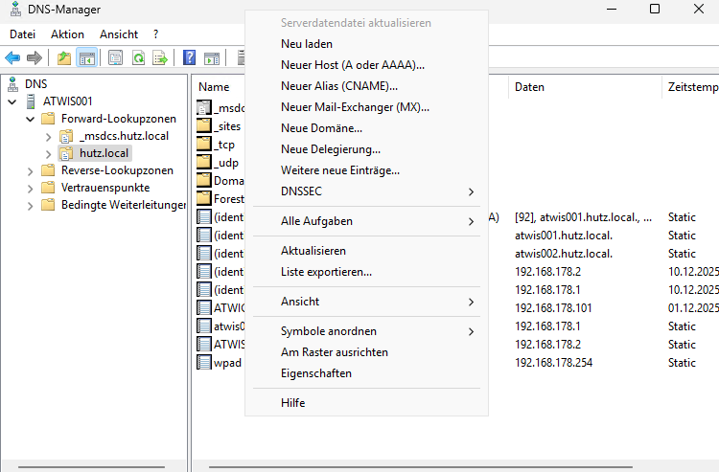
Figure 5: Context menu for creating a new host entry in the forward lookup zone

Step 3: Configure the host entry
Enter the following values in the dialog:
- Name: wpad
- IP address: the IP address of the IPFire system
Then save the entry.
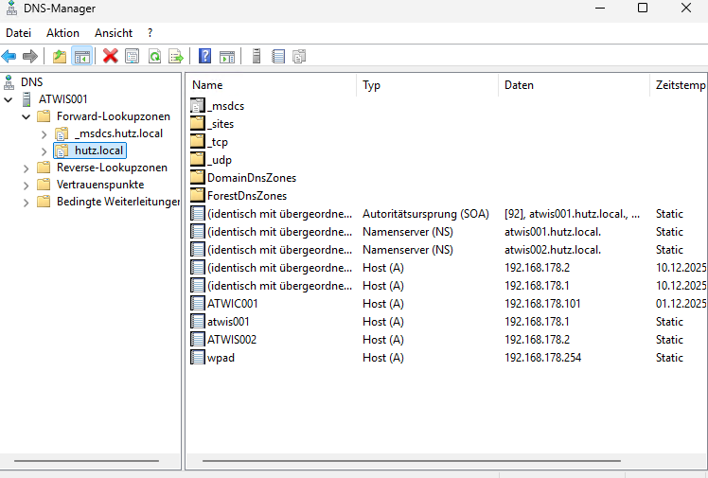
Figure 6: The “wpad” host entry created, with its associated IP address in the DNS zone

Step 4: Adjust the DNS block list
By default, Windows blocks the resolution of certain names, including “wpad”, via the so-called GlobalQueryBlockList. For the entry to work, this block list must be adjusted.
First, run the following command in the Command Prompt (CMD) to check the current behavior:
nslookup wpad
Expected Behavior Before the Change
At this point, an error message typically appears, e.g.:
“wpad could not be found by localhost: Non-existent domain.”
Then adjust the block list with the following command:
dnscmd /config /GlobalQueryBlockList isatap
Afterwards, repeat the test:
nslookup wpad
Name resolution should now succeed.
Important Note
This step must be performed individually on every DNS server in the environment.

6. Verifying the Configuration
Finally, verify that the PAC file is being served correctly via the web server.
- On a client, open the following addresses in a browser or download the file:
http://wpad.[localdomain]/proxy.pac
http://wpad.[localdomain]/wpad.dat
- Check the contents of the downloaded file. It should look roughly like this:
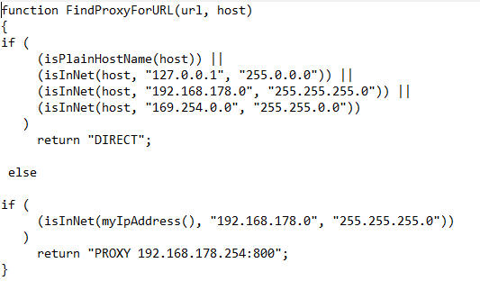
Figure 7: Example contents of a working proxy.pac – requests from the local network are resolved directly, all others are routed through the proxy
Troubleshooting with Multiple Servers
If the PAC file displays correctly on one server but not on another, the cause is often the affected client's browser cache. In that case, clear the browser cache and run the test again.

7. Summary
Once all steps are complete, IPFire automatically serves a PAC file to all clients on the network. Windows clients detect the proxy configuration automatically, either via the DHCP option or via the “wpad” DNS entry, and then use the web proxy configured on IPFire.

7.1 Quick Reference of Key Paths
Purpose | Path / Value
WPAD web root directory | /srv/web/ipfire/wpad
Vhost configuration | /etc/httpd/conf/vhosts.d/wpad.conf
PAC file (source) | /srv/web/ipfire/html/proxy.pac
Proxy port (default) | 800 (transparent: 3128)
WPAD DHCP option (code) | code 252=text
DNS hostname | wpad

