Deep Learning for Image Analysis
Midterm Project 2025
411287004 許豐有 411287019 劉銘和

- Data Preparation & Annotation
We used the PCB Defects Dataset from Kaggle (link) containing printed circuit board (PCB) images exhibiting four defect types: missing hole, mouse bite, open circuit, and short circuit.
Annotation was conducted using Roboflow, where defect regions were labeled using bounding boxes. Labels were exported in YOLO format. A total of 1,957 annotated samples were created.
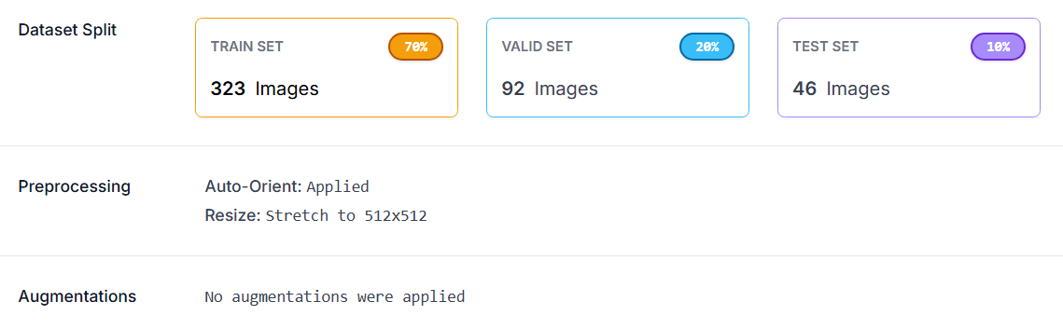
Fig.1 Baseline Dataset Preparation
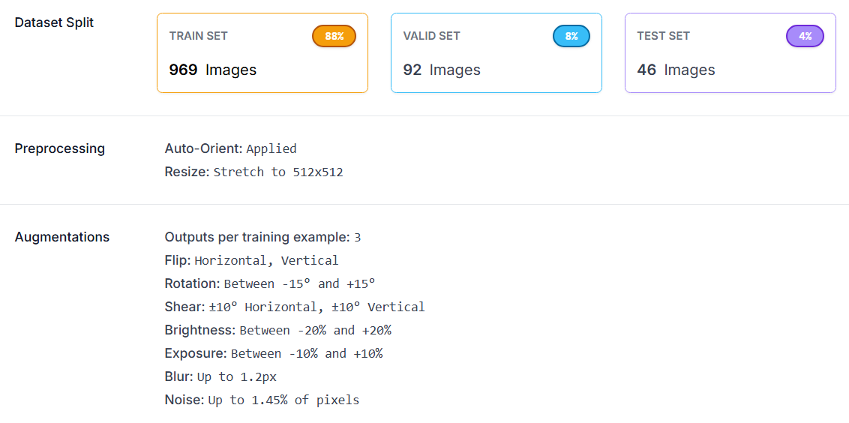
Fig.2 Enhanced Dataset Preparation
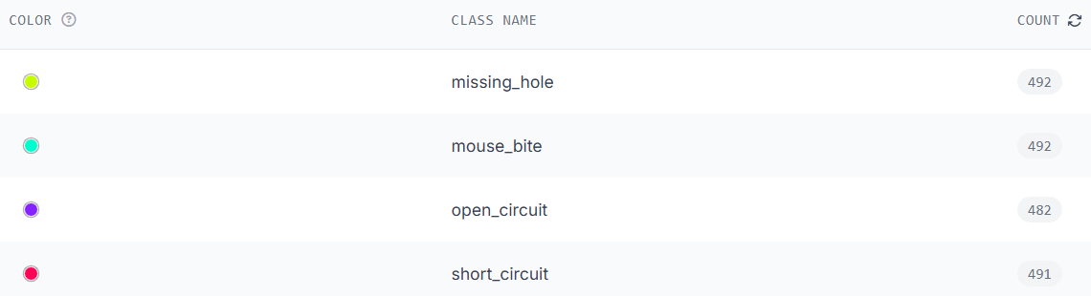
Fig.3 Class Distribution
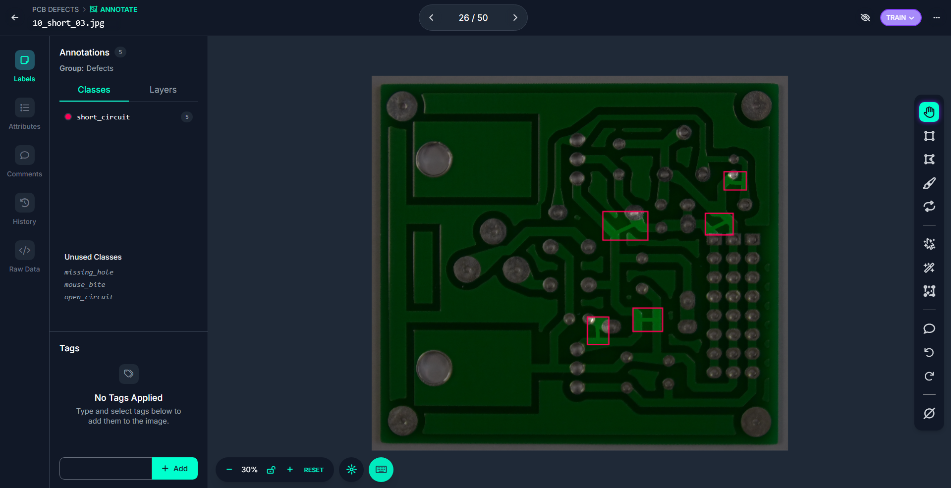
Fig.4 Labeling Interface

- Model Development
We trained a YOLOv12 object detection model for PCB defect identification.
Two experimental pipelines were implemented for comparison:
Pipeline | Description
Baseline | Trained directly on raw data without any preprocessing or augmentation.
Enhanced | Trained using preprocessing and augmentation techniques to improve robustness.
- Environment:
Python 3.10.19, Torch 2.6.0+cu124, Ultralytics 8.3.227, RTX 4060 GPU.
- Data Augmentation Summary:
Method | Purpose
Rotation (±15°) | Improves angle robustness.
90° Flip (CW/CCW) | Increases orientation invariance.
Shear (±10°) | Models’ geometric distortion.
Brightness (±20%) | Adapts to lighting variation.
Exposure (±10%) | Adapts to lighting variation.
Blur (≤1.2px) | Handles motion blur.
Noise (≤1.45%) | Improves noise tolerance.
- Why YOLOv12
Chosen for its lightweight design, real-time inference capability, and enhanced Flush Attention mechanism improving small-defect detection compared to YOLOv8.
- Model Comparison and Discussion
Both models used the same YOLOv12 architecture and dataset.
The Baseline Model trained on raw images, while the Enhanced Model used augmentation (rotation, zoom, shear, blur, noise, color jitter).
Metric | Baseline | Enhanced | Better
Recall | 0.851 | 0.871 | Enhanced
F1-score | 0.890 | 0.92 | Enhanced
mAP@0.5 | 0.918 | 0.925 | Enhanced
mAP@0.5–0.95 | 0.420 | 0.478 | Enhanced
The Enhanced Model performs better overall.
Augmentation improved its robustness to lighting, angle, and noise changes, helping it detects subtle defects such as open circuits that the baseline often missed.

- Evaluation
Both models were evaluated on the same test set using Precision, Recall, F1-score, and mAP@0.5.
- Precision
Both models reached perfect precision, but at different confidence levels. The Baseline Model achieved 1.00 precision at 0.697, while the Enhanced Model reached it at 0.803.
The higher confidence point of the Enhanced Model shows it makes more reliable predictions with fewer false positives. Its precision curve is smoother and remains high across all classes, indicating better overall stability and accuracy.
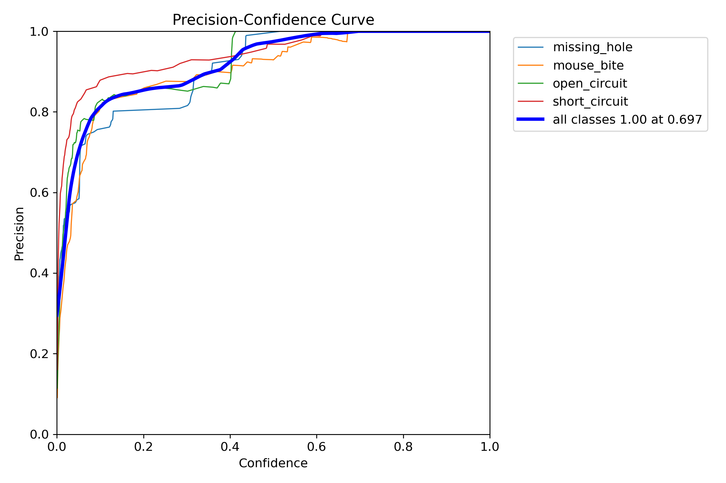
Fig.5 Baseline Precision
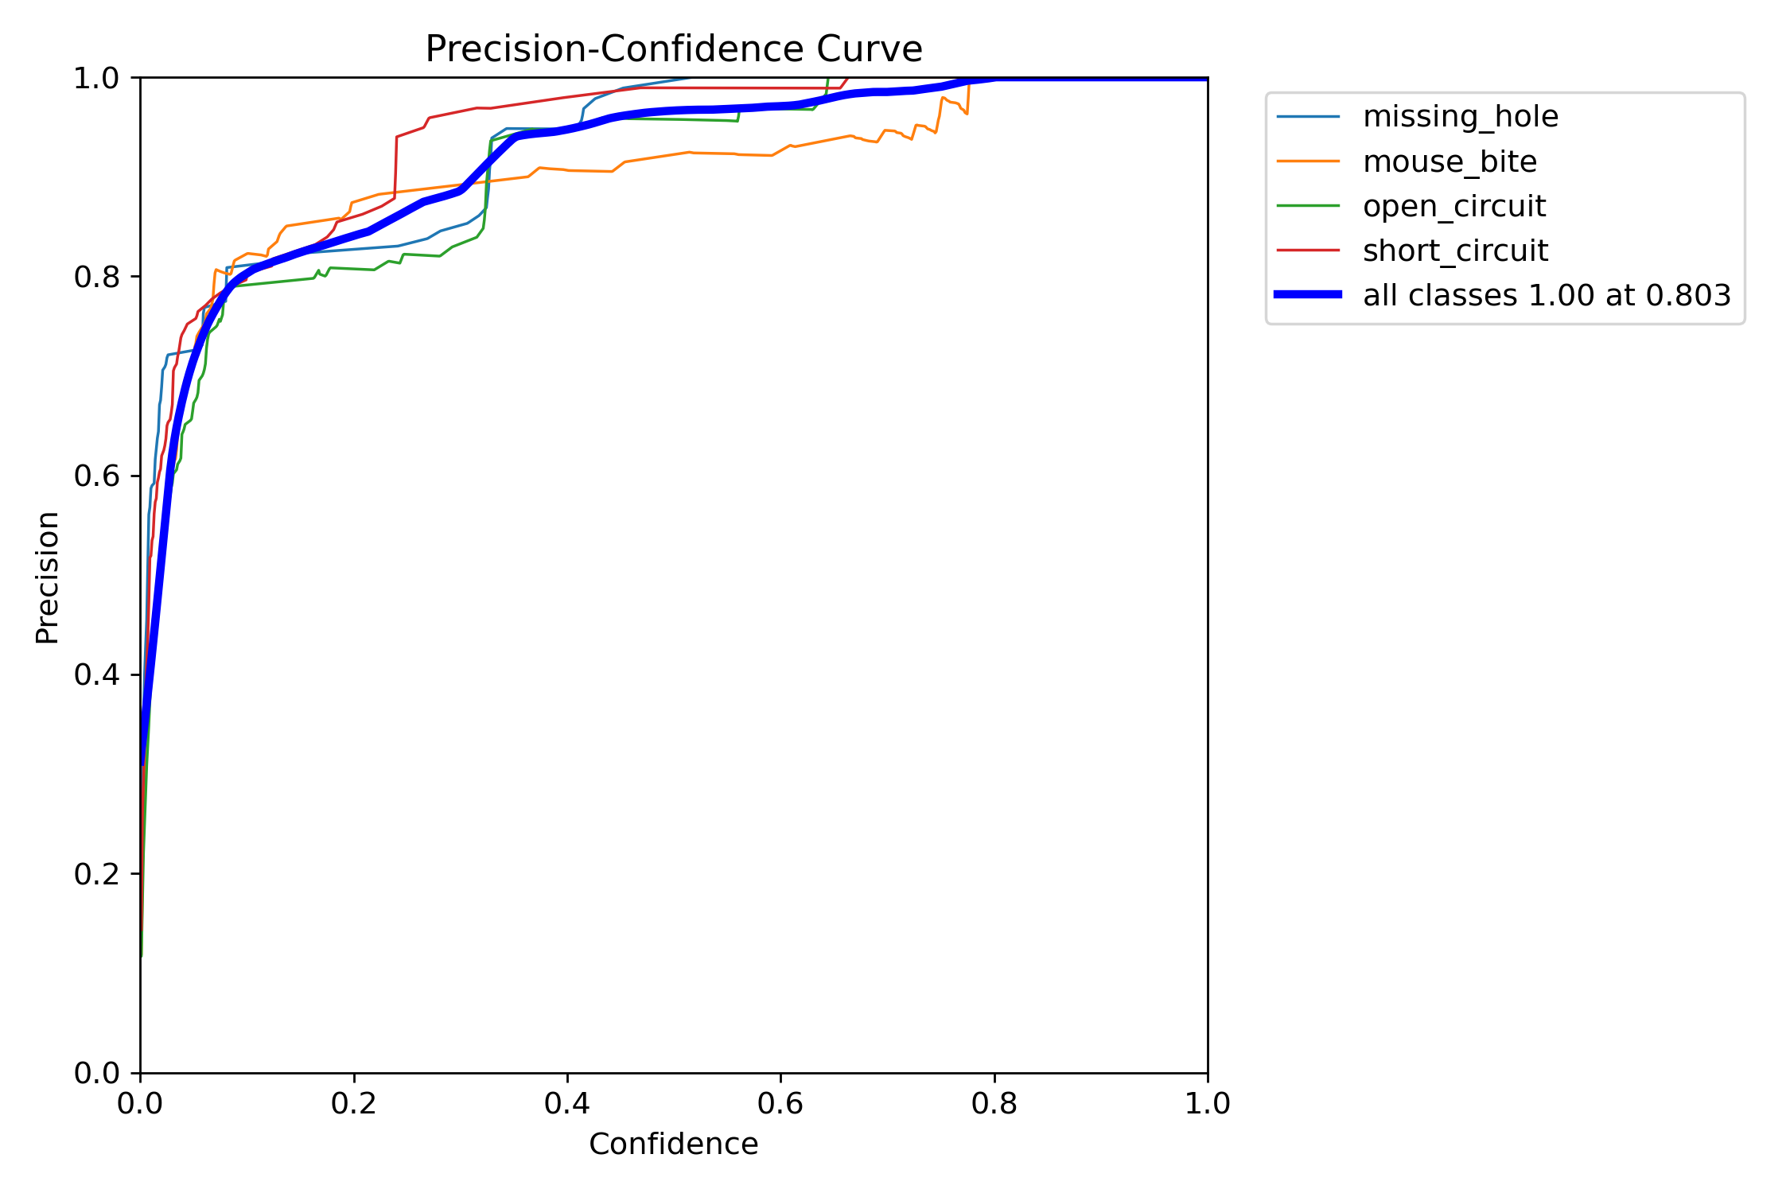
Fig.6 Enhanced Precision
- Recall
Both models achieved a maximum recall of 0.96, but their confidence behaviors differ. The Enhanced Model maintains higher recall across most confidence ranges, especially between 0.2 and 0.7, where it detects more true defects while keeping stability across all classes. The Baseline Model drops more sharply as confidence increases, indicating less consistency at higher thresholds. Overall, the Enhanced Model provides better recall balance and stronger detection reliability, especially for small or subtle defects.
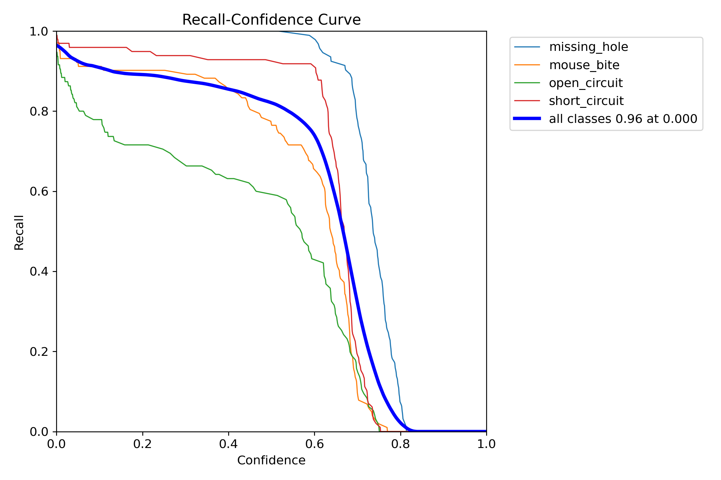
Fig.7 Baseline Recall
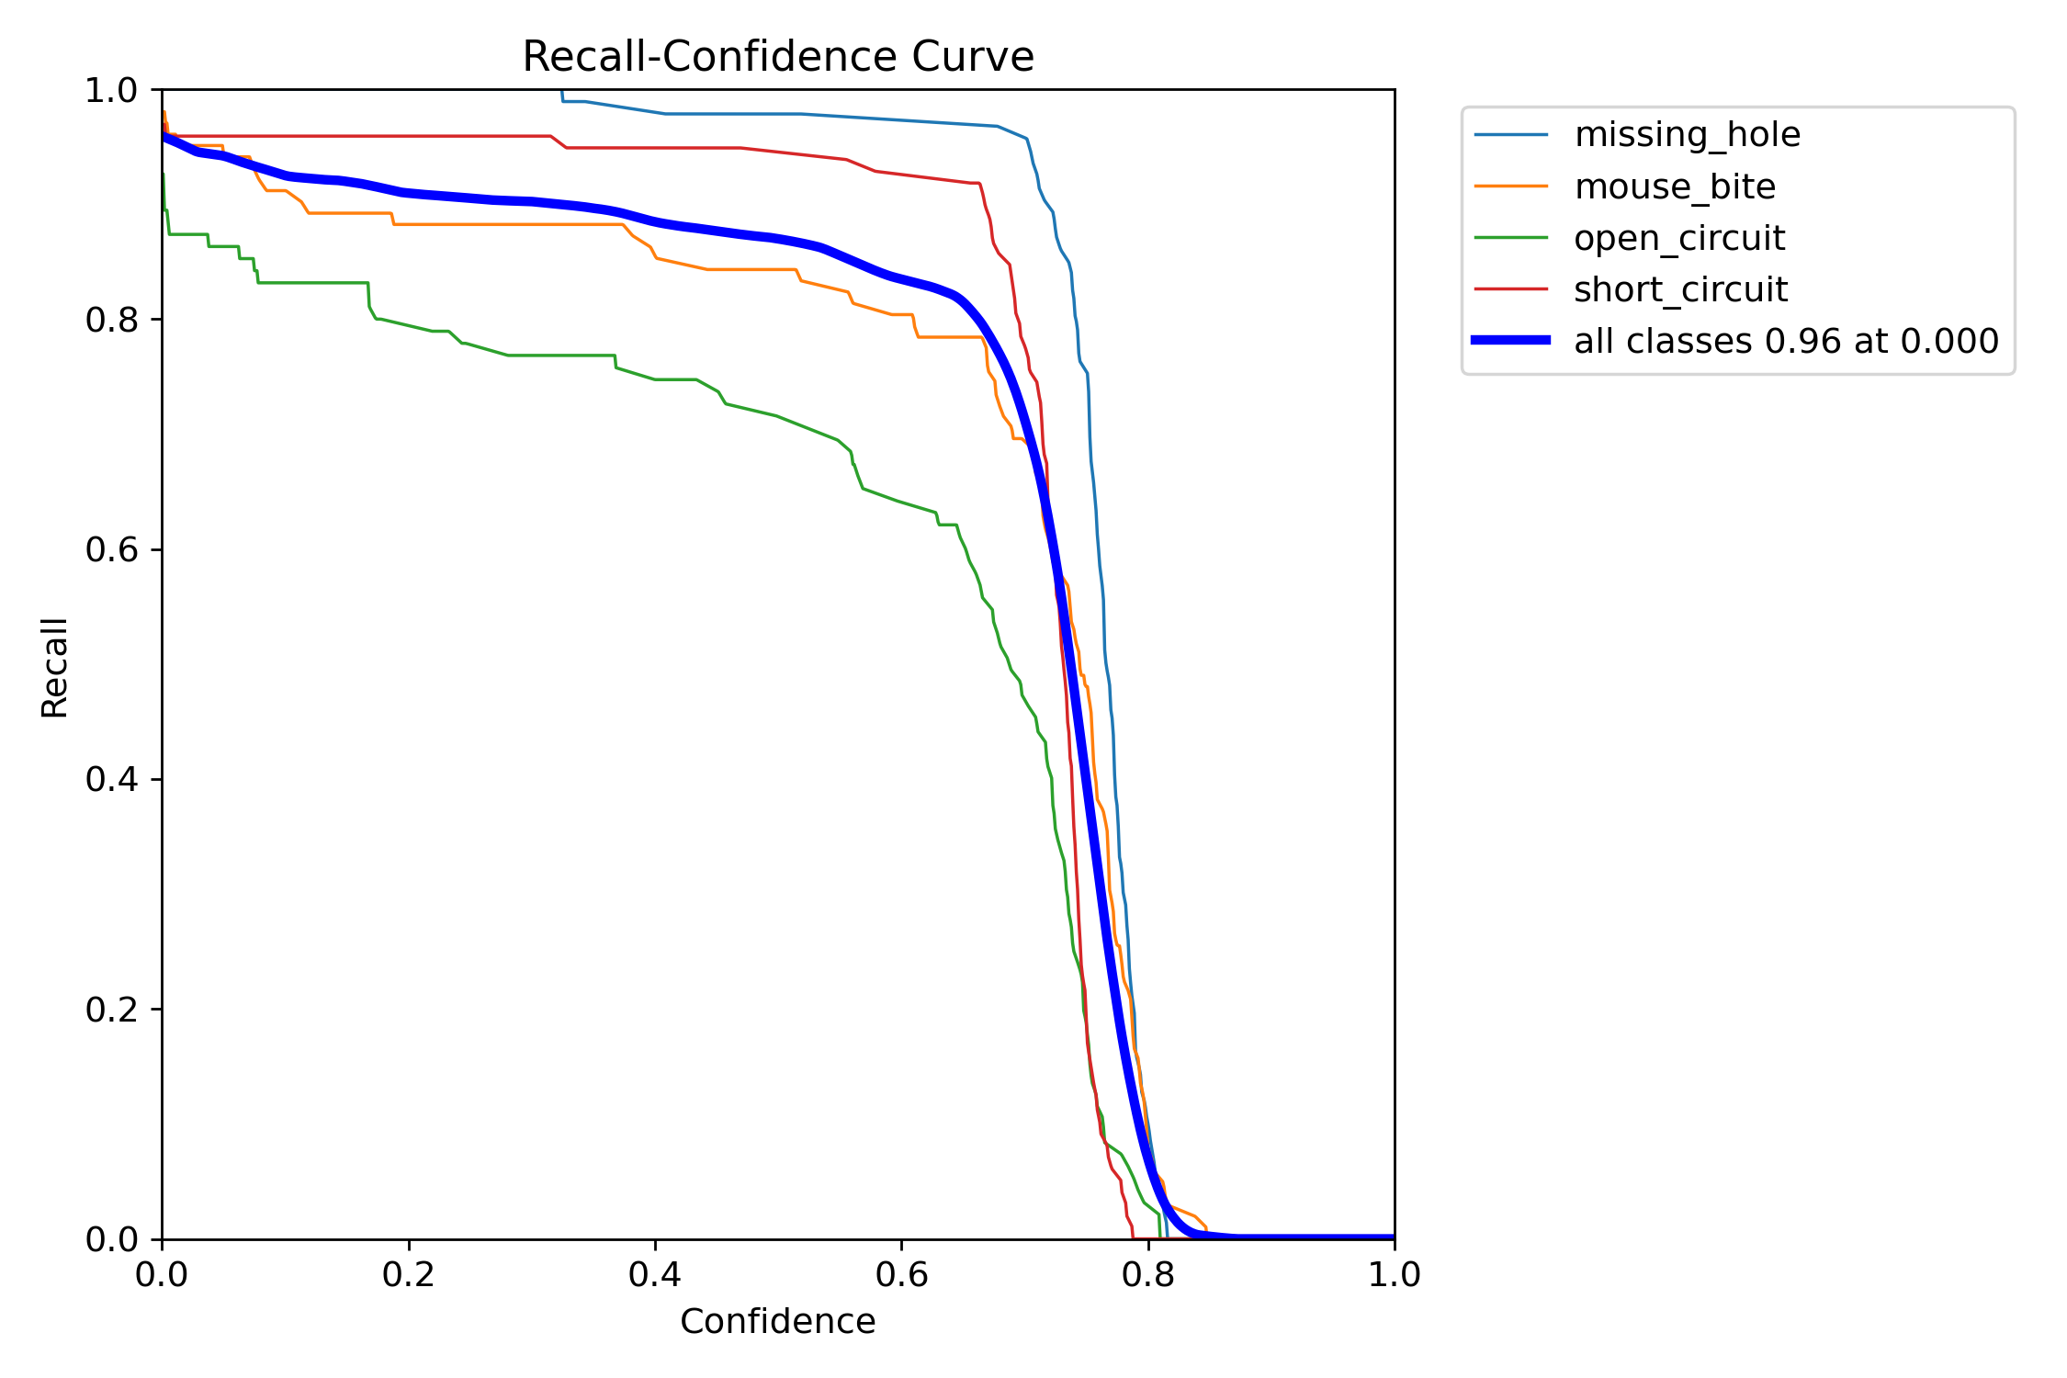
Fig.8 Enhanced Recall
- F1-score
The Baseline Model achieved a maximum F1 score of 0.89 at a confidence of 0.435, while the Enhanced Model reached 0.92 at 0.357. The Enhanced Model’s curve is consistently higher and smoother, showing stronger balance between precision and recall across all classes. Indicating improved overall detection consistency and robustness.
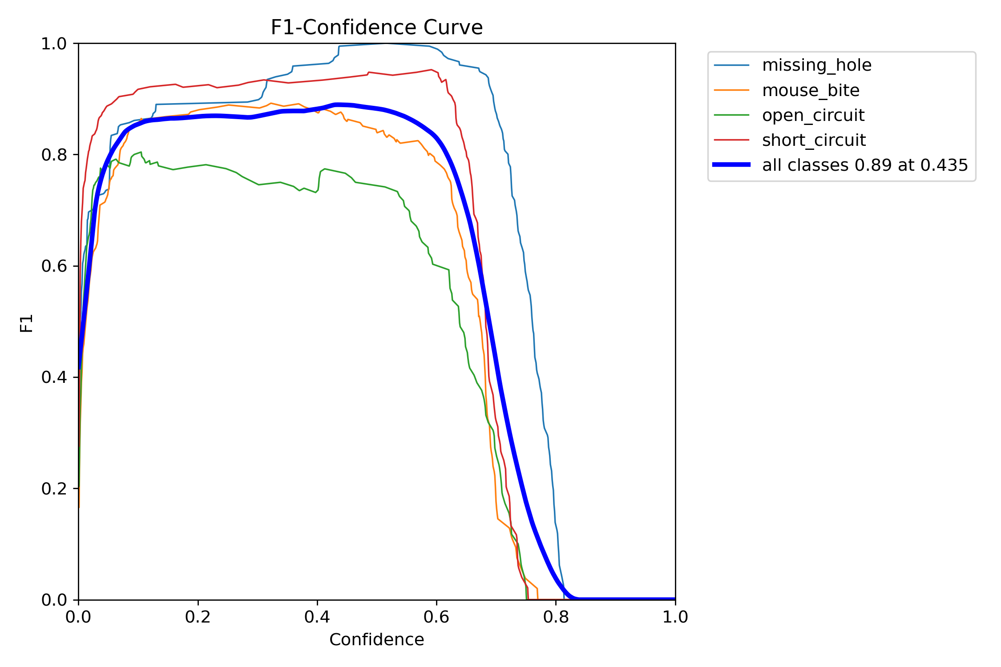
Fig.9 Baseline F1-score
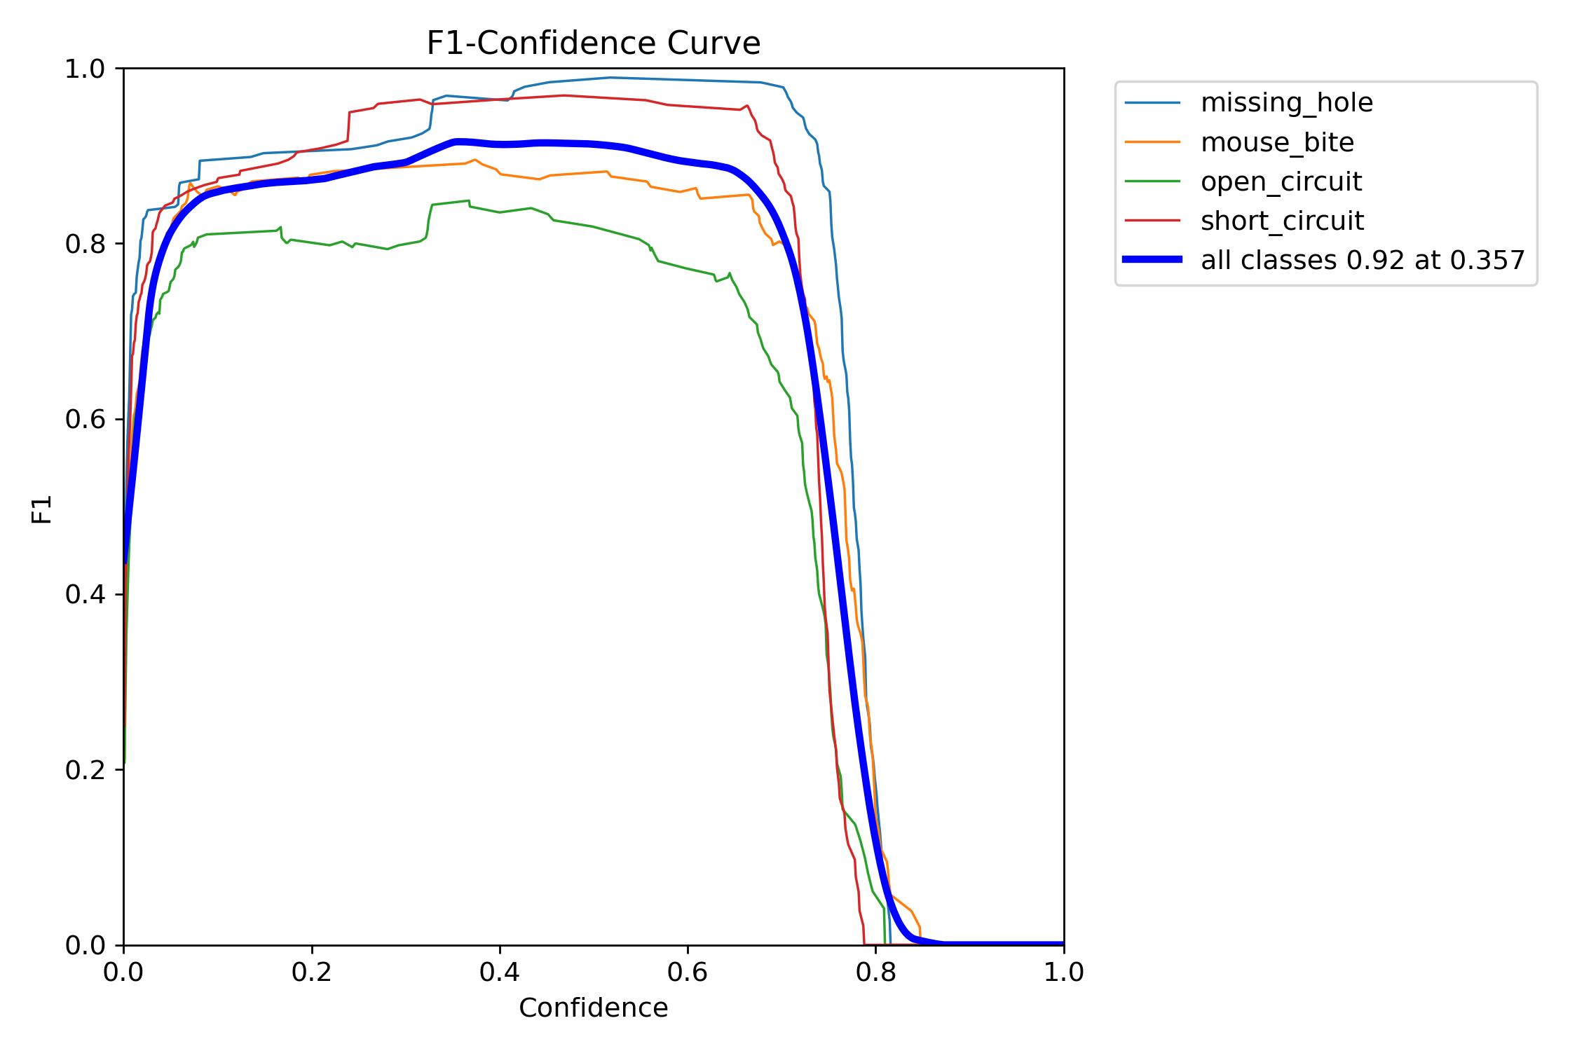
Fig.10 Enhanced F1-score
- mAP@0.5
The Enhanced Model reached higher mAP@0.5 values and converged faster than the Baseline Model. It surpassed 0.80 before Epoch 20, while Baseline required about 40 epochs to reach the same level. Throughout training, the Enhanced Model’s curve is smoother and remains above Baseline, indicating better learning stability and stronger generalization. By the final epochs, both models approach similar peaks, but the Enhanced Model maintains consistently higher precision-recall balance across all stages.
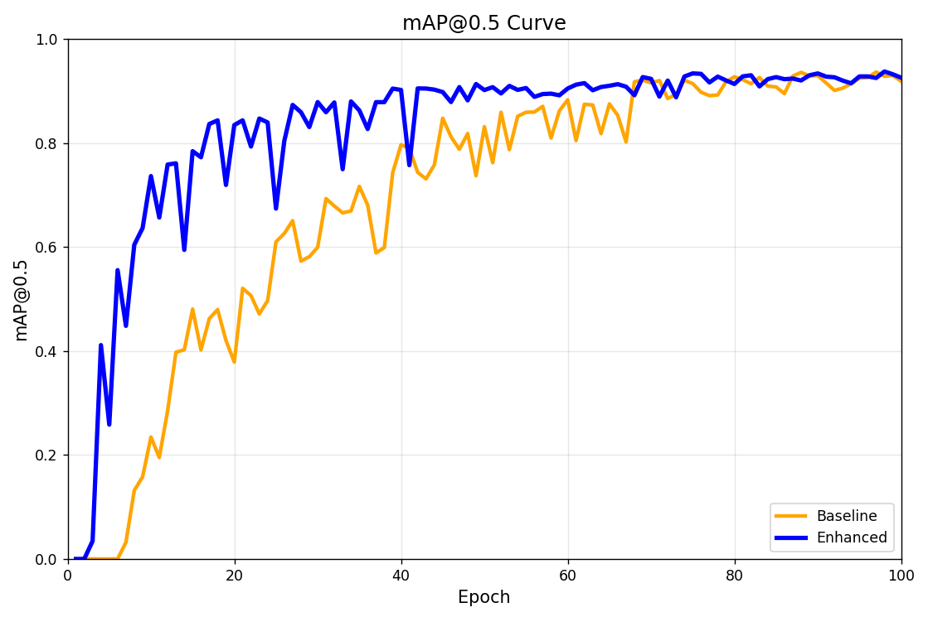
Fig.11 mAP@0.5 Baseline vs. Enhanced
- Qualitative Results
Both models show a steady decrease in loss and improvement in precision, recall, and mAP over epochs. The Enhanced Model exhibits smoother and faster convergence across all loss terms (box, cls, dfl) and validation metrics compared to the Baseline Model.
In particular:
- Validation losses for the Enhanced Model are consistently lower, indicating better generalization.
- Precision and Recall curves rise more rapidly and stabilize earlier.
- mAP@0.5 and mAP@0.5–0.95 grow faster and reach higher final values.
Overall, the Enhanced Model demonstrates clearer learning stability, reduced fluctuation, and stronger performance across all evaluation metrics.
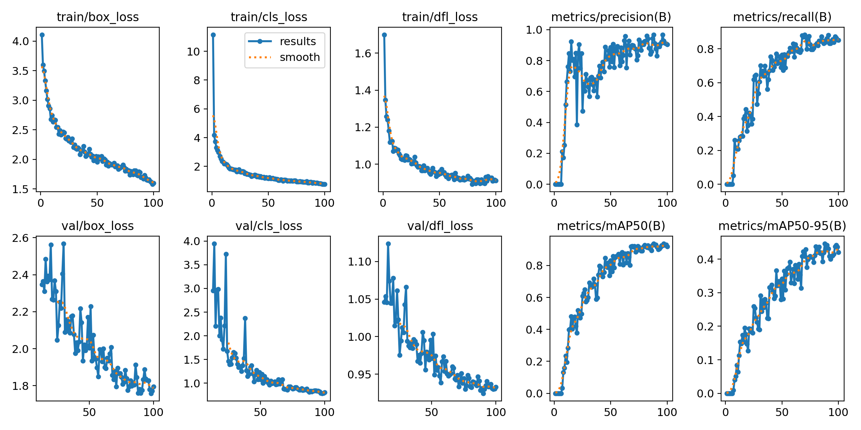
Fig.12 Baseline Result
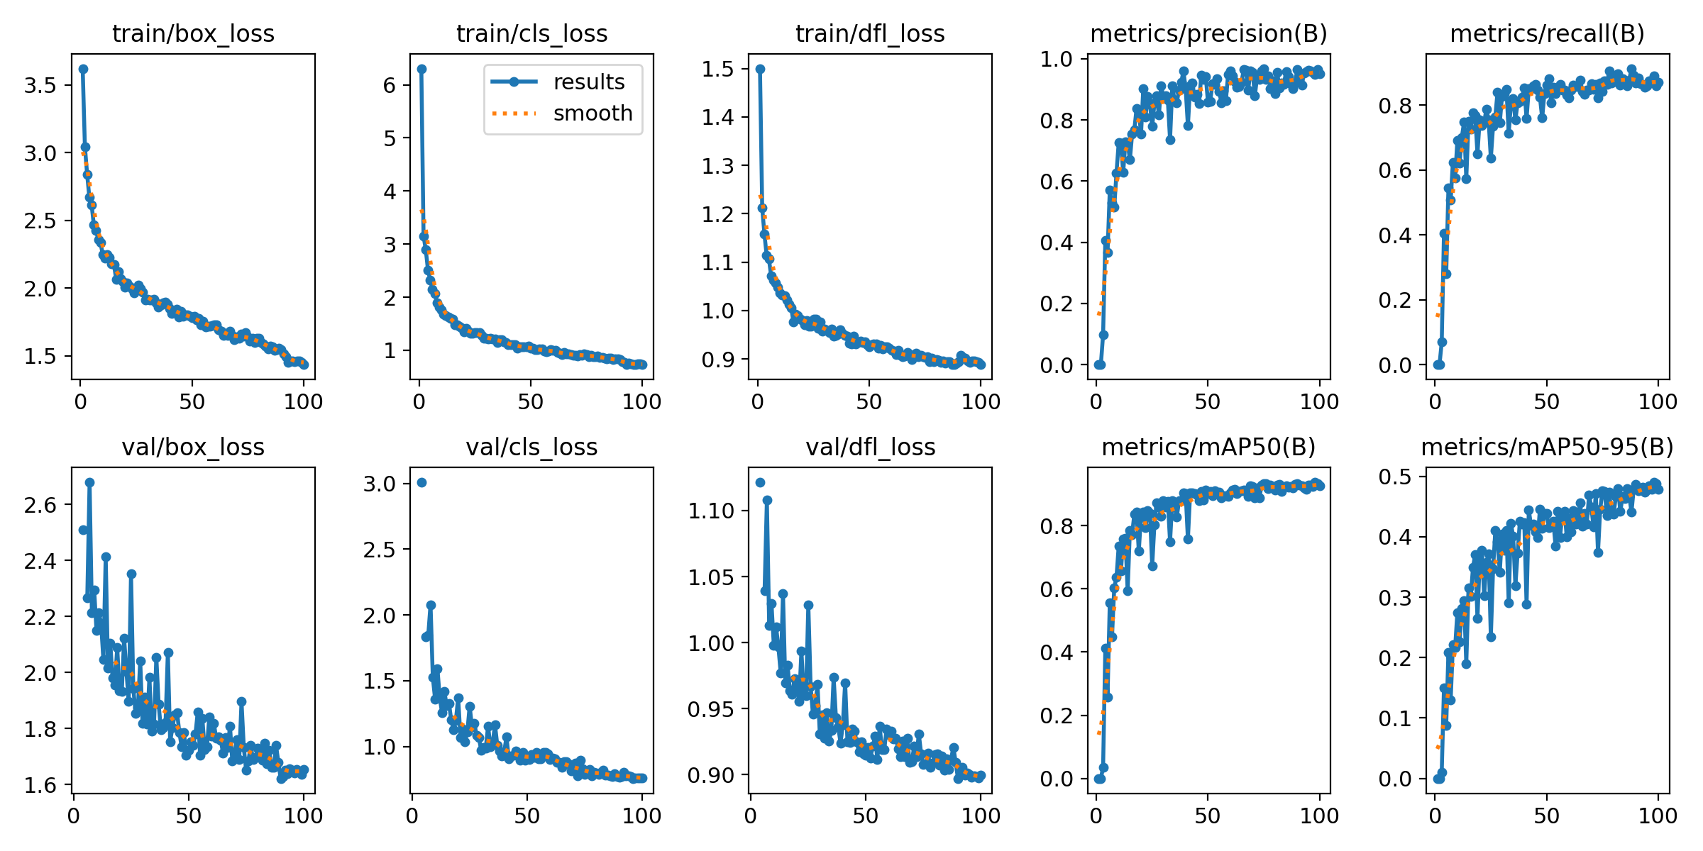
Fig.13 Enhanced Result
- Sample Prediction
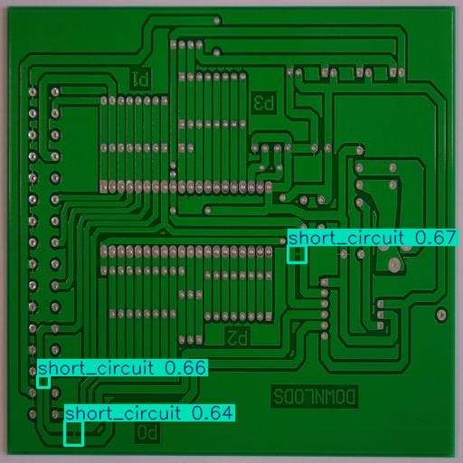
Fig.14 Baseline Sample Prediction
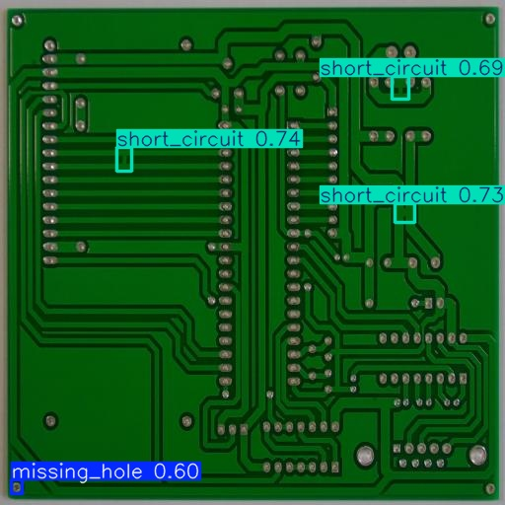
Fig.15 Enhanced Sample Prediction

- Analysis & Discussion
- Open circuit is a major weakness of Baseline
- Evidence
In the F1-Score graph, the baseline's open circuit F1 peak score is only about 0.80, far lower than the Enhanced Model's 0.95.
- Possible reasons
An "open circuit" is a tiny gap or break in a circuit trace. Visually, it is a very subtle defect that can easily be confused with the normal trace background.
- How Enhanced Model solved
The Enhanced Model uses data augmentation. This forces the model to learn subtle features more carefully, explaining why the Enhanced Model achieves a significant improvement in its F1 score on open circuits.
- False Positives: Confusion caused by low confidence thresholds
- Evidence
- Possible reasons
The baseline model may be unable to distinguish between real defects and visual interference. It may make silkscreen lines, solder reflections, or uneven lighting for mouse bite or short circuit, resulting in a large number of low-confidence false alarms.
- How Enhanced Model solved
Enhanced models utilize data augmentation to simulate various visual disturbances in the test environment. This forces the model to learn more carefully to distinguish between "real features" and "noise," thus significantly reducing false positives and achieving better operational confidence.
- Model architecture diagram
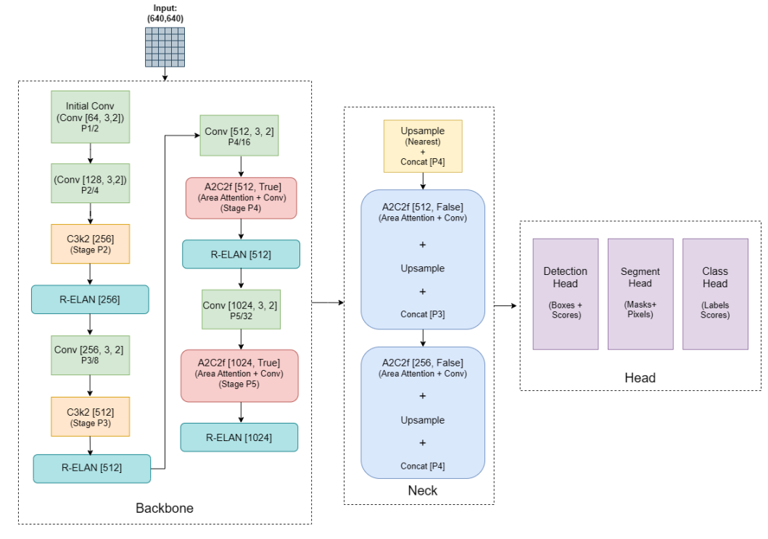
Fig.16 YOLOv12 Model architecture
- Backbone
- Purpose: Feature Extractor
- Function: This is the model's "eyes." It receives a 640x640 PCB image as input and then extracts key visual features (such as edges, textures, and shapes) layer by layer through a series of Conv and R-ELAN modules.
- Neck
- Purpose: Feature Fusion
- Function: The Neck's job is to fuse deep and shallow features. It uses Unsample and Concat operations to combine deep and shallow features, allowing the model to detect both large and small defects simultaneously.
- Head
- Purpose: Predictor.
- Function: Function: This is the model's "brain" and "mouth." It receives feature maps fused from the Neck at three different scales and uses the Flush Attention module to output the detection results.

