[Institution Name]
[College / Department]

GOAL AND TASK
RECOMMENDATION SYSTEM
A Rule-Based Prolog Project

Submitted in partial fulfillment of the requirements for
CMPSC 162
First Semester, School Year 2026–2027

Submitted by:
[Student Name / Group Members]
[Program, Year, and Section]

Submitted to:
[Instructor Name]

[Submission Date]

Acknowledgment
We express our appreciation to [Instructor Name] for the guidance provided in CMPSC 162 and for the opportunity to apply logic programming to a practical task recommendation problem. We also thank [individuals or group members to acknowledge] for their contributions to the preparation and completion of this project.
We acknowledge the SWI-Prolog community for providing the programming environment and reference documentation used to develop and explain the system. This project gave us an opportunity to practice representing knowledge through facts and applying rules to derive understandable recommendations.
[Edit this acknowledgment to reflect the people who actually contributed to your project.]

Table of Contents
Acknowledgment 2
Table of Contents 3
List of Figures 4
List of Tables 4
Part 1: Project Overview 5
1.1 Project Name 5
1.2 Background 5
1.3 Objectives 5
1.4 Scope and Limitations 6
Part 2: Main Features 7
2.1 Knowledge Base 7
2.2 Inference Engine 8
2.3 Interactive Query 9
Part 3: Technical Requirements/Specifications 10
3.1 Language and Environment 10
3.2 Key Fact Predicates 10
3.3 Key Rule Predicates 11
Part 4: Sample Outputs 12
4.1 Captured Query Results 12
4.2 Test Queries and Validation 16
Part 5: References/Sources 17
Part 6: Program Listing 18

List of Figures
Figure 1. Recommendations for different time budgets 12
Figure 2. Time limits and excluded tasks 13
Figure 3. Recommendation score and explanation 14
Figure 4. Recursive duration and data validation 15

List of Tables
Table 1. Fields of a task record 7
Table 2. Recommendation scoring policy 8
Table 3. Fact predicates and their roles 10
Table 4. Rule predicates and their responsibilities 11
Table 5. Test queries and observed results 16

Part 1: Project Overview

1.1 Project Name
Goal and Task Recommendation System

1.2 Background
Students often manage several responsibilities at the same time, such as assignments, examination review, personal activities, and household tasks. Choosing what to do next can be difficult when the available time is limited and different tasks have different deadlines, priorities, and levels of progress. A task that is important may not fit the current time allowance, while a short task may belong to a goal that is no longer active.
This project addresses that decision by representing goals and tasks as Prolog facts and applying explicit rules to select suitable work. The implementation in proj2.pl checks whether a task is valid, unfinished, connected to an active goal, and short enough to complete within the available minutes. It then compares eligible tasks using a score based on deadline urgency, priority, and progress [1].
The project was chosen because it connects an everyday planning problem with declarative programming. Instead of writing a separate instruction for every possible choice, the program describes task characteristics and the conditions for a recommendation. Users can inspect both the stored information and the rules that produced the answer. SWI-Prolog provides the environment for loading the source and evaluating queries [2].

1.3 Objectives
The general objective is to build a rule-based assistant that recommends the most suitable next task from a supplied set of goals and tasks, using the user’s available time and predefined decision rules.
- Represent task types, goals, priorities, deadlines, remaining durations, difficulty levels, statuses, and progress as structured facts.
- Validate task information and exclude completed or archived tasks and tasks associated with inactive goals from recommendations.
- Compare eligible tasks using deadline points, priority points, and a small progress bonus.
- Explain a recommendation through task characteristics such as being overdue, nearly finished, or short in duration.
- Demonstrate logical queries, negation as failure, backtracking, list collection, and recursion through testable examples.

1.4 Scope and Limitations
The intended users are students and beginners studying Prolog and symbolic artificial intelligence. The program is a single-file prototype with six sample goals and eleven sample tasks. Users can replace or extend these facts, reload the file, and ask questions through the SWI-Prolog prompt. Its coverage includes task validation, eligibility checking, score calculation, recommendation explanations, and the total remaining duration of a supplied task list.
The system has no graphical interface, interactive data-entry menu, database, calendar integration, or automatic notification delivery. Days remaining are stored as numbers and must be updated manually as time passes. The program does not learn from user behavior, estimate durations automatically, divide a task into smaller sessions, or build a complete daily schedule. Difficulty is descriptive and does not affect the recommendation score. The scoring weights are a project design choice, rather than a policy validated by a user study.
Task names should be unique, and each task should be linked to one goal. These are data-entry conventions; the program does not provide a global duplicate-record checker. The current progress vocabulary permits increments of ten from 0 to 100. Correct recommendations depend on accurate task facts and realistic remaining-time estimates [1].

Part 2: Main Features

2.1 Knowledge Base
The knowledge base contains 148 domain facts: 116 vocabulary and classification facts, 6 goal records, 11 task records, 11 task-to-goal links, and 4 priority-point mappings. This count excludes executable rule clauses and base cases. The facts describe the allowed values and the sample work to be considered by the system [1].
Each goal uses goal(Name, Category, Status). For example, pass_subjects is an active academic goal, while learn_drawing is a paused creative goal. Each task is connected to a goal through task_goal(Task, Goal). A task’s type determines its category, which must agree with the linked goal’s category.
A task record follows this structure:
task(Name, Type, MinutesLeft, Priority, DaysLeft, Difficulty, Status, Progress).
Table 1. Fields of a task record
Field | Meaning and accepted representation
Name | A unique task identifier, such as lab_report.
Type | A defined task type, such as lab_work or review.
MinutesLeft | Whole-number estimate of remaining work, in minutes.
Priority | urgent, high, medium, or low.
DaysLeft | Negative = overdue; 0 = today; positive = days remaining; none = no deadline.
Difficulty | easy, moderate, hard, or very_hard.
Status | pending, in_progress, completed, overdue, or archived.
Progress | A defined percentage: 0, 10, 20, …, 100.

The remaining minutes already represent unfinished work. The program therefore does not reduce this value a second time based on the progress percentage. Validation also checks consistency: a completed task must have 100% progress and zero remaining minutes, while a pending task must have 0% progress and positive remaining minutes.
The original vocabulary also defines days of the week, time periods, session types, reminders, notifications, skill categories, and category priorities. These definitions remain in the file, but the current recommendation rules do not implement scheduling or notification features from them. The selected priority of each task, rather than category_priority/2, supplies the priority score.

2.2 Inference Engine
The inference engine first applies eligible_task/2. A candidate must pass valid_task/1, unfinished_task/1, active_goal_task/1, and fits_time/2. The available minutes must be a nonnegative integer, and the task must have positive remaining work that does not exceed that allowance. An exact time match is accepted.
After filtering, task_score/2 calculates the score using arithmetic evaluation and integer division [3]:
Score = DeadlinePoints + PriorityPoints + Progress // 10
Table 2. Recommendation scoring policy
Component | Condition | Points
Deadline | Overdue: negative days left | 200
Deadline | Due today or within two days | 100
Deadline | Later than two days, or no deadline | 0
Priority | urgent / high / medium / low | 40 / 30 / 20 / 10
Progress | Integer division of progress by 10 | Progress // 10

For lab_report, the score is 200 + 40 + 8 = 248. It is overdue, urgent, and 80% complete. For prepare_slides, the score is 100 + 30 + 9 = 139. This exceeds review_notes at 136, even though review_notes is due today, because the policy treats all deadlines from today through two days away as the same urgency band.
The recommend_task/2 rule succeeds when a candidate is eligible and no other eligible task has a strictly higher score. It uses negation as failure, written as \+, to test that a better candidate cannot be proved [4]. If two tasks share the highest score, both may be obtained by requesting further solutions through backtracking. If no task is eligible, the query returns false.
The recommendation/3 rule collects descriptive reasons with findall/3 [5]. Reasons can include overdue, near_deadline, high_priority, almost_finished, easy_work, and short_duration. These describe characteristics of the selected task; easy_work and short_duration are not additional score components.
The total_duration/2 rule demonstrates recursion. The empty list has a total of zero. For a nonempty list, the program adds the first task’s remaining minutes to the recursively computed total for the rest. This rule totals a supplied list; it does not automatically choose a schedule or require every listed task to be eligible for recommendation.

2.3 Interactive Query
Interaction takes place through the normal SWI-Prolog query prompt. Start a fresh session in the folder containing proj2.pl and load it with [proj2]. Each query ends with a period. Entering a semicolon after an answer requests another solution when alternatives exist [2].
?- [proj2].
?- recommend_task(Task, 60).
?- recommendation(Task, 60, Reasons).
?- total_duration([lab_report, review_notes, send_resume], Minutes).
The first recommendation query asks what to do with 60 available minutes. The explanation query asks for the chosen task and its characteristics. The duration query asks how much time a specified group of tasks requires. Users change the time allowance directly in the query. To use their own tasks, they edit the goal/3, task/8, and task_goal/2 facts and reload the file.

Part 3: Technical Requirements/Specifications

3.1 Language and Environment
The project is written in Prolog and was verified using SWI-Prolog 10.0.2 for 64-bit Windows. It consists of one source file, proj2.pl. No additional project modules, database connection, or network service is required. A text editor and a working SWI-Prolog installation are sufficient to edit and run the program. The tested version is reported here; compatibility with older versions was not separately tested.
The implementation uses predicates and arithmetic supported by SWI-Prolog, including integer/1, member/2, findall/3, is/2, comparison operators, if-then-else, and negation as failure. The documented validation query also uses forall/2. The normal usage supplies an integer time allowance and existing task identifiers, rather than arbitrary unbound inputs to arithmetic helper predicates.

3.2 Key Fact Predicates
Predicate notation uses name/arity, where arity is the number of arguments. The following predicates define the data used or retained in the knowledge base.
Table 3. Fact predicates and their roles
Predicate | Role
task_type/2 | Maps task types to categories.
goal_category/1 | Defines allowed goal categories.
priority_level/1 | Defines allowed task priorities.
category_priority/2 | Stores category defaults; not used in scoring.
task_status_value/1; goal_status_value/1 | Define allowed task and goal statuses.
day_of_week/1; time_period/1 | Store day/time vocabulary; no scheduling behavior.
duration_category/2 | Stores duration limits; short/30 is used by short_task/1.
difficulty_level/1 | Defines allowed difficulty values.
session_type/1; reminder_frequency/1 | Retain session/reminder vocabulary only.
notification_type/1; skill_category/1 | Retain notification/skill vocabulary only.
progress_percentage/1 | Defines permitted progress percentages.
goal/3 | Stores a goal name, category, and status.
task/8 | Stores the eight task characteristics.
task_goal/2 | Connects a task to its goal.
priority_points/2 | Maps the chosen priority to numeric points.

3.3 Key Rule Predicates
Table 4. Rule predicates and their responsibilities
Predicate | Responsibility
valid_deadline/1 | Accepts none or an integer days-left value.
valid_progress/3 | Checks agreement between status, progress, and minutes.
valid_task/1 | Checks allowed values and linked goal/category consistency.
task_category/2 | Derives a task category from its type.
unfinished_task/1 | Recognizes pending, in-progress, or overdue work below 100%.
active_goal_task/1 | Checks whether the linked goal is active.
fits_time/2 | Checks positive remaining work against available minutes.
overdue_task/1 | Identifies unfinished tasks with negative days left.
due_soon_task/1 | Identifies unfinished tasks due in zero through two days.
high_priority_task/1 | Identifies high or urgent tasks.
easy_task/1 | Identifies tasks with easy difficulty.
short_task/1 | Identifies tasks with 1–30 remaining minutes.
almost_done/1 | Identifies unfinished tasks at least 80% complete.
eligible_task/2 | Combines validation, unfinished status, active goal, and time fit.
deadline_score/2 | Assigns deadline points using mutually exclusive cases.
task_score/2 | Adds deadline points, priority points, and progress bonus.
recommend_task/2 | Selects a task with no higher-scoring eligible competitor.
recommendation_reason/2 | Produces descriptive reasons for a task.
recommendation/3 | Returns a recommended task and collected reasons.
total_duration/2 | Recursively totals the minutes of a supplied task list.

Part 4: Sample Outputs

4.1 Captured Query Results
Figures 1–4 are screenshots of a read-only transcript viewer containing outputs captured from actual SWI-Prolog 10.0.2 runs of proj2.pl. They are not screenshots of the native console window. Each query was wrapped in once/1 to record its first result consistently; this wrapper did not modify the project source. The question and the interpreter’s returned answer are shown together.
Figure 1. Recommendations for different time budgets
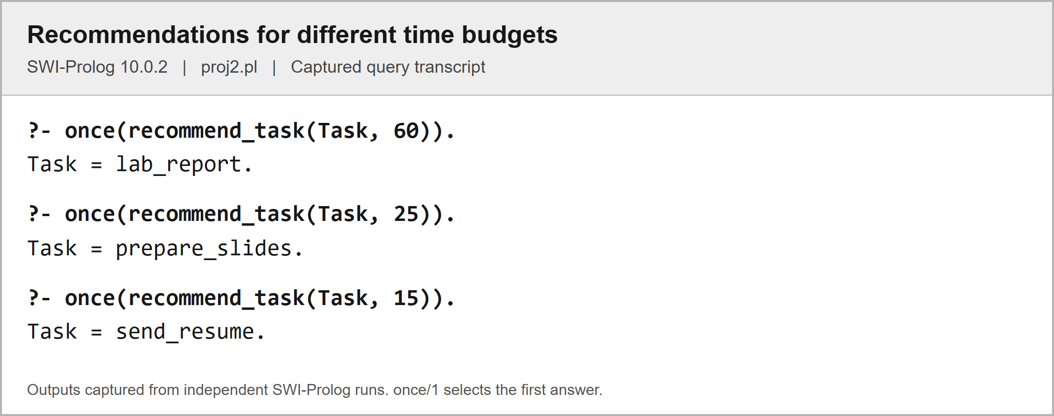
With 60 minutes, lab_report is selected. With 25 minutes, prepare_slides is selected because lab_report no longer fits. With 15 minutes, send_resume is selected.

Figure 2. Time limits and excluded tasks
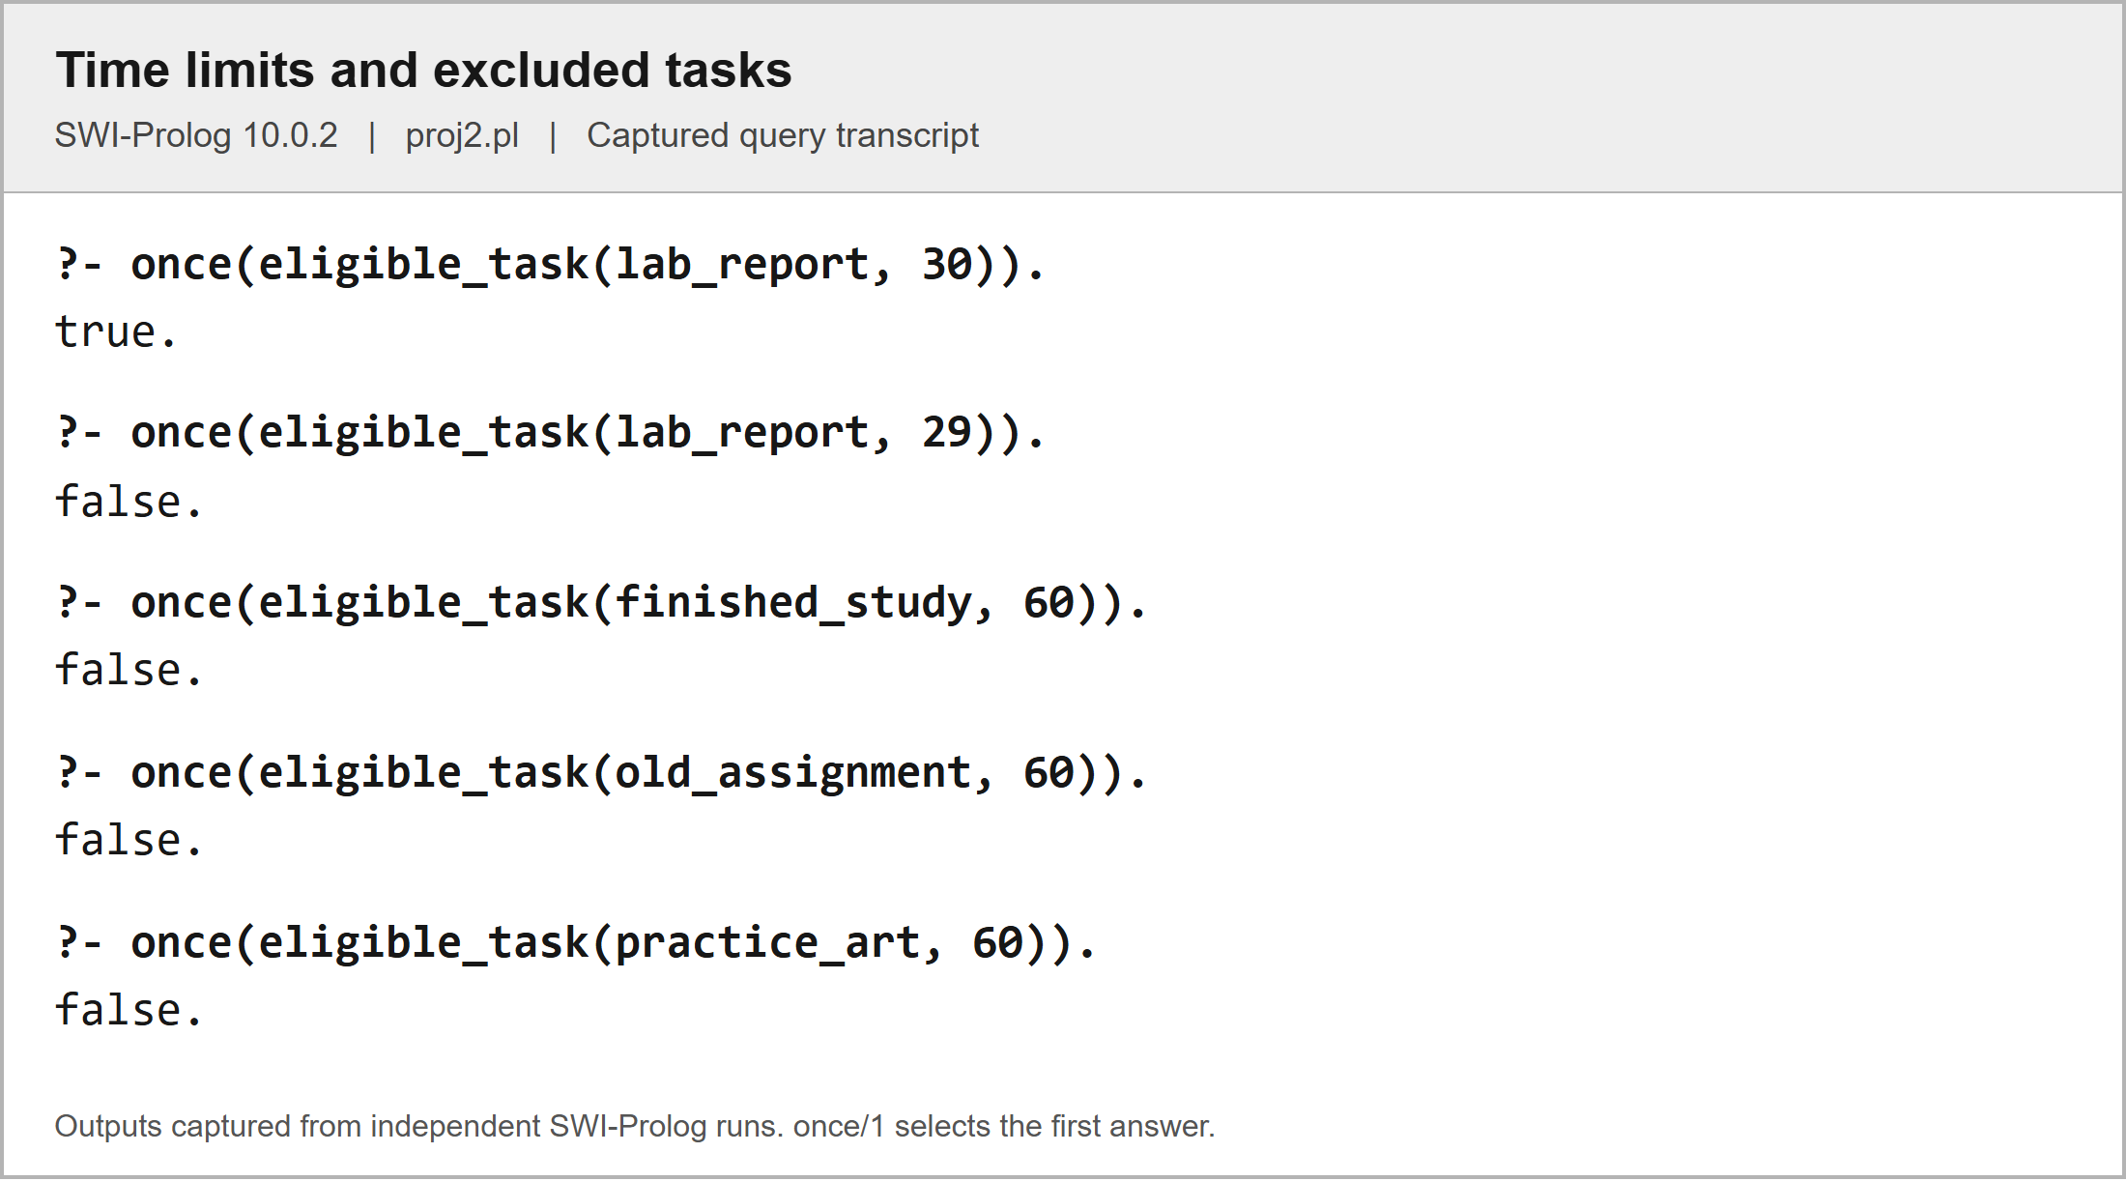
A 30-minute allowance accepts lab_report, while 29 minutes does not. Completed and archived tasks are excluded, and practice_art is excluded because its goal is paused.

Figure 3. Recommendation score and explanation
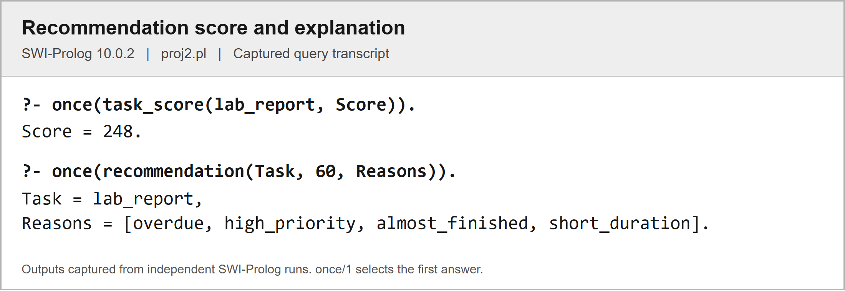
The program calculates 248 points for lab_report and reports its overdue status, high priority, near completion, and short remaining duration.

Figure 4. Recursive duration and data validation
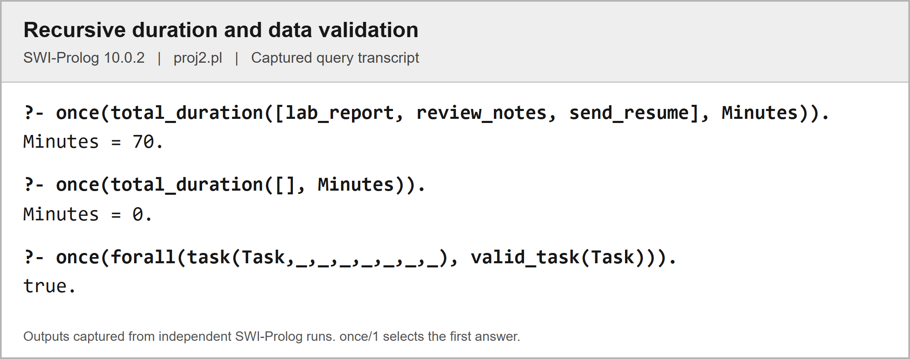
The three supplied tasks total 70 minutes. The empty list returns zero, and the validation query confirms that all eleven sample task records satisfy valid_task/1.

4.2 Test Queries and Validation
All sixteen documented queries produced their expected first results during verification. The file also loaded and passed the SWI-Prolog check query without reported warnings. These checks cover normal recommendations, time boundaries, excluded statuses, a paused goal, a missing deadline, scoring, explanations, recursion, and record validity. They verify the supplied examples, rather than proving every possible future dataset correct.
Table 5. Test queries and observed results
No. | Query | Expected and observed result | Status
1 | recommend_task(Task, 60). | Task = lab_report. | Pass
2 | recommend_task(Task, 25). | Task = prepare_slides. | Pass
3 | recommend_task(Task, 15). | Task = send_resume. | Pass
4 | recommend_task(_, 5). | false. | Pass
5 | eligible_task(lab_report, 30). | true. | Pass
6 | eligible_task(lab_report, 29). | false. | Pass
7 | eligible_task(finished_study, 60). | false. | Pass
8 | eligible_task(old_assignment, 60). | false. | Pass
9 | eligible_task(practice_art, 60). | false. | Pass
10 | due_soon_task(prepare_slides). | true. | Pass
11 | due_soon_task(short_walk). | false. | Pass
12 | task_score(lab_report, Score). | Score = 248. | Pass
13 | recommendation(Task, 60, Reasons). | Task = lab_report, Reasons = [overdue, high_priority, almost_finished, short_duration]. | Pass
14 | total_duration([lab_report, review_notes, send_resume], Minutes). | Minutes = 70. | Pass
15 | total_duration([], Minutes). | Minutes = 0. | Pass
16 | forall(task(Task,_,_,_,_,_,_,_), valid_task(Task)). | true. | Pass

Part 5: References/Sources
[1] “proj2.pl,” Goal and Task Recommendation System, unpublished Prolog source code, Oct. 2026.
[2] SWI-Prolog, “Getting started quickly,” SWI-Prolog Reference Manual. Accessed: Oct. 26, 2026. [Online]. Available: https://www.swi-prolog.org/pldoc/man?section=quickstart
[3] SWI-Prolog, “Arithmetic,” SWI-Prolog Reference Manual. Accessed: Oct. 26, 2026. [Online]. Available: https://www.swi-prolog.org/pldoc/man?section=arith
[4] SWI-Prolog, “\+/1,” SWI-Prolog Reference Manual. Accessed: Oct. 26, 2026. [Online]. Available: https://www.swi-prolog.org/pldoc/man?predicate=%5C%2B/1
[5] SWI-Prolog, “findall/3,” SWI-Prolog Reference Manual. Accessed: Oct. 26, 2026. [Online]. Available: https://www.swi-prolog.org/pldoc/man?predicate=findall/3

Part 6: Program Listing
The following editable listing reproduces the complete proj2.pl source used for the sample outputs. Comments and test queries are included. The original source file was not changed while preparing this document.
% Academic
task_type(study, academic).
task_type(assignment, academic).
task_type(research, academic).
task_type(review, academic).
task_type(exam_preparation, academic).
task_type(thesis_writing, academic).
task_type(lab_work, academic).
task_type(presentation_prep, academic).
task_type(group_project, academic).

% Professional
task_type(job_application, professional).
task_type(interview_prep, professional).
task_type(resume_building, professional).
task_type(meeting, professional).
task_type(report_writing, professional).
task_type(project_planning, professional).
task_type(portfolio_building, professional).

% Skill development
task_type(practice, skill_development).
task_type(tutorial, skill_development).
task_type(coding, skill_development).
task_type(language_learning, skill_development).

% Health
task_type(exercise, health).
task_type(workout, health).
task_type(meditation, health).
task_type(stretching, health).
task_type(meal_prep, health).
task_type(medical_checkup, health).

% Creative
task_type(writing, creative).
task_type(drawing, creative).
task_type(music_composition, creative).
task_type(video_editing, creative).
task_type(photography, creative).

% Social
task_type(volunteering, social).
task_type(family_time, social).
task_type(socializing, social).

% Household
task_type(cleaning, household).
task_type(grocery_shopping, household).
task_type(errands, household).

% Goal category
goal_category(personal).
goal_category(academic).
goal_category(professional).
goal_category(skill_development).
goal_category(health).
goal_category(creative).
goal_category(social).
goal_category(household).

% Priority level
priority_level(urgent).
priority_level(high).
priority_level(medium).
priority_level(low).

% Category priority
category_priority(academic, high).
category_priority(professional, high).
category_priority(health, medium).
category_priority(personal, medium).
category_priority(social, low).
category_priority(creative, low).

% Task status value
task_status_value(pending).
task_status_value(in_progress).
task_status_value(completed).
task_status_value(overdue).
task_status_value(archived).

% Goal status value
goal_status_value(active).
goal_status_value(completed).
goal_status_value(paused).
goal_status_value(abandoned).

% Day of week
day_of_week(monday).
day_of_week(tuesday).
day_of_week(wednesday).
day_of_week(thursday).
day_of_week(friday).
day_of_week(saturday).
day_of_week(sunday).

% Time period
time_period(morning).
time_period(afternoon).
time_period(evening).
time_period(night).

% Duration category
duration_category(short, 30).
duration_category(medium, 60).
duration_category(long, 120).
duration_category(extended,240).

% Difficulty level
difficulty_level(easy).
difficulty_level(moderate).
difficulty_level(hard).
difficulty_level(very_hard).

% Session type
session_type(focus_session).
session_type(break).
session_type(review_session).
session_type(planning_session).

% Reminder frequency
reminder_frequency(daily).
reminder_frequency(weekly).
reminder_frequency(before_deadline).
reminder_frequency(custom).

% Notification type
notification_type(reminder).
notification_type(deadline_alert).
notification_type(recommendation).
notification_type(achievement).
notification_type(motivational).
notification_type(weekly_summary).

% Skill category
skill_category(design).
skill_category(programming).
skill_category(writing).
skill_category(marketing).
skill_category(language).
skill_category(fitness).
skill_category(music).
skill_category(photography).

% Progress percentage
progress_percentage(0).
progress_percentage(10).
progress_percentage(20).
progress_percentage(30).
progress_percentage(40).
progress_percentage(50).
progress_percentage(60).
progress_percentage(70).
progress_percentage(80).
progress_percentage(90).
progress_percentage(100).

% ============================================================
% SIMPLE GOAL AND TASK RECOMMENDATION SYSTEM
%
% Load this file in a fresh SWI-Prolog session: [proj2].
% Then try: recommend_task(Task, 60).
% The number 60 means the user has 60 minutes available.
% ============================================================

% SAMPLE GOALS
% goal(GoalName, Category, Status).

goal(pass_subjects, academic, active).
goal(find_job, professional, active).
goal(improve_coding, skill_development, active).
goal(stay_healthy, health, active).
goal(keep_home_clean, household, active).
goal(learn_drawing, creative, paused).

% SAMPLE TASKS
% task(Name, Type, MinutesLeft, Priority, DaysLeft, Difficulty, Status, Progress).
%
% MinutesLeft is the estimated REMAINING work, not the original duration.
% DaysLeft: -1 = overdue by one day, 0 = today, 1 = tomorrow.
% Use none for a task without a deadline. Update DaysLeft as days pass.
% Progress uses your existing facts: 0, 10, 20, ..., 100.
% Add or edit these task facts to represent the users own tasks.

task(lab_report, lab_work, 30, urgent, -1, moderate, in_progress, 80).
task(review_notes, review, 25, high, 0, easy, in_progress, 60).
task(math_homework, assignment, 45, high, 1, hard, pending, 0).
task(send_resume, job_application, 15, high, 0, easy, pending, 0).
task(practice_code, coding, 60, medium, 3, hard, in_progress, 40).
task(short_walk, exercise, 15, medium, none,easy, pending, 0).
task(clean_room, cleaning, 30, low, none,easy, pending, 0).
task(finished_study, study, 0, high, -2, easy, completed, 100).
task(old_assignment, assignment, 20, urgent, -3, easy, archived, 50).
task(practice_art, drawing, 20, high, 0, easy, pending, 0).
task(prepare_slides, presentation_prep, 20, high, 2, moderate, in_progress, 90).

% Connect each task to one goal. Keep task names unique.
% task_goal(TaskName, GoalName).

task_goal(lab_report, pass_subjects).
task_goal(review_notes, pass_subjects).
task_goal(math_homework, pass_subjects).
task_goal(send_resume, find_job).
task_goal(practice_code, improve_coding).
task_goal(short_walk, stay_healthy).
task_goal(clean_room, keep_home_clean).
task_goal(finished_study, pass_subjects).
task_goal(old_assignment,pass_subjects).
task_goal(practice_art, learn_drawing).
task_goal(prepare_slides, pass_subjects).

% Points for the users chosen priority.
priority_points(urgent, 40).
priority_points(high, 30).
priority_points(medium, 20).
priority_points(low, 10).

% ============================================================
% RULES
% :- means "if". A comma means "and". \+ means "cannot prove".
% An underscore (_) means a field is not needed in that rule.
% ============================================================

% 1. A deadline is either none or a whole number of days left.
valid_deadline(none).
valid_deadline(DaysLeft) :-
integer(DaysLeft).

% 2. Status, progress, and remaining minutes must agree.
valid_progress(completed, 100, 0).
valid_progress(pending, 0, Minutes) :-
Minutes > 0.
valid_progress(in_progress, Progress, Minutes) :-
Progress > 0, Progress < 100, Minutes > 0.
valid_progress(overdue, Progress, Minutes) :-
Progress < 100, Minutes > 0.
valid_progress(archived, Progress, Minutes) :-
(Progress =:= 100 -> Minutes =:= 0 ; Minutes > 0).

% 3. Check a task against your allowed values and its goals category.
valid_task(Task) :-
task(Task, Type, Minutes, Priority, DaysLeft, Difficulty, Status, Progress),
task_type(Type, Category),
task_goal(Task, Goal),
goal(Goal, Category, GoalStatus),
goal_category(Category),
goal_status_value(GoalStatus),
integer(Minutes), Minutes >= 0,
priority_level(Priority),
valid_deadline(DaysLeft),
difficulty_level(Difficulty),
task_status_value(Status),
progress_percentage(Progress),
valid_progress(Status, Progress, Minutes),
(Status == overdue -> integer(DaysLeft), DaysLeft < 0 ; true).

% 4. Find the tasks category using its type.
task_category(Task, Category) :-
task(Task, Type, _, _, _, _, _, _),
task_type(Type, Category).

% 5. Completed and archived tasks are not unfinished work.
unfinished_task(Task) :-
task(Task, _, _, _, _, _, Status, Progress),
member(Status, [pending, in_progress, overdue]),
Progress < 100.

% 6. The task must belong to an active goal.
active_goal_task(Task) :-
task_goal(Task, Goal),
goal(Goal, _, active).

% 7. Remaining work must fit the users available minutes.
fits_time(Task, AvailableMinutes) :-
integer(AvailableMinutes), AvailableMinutes >= 0,
task(Task, _, Minutes, _, _, _, _, _),
Minutes > 0, Minutes =< AvailableMinutes.

% 8. Negative days left means unfinished work is overdue.
overdue_task(Task) :-
unfinished_task(Task),
task(Task, _, _, _, DaysLeft, _, _, _),
integer(DaysLeft), DaysLeft < 0.

% 9. A near deadline is today or within the next two days.
due_soon_task(Task) :-
unfinished_task(Task),
task(Task, _, _, _, DaysLeft, _, _, _),
integer(DaysLeft), DaysLeft >= 0, DaysLeft =< 2.

% 10. High and urgent priorities deserve attention.
high_priority_task(Task) :-
task(Task, _, _, Priority, _, _, _, _),
member(Priority, [high, urgent]).

% 11. Identify easy work for the explanation.
easy_task(Task) :-
task(Task, _, _, _, _, easy, _, _).

% 12. Use your short-duration fact as the upper limit.
short_task(Task) :-
duration_category(short, Limit),
task(Task, _, Minutes, _, _, _, _, _),
Minutes > 0, Minutes =< Limit.

% 13. An unfinished task at 80% or 90% is almost done.
almost_done(Task) :-
unfinished_task(Task),
task(Task, _, _, _, _, _, _, Progress),
Progress >= 80.

% 14. Combine the basic checks before considering a recommendation.
eligible_task(Task, AvailableMinutes) :-
valid_task(Task),
unfinished_task(Task),
active_goal_task(Task),
fits_time(Task, AvailableMinutes).

% 15. Deadline points: overdue = 200, near = 100, otherwise = 0.
% The if-then-else chooses exactly one case for each task.
deadline_score(Task, Points) :-
task(Task, _, _, _, DaysLeft, _, _, _),
valid_deadline(DaysLeft),
( DaysLeft == none -> Points = 0
; DaysLeft < 0 -> Points = 200
; DaysLeft =< 2 -> Points = 100
; Points = 0
).

% 16. Combine urgency, priority, and progress into one score.
% Example: lab_report = 200 + 40 + 8 = 248.
% Progress is a small bonus; it does not reduce MinutesLeft again.
task_score(Task, Score) :-
valid_task(Task),
task(Task, _, _, Priority, _, _, _, Progress),
priority_points(Priority, PriorityPoints),
deadline_score(Task, DeadlinePoints),
Score is DeadlinePoints + PriorityPoints + Progress // 10.

% 17. Recommend a task when no other eligible task has a higher score.
% Equal top scores return multiple choices when you press ; at the prompt.
% If nothing fits, the query returns false.
recommend_task(Task, AvailableMinutes) :-
eligible_task(Task, AvailableMinutes),
task_score(Task, Score),
\+ (eligible_task(Other, AvailableMinutes),
task_score(Other, OtherScore),
OtherScore > Score).

% 18. Explain the recommended tasks characteristics.
% Difficulty is descriptive here; it does not override urgency or priority.
recommendation_reason(Task, overdue) :- overdue_task(Task).
recommendation_reason(Task, near_deadline) :- due_soon_task(Task).
recommendation_reason(Task, high_priority) :- high_priority_task(Task).
recommendation_reason(Task, almost_finished) :- almost_done(Task).
recommendation_reason(Task, easy_work) :- easy_task(Task).
recommendation_reason(Task, short_duration) :- short_task(Task).

% 19. Collect all reasons for the recommendation into a list.
recommendation(Task, AvailableMinutes, Reasons) :-
recommend_task(Task, AvailableMinutes),
findall(Reason, recommendation_reason(Task, Reason), Reasons).

% 20. Recursion: add the remaining minutes of a supplied list of tasks.
% The empty list needs 0 minutes. Each step handles one task, then the rest.
% This totals duration only; it does not automatically select a session plan.
total_duration([], 0).
total_duration([Task|Rest], TotalMinutes) :-
valid_task(Task),
task(Task, _, Minutes, _, _, _, _, _),
total_duration(Rest, RestMinutes),
TotalMinutes is Minutes + RestMinutes.

% ============================================================
% TEST QUERIES AND EXPECTED ANSWERS
% Type these at the Prolog prompt after loading proj2.pl.
% ============================================================
%
% 1. recommend_task(Task, 60).
% Task = lab_report.
%
% 2. recommend_task(Task, 25).
% Task = prepare_slides. It is almost finished and due soon.
%
% 3. recommend_task(Task, 15).
% Task = send_resume.
%
% 4. recommend_task(_, 5).
% false. No unfinished task fits five minutes.
%
% 5. eligible_task(lab_report, 30).
% true. An exact time match is allowed.
%
% 6. eligible_task(lab_report, 29).
% false. It needs 30 minutes.
%
% 7. eligible_task(finished_study, 60).
% false. It is already completed.
%
% 8. eligible_task(old_assignment, 60).
% false. Archived tasks are excluded even when overdue.
%
% 9. eligible_task(practice_art, 60).
% false. Its goal is paused.
%
% 10. due_soon_task(prepare_slides).
% true. Two days is inside the near-deadline range.
%
% 11. due_soon_task(short_walk).
% false. It has no deadline.
%
% 12. task_score(lab_report, Score).
% Score = 248.
%
% 13. recommendation(Task, 60, Reasons).
% Task = lab_report,
% Reasons = [overdue,high_priority,almost_finished,short_duration].
%
% 14. total_duration([lab_report, review_notes, send_resume], Minutes).
% Minutes = 70.
%
% 15. total_duration([], Minutes).
% Minutes = 0. This is the recursions stopping case.
%
% 16. forall(task(Task,_,_,_,_,_,_,_), valid_task(Task)).
% true. All sample tasks use valid values and matching goal categories.
%
% To use your own data, edit/add goal, task, and task_goal facts above,
% then reload this file. Change the minutes in your query for each session.

