Mariano Marcos State University
College of Computing and Information Sciences / Department of Computer Science

GOAL AND TASK
RECOMMENDATION SYSTEM
A Rule-Based Prolog Project

Submitted in partial fulfillment of the requirements for
CMPSC 162
First Semester, School Year 2026–2027

Submitted by:
Iya
Francess
Ckhiel
BSCS, 3B

Submitted to:
Rey Villacillo

October 26, 2026

Acknowledgment
We express our appreciation to Rey Villacillo for the guidance provided in CMPSC 162 and for the opportunity to apply logic programming to a practical task recommendation problem. We also thank [individuals or group members to acknowledge] for their contributions to the preparation and completion of this project.
We acknowledge the SWI-Prolog community for providing the programming environment and reference documentation used to develop and explain the system. This project gave us an opportunity to practice representing knowledge through facts and applying rules to derive understandable recommendations.
[Edit this acknowledgment to reflect the people who actually contributed to your project.]

Table of Contents
Acknowledgment 2
Table of Contents 3
List of Figures 4
List of Tables 4
Part 1: Project Overview 5
1.1 Project Name 5
1.2 Background 5
1.3 Objectives 5
1.4 Scope and Limitations 6
Part 2: Main Features 7
2.1 Knowledge Base 7
2.2 Inference Engine 8
2.3 Interactive Query 9
Part 3: Technical Requirements/Specifications 10
3.1 Language and Environment 10
3.2 Key Fact Predicates 10
3.3 Key Rule Predicates 11
Part 4: Sample Outputs 12
4.1 Captured Query Results 12
4.2 Test Queries and Validation 16
Part 5: References/Sources 17
Part 6: Program Listing 18

List of Figures
Figure 1. Recommendations for different time budgets 12
Figure 2. Time limits and excluded tasks 13
Figure 3. Recommendation score and explanation 14
Figure 4. Recursive duration and data validation 15

List of Tables
Table 1. Fields of a task record 7
Table 2. Recommendation scoring policy 8
Table 3. Fact predicates and their roles 10
Table 4. Rule predicates and their responsibilities 11
Table 5. Test queries and observed results 16

Part 1: Project Overview

1.1 Project Name
Goal and Task Recommendation System

1.2 Background
It is common for students to juggle multiple tasks simultaneously; for example, assignments, exam preparation, personal matters, and chores in the house. Making decisions on what task to undertake next can be a challenge given limited time and varying priorities and deadlines among other factors. It can be possible that an important task might not be suitable for the available time, and a shorter one may not be relevant to an expired objective.
This is achieved through this project by defining tasks and goals as Prolog facts and implementing rules to determine what kind of work should be done. The algorithm implemented in proj.pl file determines if a task is valid, not completed yet, related to an active goal, and is short enough to be accomplished in the given number of minutes. The tasks are then compared according to their scores [1].
The project was selected due to its relevance to a problem in everyday planning and declarative programming. Rather than using a single rule for each option, the code explains task features and criteria for the decision made. The user is allowed to examine both the information stored and the rule used to generate the result. The SWI-Prolog environment allows one to load the source and query it [2].

1.3 Objectives
The main goal is to design a system based on rules, which can suggest an optimal task to do from a given list of tasks, considering available time and predefined decision rules.
- Represent task types, goals, priorities, deadlines, remaining durations, difficulty levels, statuses, and progress as structured facts.
- Validate task information and exclude completed or archived tasks and tasks associated with inactive goals from recommendations.
- Compare eligible tasks using deadline points, priority points, and a small progress bonus.
- Explain a recommendation through task characteristics such as being overdue, nearly finished, or short in duration.
- Demonstrate logical queries, negation as failure, backtracking, list collection, and recursion through testable examples.

1.4 Scope and Limitations
The intended users of the program will be novice users who are learning Prolog and symbolic artificial intelligence. This will be a single file program with six sample goals and eleven sample tasks. These can be replaced or supplemented by users to ask their queries in the SWI-Prolog prompt. The capabilities include task validation, eligibility, score evaluation, recommendation justification, and remaining total time for given tasks.
There is no use of graphical interface, interactive data entry menu, database, calendar and automated message delivery features in the system. Days to go are saved as numbers and should be manually changed after some days. The software is not capable of learning from user actions, duration estimation, task segmentation or creating a full day schedule for users. Difficulty level is only descriptive and does not influence recommendation weight. The weights of scoring are set arbitrarily and not based on user study results.
Task names should be unique, and each task should be linked to one goal. These are data-entry conventions; the program does not provide a global duplicate-record checker. The current progress vocabulary permits increments of ten from 0 to 100. Correct recommendations depend on accurate task facts and realistic remaining-time estimates [1].

Part 2: Main Features

2.1 Knowledge Base
The knowledge base contains 148 domain facts: 116 vocabulary and classification facts, 6 goal records, 11 task records, 11 task-to-goal links, and 4 priority-point mappings. This count excludes executable rule clauses and base cases. The facts describe the allowed values and the sample work to be considered by the system [1].
For each goal, there is goal(Name, Category, Status). For instance, pass_subjects is an active goal of the academic kind, whereas learn_drawing is a paused goal for creativity. The relation task_goal(Task, Goal) links each task to its goal, and the type of the task corresponds to the category of the goal.
A task record follows this structure:
task(Name, Type, MinutesLeft, Priority, DaysLeft, Difficulty, Status, Progress).
Table 1. Fields of a task record
Field | Meaning and accepted representation
Name | A unique task identifier, such as lab_report.
Type | A defined task type, such as lab_work or review.
MinutesLeft | Whole-number estimate of remaining work, in minutes.
Priority | urgent, high, medium, or low.
DaysLeft | Negative = overdue; 0 = today; positive = days remaining; none = no deadline.
Difficulty | easy, moderate, hard, or very_hard.
Status | pending, in_progress, completed, overdue, or archived.
Progress | A defined percentage: 0, 10, 20, …, 100.

These minutes are themselves uncompleted work. For this reason, the program does not decrease the value based on the percentage of progress for these minutes a second time. In addition to this, validation will make sure that the consistency is there – the completed task should have 100% progress and no remaining minutes left.
The original vocabulary also defines days of the week, time periods, session types, reminders, notifications, skill categories, and category priorities. These definitions remain in the file, but the current recommendation rules do not implement scheduling or notification features from them. The selected priority of each task, rather than category_priority/2, supplies the priority score.

2.2 Inference Engine
The inference engine first applies eligible_task/2. A candidate must pass valid_task/1, unfinished_task/1, active_goal_task/1, and fits_time/2. The available minutes must be a nonnegative integer, and the task must have positive remaining work that does not exceed that allowance. An exact time match is accepted.
After filtering, task_score/2 calculates the score using arithmetic evaluation and integer division [3]:
Score = DeadlinePoints + PriorityPoints + Progress // 10
Table 2. Recommendation scoring policy
Component | Condition | Points
Deadline | Overdue: negative days left | 200
Deadline | Due today or within two days | 100
Deadline | Later than two days, or no deadline | 0
Priority | urgent / high / medium / low | 40 / 30 / 20 / 10
Progress | Integer division of progress by 10 | Progress // 10

The score for lab_report is 200 + 40 + 8 = 248. This task is late, urgent, and 80 percent done. The score for prepare_slides is 100 + 30 + 9 = 139, which is greater than that of review_notes, which is 136, although the latter is due today because deadlines in the next two days are of the same level of urgency.
Recommend_task/2 predicate holds true in the case where the candidate has sufficient eligibility and there is no such task which has a greater score than the given one among the eligible tasks. This is done using the technique of negation as failure, denoted as \+. If there are two candidates with equal scores, both can be retrieved by querying more solutions.
Recommendation/3 uses findall/3 to get descriptive reasons [5]. The reasons are as follows: overdue, near_deadline, high_priority, almost_finished, easy_work, and short_duration. The above reasons refer to the characteristics of the selected task and easy_work, short_duration are not further score components.
Total_duration/2 is an example of recursion. The sum of the total time taken by the empty list is zero. In case of the non-empty list, the program will add up the remaining number of minutes in the first task to the total of the remaining tasks through recursion. Total_duration/2 is used to compute the total of a given list of tasks.

2.3 Interactive Query
Interaction is done using the standard SWI-Prolog query prompt. Begin a new query in the directory with the proj.pl file and consult proj. Every query should be terminated with a period, and a semicolon after the answer will yield further solutions if available [2].
?- [proj].
?- recommend_task(Task, 60).
?- recommendation(Task, 60, Reasons).
?- total_duration([lab_report, review_notes, send_resume], Minutes).

The initial recommendation query is on how to utilize 60 minutes. The explanation query will be about the selected activity and its attributes. The duration query is to be answered in how long the assigned set of activities will take. Time allowance is being changed through the query directly by the user. In order to enter their own activities, the users need to edit goal/3, task/8, and task_goal/2 facts.

Part 3: Technical Requirements/Specifications

3.1 Language and Environment
This program is developed using Prolog, and the verification is done using SWI-Prolog 10.0.2 running on 64-bit Windows. The program contains only one source file called proj.pl. There are no other project files or modules necessary for the program to work. All that is needed is a text editor and the installed SWI-Prolog software.
The solution relies on predicates and arithmetic that are provided by SWI-Prolog, such as integer/1, member/2, findall/3, is/2, relational operators, if-then-else construct, and not/1. For documentation purposes, the query uses forall/2 predicate as well. In regular scenarios, the input would include integers corresponding to time allowance and available tasks.

3.2 Key Fact Predicates
Predicate notation uses name/arity, where arity is the number of arguments. The following predicates define the data used or retained in the knowledge base.
Table 3. Fact predicates and their roles
Predicate | Role
task_type/2 | Maps task types to categories.
goal_category/1 | Defines allowed goal categories.
priority_level/1 | Defines allowed task priorities.
category_priority/2 | Stores category defaults; not used in scoring.
task_status_value/1; goal_status_value/1 | Define allowed task and goal statuses.
day_of_week/1; time_period/1 | Store day/time vocabulary; no scheduling behavior.
duration_category/2 | Stores duration limits; short/30 is used by short_task/1.
difficulty_level/1 | Defines allowed difficulty values.
session_type/1; reminder_frequency/1 | Retain session/reminder vocabulary only.
notification_type/1; skill_category/1 | Retain notification/skill vocabulary only.
progress_percentage/1 | Defines permitted progress percentages.
goal/3 | Stores a goal name, category, and status.
task/8 | Stores the eight task characteristics.
task_goal/2 | Connects a task to its goal.
priority_points/2 | Maps the chosen priority to numeric points.

3.3 Key Rule Predicates
Table 4. Rule predicates and their responsibilities
Predicate | Responsibility
valid_deadline/1 | Accepts none or an integer days-left value.
valid_progress/3 | Checks agreement between status, progress, and minutes.
valid_task/1 | Checks allowed values and linked goal/category consistency.
task_category/2 | Derives a task category from its type.
unfinished_task/1 | Recognizes pending, in-progress, or overdue work below 100%.
active_goal_task/1 | Checks whether the linked goal is active.
fits_time/2 | Checks positive remaining work against available minutes.
overdue_task/1 | Identifies unfinished tasks with negative days left.
due_soon_task/1 | Identifies unfinished tasks due in zero through two days.
high_priority_task/1 | Identifies high or urgent tasks.
easy_task/1 | Identifies tasks with easy difficulty.
short_task/1 | Identifies tasks with 1–30 remaining minutes.
almost_done/1 | Identifies unfinished tasks at least 80% complete.
eligible_task/2 | Combines validation, unfinished status, active goal, and time fit.
deadline_score/2 | Assigns deadline points using mutually exclusive cases.
task_score/2 | Adds deadline points, priority points, and progress bonus.
recommend_task/2 | Selects a task with no higher-scoring eligible competitor.
recommendation_reason/2 | Produces descriptive reasons for a task.
recommendation/3 | Returns a recommended task and collected reasons.
total_duration/2 | Recursively totals the minutes of a supplied task list.

Part 4: Sample Outputs

4.1 Captured Query Results
Figures 1–4 are screenshots of a read-only transcript viewer containing outputs captured from actual SWI-Prolog 10.0.2 runs of proj.pl. They are not screenshots of the native console window. Each query was wrapped in once/1 to record its first result consistently; this wrapper did not modify the project source. The question and the interpreter’s returned answer are shown together.
Figure 1. Recommendations for different time budgets
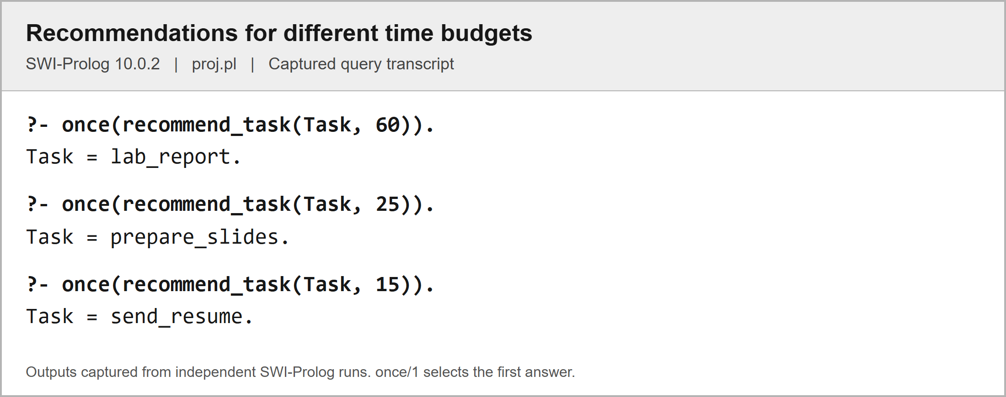
With 60 minutes, lab_report is selected. With 25 minutes, prepare_slides is selected because lab_report no longer fits. With 15 minutes, send_resume is selected.

Figure 2. Time limits and excluded tasks
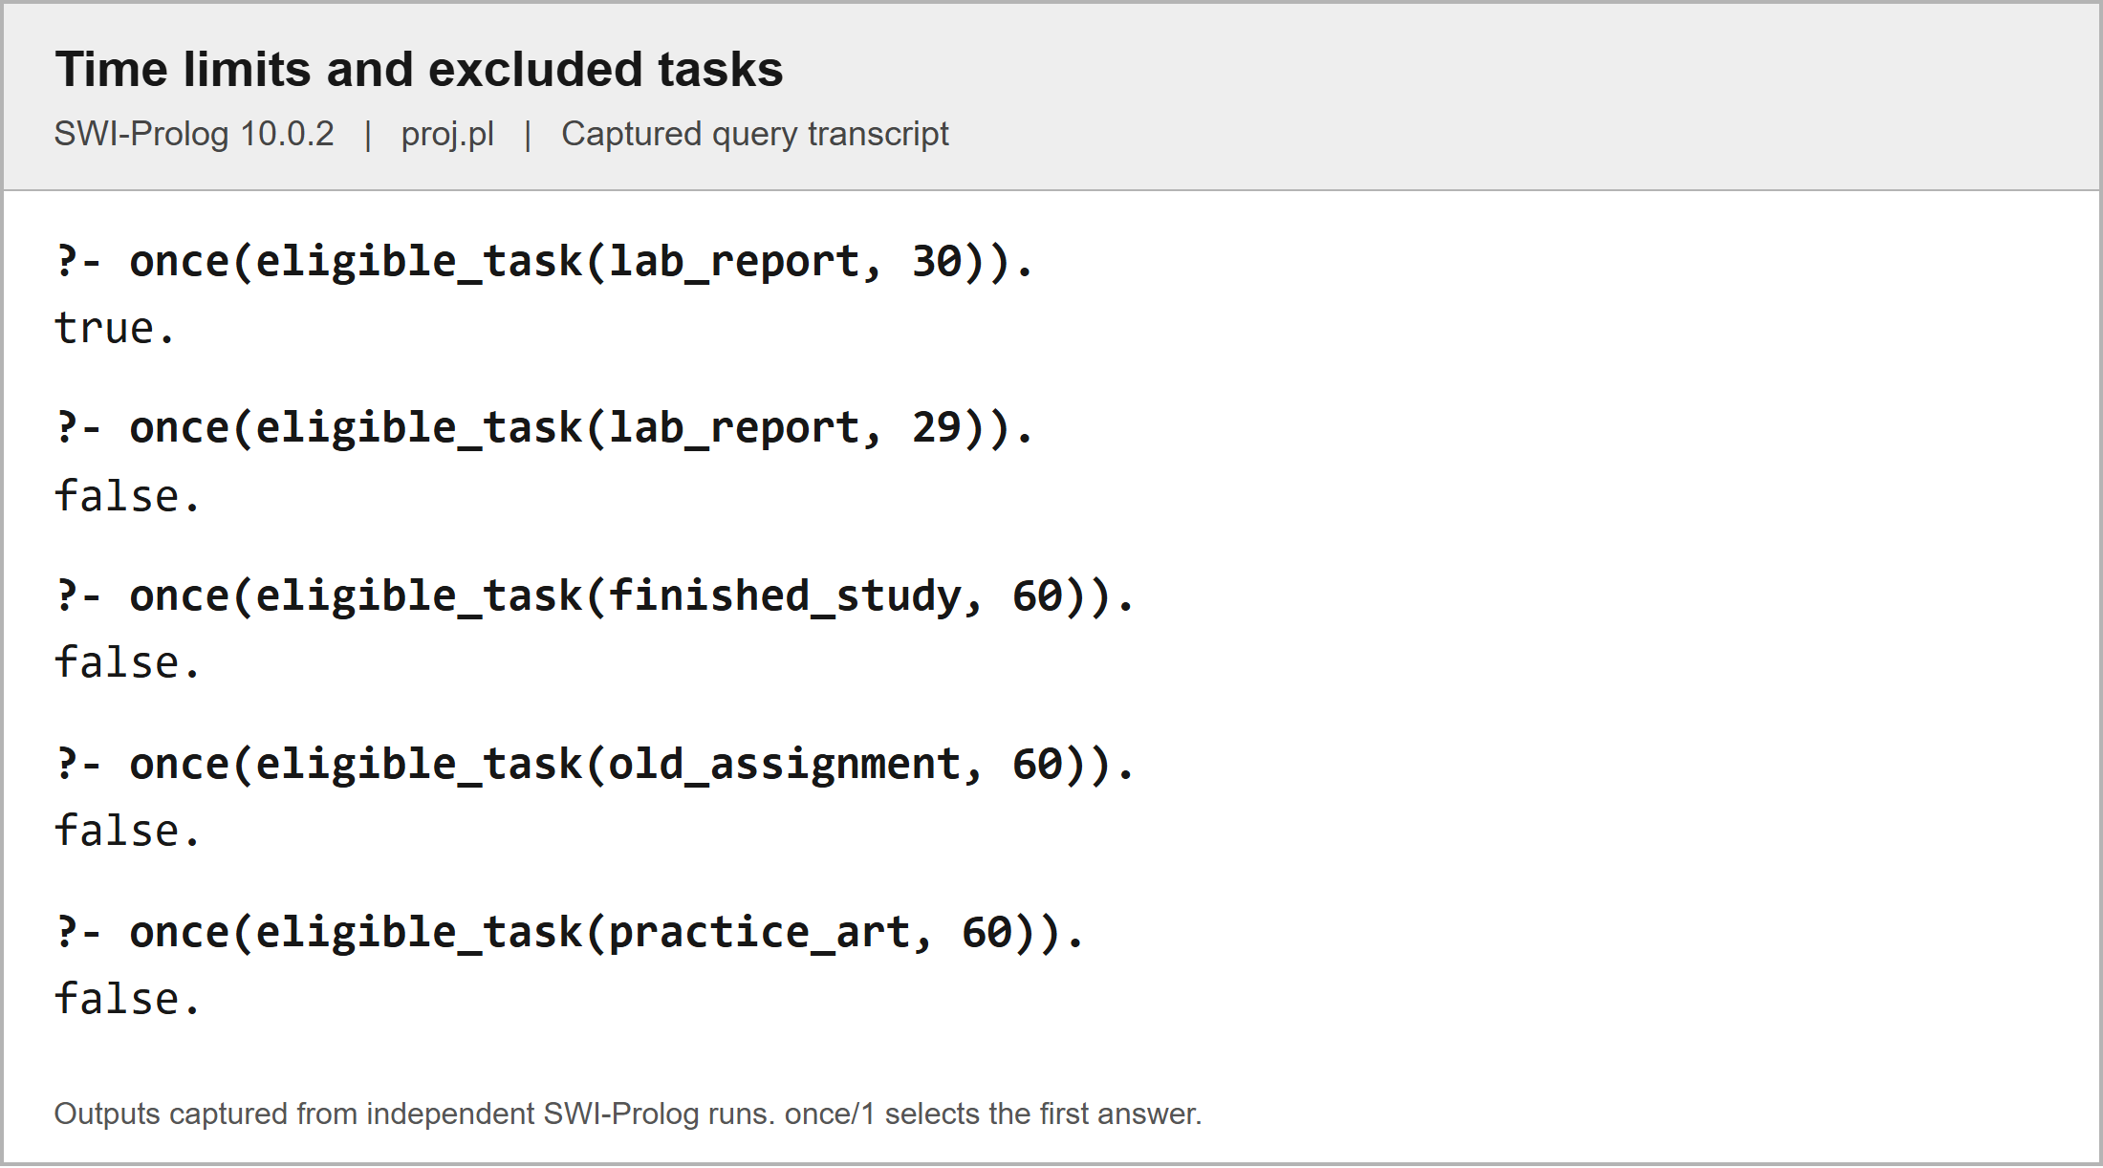
A 30-minute allowance accepts lab_report, while 29 minutes does not. Completed and archived tasks are excluded, and practice_art is excluded because its goal is paused.

Figure 3. Recommendation score and explanation
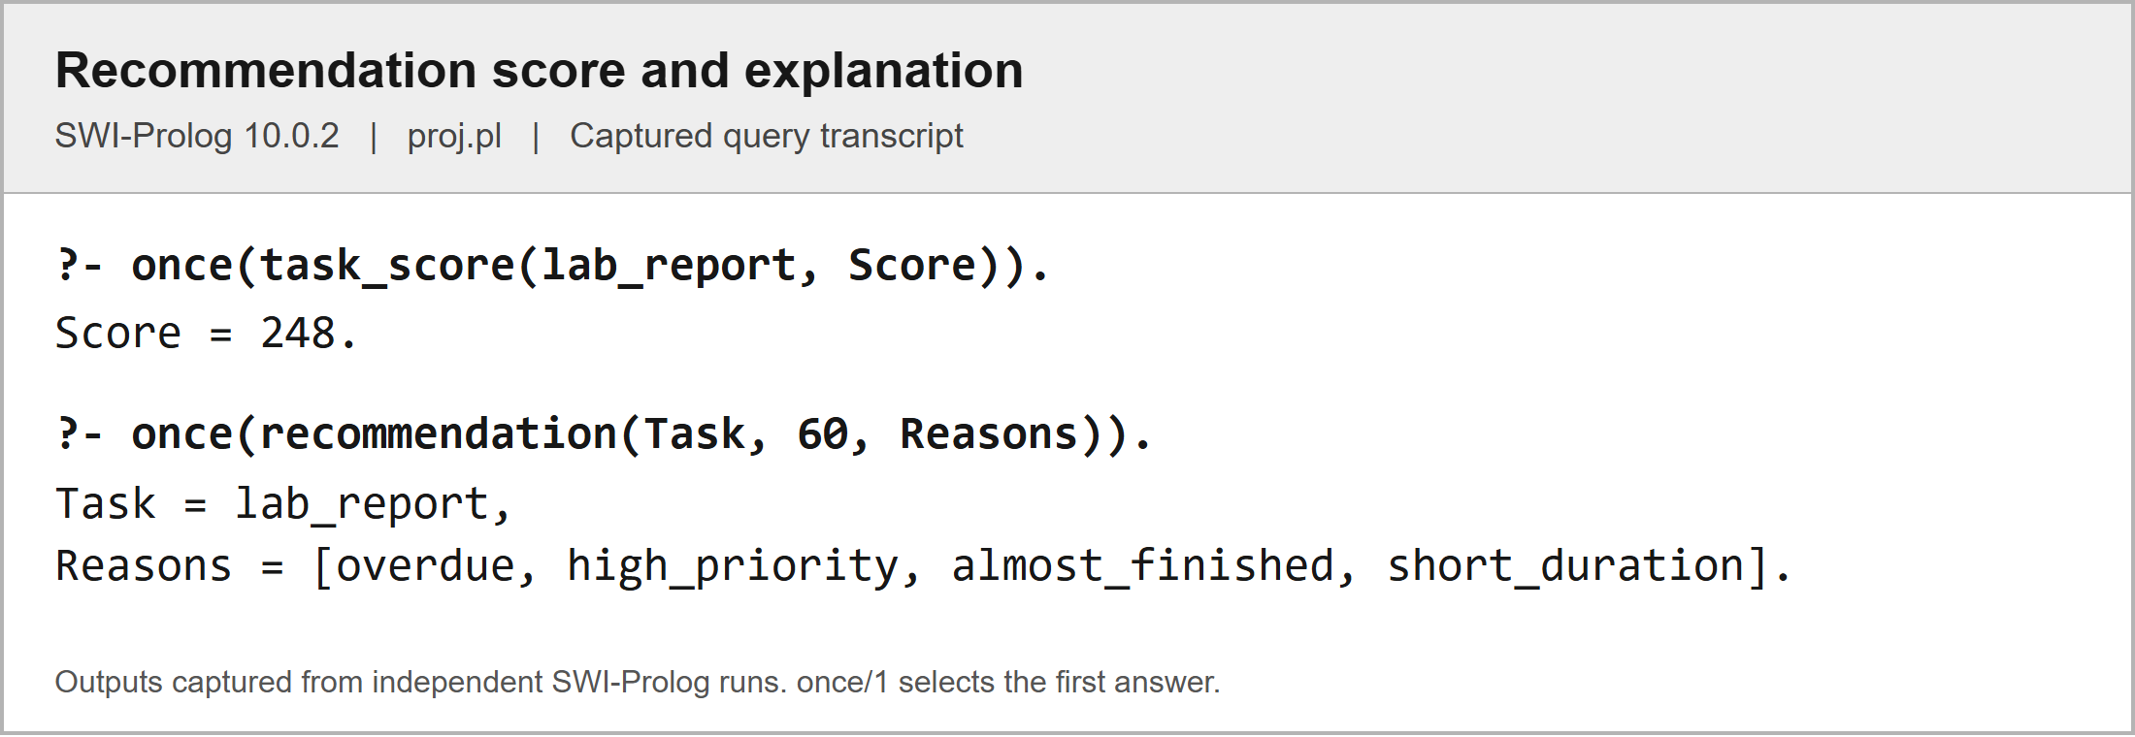
The program calculates 248 points for lab_report and reports its overdue status, high priority, near completion, and short remaining duration.

Figure 4. Recursive duration and data validation
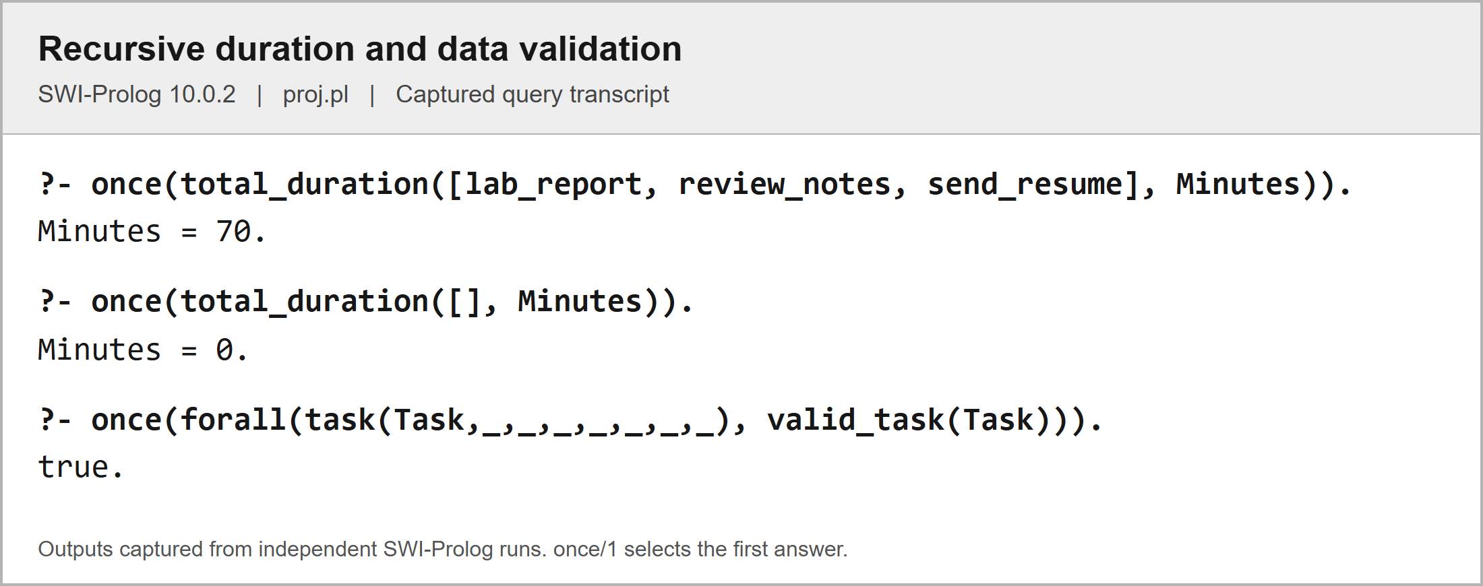
The three supplied tasks total 70 minutes. The empty list returns zero, and the validation query confirms that all eleven sample task records satisfy valid_task/1.

4.2 Test Queries and Validation
All sixteen queries checked gave their respective expected results as the first one. Moreover, the file also got loaded and tested against the SWI-Prolog check query without any warning messages. The checks performed included regular recommendations, time ranges, status exclusion, paused goals, lack of deadlines, scores, explanations, recursion, and record validation. The tests are for validating the provided examples, not all future datasets.
Table 5. Test queries and observed results
No. | Query | Expected and observed result | Status
1 | recommend_task(Task, 60). | Task = lab_report. | Pass
2 | recommend_task(Task, 25). | Task = prepare_slides. | Pass
3 | recommend_task(Task, 15). | Task = send_resume. | Pass
4 | recommend_task(_, 5). | false. | Pass
5 | eligible_task(lab_report, 30). | true. | Pass
6 | eligible_task(lab_report, 29). | false. | Pass
7 | eligible_task(finished_study, 60). | false. | Pass
8 | eligible_task(old_assignment, 60). | false. | Pass
9 | eligible_task(practice_art, 60). | false. | Pass
10 | due_soon_task(prepare_slides). | true. | Pass
11 | due_soon_task(short_walk). | false. | Pass
12 | task_score(lab_report, Score). | Score = 248. | Pass
13 | recommendation(Task, 60, Reasons). | Task = lab_report, Reasons = [overdue, high_priority, almost_finished, short_duration]. | Pass
14 | total_duration([lab_report, review_notes, send_resume], Minutes). | Minutes = 70. | Pass
15 | total_duration([], Minutes). | Minutes = 0. | Pass
16 | forall(task(Task,_,_,_,_,_,_,_), valid_task(Task)). | true. | Pass

Part 5: References/Sources
[1] “proj.pl,” Goal and Task Recommendation System, unpublished Prolog source code, Oct. 2026.
[2] SWI-Prolog, “Getting started quickly,” SWI-Prolog Reference Manual. Accessed: Oct. 26, 2026. [Online]. Available: https://www.swi-prolog.org/pldoc/man?section=quickstart
[3] SWI-Prolog, “Arithmetic,” SWI-Prolog Reference Manual. Accessed: Oct. 26, 2026. [Online]. Available: https://www.swi-prolog.org/pldoc/man?section=arith
[4] SWI-Prolog, “\+/1,” SWI-Prolog Reference Manual. Accessed: Oct. 26, 2026. [Online]. Available: https://www.swi-prolog.org/pldoc/man?predicate=%5C%2B/1
[5] SWI-Prolog, “findall/3,” SWI-Prolog Reference Manual. Accessed: Oct. 26, 2026. [Online]. Available: https://www.swi-prolog.org/pldoc/man?predicate=findall/3

Part 6: Program Listing
The following editable listing reproduces the complete proj.pl source used for the sample outputs. Comments and test queries are included. The original source file was not changed while preparing this document.
% Academic
task_type(study, academic).
task_type(assignment, academic).
task_type(research, academic).
task_type(review, academic).
task_type(exam_preparation, academic).
task_type(thesis_writing, academic).
task_type(lab_work, academic).
task_type(presentation_prep, academic).
task_type(group_project, academic).

% Professional
task_type(job_application, professional).
task_type(interview_prep, professional).
task_type(resume_building, professional).
task_type(meeting, professional).
task_type(report_writing, professional).
task_type(project_planning, professional).
task_type(portfolio_building, professional).

% Skill development
task_type(practice, skill_development).
task_type(tutorial, skill_development).
task_type(coding, skill_development).
task_type(language_learning, skill_development).

% Health
task_type(exercise, health).
task_type(workout, health).
task_type(meditation, health).
task_type(stretching, health).
task_type(meal_prep, health).
task_type(medical_checkup, health).

% Creative
task_type(writing, creative).
task_type(drawing, creative).
task_type(music_composition, creative).
task_type(video_editing, creative).
task_type(photography, creative).

% Social
task_type(volunteering, social).
task_type(family_time, social).
task_type(socializing, social).

% Household
task_type(cleaning, household).
task_type(grocery_shopping, household).
task_type(errands, household).

% Goal category
goal_category(personal).
goal_category(academic).
goal_category(professional).
goal_category(skill_development).
goal_category(health).
goal_category(creative).
goal_category(social).
goal_category(household).

% Priority level
priority_level(urgent).
priority_level(high).
priority_level(medium).
priority_level(low).

% Category priority
category_priority(academic, high).
category_priority(professional, high).
category_priority(health, medium).
category_priority(personal, medium).
category_priority(social, low).
category_priority(creative, low).

% Task status value
task_status_value(pending).
task_status_value(in_progress).
task_status_value(completed).
task_status_value(overdue).
task_status_value(archived).

% Goal status value
goal_status_value(active).
goal_status_value(completed).
goal_status_value(paused).
goal_status_value(abandoned).

% Day of week
day_of_week(monday).
day_of_week(tuesday).
day_of_week(wednesday).
day_of_week(thursday).
day_of_week(friday).
day_of_week(saturday).
day_of_week(sunday).

% Time period
time_period(morning).
time_period(afternoon).
time_period(evening).
time_period(night).

% Duration category
duration_category(short, 30).
duration_category(medium, 60).
duration_category(long, 120).
duration_category(extended,240).

% Difficulty level
difficulty_level(easy).
difficulty_level(moderate).
difficulty_level(hard).
difficulty_level(very_hard).

% Session type
session_type(focus_session).
session_type(break).
session_type(review_session).
session_type(planning_session).

% Reminder frequency
reminder_frequency(daily).
reminder_frequency(weekly).
reminder_frequency(before_deadline).
reminder_frequency(custom).

% Notification type
notification_type(reminder).
notification_type(deadline_alert).
notification_type(recommendation).
notification_type(achievement).
notification_type(motivational).
notification_type(weekly_summary).

% Skill category
skill_category(design).
skill_category(programming).
skill_category(writing).
skill_category(marketing).
skill_category(language).
skill_category(fitness).
skill_category(music).
skill_category(photography).

% Progress percentage
progress_percentage(0).
progress_percentage(10).
progress_percentage(20).
progress_percentage(30).
progress_percentage(40).
progress_percentage(50).
progress_percentage(60).
progress_percentage(70).
progress_percentage(80).
progress_percentage(90).
progress_percentage(100).

% ============================================================
% SIMPLE GOAL AND TASK RECOMMENDATION SYSTEM
%
% Load this file in a fresh SWI-Prolog session: [proj].
% Then try: recommend_task(Task, 60).
% The number 60 means the user has 60 minutes available.
% ============================================================

% SAMPLE GOALS
% goal(GoalName, Category, Status).

goal(pass_subjects, academic, active).
goal(find_job, professional, active).
goal(improve_coding, skill_development, active).
goal(stay_healthy, health, active).
goal(keep_home_clean, household, active).
goal(learn_drawing, creative, paused).

% SAMPLE TASKS
% task(Name, Type, MinutesLeft, Priority, DaysLeft, Difficulty, Status, Progress).
%
% MinutesLeft is the estimated REMAINING work, not the original duration.
% DaysLeft: -1 = overdue by one day, 0 = today, 1 = tomorrow.
% Use none for a task without a deadline. Update DaysLeft as days pass.
% Progress uses your existing facts: 0, 10, 20, ..., 100.
% Add or edit these task facts to represent the users own tasks.

task(lab_report, lab_work, 30, urgent, -1, moderate, in_progress, 80).
task(review_notes, review, 25, high, 0, easy, in_progress, 60).
task(math_homework, assignment, 45, high, 1, hard, pending, 0).
task(send_resume, job_application, 15, high, 0, easy, pending, 0).
task(practice_code, coding, 60, medium, 3, hard, in_progress, 40).
task(short_walk, exercise, 15, medium, none,easy, pending, 0).
task(clean_room, cleaning, 30, low, none,easy, pending, 0).
task(finished_study, study, 0, high, -2, easy, completed, 100).
task(old_assignment, assignment, 20, urgent, -3, easy, archived, 50).
task(practice_art, drawing, 20, high, 0, easy, pending, 0).
task(prepare_slides, presentation_prep, 20, high, 2, moderate, in_progress, 90).

% Connect each task to one goal. Keep task names unique.
% task_goal(TaskName, GoalName).

task_goal(lab_report, pass_subjects).
task_goal(review_notes, pass_subjects).
task_goal(math_homework, pass_subjects).
task_goal(send_resume, find_job).
task_goal(practice_code, improve_coding).
task_goal(short_walk, stay_healthy).
task_goal(clean_room, keep_home_clean).
task_goal(finished_study, pass_subjects).
task_goal(old_assignment,pass_subjects).
task_goal(practice_art, learn_drawing).
task_goal(prepare_slides, pass_subjects).

% Points for the users chosen priority.
priority_points(urgent, 40).
priority_points(high, 30).
priority_points(medium, 20).
priority_points(low, 10).

% ============================================================
% RULES
% :- means "if". A comma means "and". \+ means "cannot prove".
% An underscore (_) means a field is not needed in that rule.
% ============================================================

% 1. A deadline is either none or a whole number of days left.
valid_deadline(none).
valid_deadline(DaysLeft) :-
integer(DaysLeft).

% 2. Status, progress, and remaining minutes must agree.
valid_progress(completed, 100, 0).
valid_progress(pending, 0, Minutes) :-
Minutes > 0.
valid_progress(in_progress, Progress, Minutes) :-
Progress > 0, Progress < 100, Minutes > 0.
valid_progress(overdue, Progress, Minutes) :-
Progress < 100, Minutes > 0.
valid_progress(archived, Progress, Minutes) :-
(Progress =:= 100 -> Minutes =:= 0 ; Minutes > 0).

% 3. Check a task against your allowed values and its goals category.
valid_task(Task) :-
task(Task, Type, Minutes, Priority, DaysLeft, Difficulty, Status, Progress),
task_type(Type, Category),
task_goal(Task, Goal),
goal(Goal, Category, GoalStatus),
goal_category(Category),
goal_status_value(GoalStatus),
integer(Minutes), Minutes >= 0,
priority_level(Priority),
valid_deadline(DaysLeft),
difficulty_level(Difficulty),
task_status_value(Status),
progress_percentage(Progress),
valid_progress(Status, Progress, Minutes),
(Status == overdue -> integer(DaysLeft), DaysLeft < 0 ; true).

% 4. Find the tasks category using its type.
task_category(Task, Category) :-
task(Task, Type, _, _, _, _, _, _),
task_type(Type, Category).

% 5. Completed and archived tasks are not unfinished work.
unfinished_task(Task) :-
task(Task, _, _, _, _, _, Status, Progress),
member(Status, [pending, in_progress, overdue]),
Progress < 100.

% 6. The task must belong to an active goal.
active_goal_task(Task) :-
task_goal(Task, Goal),
goal(Goal, _, active).

% 7. Remaining work must fit the users available minutes.
fits_time(Task, AvailableMinutes) :-
integer(AvailableMinutes), AvailableMinutes >= 0,
task(Task, _, Minutes, _, _, _, _, _),
Minutes > 0, Minutes =< AvailableMinutes.

% 8. Negative days left means unfinished work is overdue.
overdue_task(Task) :-
unfinished_task(Task),
task(Task, _, _, _, DaysLeft, _, _, _),
integer(DaysLeft), DaysLeft < 0.

% 9. A near deadline is today or within the next two days.
due_soon_task(Task) :-
unfinished_task(Task),
task(Task, _, _, _, DaysLeft, _, _, _),
integer(DaysLeft), DaysLeft >= 0, DaysLeft =< 2.

% 10. High and urgent priorities deserve attention.
high_priority_task(Task) :-
task(Task, _, _, Priority, _, _, _, _),
member(Priority, [high, urgent]).

% 11. Identify easy work for the explanation.
easy_task(Task) :-
task(Task, _, _, _, _, easy, _, _).

% 12. Use your short-duration fact as the upper limit.
short_task(Task) :-
duration_category(short, Limit),
task(Task, _, Minutes, _, _, _, _, _),
Minutes > 0, Minutes =< Limit.

% 13. An unfinished task at 80% or 90% is almost done.
almost_done(Task) :-
unfinished_task(Task),
task(Task, _, _, _, _, _, _, Progress),
Progress >= 80.

% 14. Combine the basic checks before considering a recommendation.
eligible_task(Task, AvailableMinutes) :-
valid_task(Task),
unfinished_task(Task),
active_goal_task(Task),
fits_time(Task, AvailableMinutes).

% 15. Deadline points: overdue = 200, near = 100, otherwise = 0.
% The if-then-else chooses exactly one case for each task.
deadline_score(Task, Points) :-
task(Task, _, _, _, DaysLeft, _, _, _),
valid_deadline(DaysLeft),
( DaysLeft == none -> Points = 0
; DaysLeft < 0 -> Points = 200
; DaysLeft =< 2 -> Points = 100
; Points = 0
).

% 16. Combine urgency, priority, and progress into one score.
% Example: lab_report = 200 + 40 + 8 = 248.
% Progress is a small bonus; it does not reduce MinutesLeft again.
task_score(Task, Score) :-
valid_task(Task),
task(Task, _, _, Priority, _, _, _, Progress),
priority_points(Priority, PriorityPoints),
deadline_score(Task, DeadlinePoints),
Score is DeadlinePoints + PriorityPoints + Progress // 10.

% 17. Recommend a task when no other eligible task has a higher score.
% Equal top scores return multiple choices when you press ; at the prompt.
% If nothing fits, the query returns false.
recommend_task(Task, AvailableMinutes) :-
eligible_task(Task, AvailableMinutes),
task_score(Task, Score),
\+ (eligible_task(Other, AvailableMinutes),
task_score(Other, OtherScore),
OtherScore > Score).

% 18. Explain the recommended tasks characteristics.
% Difficulty is descriptive here; it does not override urgency or priority.
recommendation_reason(Task, overdue) :- overdue_task(Task).
recommendation_reason(Task, near_deadline) :- due_soon_task(Task).
recommendation_reason(Task, high_priority) :- high_priority_task(Task).
recommendation_reason(Task, almost_finished) :- almost_done(Task).
recommendation_reason(Task, easy_work) :- easy_task(Task).
recommendation_reason(Task, short_duration) :- short_task(Task).

% 19. Collect all reasons for the recommendation into a list.
recommendation(Task, AvailableMinutes, Reasons) :-
recommend_task(Task, AvailableMinutes),
findall(Reason, recommendation_reason(Task, Reason), Reasons).

% 20. Recursion: add the remaining minutes of a supplied list of tasks.
% The empty list needs 0 minutes. Each step handles one task, then the rest.
% This totals duration only; it does not automatically select a session plan.
total_duration([], 0).
total_duration([Task|Rest], TotalMinutes) :-
valid_task(Task),
task(Task, _, Minutes, _, _, _, _, _),
total_duration(Rest, RestMinutes),
TotalMinutes is Minutes + RestMinutes.

% ============================================================
% TEST QUERIES AND EXPECTED ANSWERS
% Type these at the Prolog prompt after loading proj.pl.
% ============================================================
%
% 1. recommend_task(Task, 60).
% Task = lab_report.
%
% 2. recommend_task(Task, 25).
% Task = prepare_slides. It is almost finished and due soon.
%
% 3. recommend_task(Task, 15).
% Task = send_resume.
%
% 4. recommend_task(_, 5).
% false. No unfinished task fits five minutes.
%
% 5. eligible_task(lab_report, 30).
% true. An exact time match is allowed.
%
% 6. eligible_task(lab_report, 29).
% false. It needs 30 minutes.
%
% 7. eligible_task(finished_study, 60).
% false. It is already completed.
%
% 8. eligible_task(old_assignment, 60).
% false. Archived tasks are excluded even when overdue.
%
% 9. eligible_task(practice_art, 60).
% false. Its goal is paused.
%
% 10. due_soon_task(prepare_slides).
% true. Two days is inside the near-deadline range.
%
% 11. due_soon_task(short_walk).
% false. It has no deadline.
%
% 12. task_score(lab_report, Score).
% Score = 248.
%
% 13. recommendation(Task, 60, Reasons).
% Task = lab_report,
% Reasons = [overdue,high_priority,almost_finished,short_duration].
%
% 14. total_duration([lab_report, review_notes, send_resume], Minutes).
% Minutes = 70.
%
% 15. total_duration([], Minutes).
% Minutes = 0. This is the recursions stopping case.
%
% 16. forall(task(Task,_,_,_,_,_,_,_), valid_task(Task)).
% true. All sample tasks use valid values and matching goal categories.
%
% To use your own data, edit/add goal, task, and task_goal facts above,
% then reload this file. Change the minutes in your query for each session.

