Technical Report
for
Smart IV Fluid Monitoring System
Prepared by
NAME | REGISTRATION NUMBER | STUDENT NUMBER | COLLEGE
SSERUNKUUMA JOSHUA | 25/U/03587/PS | 2500703587 | COCIS
NEBIRAH PRECIOUS MERISAH | 25/U/03541/PS | 2500703541 | COCIS
TAMBWE RAHIM STONE | 25/U/E/03597/EVE | 2500703597 | COCIS
MUGABE GIDEON | 25/U/03455/PS | 2500703455 | COCIS
NANSUBUGA ZAHRA | 25/U/03531/PS | 2500703531 | JINJA
Group 20

Mentor: | DR. LILLIAN MUYAMA
Course: | CSC 1304 Practical Skills Development
Date:

Contents
COVER PAGE
TABLE OF CONTENTS
ABSTRACT………………………………………..………………………………. iii

- INTRODUCTION ……………………………………………………….………. 1
  - USER CHALLENGE
  - PROJECT GOALS
  - FUNCTIONAL REQUIREMENTS

- PROJECT RESULTS
  - PROJECT DESIGN
  - PROJECT FUNCTIONALITY AND SCREENSHOTS
  - PROJECT WEBSITE AND REPOSITORY

- LIMITATIONS AND NEXT STEPS
  - LIMITATIONS
  - NEXT STEPS

REFERENCES
APPENDIX A - PROJECT WORK PLAN
APPENDIX B - CONTRIBUTION BY TEAM MEMBERS

Abstract
There is a known inadequacy of health-workers in hospitals and health centres around Uganda. In these resource-limited settings, persistent challenges are faced including monitoring intravenous (IV) fluid therapy. The monitoring of the IV fluid is manually done by nurses, who amongst their busy schedule must move frequently between patients to visually check fluid levels, whereby conventional IV stands give no early warning before a bag runs empty, therefore creating avoidable patient safety risk of air entering the IV tube and unnecessary workload.
This report presents the Smart IV Fluid Monitoring System, a low-cost embedded prototype built around an ESP32 microcontroller, a load cell (via HX711 amplifier) that continuously weighs the IV bag, an LCD and a colour-coded LED that classifies fluid status as Normal, Low, or Critical in real time. A micro servo automatically pinches the IV tubing as the critical threshold is reached, and a reset button recalibrates the sensor after a bag change. The system has since been extended with a companion mobile application, IV Sentinel, which receives fluid-level readings from the system over a ThingSpeak channel and gives nurses a remote, per-bed view of fluid percentage, current status, alert thresholds, and a rolling history of recent readings, together with push notifications when a bag crosses into the Low or Critical range. Testing confirmed that the system reliably distinguishes between the three fluid states and triggers the corresponding alerts with adequate warning time, that the reset/recalibration function performs consistently across bag changes, and that the mobile app correctly reflects the device's readings and status in near real time. Although the core sensing station remains inexpensive, single-bed hardware, the underlying sensing, alert, and cloud-reporting logic is hardware-independent and can scale to a centralised, multi-bed ward view within the same app.
The core contribution of this work is therefore the sensing, escalation, and remote-reporting logic itself, offering an affordable, reliable, and easy-to-operate way of reducing unnoticed IV depletion and easing nurse workload in Uganda and other resource-limited healthcare settings.
1. Introduction
This report documents the design, implementation, and testing of the Smart IV Fluid Monitoring System, a prototype embedded system developed to give nurses early, automatic warning of low or depleted IV fluid bags. It describes the user challenge motivating the project, the goals and functional requirements of the system, the product design and results obtained from testing, the limitations and next steps for further development.

1.1 User Challenge
In hospitals and health centres, particularly in resource-limited settings, a single nurse is often responsible for many patients receiving IV therapy at once. Monitoring fluid levels currently relies on nurses physically walking to each bedside to visually inspect the bag, which consumes time that could be spent on other critical responsibilities. Because conventional IV stands provide no early warning, a bag can run empty before staff notice, interrupting treatment and increasing the risk of air entering the tube. This lack of real-time visibility into IV status creates unnecessary patient safety risk and leaves nurses performing repetitive manual checks rather than higher-value care.

1.2 Project Goals
The project's goal is to automatically track IV fluid levels and alert healthcare workers when a bag needs replacing, using low-cost hardware that remains simple and affordable to adopt. A weight-based sensor mounted on the IV stand continuously reports data to a microcontroller, which classifies the fluid level as Normal, Low, or Critical and communicates that status immediately through visual indicators at the bedside, and as an added safeguard, a micro servo motor automatically pinches the IV tubing once the critical threshold is reached. To extend visibility beyond the bedside, the system also reports each reading to a ThingSpeak cloud channel over Wi-Fi, which the companion IV Sentinel mobile app reads to give nurses a remote, per-bed view of fluid status, along with push notifications when a bag needs attention. This lets a nurse monitor several beds from a single device without needing to be physically present at each one, while the bedside unit itself continues to work independently of the app.

1.3 Functional Requirements
The system's functional requirements are grouped into the following areas:
Fluid level sensing
Continuously measure the weight of the suspended IV bag using a load cell(5kgs) and HX711 amplifier.
Classify the current reading into one of three states i.e Normal, Low, or Critical against configurable thresholds.
Status display and alerting
Drive colour-coded LED indicators (green = Normal, Blue = Low, Red = Critical).
Display the current status and reading on an LCD screen at all times.
Automatic tube safeguard
Actuate a micro servo to pinch the IV tubing when the Critical threshold is reached, reducing the risk of air entering the line if the bag is not replaced promptly.
Recalibration
Provide a reset button that, once pressed after a bag change, resets the load cell and resumes automatic monitoring.
Remote monitoring and notifications
- Publish each fluid-level reading from the system to a dedicated ThingSpeak channel over Wi-Fi.
- Provide a companion mobile application (IV Sentinel) that reads a bed's ThingSpeak channel and displays the current fluid percentage status (Normal/Low/Critical), and channel/bed identification.
- Allow Low and Critical alert thresholds to be configured within the app on a per-channel basis.
- Display a rolling history chart of recent readings (most recently, the last 60) with the configured Low and Critical thresholds overlaid.
- Send a notification to the nurse's device when a bed's reading crosses into the Low or Critical range.

2. Project Results
2.1 Product Design
The system architecture has two layers. At the bedside, an ESP32microcontroller reads the load cell through an HX711 amplifier, applies the classification logic, and drives the local LED, LCD, and servo outputs exactly as before, so the unit continues to function independently at the bedside even if connectivity is unavailable. The core bedside components are; an ESP32 microcontroller, a load cell with HX711 amplifier module, a micro servo, an LCD screen, colour-coded LEDs, a reset button, and associated resistors.
The ESP32's built-in Wi-Fi is additionally used to publish each fluid-level reading to a dedicated ThingSpeak channel for that bed. The IV Sentinel mobile app then obtains the relevant channel and outputs the same reading remotely, It also shows a live fluid-percentage gauge, the current status label, the configured Low/Critical alert thresholds, a rolling history chart of recent readings, channel information (including the Channel ID), and a notification whenever the reading crosses a threshold. This cloud layer is an enhancement, it gives nurses a remote, per-bed view and alerting on their phones, but the bedside device remains the authority on sensing, classification, and the physical LED/LCD/servo response.
Mechanically, the load cell's fixed end is bolted to a rigid bracket rather than to the electronics enclosure directly, so the bag's weight and moment are carried by the bracket rather than stressing the enclosure. The free end of the load cell carries a hook from which the IV bag hangs clear of the enclosure and the pole. The micro servo and tube-pinching mechanism are mounted separately, lower along the IV tubing clipped to the pole, with a fixed backstop that the servo arm presses the tubing against to stop it. <TODO: insert system architecture / block diagram and enclosure photographs here.>
2.2 Product Functionality and Screenshots
The project was tested by incrementally reducing the weight on the load cell to simulate fluid depletion and observing the resulting system behaviour:
Normal: green LED lit, LCD displays current fluid level as Normal, no servo activity.
Low: blue LED lit, LCD updates to Low, giving the nurse advance warning to prepare a replacement bag.
Critical: red LED lit, the servo pinches the IV tubing to reduce the risk of air entering the line.
Reset: after the bag is replaced and the reset button is pressed, the load cell resets to the new baseline and monitoring resumes automatically.
<TODO: insert screenshots/photographs of the LCD and LED states, and of the Wokwi simulation, here.>
The IV Sentinel mobile app was tested against the live ThingSpeak channel and correctly reflected the bedside unit's readings. Figure 1 below shows the app's bed detail screen: a live fluid-percentage gauge (23%, status LOW), the configured Low and Critical alert thresholds (30% and 15% respectively), a history chart of the last 60 readings with both thresholds overlaid as reference lines, and the channel information for the bed being monitored.
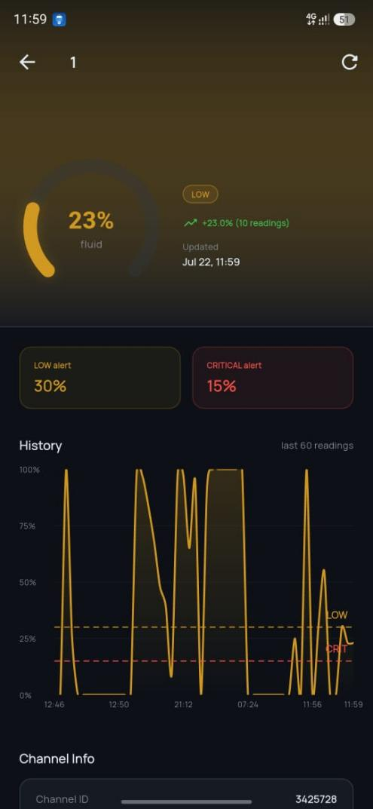
Figure 1: IV Sentinel app — bed detail view showing fluid percentage, status, alert thresholds, and reading history.

2.3 Project website and repository
Simulation: https://wokwi.com/projects/468919118346320897
<TODO: insert links to the project's code repository and any additional project website.>

3. Limitations and Next Steps
3.1 Limitations
The mobile app currently presents one bed per channel; it does not yet offer a single consolidated multi-bed ward view within the app itself.
Remote monitoring now depends on the ESP32's Wi-Fi connection and ThingSpeak's availability, if either is down, the bedside LED/LCD/servo response still works, but the app will not reflect the current reading until connectivity is restored.
ThingSpeak's free-tier channel update rate limits how frequently readings can be published, which limits how current the app's display and notifications can be.
Calibration is sensitive to the mechanical mounting of the load cell therefore, bracket flex, cable strain, or contact between the bag and the enclosure can introduce reading errors.
The tube-pinching mechanism has not been validated against clinical infusion safety standards and is presented as a prototype safeguard, not a certified medical device feature.

3.2 Next Steps
Extend the IV Sentinel app to a consolidated multi-bed ward view within a single screen, building on the per-channel data already available.
Add local buffering on the ESP32 so readings taken during a Wi-Fi or ThingSpeak outage are queued and published once connectivity returns.
Add a manual override for the servo clamp to guard against a stuck-closed failure mode.
Conduct extended calibration and drift testing across repeated bag changes and temperature conditions.
Explore low-power and battery-backup operation for use during power interruptions.

References
<TODO: List references using the IEEE citation format. See the IEEE citation guide at http://www.ieee.org/documents/ieeecitationref.pdf.>

Appendix A – Project Work plan
The Gantt chart below summarises the project work plan followed during development.
Task | Week 1 | Week 2 | Week 3 | Week 4 | Week 5 | Week 6
Requirements & literature review
Hardware sourcing (ESP32, load cell, HX711, resistors, breadboard, LED lights, LCD, servo)
Sensing & classification logic
LED / LCD integration
Enclosure of the electronics
Mounting and system setup design
Micro servo tube pinch mechanism and Integration testing
Report writing & documentation

Appendix B – Contribution by Team Members

No. | Team Member | Contribution
1. | SSERUNKUUMA JOSHUA
2. | NEBIRAH PRECIOUS MERISAH
3. | TAMBWE RAHIM STONE
4. | NANSUBUGA ZAHRA

