Software Requirements Specification
for
Smart IV Fluid Monitoring System

Version 1.0

Prepared by
Group 20
NAME | REGISTRATION NUMBER | STUDENT NUMBER | COLLEGE
SSERUNKUUMA JOSHUA | 25/U/03587/PS | 2500703587 | COCIS
NEBIRAH PRECIOUS MERISAH | 25/U/03541/PS | 2500703541 | COCIS
TAMBWE RAHIM STONE | 25/U/E/03597/EVE | 2500703597 | COCIS
MUGABE GIDEON | 25/U/03455/PS | 2500703455 | COCIS
NANSUBUGA ZAHRA | 25/U/03531/PS | 2500703531 | JINJA

Mentor: | DR. LILLIAN MUYAMA
Course: | CSC 1304 Practical Skills Development
Date:

Revisions
Version | Primary Author(s) | Description of Version | Date Completed
1.0 | SSERUNKUUMA JOSHUA  NEBIRAH PRECIOUS MERISAH  TAMBWE RAHIM STONE  MUGABE GIDEON  NANSUBUGA ZAHRA | Initial SRS covering the bedside monitoring unit and the IV Sentinel mobile app / ThingSpeak integration. | <00/00/00>

Contents
REVISIONS

1 INTRODUCTION

  - DOCUMENT PURPOSE
  - PRODUCT SCOPE
  - INTENDED AUDIENCE AND DOCUMENT REVIEW
  - DEFINITIONS, ACRONYMS AND ABBREVIATIONS
  - DOCUMENT CONVENTIONS
  - REFERENCES AND ACKNOWLEDGEMENTS

2 OVERALL DESCRIPTION

2.1 PRODUCT PERSPECTIVE
2.2 PRODUCT FUNCTIONALITY
2.3 USERS AND CHARACTERISTICS
2.4 OPERATING ENVIRONMENT
2.5 DESIGN AND IMPLEMENTATION CONSTRAITS
2.6 USER DOCUMENTATION
2.7 ASSUMPTIONS AND DEPENDENCIES

3 SPECIFIC REQUIREMENTS

3.1 EXTERNAL INTERFACE REQUIREMENTS
3.2 FUNCTIONAL REQUIREMENTS
3.3 BEHAVIOUR REQUIREMENTS

4 OTHER NON-FUNCTIONAL REQUIREMENTS

4.1 PERFORMANCE REQUIREMENTS
4.2 SAFETY AND SECURITY REQUIREMENTS
4.3 SOFTWARE QUALITY ATTRIBUTES

5 OTHER REQUIREMENTS

APPENDIX B - GROUP LOG

1. Introduction
This section introduces the Smart IV Fluid Monitoring System, an embedded systems prototype that automatically track intravenous (IV) fluid levels and alerts nursing staff when a bag needs replacing, accompanied by a mobile application. The remainder of this section describes the purpose and scope of this document, its intended readers, key terms, formatting conventions, and references.

1.1 Document Purpose
This Software Requirements Specification (SRS) defines the requirements for Version 1.0 of the Smart IV Fluid Monitoring System, comprising of the bedside monitoring unit (sensor, micro controller, local alerts, and tube-clamp mechanism) and its companion, a mobile application, IV Sentinel, which reports each bed's status over a ThingSpeak cloud channel. This document specifies the complete system as delivered for the CSC 1304 Practical Skills Development project.

1.2 Product Scope
The Smart IV Fluid Monitoring System addresses a specific patient-safety gap. Conventional IV stands give no warning before a bag runs empty, and nurses responsible for many patients at once cannot continuously watch every bedside. The system continuously weighs the IV bag using a load cell, classifies its status as Normal, Low, or Critical, and responds locally through colour-coded LEDs, an LCD display and a micro servo tube clamp that carries out a pinch mechanism at the Critical threshold. The system additionally publishes each reading to a ThingSpeak channel, which the IV Sentinel mobile app reads to give nurses a remote, per-bed view of fluid percentage, status, and history, together with push notifications when attention is needed. The product's goal is to reduce unnoticed IV depletion and ease nurse workload using affordable, low-power hardware suited to resource-limited healthcare settings.

1.3 Intended Audience and Document Overview
This document is intended for the course facilitator/mentor evaluating the project, and for the group members themselves as a reference during implementation and testing. A reader new to the project should begin with Section 2 (Overall Description) for a high-level picture of the system before proceeding to Section 3 (Specific Requirements), which details the functional and interface requirements, and Section 4 (Other Non-functional Requirements), which covers performance, safety, security, and quality attributes
.
1.4 Definitions, Acronyms and Abbreviations
ESP32 — A Wi-Fi/Bluetooth-capable micro controller used as the bedside unit's processor.
HX711 — A 24-bit analogue-to-digital amplifier module used to read the load cell.
IV — Intravenous — administration of fluid directly into a patient's vein.
IV Sentinel — The companion mobile application used by nurses to remotely view bed status and receive notifications.
LCD — Liquid Crystal Display, used for the bedside status readout.
LED — Light-Emitting Diode, used for the bedside colour-coded status indicator.
SRS — Software Requirements Specification (this document).
ThingSpeak — A cloud IoT platform used to store and serve each bed's fluid-level readings via channels.

1.5 Document Conventions
This document follows IEEE SRS formatting conventions. Body text is set in Times New Romanl 12pt, 1.5 line spacing. Section and subsection headings are numbered as shown in the Contents. Requirement statements use "shall" to denote a mandatory requirement and are labelled with an identifier of the form FR-<area>-<number> for functional requirements and NFR-<area>-<number> for non-functional requirements, to allow transparency during testing.

1.6 References and Acknowledgments
- IEEE citation guide: http://www.ieee.org/documents/ieeecitationref.pdf
- ThingSpeak documentation: https://www.mathworks.com/help/thingspeak/
- HX711 load cell amplifier datasheet.

2. Overall Description
2.1 Product Perspective
The Smart IV Fluid Monitoring System is a self-contained product consisting of two cooperating parts, a bedside embedded unit and a cloud-connected mobile application. The bedside unit is fully self-sufficient. It senses, classifies, displays, and acts (via LEDs, LCD, HX711 and a micro servo tube clamp) without depending on network connectivity. The mobile application is an additive layer, it reads the bedside unit's published readings from a ThingSpeak channel to give nurses remote visibility and notifications, but does not control the bedside unit directly. Figure 1 shows the major components and their interconnections.
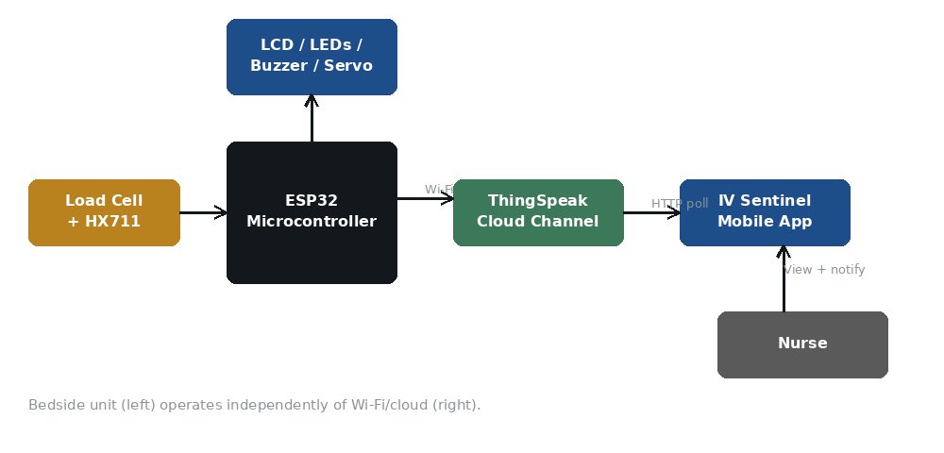
Figure 1: System architecture — bedside unit, cloud channel, and mobile app.

2.2 Product Functionality
The system performs the following major functions:
Continuously measure IV bag weight and classify fluid level as Normal, Low, or Critical.
Display current status locally via colour-coded LEDs and an LCD screen.
Automatically pinch the IV tubing via a micro servo when the Critical threshold is reached.
Recalibrate (reset) the sensor on demand via a reset button after a bag change.
Publish each reading to a ThingSpeak channel over Wi-Fi.
Display live bed status, configurable alert thresholds, and reading history in the IV Sentinel mobile app.
Send push notifications to the nurse's device when a bed's reading crosses into the Low or Critical range.

2.3 Users and Characteristics
The primary intended user is the ward nurse, who interacts with the system in two ways: directly at the bedside (observing LEDs/LCD, pressing the reset button after a bag change) and remotely through the IV Sentinel app (checking bed status, configuring thresholds, and receiving notifications). Nurses are assumed to have no special technical training and interact with the app only through its simple interface.
A secondary user is a ward supervisor or biomedical technician who may configure ThingSpeak channel settings or alert thresholds and is assumed to have slightly more technical familiarity with the system than a bedside nurse.

2.4 Operating Environment
The bedside unit runs on an ESP32 microcontroller with attached load cell, HX711, LCD, LEDs, micro servo, and reset button, powered via USB or a suitable DC supply, and requires a 2.4GHz Wi-Fi network to reach ThingSpeak (local sensing and alerting continue to function without it). The IV Sentinel mobile app targets Android smartphones with internet connectivity (Wi-Fi or mobile data) and a modern Android OS version, and communicates with ThingSpeak over HTTPS.

2.5 Design and Implementation Constraints
The bedside unit must remain low-cost, using only widely available ESP32-class hardware.
The bedside unit must continue to sense, classify, and alert locally even when Wi-Fi or ThingSpeak is unavailable.
ThingSpeak's free-tier channel update rate limits how frequently readings can be published.
The load cell must be mechanically isolated from the electronics enclosure to avoid wrong measurements that might be caused due to friction, among others(see Section 4.3).
The micro servo-actuated tube clamp is a prototype safeguard only, and is not certified to clinical infusion-safety standards.
The mobile app is developed for Android only in this version no iOS release is in scope.

2.6 User Documentation
A short printed instructions card will be provided at the bedside, covering what each LED colour and LCD message means, and how to use the reset button after a bag change. The IV Sentinel app will include a brief in-app help screen covering how to add a bed's channel, configure thresholds, and enable notifications. <TODO: attach or link the actual quick-start card and in-app help text once finalised.>

2.7 Assumptions and Dependencies
The ward has a working 2.4GHz Wi-Fi network reachable from each bedside unit.
Nurses carry an Android smartphone capable of running the IV Sentinel app.
ThingSpeak remains available and free-tier limits are sufficient for the number of beds deployed.
Each IV bag's hanging weight, once reset, changes only due to fluid use (i.e. no other object is added to or removed from the hook while monitoring).
The HX711 and load cell combination provides sufficiently stable readings once properly mounted and calibrated (see the mounting guidance developed during this project).

3. Specific Requirements
3.1 External Interface Requirements
3.1.1 User Interfaces
The system exposes two user interfaces:
Bedside interface: an LCD screen showing the current fluid percentage and status word (Normal/Low/Critical), three colour-coded LEDs (green/blue/red) mirroring that status, and a reset button used after a bag change.
Mobile app interface (IV Sentinel): a bed detail screen showing a circular fluid-percentage gauge, current status badge, configured Low/Critical alert thresholds, a rolling history chart of recent readings with threshold lines highlighted, channel information (Channel ID), and a refresh control.
See Figure 2.
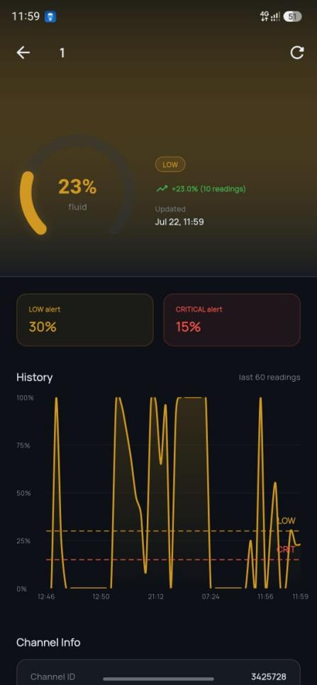
Figure 2: IV Sentinel — bed detail screen.

3.1.2 Hardware Interfaces
The ESP32 interfaces with a load cell through the HX711 24-bit ADC amplifier over a simple two-wire (clock/data) digital interface. It drives the LCD (parallel or I2C, per the specific module used), three LED outputs through current-limiting resistors, a micro servo via a PWM signal, and reads the reset button as a digital input with debouncing handled in software.

3.1.3 Software Interfaces
Bedside unit firmware: ESP32 sketch (C/C++), using an HX711 library for load cell readings and the ESP32's built-in Wi-Fi stack.
Cloud service: ThingSpeak channels, one per bed, accessed via ThingSpeak's REST API for both writing (from the ESP32) and reading (from the mobile app).
Mobile app: Android application (IV Sentinel) communicating with ThingSpeak over HTTPS; no other backend service is used in this version.

3.1.4 Communications Interfaces
The ESP32 communicates with ThingSpeak over Wi-Fi using HTTPS REST calls to publish new values on a timed interval of 15 seconds. The IV Sentinel app polls the same channel's REST endpoint over HTTPS to retrieve the latest and historical readings. Notification delivery uses the Android platform's standard notification mechanism, triggered when a polled reading crosses a configured threshold.

3.2 Functional Requirements
Sensing and Classification
FR-SENSE-1: The system shall continuously measure the suspended IV bag's weight using the load cell and HX711 amplifier.
FR-SENSE-2: The system shall convert the measured weight to a fluid percentage relative to a full-bag reference established at the last reset/calibration.
FR-SENSE-3: The system shall classify the current fluid percentage as Normal, Low, or Critical against configurable thresholds (default Low = 30%, Critical = 15%).
Local Alerting
FR-ALERT-1: The system shall light the green LED and display "Normal" on the LCD while fluid percentage is above the Low threshold.
FR-ALERT-2: The system shall light the blue LED and display "Low" on the LCD when fluid percentage is at or below the Low threshold and above the Critical threshold.
FR-ALERT-3: The system shall light the red LED, display "Critical" on the LCD when fluid percentage reaches or falls below the Critical threshold.
FR-ALERT-4: The system shall actuate the micro servo to pinch the IV tubing when the Critical threshold is reached.
Recalibration
FR-RESET-1: The system shall reset the load cell to a new full-bag baseline when the reset button is pressed.
FR-RESET-2: The system shall resume automatic monitoring immediately after a successful reset.
Remote Monitoring (IV Sentinel App)
FR-APP-1: The bedside unit shall publish each new reading to its assigned ThingSpeak channel over Wi-Fi.
FR-APP-2: The app shall display the current fluid percentage and status for a selected bed's channel.
FR-APP-3: The app shall allow the Low and Critical alert thresholds to be configured per channel.
FR-APP-4: The app shall display a history chart of recent readings (at least the last 60) with the configured thresholds overlaid.
FR-APP-5: The app shall send a notification to the nurse's device when a bed's reading crosses into the Low or Critical range.
FR-APP-6: The app shall display the ThingSpeak Channel ID associated with each bed for troubleshooting and reference.

3.3 Behaviour Requirements
3.3.1 Use Case View
Figure 3 shows the primary actors, the Nurse and the ThingSpeak-based app backend, and the main use cases they perform against the Smart IV Fluid Monitoring System.
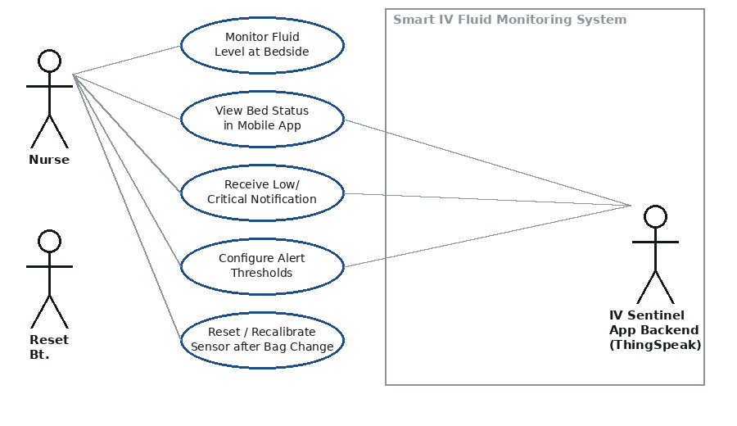
Figure 3: Use case diagram.
Monitor Fluid Level at Bedside — the nurse observes the LED/LCD status directly at the bedside.
View Bed Status in Mobile App — the nurse checks a bed's remote status, gauge, and history in IV Sentinel.
Receive Low/Critical Notification — the app notifies the nurse when a bed needs attention.
Configure Alert Thresholds — the nurse or supervisor sets the Low/Critical percentage thresholds for a channel.
Reset/Recalibrate Sensor after Bag Change — the nurse presses the bedside reset button after replacing a bag.

4. Other Non-functional Requirements
4.1 Performance Requirements
NFR-PERF-1: The bedside unit shall update its local LED/LCD status within 1 second of a change in classified fluid level.
NFR-PERF-3: The micro servo shall complete the tube-pinching motion within 2 seconds of the Critical threshold being reached.
NFR-PERF-4: The bedside unit shall publish a new reading to ThingSpeak at least twice per minute when Wi-Fi is available, subject to ThingSpeak rate limits.
NFR-PERF-5: The IV Sentinel app shall refresh a bed's displayed status within 5 seconds of a manual refresh action.

4.2 Safety and Security Requirements
NFR-SAFE-1: Loss of Wi-Fi or ThingSpeak connectivity shall not disable or delay the bedside unit's local sensing, LED/LCD or micro servo response.
NFR-SAFE-2: The micro servo-actuated tube clamp shall include a manual override so staff can open it if the servo fails in the closed position.
NFR-SAFE-3: The load cell mounting shall mechanically isolate the electronics enclosure from the bag's weight, so a mounting fault cannot damage the enclosure.
NFR-SEC-1: Communication between the bedside unit, ThingSpeak, and the mobile app shall use HTTPS.
NFR-SEC-2: ThingSpeak channel write keys shall not be exposed in the mobile app; only read-scoped access shall be used by the app.
NFR-SEC-3: The app shall not store patient-identifying information, beds shall be referenced only by channel/bed identifier.

4.3 Software Quality Attributes
4.3.1 Reliability
The bedside unit shall continue local sensing and alerting correctly even during Wi-Fi or ThingSpeak outages, since safety-critical behaviour (LED/LCD/servo) does not depend on the cloud layer. Mechanically isolating the load cell from the enclosure (fixed end bolted to a dedicated bracket, not the enclosure wall) is intended to reduce false readings that would otherwise reduce reliability over time.
4.3.2 Usability
The bedside interface shall be understandable at a glance without training, using colour and short text only. The IV Sentinel app shall present each bed's status, thresholds, and history on a single screen without requiring navigation through multiple pages for routine checks.

4.3.3 Maintainability
Alert thresholds shall be configurable without firmware changes (via the app, per channel), and the sensing/classification logic is kept hardware-independent so it can be reused if the underlying microcontroller or sensor module is later swapped or scaled to additional beds.

5. Other Requirements
No additional requirements beyond those listed in Sections 3 and 4 have been identified at this time.

Appendix B - Group Log
<Please include here all the minutes from your group meetings and meetings with users, your group activities, and any other relevant information that will assist the Course Facilitator to determine the effort put forth to produce this document.>
Date | Attendees | Summary of Discussion / Activity
06/07/26 | All group members | Requirements and literature review
08/07/26 | All group members | Hardware sourcing(ESP32,load cell, HX711, micro servo, resistors, LED lights, LCD, breadborad wires etc)
09/07/26 | All group members | Sensing and classification logic
13/07/26 | All group members | LED and LCD integration
15/07/26 | All group members | Enclosure of the electronics
16/07/26 | All group members | Mounting of the load cell
20/07/26 | All group members | Mounting of the load cell and system setup design
22/07/26 | All group members | Micro servo tube pinch mechanism
23/07/26 | All group members | Integration Testing
24/07/26 | All group members | Report writing and documentation

