# INTRODUCTION

The system can be accessed by entering the below address on the address bar of the browser:-

<http://eiddash.nascop.org>

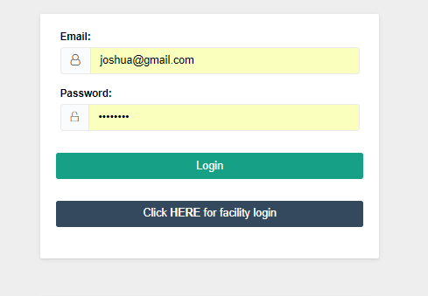

Figure 1: Login Page

In this page you are required to enter the email used while being registered into the system, alongside the password.

## Page Components

In this system the menu is a side menu and is located on the left side of the page as shown below

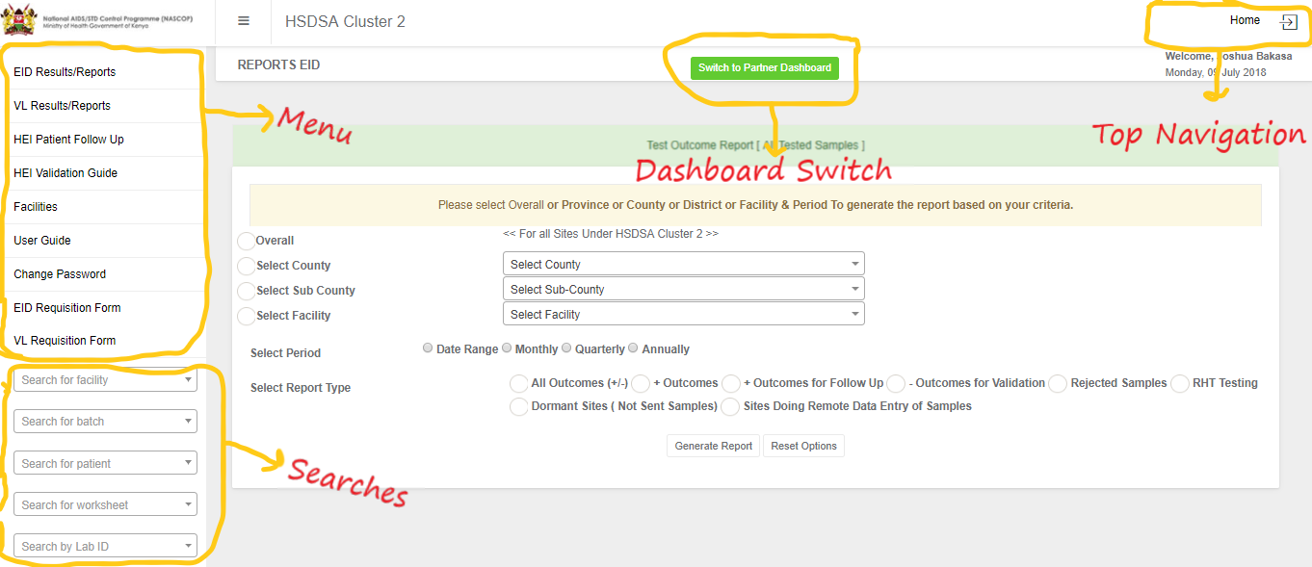

Figure 2: Page Components

Every page of the system has this structure where the menu is on the top left section, the searches are at the bottom left of the page. The switch button to the relevant pages of the dashboard will be located at the top-middle section of the page, while the auxiliary links such as the homepage and logout button, will be located at the top right section of the page. At the middle of the page is the contents of the page that one has selected from the menu, or landing page after login.

# REPORTS

Upon login the partner will be redirected to the EID reports page. To access the viral load reports, select the *VL Results/Reports* from the side menu.

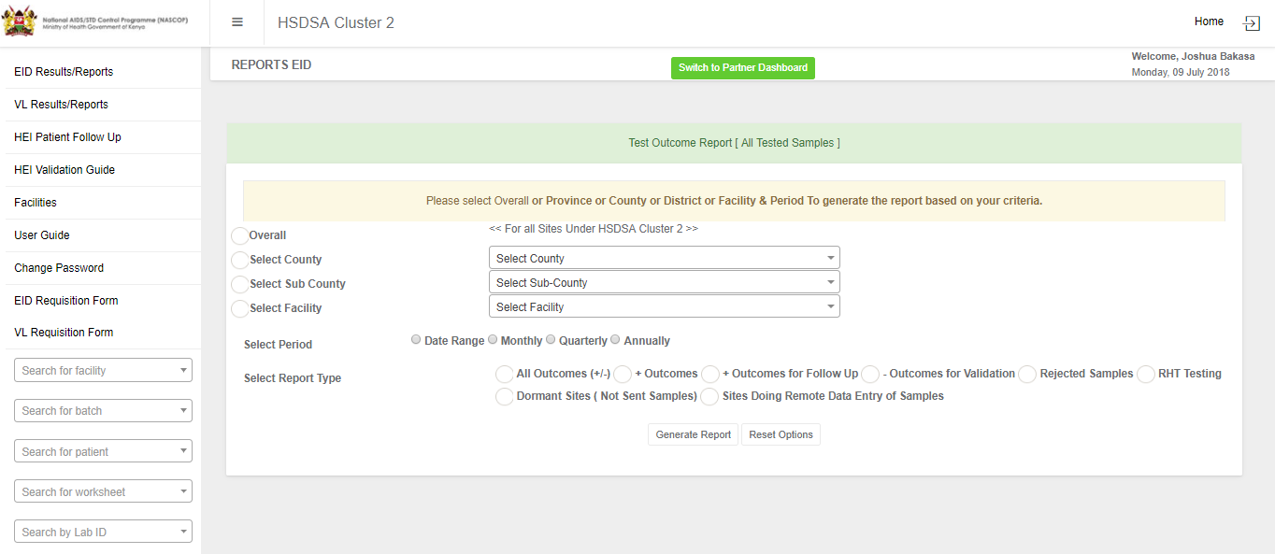

Figure 3: Partner Homepage

In order to download the reports one has to selected the criteria on the page. The first criteria are the coverages; Overall (All counties, sub-counties, and facilities supported by the partner), specific county, specific sub-county, or a specific facility. In this section one should select the radio box in front of the criteria first before selecting the coverage. For example, one should check the radio box in front of the label *“Select County”* before heading to select the actual county. Any selection without a prior radio box check is ignored.

The next criteria is the time period of the intended reports. This can be a specific date range, on a monthly basis, a specific quarter, or a specific year.

The final criteria is the data indicators that you wish to be present in the reports. It is important to note the for each of these criteria you can only pick one per section, i.e. in the data indicators for example, one can only pick one of them. This applies to the coverage and period.

# HEI FOLLOW UP

## Updating Initiation Date

To access this page, one should click the *“HEI Patient Follow Up”* link on the side menu. The page brings up a list of the positive infants and the breakdown of the infants who have been followed up with their ratios. Each of these validations has a link to its right to allow one to view the infants and edit where necessary, as shown in the image below.

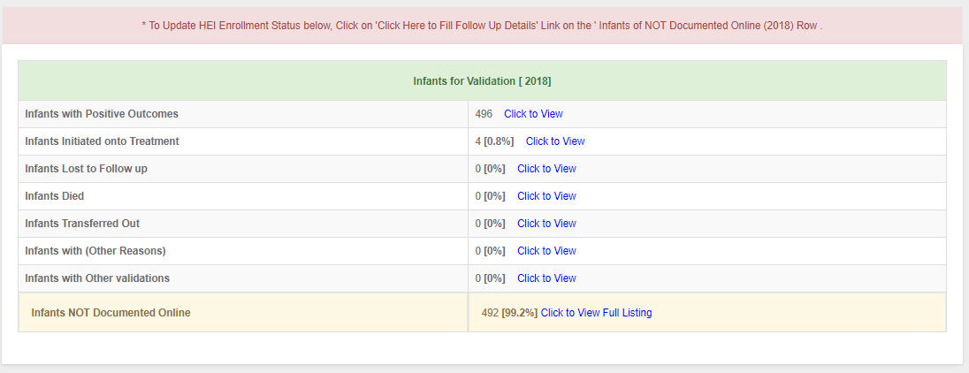

Figure 4: HEI Validation

To perform follow up on new infants one should select the link next to the *“Infants Not Documented Online”*. This will take you to a page called HEI follow up with the details of the new positive infants batched in 10 on the initial load. This number can be changed by selecting a different number from the drop down at the top left of the table.

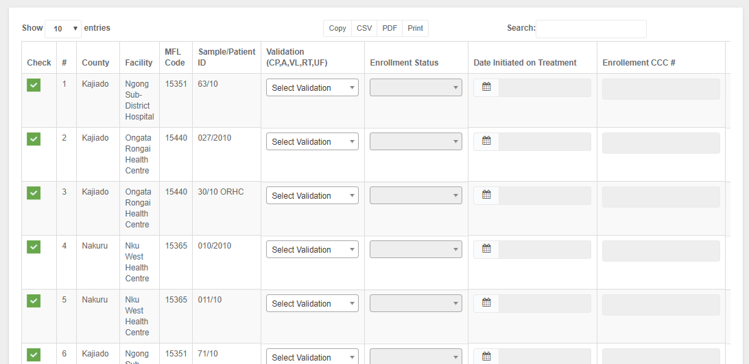

Figure 5: HEI Follow up

## HEI Validation Tool Guide

On the side menu there is a link for *“HEI Validation Guide”*. This link points to a download file that provides the national guideline to be followed on Updating patients` initiation dates.

# PARTNER FACILITIES

Click on the link *“Facilities”* to view the sites the partner is supporting. One can search for a particular site from the search box on the top right of the table or expand the list from the drop down box on the top left of the table.

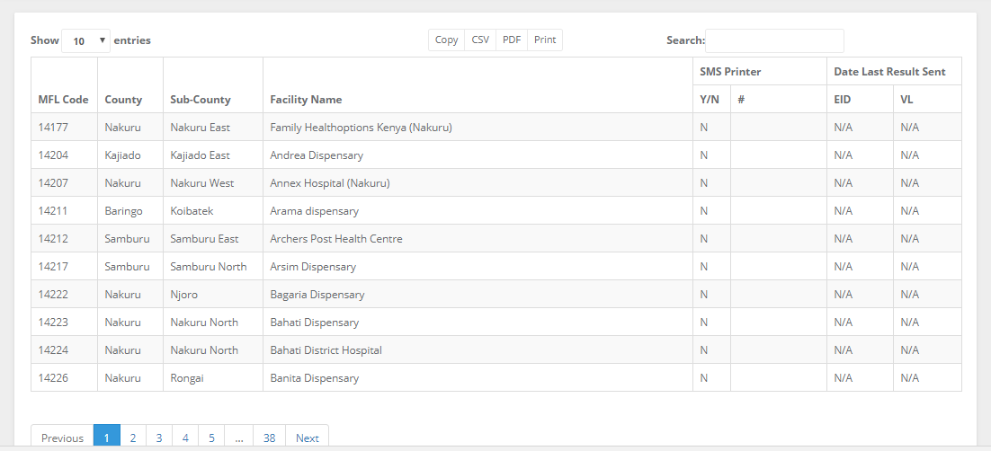

# PARTNER UTILITIES

## Requisition Forms

The current EID and VL request forms are available for download under the links, *“EID Requisition Form”* and *“VL Requisition Form”*. The requisition forms will be updated following every update by NASCOP, this is to ensure that there is at all times the current requisition forms.

## User Guide

This is the documentation containing the details of how the user will be able to interact with the system. The link to the document is located on the side menu, which provides a download for the document for the specific user.

## Change Password

One can change their password by clicking the change password link from the side navigation. A page as the one below comes up, with the name and email of the user which cannot be edited, that requires the user to enter their new password alongside a confirmatory password which should be identical to the new password.

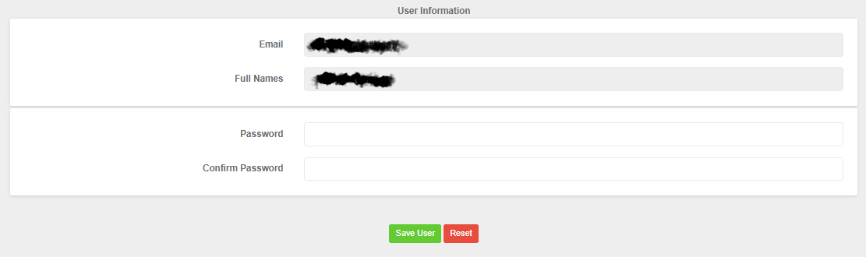

Figure 6: Change Password

## Partner Dashboards

This is located at the top of the page as a button, as shown in the image below. It is a link that redirects the partner to the partners national dashboards.



Figure 7: Top Navigation

## Logout

This is a button located at the top right of the page as shown in the figure (Figure 7: Top Navigation) above.