CUSTOMER SEGME NTATION

INTRODUCTION

The preprocessing is a Real-world datasets are generally messy, raw, incomplete, inconsistent, and unusable. It can contain manual entry errors, missing values, inconsistent schema, etc. Data Preprocessing is the process of converting raw data into a format that is understandable and usable. It is a crucial step in any Data Science project to carry out an efficient and accurate analysis. It ensures that data quality is consistent before applying any **Machine Learning** or **Data Mining techniques**.

**DIMENSTION REDUCTION**

**The dimension of the data is reducing to find and analysis the data set.**

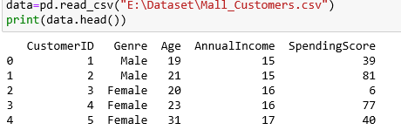

Let find the data types of the data set.

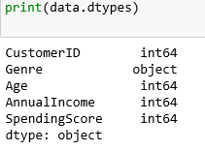

We trans form the data into reduction dimentions for process.

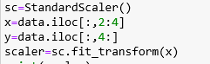

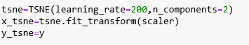

**Now let implement the data set into the Kmeans algorithm.**

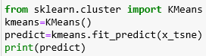

**The predict value is**

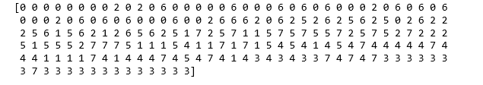CONCLUSION

**From this we can able to predict the values from data of dimenstion reduced**

**Data set using TSNE algorithm and implemented into KMeans clustureing algorithm.**