CUSTOMER SEGMENTATION

FEATURE ENGINEERING

Feature engineering or feature extraction or feature discovery is the process of extracting features from raw data. Due to deep learning networks, such as convolutional neural networks, that are able to learn it by itself, domain-specific- based feature engineering has become obsolete for vision and manipulation — addition, deletion, combination, mutation — of your data set to improve machine learning model training, leading to better performance and greater accuracy.

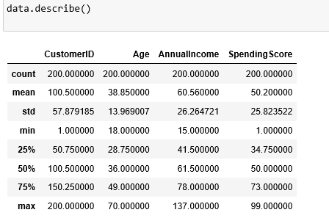

The data have been described over.

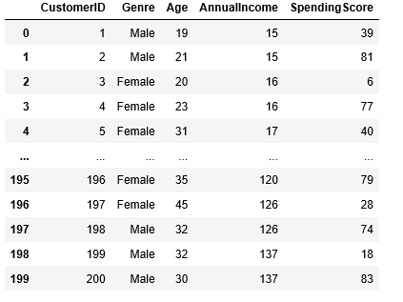

The data is trans formed using the Standards scaler and TSNE algorithm for reduce the dimension of the data set and find predictions.

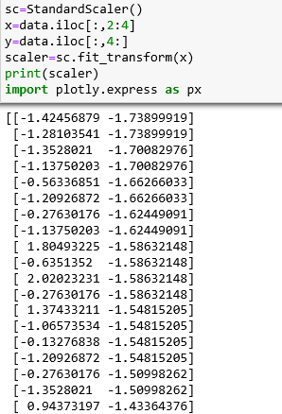

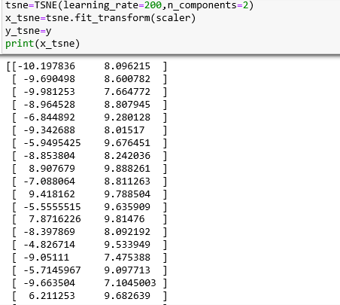

KMEANS ALGORITHM

Let implement the data into Kmeans algorithm.

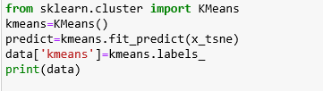

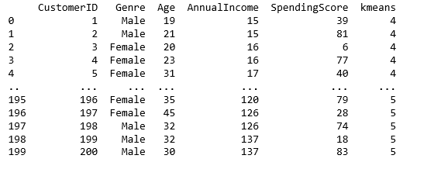

Let find out the prediction value and add it into data set for visualisation.

**VISUALIZATION**

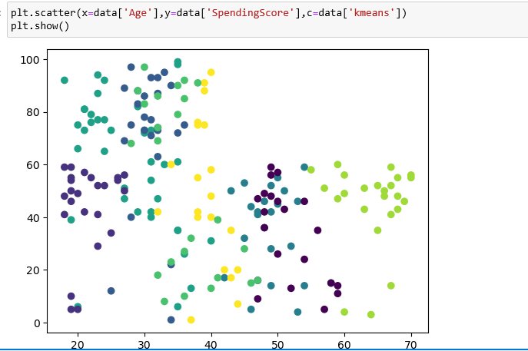

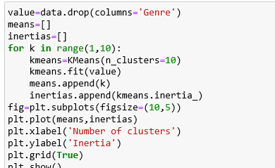

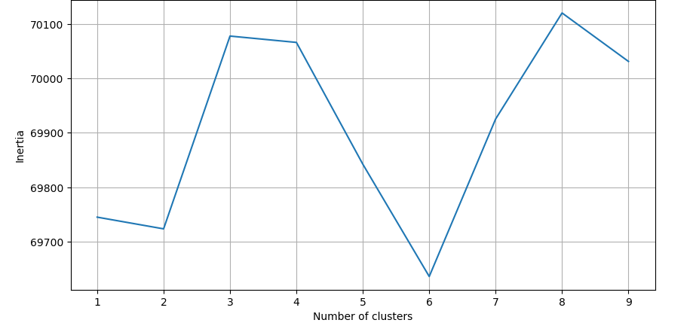

### **Interpreting the Meaning of the Clusters**

The above visual part defines the data predicton of kmeans Algorithm.

The graph represents the number of clustures and the value of inertia with the data value of data set.