**CUSTOMER SEGMENTAION**

PROBLEM STATEMENT

One of the biggest issues with customer segmentation is data quality. Inaccurate data in source systems will usually result in poor grouping. customers who are individuals, attributes like age, gender, and marital status are frequently used.

DESIGN THINKING

In this project we are going to find problem faced by the customers during shopping , using this project we're going to find the people age and their spending price according to their age we’re going to find how much they spend on their product , and let find their interest based on their previous data set by the interest we can alter the marketing style according to their behaviors'. And the customer will be stratified.

DATASET

Dataset used for the project is MallCustomer data set.

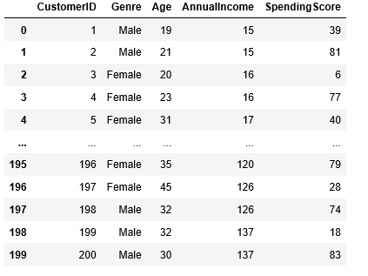

The dataset has the attributes like CustomerId , Genere , Age , AnnualIncome , spending score.

Let see the data set characteristics.

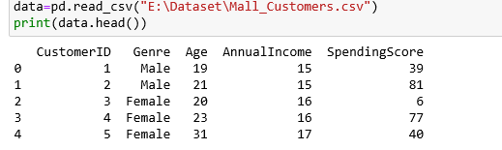

For a consistent data let us known about the data types for implement and check for the null values.

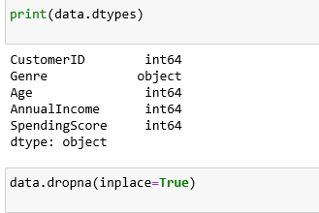

Before the implementaion and preprocessing of the data we need to known about the data types of the attributes,

And let's describe about the data set.

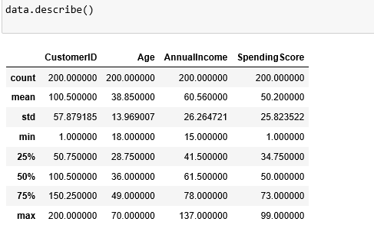

DATA PREPROCESSING

Our aim to find the people interest based on the spending score according to their age and annualIncome, so before the data transmit,let choose the Age and AnnualIncome data attribute into one data value and Spendscore on another.

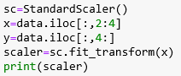

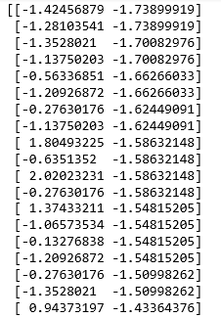

Now made this data into transformed data for make the dimention less.

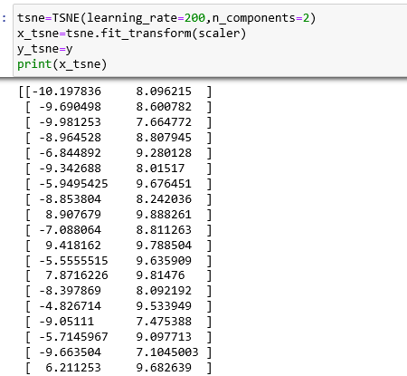

ANALYSIS TECHNIQUE

The data set is analysis by the clustering algorithm – KMeans algorithm.

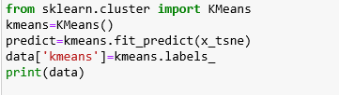

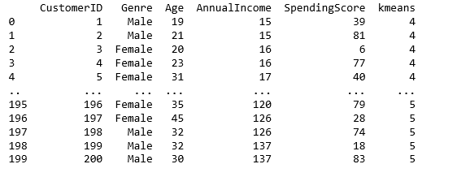

Kmeans clustering algorithm is used to find the data by combine together the same class of data into same clusters and find most similar charter of other data and combine together.

Above we combine togrther the Age and AnnualIncome data into same attribute and spending income into another data.

And let predict the value of kmeans and add into data set as kmeans.

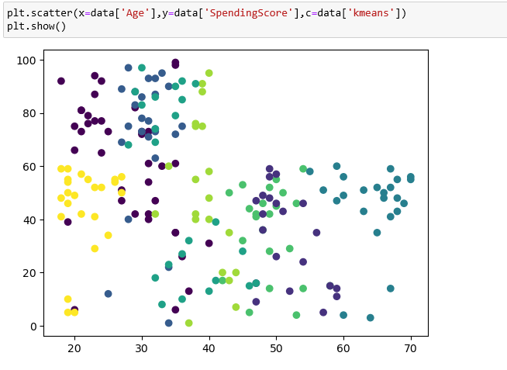

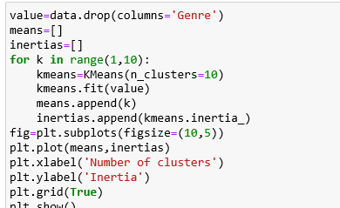

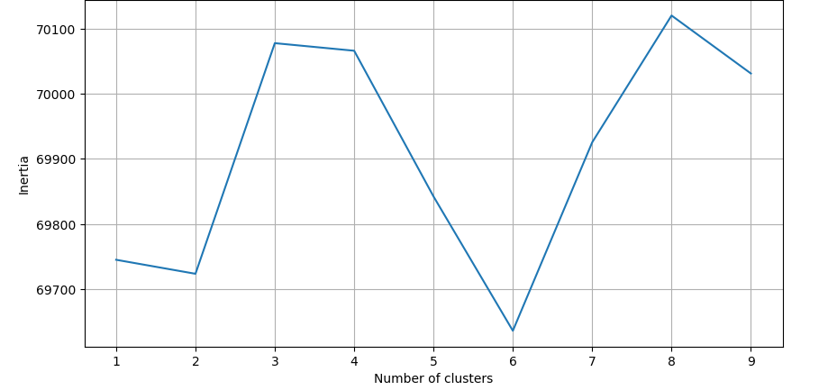

From the above Visualization we’re come to know about how people spend according into their income and age.

PRESENT KEY

According to the visualization we’re able to observe the people behaviours according to their color.

RECOMMENDATIONA BASED ON CUSTOMER SEGMENTATION

According to the graph visualization we can able to predict the people interest according to their interest we can modify in the marketing side and we I'll be satisfied with customers needs.

Example – people with low age and high income will spend high we can recommend my expensive things to them.