Joshua Alvarado, JBA230001
Aarej Syed, AAS210020

Part 1

Trial Logs

Learning Rate (α) | Iterations | Training MSE | Test MSE | R2 Score
0.1 | 1000 | 410,836.25 | 583,434.60 | 0.3953
0.01 | 1000 | 411,252.07 | 584,143.81 | 0.3946
0.001 | 1000 | 773,897.42 | 953,824.09 | 0.0115

Evaluation Statistics

Optimal Learning Rate: 0.1
Final Training MSE: 410,836.25
Final Test MSE: 583,434.60
R2 Value: 0.3953
Weight Coefficients: The model calculated 57 weights for the standardized attributes.

Plot
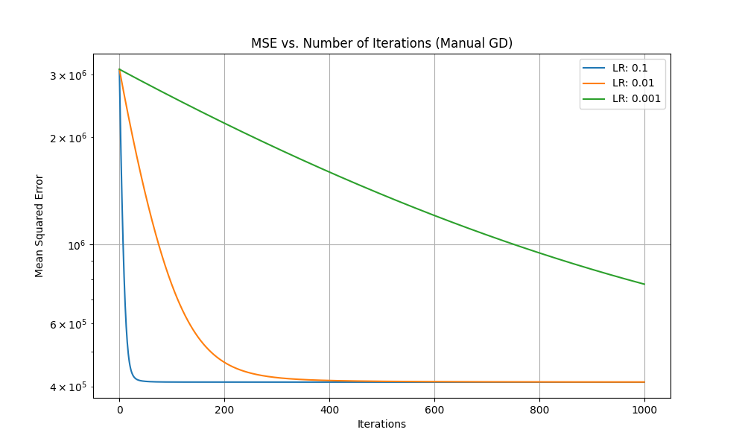
Reflection
I am satisfied with this solution. By testing different learning rates, I identified that α = 0.1 provides a sufficient step size to reach a local minimum within the 1,000-iteration limit. The R2 of 0.4 shows that while the model successfully identified primary price drivers like square footage, it is likely missing other variables, such as building amenities not found within the dataset.

Part 2

Trial Logs
Learning_Rate, Iterations, Train_MSE, Test_MSE
0.0001, 1000, 409702675623652542711332864.00, 75512612709904203776.00
0.0001, 2000, 409702675636657153927806976.00, 75512612709904252928.00
0.0001, 3000, 409702675649661833863757824.00, 75512612709904269312.00
1e-05, 1000, 410641.99, 583896.00
1e-05, 2000, 410640.40, 583907.56
1e-05, 3000, 410640.40, 583908.21
1e-06, 1000, 410891.44, 583528.88
1e-06, 2000, 410720.97, 583413.05
1e-06, 3000, 410627.66, 583360.19

Best Parameters Report:
LR: 1e-06, Iterations: 3000, Test MSE: 583360.19, R2: 0.3954

Evaluation Statistics

Optimal Learning Rate: 1e-06
Optimal Iterations: 3000
Best Test MSE: 583,360.19
R2 Value: 0.3954

Reflection
I am confident that this solution is an excellent approximation of the best solution. The specific combination that we determined to be optimal, which has a learning rate of 1e-06 and 3000 iterations, beats the combinations with 1e-05 and 1e-07 learning rates, meaning that we have greatly narrowed down where the optimal solution could be.

Comparison

Metric | Part 1 | Part 2
Best Test MSE | 583,434.60 | 583,360.19
R2 Score | 0.3953 | 0.3954

TRAINING
Learning_Rate, Iterations, Train_MSE, Test_MSE
0.0001, 1000, 409702675623652542711332864.00, 75512612709904203776.00
0.0001, 2000, 409702675636657153927806976.00, 75512612709904252928.00
0.0001, 3000, 409702675649661833863757824.00, 75512612709904269312.00
1e-05, 1000, 410641.99, 583896.00
1e-05, 2000, 410640.40, 583907.56
1e-05, 3000, 410640.40, 583908.21
1e-06, 1000, 410891.44, 583528.88
1e-06, 2000, 410720.97, 583413.05
1e-06, 3000, 410627.66, 583360.19

Best Parameters Report:
LR: 1e-06, Iterations: 3000, Test MSE: 583360.19, R2: 0.3954
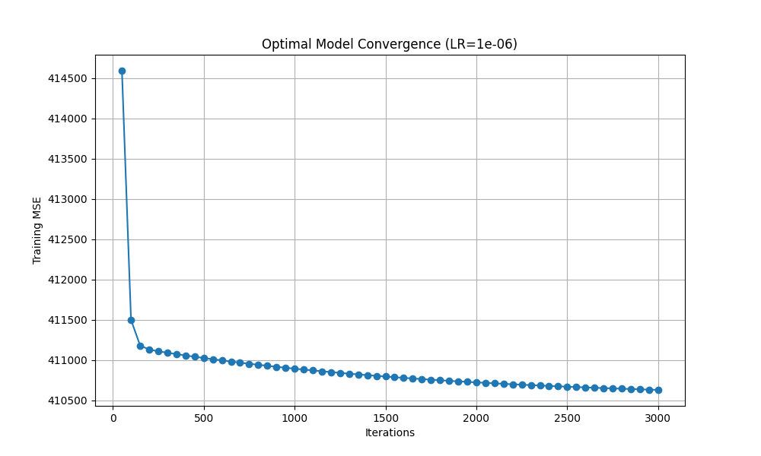
Conclusion

Both implementations successfully modeled the apartment price data accurately. Part 1 was as effective as Part 2.

