PortSwigger Academy – Business Logic Vulnerabilities
- Business/Application logic vulnerabilities are flaws in the design and implementation of an application that allows an attacker to elicit unintended behaviour.
- Logic flaws are often invisible to people who aren’t explicitly looking for them as they typically won’t be exposed by normal use of the application.
- Logic flaws are difficult for automated vulnerability scanners and are therefore a great target for bug bounty hunters.
- These flaws often arise because the design and development teams make flawed assumptions about how users will interact with the application or specific sections of the application. For example, weak client-side controls might be used to validate user input for a login function. A simple intercepting proxy could be used to bypass this.
- They can also arise because developers do not have a full understanding of the application and how other areas of the application will be used or interacted with. This could be because development teams are assigned different areas of the application and so do not work with complete unity. It could also be down to the fact that the application/system is too complicated to get an 100% understanding of it.
- This category of vulnerability is broad which means the impact of the flaws found can vary greatly
Examples of business logic vulnerabilities
- Due to the broadness of the category it is hard to practice testing for them. However, there are some examples of flaws that are most common and worth testing for:
- Excessive trust in client-side controls is a flawed assumption that users will only interact with the application via the provided web interface. This also include the assumption that client-side validation will prevent users from supplying malicious input. By using an interception proxy, an attacker can simply change the data being sent which will then not be interacted with by client-side validation.
- Failing to handle unconventional input is where an application rejects inputs that go against ‘buiness rules and logic’. For example, an attacker might be able to set the price of an item to a negative value such as -$1000 when they are adding it to their basket. This could mean that when they complete their order, the business ends up ‘sending funds the wrong way’ which means that the attacker would be send $1000 from the business + receive the products that they ordered.
- Trusted users won’t always remain trustworthy. Applications might assume that because a user has passed strict controls initially, the user and their data can be trusted indefinitely and weaker/no security measures need to be put in place after that point. This is wrong and a business should use rules and measures that are applied consistently throughout the application to avoid any loopholes that could be exploited.
- A misconception is that users will always supply values for mandatory input fields. Browsers may prevent users from submitting a form without the required input but an intercepting proxy can be used to easily remove/modify the paramters being sent
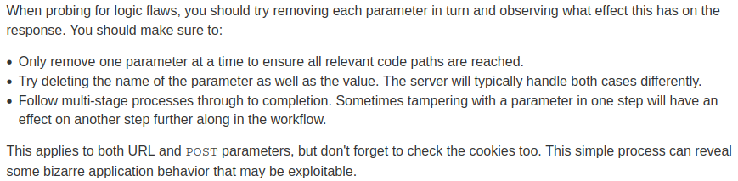
- Another serious flaw is the assumption that users will follow the predefined squence of steps to carry out different ‘actions’ such as purchasing something or resetting a password. Weak MFA can be bypassed due to weakened security on later stages due to the assumption that to get to those later stages, the user has passed the first phase (which has strong defences). An attack might be able to ‘skip’ the first stage or complete the steps in the wrong order allowing them to bypass the multi factor authentication
- It is worth checking any situations where prices or other sensitive values are adjusted based on criteria determined by user actions. For example, an online shop might apply a 10% discount when the basket total is £1000 but it might no remove that discount if items are removed from the basket to bring the price to under a £1000.
- Dangerous scenarios can occur when user-controllable input is encrypted and the resulting ciphertext is then made available to the user in some way. This kind of input is known as an “encryption oracle”. This becomes dangerous if there are other user-controllable inputs in the application that expect data encrypted with the same algorithm. In this case, an attacker could potentially user the encryption oracle to generate valid, encrypted input and then pass it into other sensitive functions. The attack might also be able to work out the algorithm.

